Team 5

Section 101  
Team Gopher Milk

Project Milestone 1

**Team Members**

* Ziad Alwazzan
* Lillie Bahrami
* Haley Hartin
* Byungjin (BJ) Kim
* Mauro Vargas Jr.

**Application Name**

Shelf Life

**Application Description**

Our team wants to implement a software restaurants would use to keep track of food inventory and profit. The software has an inventory of each individual ingredient the restaurant uses in dishes. The ingredients have a cost associated with it that the restaurant pays to get the food. When the dish is ordered, the amount of each ingredient used in the dish is subtracted from the inventory. The software keeps track of the money made from each dish, and they money used on the ingredients, and the amount of times each dish is ordered

By keeping track of this data, restaurants can keep track of profits, expenses and inventory. The software allows the user to see when they are running low on inventory, so they can re-order. By keeping track of how much of each ingredient is used each month, restaurants can predict how much of each ingredient to re order.

**Vision Statement**

Our software, Shelf Life, is a product that makes restaurant managers’ lives easier with a user friendly inventory tracking system, that will allow the managers to see how much of every ingredient they have left and when they would need to reorder certain ingredients. In addition to tracking the inventory of the restaurant, our software will be able to track profits and losses through a specific time period, whether it be a month, a couple weeks, or a day. Unlike the traditional method of hand counting the inventory of all the ingredients, our product allows for managers to save time by automatically updating ingredients that have been used during the day.

**Version Control**

Code: <https://github.com/cinnamonappletea/gopher-code.git>

Milestone Submission: <https://github.com/cinnamonappletea/gopher-milestones.git>

Meeting Logs: <https://github.com/cinnamonappletea/gopher-logs.git>

These repositories have been shared by Lillie Bahrami with everyone in our group, including our TA, Carl Mueller.

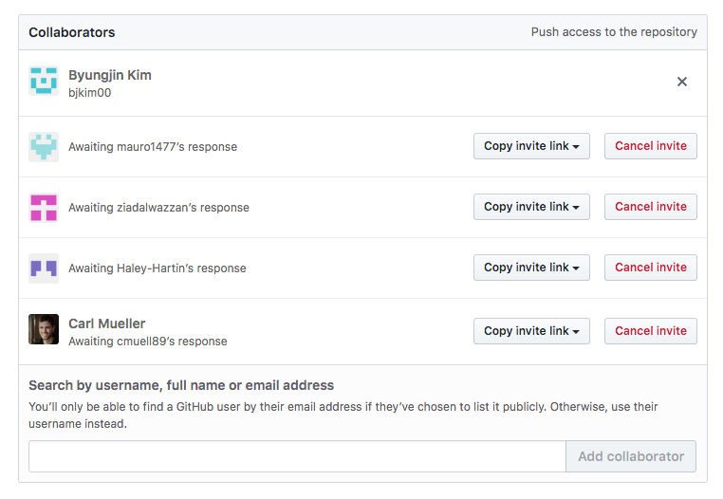

**Development Method**

We have chosen to use the Waterfall methodology because of its tight project scopes which are defined early on.

**Communication Plan**

Our communication plan is to primarily use imessage group chat to communicate ideas and updates with each other as we work throughout the week. We also have a google docs folder for our project to collaborate on assignments such as milestone submissions, so we can all work on the same document at once.

**Proposed Architecture Plan**

Back-end:

* Hash Table
* FireBase? ( if we can use this to manage our user login/password database)
* Classes ( store our inventory, user login for restaurant manager)

Front end:

* Javascript
* HTML
* CSS

**Meeting Plan**

We are meeting Monday evenings around 6:15 for a couple hours each week. The Wolf Law building is the place we have decided to meet, and we all plan on meeting in person each week. Our meetings will consist of discussing what we have done the past week, and getting on the same page for the next week's tasks. We will also talk about any issues, concerns or ideas we have.