**mVACS & MIMIC Lab Protocol**

**Table of Contents**

Purpose 1

Materials & Equipment 1

Procedures 1

**A.** **Cerner Report Generation** 2

**B.** **Finding Matching Negatives** 3

**C.** **LabVantage Specimen Accessioning** 5

**D.** **Specimen Collection** 6

**E.** **Data Collection Finalization** 7

**F.** **Notes on MIMIC** 7

Change Control 7

|  |
| --- |
| Purpose |

The collection of *C. difficile* positive stool and banana broth samples for downstream applications as part of the mVACS *C. difficile* biorepository initiative.

|  |
| --- |
| Materials & Equipment |

* Copan Diagnostics Nylon-Flocked Swab (catalog no. 23-600-959)
* Corning spatula with small spoon (catalog no. 14-245-96)
* Starstedt micro tubes with cap assembled (catalog no. NC0418367)
* Samco graduated transfer pipettes (catalog no. 22-610-171)
* Fisherbrand cryo/freezer box with 8x8 separators (catalog no. 03-395-464)

|  |
| --- |
| Procedures |

**Note**: Specimen collection and biobanking for mVACS is to occur three times per week and is based on reports pulled via Cerner. MIMIC specimen collection and biobanking will occur intermittently, per request, but can physically be accomplished in the same three days.

## **Cerner Report Generation**

* + - 1. Open Cerner and sign in. Note: For access-related issues, please contact your immediate supervisor and/or project manager.
      2. Select “Statistical Reports.”



* + - 1. Within the “Select Sequence” window that populates, select “Detailed Line Listing” under Report. Click “OK.”
      2. Right click in the Filters window and select “Modify Filters.” A window will populate that has a list of filterable options on the left and those that are automatically selected on the right.
      3. Click on the following selected filters and move them to the left: Encounter Type, Group – Client, Task Detail – Susceptibility Detail.
      4. From the list on the left of available filters, select “Positive Indicator” and move it to the right. Click “OK.”
      5. In the Filters window, right click on each individual filter and select “Modify Filter Defaults” and make the following selections:
         1. Date/Time - Procedure Started: The appropriate window in terms of date; note that this is selected in the number of days back from current date and number of days forward from beginning date. If report is generated on schedule, you should 2 days back and 2 days forward.
         2. Orderable Procedure: **C CDT, C CDTSCN**
         3. Positive Indicator: **Positive**
         4. Service Resource: **HUP Lab – HUP Microbiology**
      6. Your Filter window should now look like this:

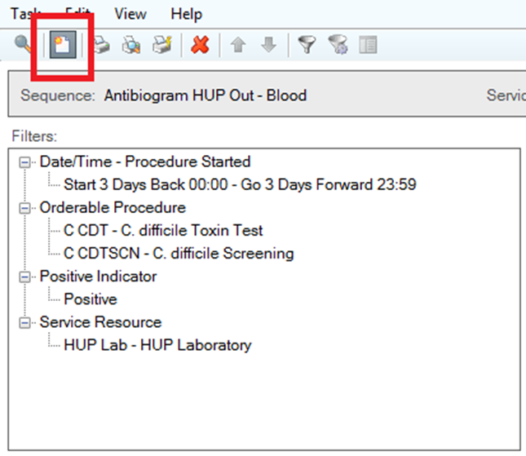

* + - 1. Click the “Run Queue” button, highlighted in the image above in red.
      2. Your Queued Report will populate in the bottom most window. Double click on it to retrieve the report.
      3. Transcribe the applicable information from the Cerner report to the study data entry spreadsheet. This spreadsheet will be used to complete the LabVantage specimen accessioning process. Information recorded is to include:
         1. HUP accession number
         2. Patient MRN
         3. Patient last name
         4. Patient first name
         5. Specimen type (stool or banana broth)
         6. Immunoassay result (EIA pos or EIA neg)

## **Finding Matching Negatives**

**Note**: This process functions as a way to filter negative specimens from patients who have had previous C. difficile positives collected during the study.

* + - 1. After running the initial report, a second report can be run to look for negative samples from subjects previously collected.
      2. By clicking on the magnifying glass, highlighted in the image below, you will return to the “Select Sequence” window.

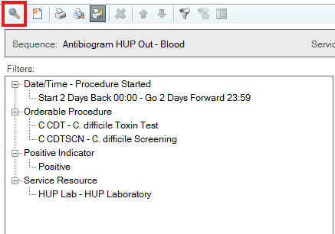

* + - 1. From the window select the “Condensed Line Listing” report and then hit “OK.”
      2. Right click on one of the filters and then select “modify filters.” The filters will be the same as the previous report:
         1. Remove the following filters by selecting them and hitting the move button. “Encounter Type”, “Group – Client”, and “Task Detail - Susceptibility Detail”
         2. Add the following filter by searching in the “To available” search bar. “Positive Indicator.”
         3. Click “OK” to complete these changes.
      3. Next right click on the filter again and select “Modify Filter Defaults”. Modify each filter as follows:
         1. Date/Time – Procedure Started: **Should accurately reflect the date range you are searching for**. The first box goes back however many days specified from the report, while the second goes forward from the first date selected. The example on the bottom will show the date range for clarity
         2. Orderable Procedure: **C CDT, C CDTSCN**. Make sure to select all the items on the right side of the window and move them to the left before hitting “OK”
         3. Positive Indicator: **Negative**
         4. Service Resource: **HUP Lab- HUP Laboratory**
      4. The filters should now look like this:

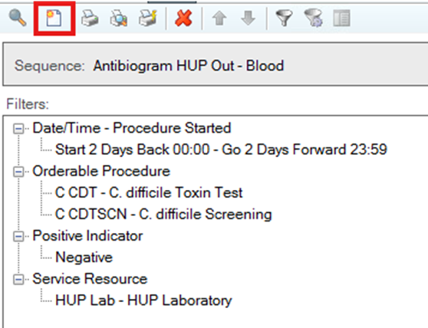

* + - 1. The page, highlighted in the red box, can now be clicked to generate the report and the report can be saved.
      2. Download the negative matching code by doing the following:
         1. Go to the “Microbiome Transmission Lab” page on GitHub.
         2. Click on “data-cleanup” -> “scripts” -> “mVACS_negative_matching.R” and download.
      3. Before running make sure to change the text in quotes on line 17 to the location and name of the saved Cerner report. Also, change the text in quotes on like 42 to where you want the file to be saved and what you want it to be called. Once those change are made the code can be run.

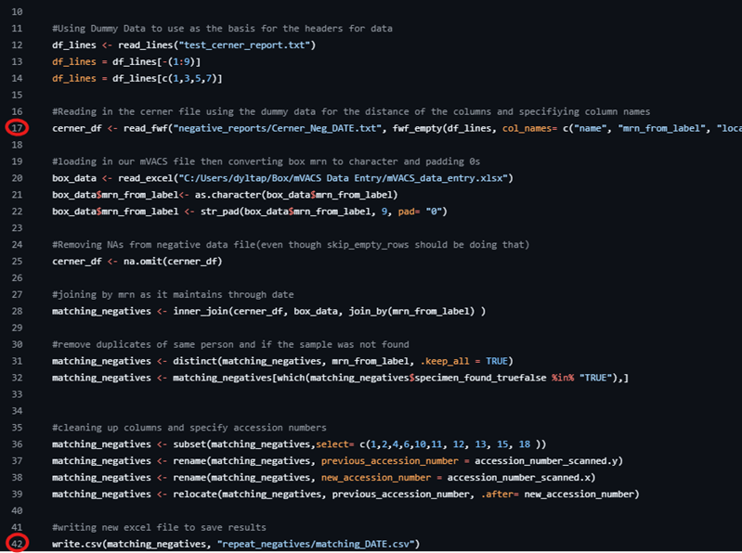

* + - 1. Transcribe any unique subjects seen in the excel report into the “mVACS_data_entry” file on box. Add the first name, last name, relevant accession number, and mrn.
         1. For “stool_naat_pos_truefalse” enter **FALSE** and for “stool_eia_pos_truefalse” enter **NA**.

## **LabVantage Specimen Accessioning**

* + - 1. Open LabVantage and sign in. **Note**: This SOP assumes basic knowledge of LabVantage. For training, see your immediate supervisor.
      2. Accession the samples according to the following specifications:
         1. Event Selector

Study: ID_mVACS OR ID_MIMIC (whichever is appropriate)

Site: UPHS

Cohort: Participant

General Collection; uncheck “add duplicate visit.”

Collection Date (the date the stool was collected from the patient)

* + - 1. Subject Selector
         1. In the “description” field, enter the mVACS or MIMIC subject ID which is assigned in the study spreadsheets located in Box.
         2. Click “Add New Subject” followed by “Next.”
      2. Expected Samples
         1. Select the appropriate Sample Type(s):

1 Stool swab = “Stool Swab”

1 Banana Broth = “BacCellIso”

3 Stool in cryovial = “Stool”

* + - 1. Once accessioned, select each new sample and add the immunoassay result under the “Species” attribute.
      2. Complete the accessioning process, print the generated labels and affix them to the appropriate sampling vessel.

## **Specimen Collection**

* + - 1. Specimens are located in the HUP Microbiology lab (Gates Building, 4th floor). For the door code, please see your immediate supervisor or project manager. Note that you are required to wear a lab coat in this area and use the appropriate PPE.
      2. **Stools**
         1. In the walk-in are bins labeled by the time since collection (24, 48 and 72 hours) Stool specimens can be found within these based on the day of the week that they were received. Collect the applicable stools in a plastic bin, marking on the container the day of the week bin from which they were removed.
         2. Once all the positives and negatives from the reports are found, be sure to include two additional, random, negatives in the collection. NOTE: if one of the matching negatives was unable to be found, a random negative can be collected instead and this new subject information will replace the information of the subject id that was unable to be found.
         3. Take the stools to the Virology Lab hood #1 (the smallest of those in Virology). All supplies required for use of the hood are available nearby (biohazard waste bags and bench pads). Ready the hood for use.
         4. For each stool, take a swab sample by inserting the flocked tip into the sample and removing it once it is sufficiently soiled. Carefully place it into its tube and set aside.
         5. Using a sterile scoopula/spoon, carefully scoop the stool in up to three 2 mL microtubes.
         6. After completion, remove the specimens from the hood. Remove any generated waste and wipe it down with hydrogen peroxide followed by ethanol. Tie biohazard bag shut and dispose of in the sharps bin. Turn off the hood only when everything has been removed.
         7. Return the primary stool containers to the appropriate bin within the walk-in.
      3. **Banana Broths**
         1. Positive (yellow) banana broths can be found in a rack within the 4°C refrigerator in the Virology corridor.
         2. Take the broths to the virology lab. Hood #1 (the smallest of those in Virology) is used for stools. All supplies required for use of the hood are available nearby (biohazard waste bags and bench pads). Ready the hood for use.
         3. Using a transfer pipette, carefully remove ~2mL of banana broth from the tube and transfer it to an appropriately labeled 2mL microtube. Once the banana broth has been aliquoted, it can be disposed of.
         4. After completion, remove the specimens from the hood. Remove any generated waste and wipe it down with hydrogen peroxide followed by ethanol. Tie biohazard bag shut and dispose of in the sharps bin. Turn off the hood only when everything has been removed.

## **Data Collection Finalization**

* + - 1. Once the specimens have been collected, return to the appropriate spreadsheet in Box (mVACS_data_entry or MIMIC_data_entry) and insert “true” or “false” in the “specimen_found_truefalse” column according to which samples were located and biobanked.
      2. For each banana broth banked, enter “tox” or “nontox” in the ID Microbial Species attribute column in LabVantage according to spreadsheet.
         1. This information can also be found in the Cerner report (Cepheid C.diff/Epi result).
      3. For each stool swab/stool vial collected, enter “EIA pos” or “EIA neg” in the ID Microbial Species attribute column in LabVantage according to the spreadsheet.
         1. This information can also be found in the Cerner report (Immunoassay result).

## **Notes on MIMIC**

* + - 1. A representative from the MIMIC study will reach out to the lab with particular patient stool sample(s) of interest for collection. These samples are to be collected and banked in similar fashion, but should be accessioned under the MIMIC study in LabVantage and should be recorded in the MIMIC spreadsheet in Box.
      2. PI = Dr. Amanda Pebenito

|  |
| --- |
| Change Control |

Please note any changes made to the laboratory protocol following study launch by completing the table below. Changes must be approved by the study principal investigator and laboratory director. The SOP should be saved with the date of change saved as part of its file name.

|  |  |  |  |
| --- | --- | --- | --- |
| **Date of Change Implementation (MM/DD/YYYY)** | **Brief Description of Change** | **Change Completed By** | **Approved By** |
| 07/20/2023 | Version 1, project inception | Laura Cowden | Brendan Kelly |
| 05/12/2025 | Addition of Negative Matching protocol | Dylan Tapper | Laura Cowden/Brendan Kelly |