Brendan Koehler

CSE 445 Honors Project

10/14/2017

How to use code:

This project was built using 4 different technologies: HTML5, JavaScript, CSS, and WCF service. These files are then hosted in a webserver and served as a static website with the files found in the folder all placed at the web-root folder.

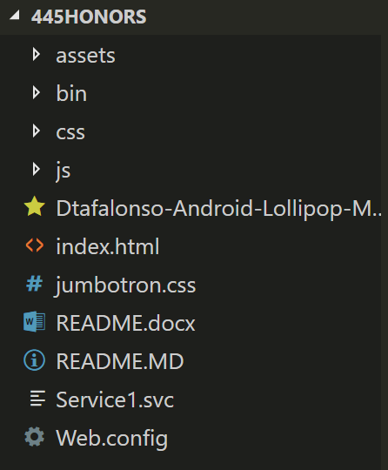

Everything should just work if the files are places and served like this. There is no need to build anything.

External libraries used:

Google – <https://developers.google.com/maps/documentation/distancematrix/>

* <https://developers.google.com/maps/documentation/webservices/>

Bootstrap - <https://getbootstrap.com/>