NOTES ON SOUND
Scribed by Dr. }CeCew Schucmcww

19 7 5
Copyright 0 1976

FOUNDATOON FOR PEACE
43 CLIFF ROAD
BELVEDERE, CALIFORNIA 94920
NOTES ON SOUND
(Copyright by The
October 30, 1972
A picture of a fork and a narrow wire..interpreted as a tuning fork. Next association of eiton whistle, and the "the range of our hearing is so much more limited than vision. Next, "very powerful receiving and sending set. "

"Beasley" image...two parallel highways very close to each other, packed
with cars, and going in opposite directions... left hand lane going east, and
right hand lane going west...a narrow but very high rectangular arch over each lane...Each arch is formed by blue electricity, AND EACH PATTERN OF CURRENTj
GOING IN SAME DIRECTION, FROM LEFT TO RIGHT. ALTHOUGH ARCHES ARE SEPARATE, THEY
ARE VERY CLOSE. BLUE ELECTRICITY may have something to do with an "aura",
Al so, it is a communication symbol. Sense of transmitting..powerful sending &
receiving set.
"Laying on of hands" has been taken too literally, because "to keep in touch" is to communicate, and not to touch physically. the "blue electric t y" involves communication by transmitting sound. You may see the color of the
current, but the PURPOSE IS THE SOUND (PROBABLY TRUE OF AURAS, ALSO) •
SOUND PATTERNS (question of definition here). HEADPHONES are joined with a
double band (VERY 12QORTANT) • (TRAFFIC IMAGE MAY BE SYMBOLIC OF HEADPHONES) • The RECTANGULAR formation on top of "blue electricity" may mean at the right angle, (because it is a rectangle), but the two lines are parallel. The right
angle then seems to mean for the headphones, NOT for the current. The slant of the ANTENNAE attached to each headphone may have to be adjusted to the right angle (related to rectangle) •
1
sot.ND
TRAFFIC GOING IN BOTH DIRECTIONS MAY RELATE TO POSITIVE & NEGATIVE ELECTRICAL POLES. Each goes under one rectangle or to one headphone.
Therefore, the headphones do NOT receive the same sound, and the total sound comes in through the joining in the mind of the hearer.
The cars on the highways are separate, but VERY a..aOSE. You could see them as a line of separate "particles" (clunks??) , or if they were going fast enough as single lines. The speed is faster than a car could possibly go, BUT THE
OPPOSITE DIRECTION ON THE OTHER SIDE SERVES THE SAME FUNCTION AS SPEED', IF THE BALANCE IS mKACT. The blue light seems to be keeping the rectangular shape with no guide. • but there may be VERY FINE wire. .
The original priestess needed an INTERCEPTOR (the Sound Current)
There is great emphasis on CONTRA- or COUNTER-INDUCTION...or reversal, backward flow.
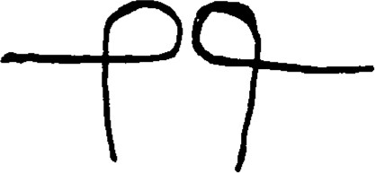
"TWISTED" INSIDE OF SOMETHING...MAYBE CONNECTED TO ANTENNAE. GENERALLY, WOULD GO THE OTHER WAY, ASSUMPTION ONE WOULD NOT USUALLY MAKE.
COIL, IF IN A BLUE PRINT, WOULD BE IN UPPER LEFT HAND SIDE. DIAGRAM NOT CENTERED. THE RELATIONSHIP OF TWO SETS OF LEADS IS NOT OPPOSITE, BUT
RECIPROCAL--THIS IS THE ESSENTIAL THING THAT MAICS THIS DISTINCTIVE.
IDEA OF SPLITTING SOMETHING, SPLITTING WIRE. .MAY BE RELATED TO RECIPROCITY.

SOt.ND
k
The "blue" color of the electricity is important because it is really colorless
but looks blue. This serves as an identificaton of something, and has something to do with numbers or a mathematical formula. It may have something to do with location. 317 may be relevant but we are not ready for this yet. Oscillations and a recording drum ——this is merely for recording, which is only a trans lation.
THE NUMBERS 317 probably do not relate to the blueprint as much as to the area or band to which the blueprint is applicable. THE NUMBERS MAY NOT BE IN RIGHT SEQUENCE, AND PROBABLY ARE ONLY PART OF THE WHOLE REPRESENTATION, BUT THE THREE DIGITS IN SOME ORDER ARE PROBABLY RIGHT.
The drum occupies a central position in the central picture (MAYBE THEORETICAL, OR POSSIBLY BLUEPRINT) in that it is the recorder of a translation process of one kind of d.imension into another. (It might be like light into sound). It is not a recording that an observer looks at —— more part of the whole apparatus itself • It represents a phase in the whole process.
At the top center (of the diagram?) is a small tapered metal needle, quite thin and obviously flexible. It is less than an inch (about 1/2 inch). It is oscillating (no, trembling, no VIBRATING VERY RAPIDLY). Looks like a phonograph needle except that it is not responding to anything that is visibly touching it,
At the back of the drum, at right angles to it (the drum is horizontal) but on the same plane, is a fairly heavy coiled spring. The metal in the spring is quite thick. The spring is attached to something (clarified below). About at the middle of the drum, the other end of the spring going through a square piece
3
SOUND
of material that looks like thick green felt. (The impression is that it softens the sound which might otherwise be deafening. This may tie in with earlier idea of turning the gain up very high. )
The number 939 seems to be part of something here. It does not seem to be related to the previous three numbers. It might be a listing of some kind; perhaps catalog listing.
An equalizer with parallel wires, about an inch long.
The drum is protected by partial metal encasing, consisting of two round end
pieces. one at each end of the drum, which is horizontally placed between them with enough space to allow its free rotation (OR R.EVOLUTIONS). There are three metal bars, each about one inch in width, running from one end piece to the
other ; One runs along each side of the drum and one across the tope They seem to be painted black (the word "lead" occurs to me (metal)
The spring is attached to the side bar toward the interior, or the side away from the drum. (The spring is in a three—dimensional plane, as implied by description on 5). It seems to be hooked on to the bar, the hook fitting into a small round metal ring fastened (or riveted or soldered) to the bar at •its outside center. The ring and the hook are not black but metal colored ( like nickle colored or chromium colored.) The spring is not black either. Only the metal around the drum (the bars) is black.
SOt.ND
The vibrations are not picked up by the needle (or stylus?) at the center top, but by a smallish bail at the tip, which is actually faceted by a large number of very small facets. It seems to be made of something transparent
(glass or maybe diamond). It acts like a sort of prism, but it catches a number
of colors that we cannot see.
on the RIGHT SIDE (OF BLUE PRINT) about in the middle, and almost at the edge, is a large loose metal coil, which seems to be hollow and probably conducts something (maybe kind of gas?..neon???) The coil is
vertical and is quite visible from the front, but both ends disappear from view as they go into the interior. , starting to go back at right angles to the coil,
but turning toward each other and almost meeting in the interior
I think they are attached to each side of something that looks like a
metal nugget of a differe ^{n} + GOIor. It seems quite bright, and almost appears to
be giving off sparks. (I am not sure whether this refers to something you can
actually see or is an allegorical reference to "high power." ) This seems to be
the thing that the vibrations or waves which reach the faceted ball at the end
of the needle at the top center come from. The fluid in the coil seems to be for the purpose of controlling and cutting down its emissions, which might
otherwise be dangerously intense. The effect is a kind of insulation.
Then I thought that the nugget might be radium—or radio...and finally
radioactive. (Originally, when thought of radium thought that the material was
synthetic and obtainable..or came about as a result of some kind of transferring
of elements )
5
SOUND
A lot of the apparatus works on the basis of different properties of different metals which, when brought together in certain specific ways, set up strong and unexpected effects • (Charges for effects??)
At the back of the interior, toward the lower right side, is a narrow pieq,e of flexible metal about a quarter of an inch wide, and five inches long. It is bent into an arc about one inch at its highest, and fastened at each end to holc it in that position. It seems to be a sort of tuning fork that operates constantly, although whatever strikes it or sets if off is not visible. Its purpose seems to be to serve as a correction device; it picks up errors and
"notifies" something (a relay, maybe? )
Under ordinary circumstances the apparatus is self corrective. Otherwise the "tuning fork" sets up an external signal to the operator. The process is very rapid. This is only one of several built—in "correction" factors. If self correction is possible, and it usually is, the relay? puts them into communicatic witl each other, one after another as needed. If the error is corrected by any one of them the process stops. The operator is notified only if they all fail.
Tlis is very rare.
A second "correction device" is set at the back, near the extreme left and about in the middle. Like the "tuning fork" it is set in wood, which is necessary to stop (or block) the overflow. The ends of the "tuning fork" are sunk into a horizontal wooden block, which extends about an inch beyond the metal arc on all sides. This device (the second one) is set vertically, attached to a wooden block similar in that it too  beyond the metal by the same amount-— one inch. It is, however, considerably longer, though not wider. At each end,

SOUND
about an inch from the edge, is a metal pin or nail (it's thick and blunt, rather
like a  are about eight inches apart. A thin metal wire is looped
around them, running from one to the other and soldered together at the back of
the lower one •
(Originally, there was some idea of two parallel loops, about a half— inch
apart) .
A third correction devige is identical with the second, but placed
horizontally at the back and centered close to the top. These two literally
"cross" each other (although they are not physically adjacent), and form a kind of closed (or shut ing off) circuit. While they facilitate the desired waves, they shut off the undesired ones if they intrude. Their function is to
interfere with the interference
The wires are probably platinum, (I first thought of uranium but this
seemed very unlikely. Maybe alloyed. Very uncertain here. Possible
 latter may have personal associations) •
The wires are very shiny. The spikes are of a duller and darker metal,
with irregular surfaces. They may be iron. They literally blunt the effect of
vibrations on the wires, which are so great that they would otherwise destroy
the whole apparatus •
The effects achieved by the wires is known, as its the crossed placing. The
blunting or dulling (toning down) effect of the (iron?) spikes is not. This is a safe and very simple control. The respective weights and masses of the two
metals balance each other off automatically. The wood serves as the additional
control.
Nu'1Lb UN SUIJNO
Copyright
P.S. Going thru the wooden block on the "tuning fork," about half—way down, is a thin metal shaft, which enters at one end of the wood and extends to the other, going thru a small hole drilled in each end of the arc, and holding it securely in place.
At the far back, in the center lower section, is a small square recess, 7"
The back is otherwise flat. The recess is closed (or sealed?) off
by thick metal door, which Is flush with the rest of the back. The door is of a dull, rough metal that looks like lead. It seems to be quite thick and heavy.
The door is very (heavily?) closed off, with a lot of bolts that slip through the wooden casing and through a metal rectangular support (probably made of steel) that surrounds the door. The support is visible from the front, and does
not look as if it is more than one—half inch thick, but extends into the wood some six inches in depth. Metal braces are attached from the door to the support at various places on all four sides. (I suppose they are removeablee to permit opening the door)
The recess itself is heavily insulated against both heat and sound. The
insulation ugh.%--.L.z.k.e--f.ee, and billows up unevenly all around the recess except
ova the door. Behind the insulation the recess is lined with lead which, in turn,is enclosed in wood. Inside, along the back center, is a vertical metal bar about one—half inch thick, flat on the side which is attached to the bacV wallwith thin metal bands, one almost at the top and the other close to the bottom of the bar. The side of the bar facing outward is rounded. The bar is almost invisible because of the fluffy insulation, which almost hides it. The
bariS fastened directly to the back metal wall, the insulation having been
removed from the strip the bar covers. However, the insulation from the sides is high, and rises above the bar so as to cover it completely.
From the bar, extending out and interlacing the whole apparatus, are numerous wires that go out through the door at the front of the recess.
Actually, they seem to come through the slight spaces around the door rather tha through it, running out from its top, bottom, and sides, and running from it along the back, sides, and front of the apparatus. Some (or one) of these wires goes through each of the platinum wire loops, another loops around the "tuning fork," and others apparently connecting with all segments of the apparatus, and then passing on.
All of these wires seem to meet at the first safety device at the front. The (iron?) bar where they originate seems to be the "co—ordinator" of the safety system, and the lead—lined recess seems to be the area from which self— correcting instructions come. The wires coming from the recess are thicker than the platinum wires relatively, and are All waves go
through the radioactive "leads" and through the platinum wires to the lead lined recess. There they are checked through the bar and along the silver wires, which transmit much slower, returning to the "leads" afterwards to be sent out again after being cleared.
Slightly to the left of center and close to the front of the apparatus there is a thin steel wheel which is notched about a quarter of an inch deep and
of a quarter of an inch wide (all around the circumference and quite close together). There is a hole 1/8 or 1/16 inch wide. One of the silver wires goes through this hole, as does a small metal pin that holds it rather loosely in place. There is sufficient space between the pin and the surrounding edge of the NOTES ON sot-ND Copyright
wheel to allow the wheel to rotate slightly unevenly. The pin is mounted on a cog behind the wheel, and is set off center. The wheel moves in a metal
enclosure which protects the wheel's movements, but is not sufficiently close to
stabilize the movements. The apparently eccentric rotations of this wheel are acually an extremely precise measure of the ongoing effects of the various metals on each other. This wheel serves as the basis of the recording
apparatus, which will be described later .
There is a thin metal pin located just above the wheel, and close enough to the circumference to press lightly against it. Since the wheel rotates unevenly, the time required for the pin to pass over the indentations along the wheel's circumference varies. The pin, which is thin and flexible (probably steel)' literally "ticks off" the varying intervals in terms of the sound patterns they produce. This is the major factor in the recording system. The changes that the apparatus measures are thus recorded in terms of sound, even though the original stimuli were light waves. The pattern finally (produced or)
recorded are therefore quite different from the original stimuli or input.
The change is however, a true change in that, had the reciprocal sound patterns of the original input been measured, they would indeed have• been different fom the sound pattern recorded. This can be demonstrated by reversing
the flow from the final patterns, building up the original input, and reducing that to its corresponding sound pattern. This enables precise comparisons between the original and final sound patterns to be made. The time factor is
controlled by the extreme speed of the whole process.

Half way to the back, or midway between the front and back, is a meta loop. The metal is very flexible and quite soft (perhaps tin?) . The metal i.

about 1/4 inch wide and is looped downward, with the bottom touching the bottot of the apparatus (which is lined with steel) • The metal is twisted like this:
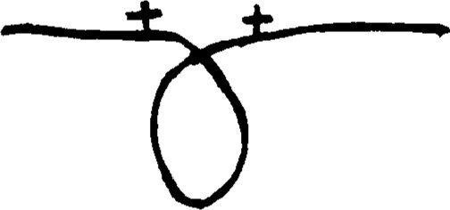
The loop is 6 inches high and 3 inches across the widest part. The side to the left as you look at it from the front is on top.
The loop touches the steel bottom of the apparatus very lightly, permitting constant interchanges which create vibrations that run along the loop at 5c "somethings" per second, (mm— or mil Xo—somethings, or maybe mille—seconds?) Th. speed is constant but the rate of interchange is not, occurring in irregular spurts. The function of the loop is to translate these spurts into a steady stream, so that it can be transmitted further. It would be impossible to break down a series of irregular spurts into the components later to be built up into sound.
This is the only part of the equipment which needs to be replaced frequently. Ten hours of use is about all it can sustain. It is soft, and the twisting tends to break it under use, as one side cuts into the other. The bottom curve of the loop, too, does not hold up well, and the shape must remain reasonably constant. It is necessary, therefore, to keep a number of duplicates of this part on hand, in the form of flat metal strips of the right size. The
NOTES ON SOUND Copyright
loop is made by twisting one of the strips as noted above, and fastening th
ends in place.
The loop is held in place by two narrow but reinforced (chrome?) bars tha
run along the box vertically above the loop, one bar projecting from each side the box. The bars slip into metal grooves on each side of the box. 'Ibward th end of each bar, at the points where the ends of the metal strip must go i
order to make a loop of the correct dimensions, is a metal prong set at th
position necessary to maintain the dimensions specified. The prongs are abou
1/2 inch high, and have a detachable clamp at the ends which hold down the end of the metal strips tightly, after the small hole in each of its ends has be slipped over one of the prongs and clamped down. The length of the stri allowed beyond the loop can vary, but the position of the holes for the prong cannot. This is easily determined by bending a strip to the desired size. Tw
to three inches on both sides beyond the top of the loop is long enough.
purpose of the loop is much like an echo, except that it echoes selectively.
echoes the ( lower or slower) vibrations, and thus enlarges ther disproportionately, so that the others are effectively drowned out or obscured.
NOTE: (I was very confused about how the loop was attached to the bars Or i inally, I thought there was one bar all the way across the box, with thf
prongs still on top. This, however, would obviously not allow the loop to b€ centered. Next, it occurred to me that the prongs could be on the underside 0 ". the bar facing downward, which would allow the loop to be centered. This dic not seem to be right, however. It also briefly crossed my mind that there might be some reinforcement from the solid bar, perhaps something like a wire or prong that served to bring the loop under the bar. The description above seems
sot.ND
tobe the right solution, although I am still not completely sure,. but wa checked ard OK'd). The loop is made of tin and 408 zinc.
The apparatus is 5 x 3 feet, measured from the outside. The outer layer c the enclosing box is made of 1/2 inch thick sheets of steel. Next to this is

one inch thick boxing of hard wood. The interior layer is a second enclosure
1/2 inch sheets of steel. The whole casing, then, is two inches thick. Th wood is absolutely necessary to prevent serious over—heating of the whol outside, since the irrelevant waves (or frequencies) are ultimately drained awa in the form of heat.
Above the tin loop is an open—ended triangle of the same metal (60% tin/ 4 zinc). The triangle rises above the bar from which the loop descends extending up 4 inches from what would be the apex of the triangle except that i is open. The sides of the triangle, which are equal in length, are cut off 1 / inch each from the apex, to leave an opening. At the bottom of each side of th triangle, between the pin holding the end of the loop and the end of the bar t which it is attached, the metal is bent inward 1/2 inch and soldered to the ba TYE bar is actually iron covered with chromium and 1/4 inch thick. Since th metal of the triangle is also 1/4 inch thick, the edge of the inward ben extension will overhang the bar a trifle, and should NOT be bent around it.
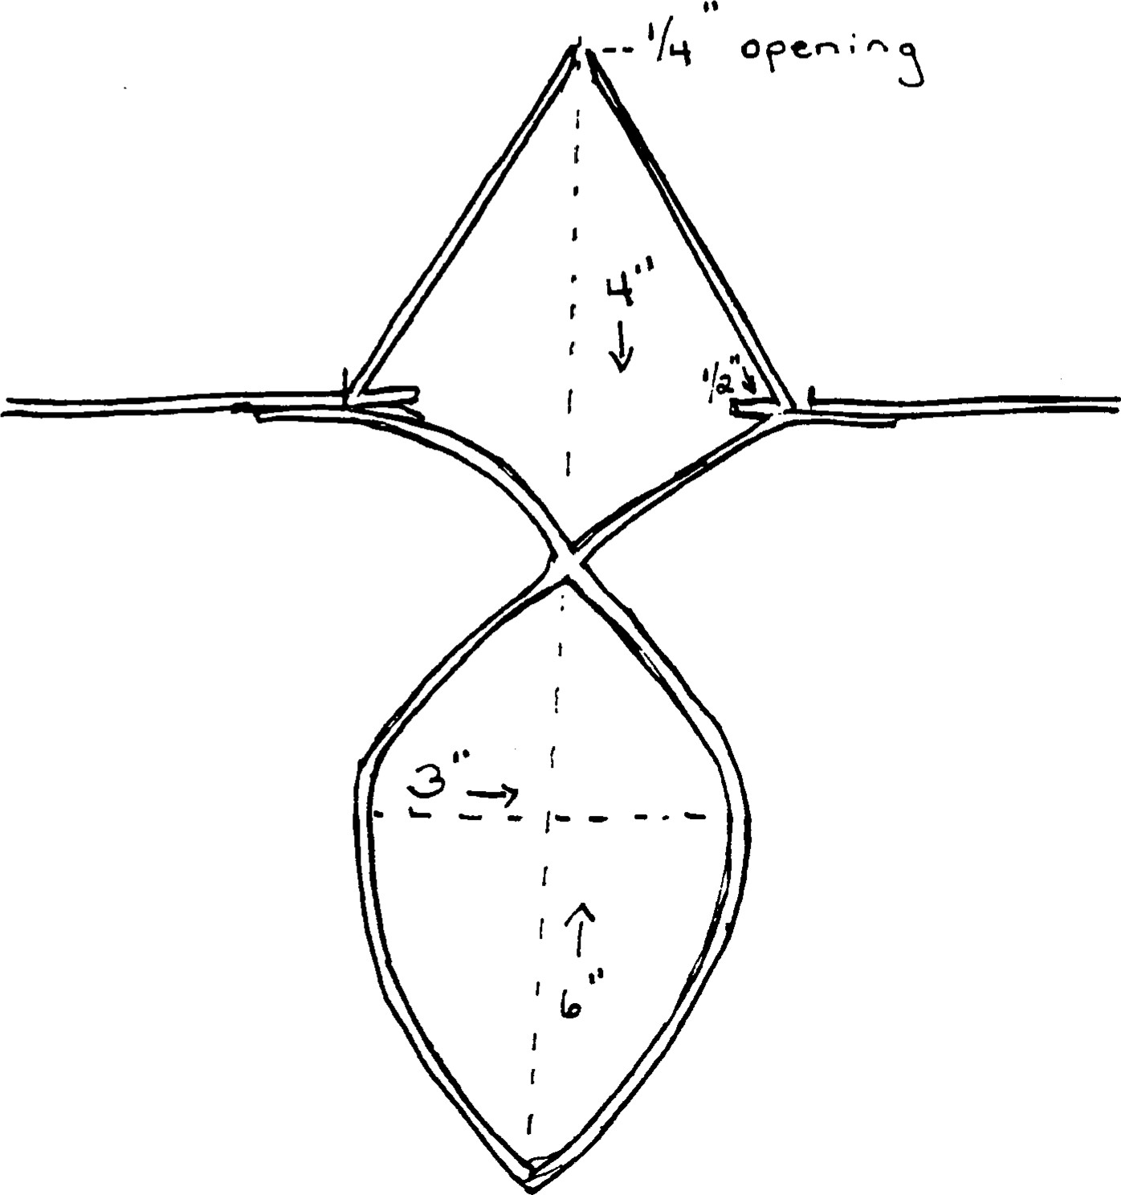

sor.ND æace
The solder should be heavy at the end of the triangle to prevent breaking.
The in—turned end of the triangle's side should be soldered to the bar along the
middle only. The solder is soft and easily removed. However, this segment is not so soft as the loop because it is not twisted, the top is open, and the
weakest point (where the bottom ends turn in) should be heavily soldered. The problem here will be that the upward sides of the triangle are apt to bend out of line, so that a vertical line could not be drawn from the top to the bar.
However, the top ends can be out of this position by as much as 1/2 inch,
although not more. It should not be necessary to realign them frequently, and they should be able to withstand 100 hours of use before the possibility replacement need even be considered. Even then, the chances are that bending the ends back into alignment with each other and with the bar would still be possible. It is wise, nevertheless, to check this part of the equipment each
time the loop needs replacing (or about every 10 hours of use) .
The triangle is really an upward extension of the loop. The loop filters
out the higher frequencies as the waves are received at the left side (as facing you), and run around the loop to come up at the right side, The (lower or
slower) frequencies have already been intensified at that time, but not all of
the higher ones may have been completely lost. (or converted to heat?) As the waves reach the bar after going around the loop, they continue up along the right side of triangle (again as facing you), and up to the open end of the
triangle at the top. The opening there is large enough to allow the ( slower or lower) frequencies to continue on (or upward), but the higher ones will automatically bridge the gap and return down the left side of the triangle,
going back to the left end of the loop to repeat the cycle. It may be necessary
sot-ND
Peace
to repeat this process several times, which will occur automatically until only the (slower or lower) frequencies remain.
The filtering action of the loop is caused by the relatively slow vibrations or frequencies produced by the interchange between the bottom of the loop and the steel floor of the box enclosing the equipment. This sets up a
counter—save (counter—check, or counter—current), that runs up along both sides of the loop from the bottom, meeting the (higher or faster frequencies) as they descend from the left side of the loop. The latter are thus reduced to the
upper levels of frequencies possible for purposes of hearing.
Note that, while the filtering (potential?) is fifty milliseconds, and the fequencies which meet it are considerably faster or higher, their impact produces an effect which is lower than the filter, reducing the (speed) of the continuing frequencies still more, and bringing them lower in the spectrum. *
The components of sound have now been established, but have not yet been brought
together in such a way that anything can actually be heard.
* This is an aspect of the alignment of metals that is not yet known.
NOTE (See p. 13, enclosing box 5 feet wide, 3 feet high, and 4 feet deep )
At each side of the inside of the enclosing box, set into the side from the top and descending for 8 inches, is a tin strip 2 inches in width. These strips

are soldered flat against the steel sides. They are located midway between the rods that holds the loop and triangle, and the back of the box. They are made o Peace
the same material (60% tin/ 40% zinc). The ratio between these dimensions an those of the triangle is such that the waves (sine curves? double sine curves perhaps a tiny space between them?) are pulled from the top of the triangle tc the strip on the right side of the box.
The waves are directed to the right by a lead which directs the waves tc the center of that strip, where the sound potential is considerably deadened As they leave the top of the triangle, after the higher frequencies have beer stripped off, the waves have a dangerously loud potential and must be reduced b ^{l} some 7 58 before it is safe to allow them to continue their transmission. The effect of the contingent metals is so great that it resembles atomic energy potential for violence. The potential would quickly dissipate if the waves were released at this point, but their efficiency is retained as long as they are enclosed in the box.
This is a very volatile effect, short in duration (lasting no more than second or two if released from the enclosure), and beginning to diminish as soon as the waves escape from the opening at the top of the triangle. Power is quickly lost as the waves run along the leads. By the time they reach the tin strip on the right side of the box, which they strike with considerable force, the further reduction of 75% of the power is all that is needed for safety.
The waves can then continue with sufficient force for the necessary transmission until they are finally released through the "exit door" on the left side of the box. (A description of this will come later). After the waves leave the tin plate on the right, the effects of the plate across the box on the left side serve as a balance. While the one on the right diminishes the force, the one on the left controls and directs it onward. This is not done by leads,
sot-ND

æace
but is the result of the size and content Identities of the two plates (or
strips), as well as their opposite but identical placements against the steel.
This is another not fully recognized property of the metal alignments. If
two such equal sized plates of the same metal are placed opposite each other but
in the same corresponding locations, and if a lead directs an (escaping currentü toward one of them, the effect caused by the subsequent impact would be
counteracted by the other. The extent of both the action and the counteraction
will be determined by the ratios between the sizes of all components which are
made of the same metal, as well as their positions in relation to the adj acent
metal. This can be worked out with many metals other than those used here, but
this is not relevant.
While far less intense, the overall effect here is not I-ml ike a miniature

atomic blast setting off a rocket. All of the remaining mechanisms
( activities? , components?) have now been sparked.
Peace
January 15, 1973
Part of the "balance pull" that redirects the current as it proceeds onwarc is supplied by crossed steel bars on the inside of each of the 4' x 3' sides 01 the box. These are made by two steel bars on each side, one running from the top left to the bottom right and the other from the top right to the bottom lef
They are solid, 4" wide and 1—1/2" thick, and welded to the sides of the box The ends are cut so that they fit tightly into the corners, each ending in triangle. In crossing each other, the bar which begins at the top left (as would face it) crosses on top of the other bar on the left side of the box while the bar starting at the top right crosses on top at the right side . This establishes the necessary reciprocal relationships which al components contributing to the "balance pull" must have. The "balance pull does more than merely control direction. It also actually changes frequencies of the waves it directs, splitting the larger molecules and causinc

the smaller particles to rotate. The rotation pulls them out of orbit, creati an entirely new pattern. It is here that the sound effects begin to build up.
The spectrum changes at this point, so that the waves can no longer retur to their former range, to which they are now alien, They are, however, stilunder considerable impetus or pressure, and will continue to build up in the nei register to which they are now suited. The "balance pull continues to redirect the reconstituting stream, so that as it turns back to the center o:
the box it begins an upward ascent. At the same time the sound effects st i 1 :
build up as the new orbits stabilize.

Tie color effects which are secondary to healing are being restored to the
primary sound changes that are an essential part of the healing process. These
changes are not secondary effects, and will remain as long as the healing itself
remains. Should there be any tendency of the sound changes to show a reversal to the color ranges, the healing effect itself is weakening and may be only temporary.
This sign should not be disregarded. It is an indication to the healer
that the patient needs additional help. One of the uses of this equipment, in
fact, is to serve as a "check up" on the patient's condition. Relapses are most likely to occur within the first day after healing, because there are many factors in the patient—healer relationship that can produce a kind of ^{t} pseudo—
healing. This can have real effects initially, but cannot be sustained.
If a patient has been checked after the first 24 hours, again after the
first week, and then at the end of the first month, yearly checkups, especially
after the third year, are more than enough. After five years they become
unnecessary. By this time, the primary changes have completely stabilized, and it would be impossible for the changes in sound to break down to color again.
The field has altered, and the relationships within it have all been readj usted
to the new "fit." Nothing in the field is now in danger of drifting, and thus disrupting the whole field.
The patient may, however, develop other symptoms, since physical healing represents a realignment of essentially local forces rather than the total context. This is because they still occur in time, and therefore retain the illusory quality of time itself. Each new symptom, or call for help, is,

æace
however, susceptible to healing on its own. Further, it can be said that this
susceptibility increases with each successful healing. It is probably better to use the same healer for the same patient for subsequent healings if possible, but it is not necessary. The beneficent effects of previous healing will
remain.
Where the steel bars cross on each side there is a round clear bulb, three
inches in diameter. This bulb has a looped filament 1— 1/2 inches long including the 1/2 inch loop. (As measured from the beginning of the loop to its rounded
end, which is its longer axis). The filament is both part of the whole system's
safety device, and part of the transforming system as well. Made of two twisted
wires tightly wrapped together, one attracts impulses in and the other propels
them out after overflow has been dissipated in the form of heat.
It will be noticed that the entire system works on one very simple principle; all its elements or components represent different procedures for
filtering out unwanted effects and magnifying the desired ones, The intake is actally fairly indiscriminate. The device is placed within five feet of an anticipated healing, with the shorter side of the box to the left toward the
patient. This will be the 4 inch long and 5 inch high side, to your left as you
face the box.
Summarizing the dimensions of the box, it is 5 feet long, 4 feet deep, and
3 feet high, the top and bottom sides measuring 5 feet by 4 feet. Sides to the front and back are 5 x 3 feet, so that the two remaining sides, which are 4 x 3
feet, are the shortest.
The changes in wave length which the healing brings about occur within the
radius of 5 feet. It does not matter in what part of the body the healing takes

mner
place, nor by what means it is brougrt about. From the theoretical point o.
view, it can be said that healing can only be the result of a change of mind which now accepts healing where it formerly accepted sickness. The change of mind alters the thought field around the patient, which seems to represent the place where he is. These changes cannot be different for a healing presumably brought about by medication, surgery, or faith. Healing can only be faith healing for sickness can only faith in sickness
The concentration of energy that seems to represent the patient is limited to the 5 foot radius not by its potential, but by the relative inefficiency of the apparatus. While it is powerful enough for its purpose, it is not capable of noting the more subtle changes that accompany a healing, nor of measuring the almost inclaculable distances across which they occur. Within the 5 foot radius, however, the equipment will pick up energy changes that "register" a healing. In a sense, these might be called shadows of an illusion; in the world of dreams they signify the sound of a different voice.
The input area is actually very simple. In consists of a round hole cut into the steel on the shorter side of the box, 3" in diameter. It is toward the back of the side toward the life, or Side A, as label led below:
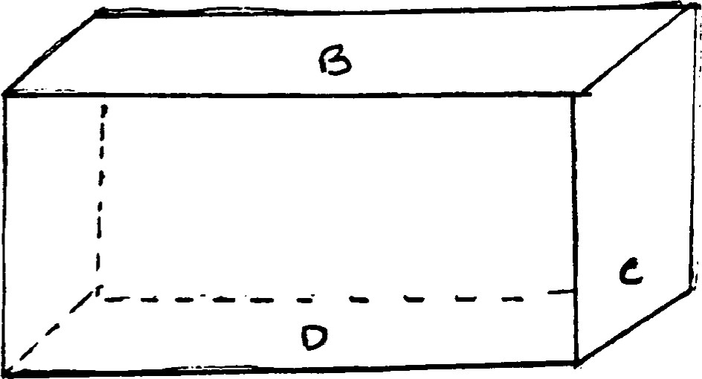

It is cut into the steel 3/4 of the way up from the bottom of side A, only a 1/4 of an inch from the back, in order to sift out extraneous sounds. If the
distance is greater than a 1/4 of an inch, the amount of extraneous sound would increase enormously. By being located so close to the back of the box many frequencies will enter, but will hit (or bounce off) the back and be blocked
immediately.
PICTURE OF SIDE A:
Side is 3' measured |  |  | From top to center of
inside Hole is 3" in |  |  | hole, 1/4" from edge on
diameter, 3/4 of the way up the side, or .75 |  |  | side.
 | O
As noted previously, Side A faces the pt., the box being placed within 5
feet of him. About 3 feet is ideal; the filtering—out devices have room to act
most efficiently and the box is well within peripheral areas of the field. The height from the floor is irrelevant to the position of the patient, He can be lying down, sitting up, or standing. What is important is the box's distance from him, and also from the f106r. About 3 feet is again ideal. It would be best to mount the box on a wooden table of this type. The 3 feet in this case is the distance from the floor to the top of the table. This will bring the
intake to just about the best height, regardless of the area of the pt. that is being healed.
It is strongly recommended that the table be constructed of very solic wood, since the box is heavy. It should rest on the top of the table with nc overhang; i.e., the table top and the bottom of the box should be as close tc identical as possible in all dimensions. since 5' x 4' x 3' are inside measurements for the allowance must be made for the 2" on each side for the enclosure. (This includes the I ^{t}' of hard wood and 1/2" on both sides which comprise the box itself). The box should rest directly on the table top, ane
the wood here should not be painted, although it should be smoothed as much as possible and oiled before the box is adjusted. The oiling should be repeated after about 10 hours of use of the apparatus. Be sure on replacing the box not to allow overhang.
Neither the kind or the thickness of the wood itself matters. The only prerequisite is the ability to sustaing the weight of the box. It is also essential that no metal come in direct contact with the box at any point. The top of the table can, however, be reinforced with metal (cleats?) to the legs on the bottom side, and the material of the legs is irrelevant. Only what actually touches the box is of concern, and this must be only wood oiled rather lightly after smoothing and again as specified above. The bottom of the table ( legs cross—braces [which are recommended] ) can be painted or preserved in any way that is convenient. The legs should be braced vertically as well as horizontally with cross wood or metal bars.
bccept for the table top, which MUST conform to requirements as specified, the remainder of the table should be built for strength and convenience. Wheels are obvious for the latter, along with a locking device which stabilizes the
ON SOt.ND
wheels when the box is in position. Handles can be placed at the center of the shorter side of the table top, extending from the bottom side of the top board so as not to interfere with the balance of the box itself. These can be screwed into a metal plate, provided the wood is thick enough to allow for at least half—inch clearance from the point of the screw to the to of the table. S ince it is difficult to make sure of this, it is better to allow for an inch leeway if screws or nails are used. The material for the handles, their size, and the
way in which they are attached to the bottom of the table top do not matter. Only what comes in direct contact with the box is relevant. A handle on both of the shorter sides is suggested, however, so that pushing and pulling will both be easy.
In reference to the patient, then, the apparatus is brought into position by placing the intake device about three feet from his middle axis. These measurements need not be exact, since the 5' field allows for considerable leeway. As healing occurs, the frequencies should become increasingly lower, dropping well into the sound register. These changes will be recorded on the drum mentioned earlier. The drum does not record directly, since it serves a major function in translating frequency levels (or ranges), It does, however, record changes in the sense that it magnifies differences that would otherwise be undetectable. The differences are then recorded in terms of D Scores. If there are no changes the score is O, which is the baseline for the reproduction on the photographic plate.

April 14, 1977
The sound is actually the basis for the power that serves to create th effects of the instrument. It is self—generating in that it Is not necessary t bring in anything from outside the box in order to set it in motion. Sounc itself is potential energy, although it is generally thought of as an effecrather than a cause. The enerating power of sound is due to its ability tc dislodge particles from their accustomed patterns and rearrange them in others
The risk here is in producing unpredictable and uncontrolled patterns, whic a^{t} would indeed produce chaos. However, the effect can be controlled by careful monitoring of the spectrum. The most important color is purple, but it is not shade that can be seen with the naked eye. In fact, to us it is generallx invisible even when light is broken down into its component parts as they are known to date
It is in tran a ting light into the lower frequencies that this purple begins to have an observable effeet The effect is in sound, not light,

Therefore this color is, strictly speaking, a sound effect. It is a very narrow frequency band (probably between blue and indigo, or indigo and violet), some of whose properties are already known. What is not knowN is its effects in terms c sound. Nor is it understood that this color can actually be generated by adjacent metals, if properly combined. It is the combination as well as the alignment that is important here. Unless both of these factors are correct, the power will not have a sound effect that can be utilized directly.
This sound potential is already present in the higher frequencies, and in a sense does not change. This is its intrinsic quality. As the frequencies
(
change from higher to lower ranges, this one band is constant. This enables it to give out the power necessary for the apparatus to shift from visual tc auditory ranges. (This seems to refer to the number 317 on page It represents the ratio between the alignment and combination of the metals and
there is some reference to the "balance pull" discussed before. The constancy of this ratio enables the power which will give rise to the color—to—sound
shift to begin the process as well as to end it.
The importance of this ratio, which is recognized in another context, is its inherent energy—production. It directs the splitting—up of energy patterns which it creates into new and much more useful forms that can be then put
directly into use. This form of energy in the end will have little or no waste, which will make it far more powerful than any form of energy yet foun'd.
However, the materials which will make this possible are not yet available. For the time being there will be waste and also a certain unpredictable and erratic re—forming of the patterns which will be uncontrollable at presente This is why the safety devices are so necessary.
The 'blue—purple" band, then, is activated to produce the necessary energy patterns only where and when the proper "power ratio" is gained. A number of hitherto unexplained phenomena are the result of the sudden attainment of the ratio by accident. many experiments have not been replicated because this
factor was unrecognized, and had no known part in the actual design. Therefore it was not included in the attempts at replication.
Note that the ratio is between different dimensions; that of space
(distance) and combinations (density). The narrowness of the band requires that
(
Copyxaght
the ratio be quite precise in order to evoke the full potential of the energ}
This has the advantage of making accidental juxtapositions rare, but also th disadvantage of achieving the ratio very exacting.
The reciprocals (see page 2) at the opening or intake area of the box ar essential parts of the ratio. So is each of the other components of th apparatus. Both their alignment and composition are contributory.
reciprocals are placed around a small opening ( 1/2 inch in size) :
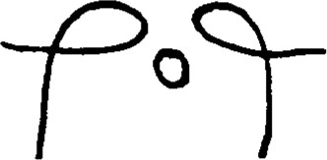
The top of the hole is aligned with the bottom of the loops of the reciprocals and is centered between them. The opposite charges between the reciprocals dra in the (frequencies?) waves from the area surrounding the patient, beginning th spectrum effect.

