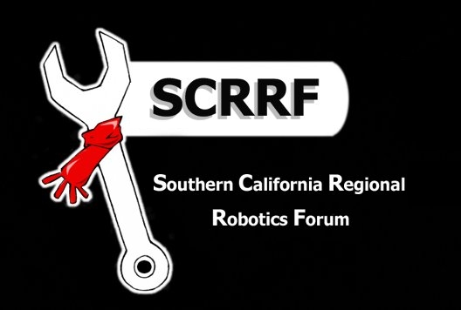
SCRRF 2016 Scholarships

The Southern California Regional Robotics Forum (SCRRF) will award $1,000 scholarships to three Southern California high school seniors for their first year of college study in the fields of science, technology, engineering or math. Each award is non-renewable and will be recognized at the Los Angeles Regional FIRST Robotics Competition and at the FIRST Championships in St. Louis, Missouri.
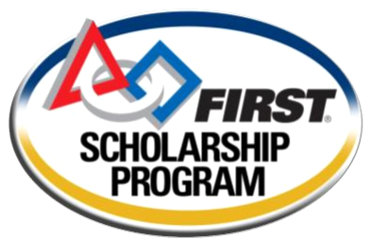

Student Eligibility Requirements:
- In senior year at a high school in the Los Angeles Region of
Southern California (i.e., Los Angeles, Ventura, Santa Barbara,
San Luis Obispo, Kern, San Bernardino or Orange counties).

- Actively participates on a robotics team in the Los Angeles Region
of Southern California for one of these programs:
  - FIRST Robotics Competition (FRC) and/or
  - FIRST Tech Challenge (FTC) and/or
  - VEX Robotics Competition (VRC).
- Participated or scheduled to participate in one or more qualifying regional events in the Los Angeles Region of Southern California.

Submission Requirements:
- Completed scholarship application form on next page.
- Picture of student – head shot preferred. If submitting group photo, please identify scholarship applicant.
- Student writes a 250-300 word essay titled “The Impact of FRC/FTC/VRC on my Future Goals.” Please include your name at the top of each page. All or selected portions of this essay may be posted on SCRRF’s web site.
- A scanned/digital photo of the student’s high school transcript (official copy not required).
- Letter of recommendation from one of the adult mentors of the student’s robotics team stating that the applicant has demonstrated the values of FRC/FTC/VRC and is a member in good standing.
- Letter of recommendation from one of the student’s recent science, technology, engineering or math teachers who is not a robotics team mentor. Please provide teacher contact information.
- All materials must be e-mailed by Monday, February 22, 2016 to:

Joseph Petito, Chair | E-mail: jpetito@etusd.org
Scholarship Committee | SCRRF
Mobile: | 310.753.1778

About SCRRF:
The Southern California Robotics Regional Forum is a nonprofit association formed by FIRST robotics teams in Southern California. Originating in Chatsworth, the Forum was formed after the 2001 FIRST Robotics season in the spirit of sharing and helping in the FIRST community. It is the goal of SCRRF to provide a way for Southern California teams, both rookies and veterans, to get help and to share opinions so that the experience can be improved for everyone. SCRRF hosts the Fall Classic and Scrimmage as well as various workshops to help teams prepare for upcoming competitions. Beside the events and workshops, teams in SCRRF have formed a sense of FIRST community, making their experience so much more enjoyable. For more information, please visit http://LARobotics.org/SCRRF.
SCRRF 2016 Scholarship Application

Editable version available online at http://larobotics.org/Scholarships.html
First Name: Last Name: Gender (M/F):
Mailing Address:
City: Zip:
Email:
High School Robotics Programs (FRC, FTC or VRC): Phone: ( ) -
Program | Team No. | Team Name (List current activities first) | Positions or Roles | Academic Years
 |  |  |  | 20__ - 2016
College or University Attending (if known):
Other Colleges or Universities – Accepted:
Other Colleges or Universities – Applications Pending:
Intended Major:

