FIRST Robotics Kickoff 1/7/2012
Seely G. Mudd (SGM) room 123

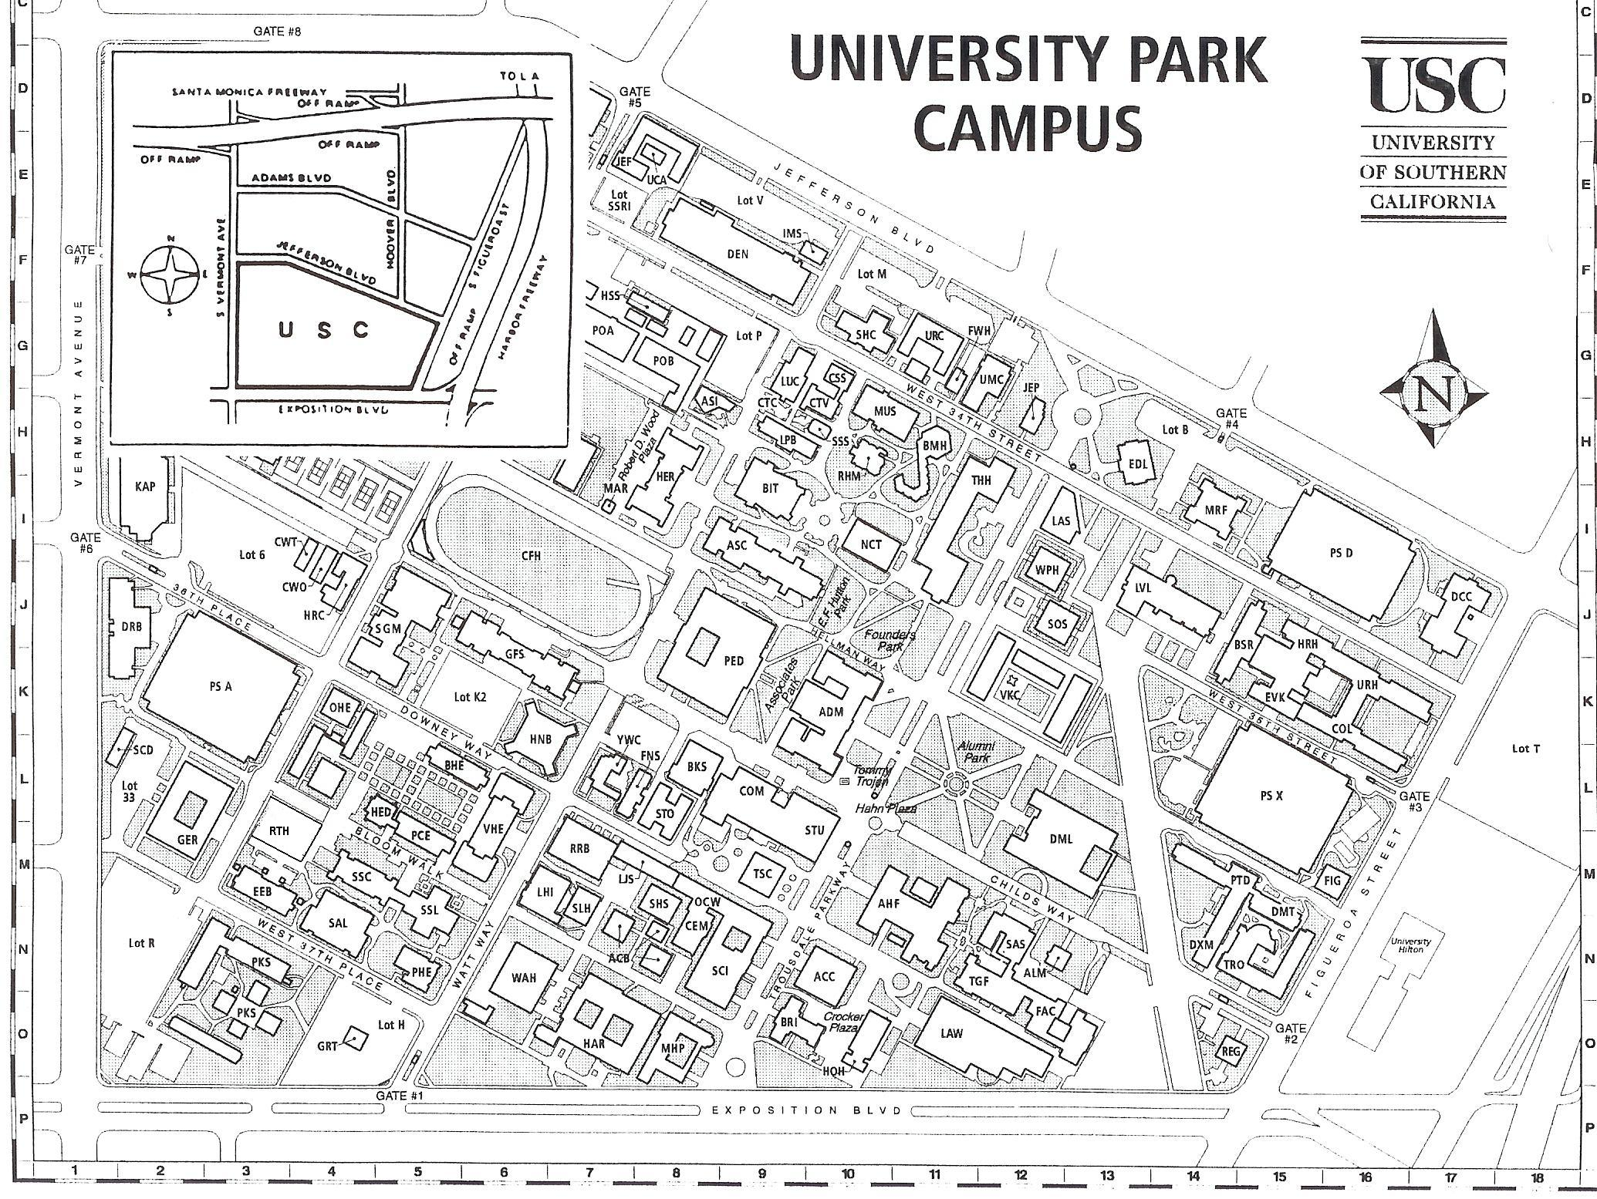
Enter Here (parking $8)
SGM 123 (Webcast) SSL 150 (kit distribution)

