WELDING SYMBOLS
Special symbols are used on a drawing to specify where welds are to be located, the type of joint to be used, as well as the size and amount of weld metal to be deposited in the joint. These symbols have been standardized by the American Welding Society (AWS). You will come into contact with these symbols anytime you do a welding job from a set of blueprints. You need to have a working knowledge of the basic weld symbols and the standard location of all the elements of a welding symbol.
A standard welding symbol (fig. 3-43) consists of a reference line, an arrow, and a tail. The reference line becomes the foundation of the welding symbol. It is used to apply weld symbols, dimensions, and other data to the weld. The arrow simply connects the reference line to the joint or area to be welded. The direction of the arrow has no bearing on the significance of the reference line. The tail of the welding symbol is used only when necessary to include a specification, process, or other reference information.
Weld Symbols
The term weld symbol refers to the symbol for a specific type of weld. As discussed earlier, fillet, groove, surfacing, plug, and slot are all types of welds. Basic weld symbols are shown in figure 3-44. The weld
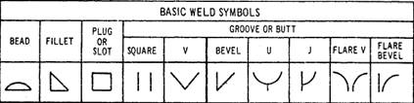
Figure 3-44.-Basic weld symbols.
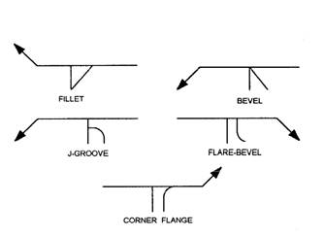
Figure 3-45.-Weld symbols applied to reference line.
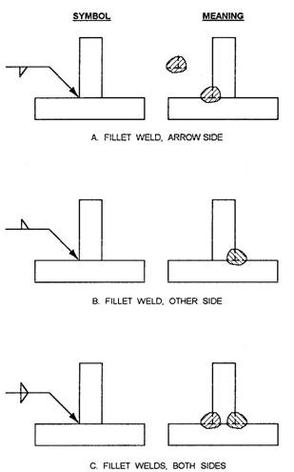
Figure 3-46.-Specifying weld locations.
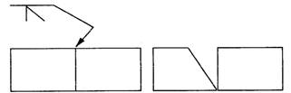
Figure 3-47.-Arrowhead indicates beveled plate.
symbol is only part of the information required in the welding symbol. The term welding symbol refers to the total symbol, which includes all information needed to specify the weld(s) required.
Figure 3-45 shows how a weld symbol is applied to the reference line. Notice that the vertical leg of the weld symbol is shown drawn to the left of the slanted leg. Regardless of whether the symbol is for a fillet, bevel, J-groove, or flare-bevel weld, the vertical leg is always drawn to the left.
Figure 3-46 shows the significance of the positions of the weld symbols position on the reference line. In view A the weld symbol is on the lower side of the reference line that is termed the arrow side. View B shows a weld symbol on the upper side of the reference line that is termed the other side. When weld symbols are placed on both sides of the reference line, welds must be made on both sides of the joint (view C).
When only one edge of a joint is to be beveled, it is necessary to show which member is to be beveled. When such a joint is specified, the arrow of the welding symbol points with a definite break toward the member to be beveled. This is shown in figure 3-47.
Figure 3-48 shows other elements that may be added to a welding symbol. The information applied to the reference line on a welding symbol is read from left to right regardless of the direction of the arrow.
Dimensioning
In figure 3-48, notice there are designated locations for the size, length, pitch (center-to-center spacing), groove angle, and root opening of a weld. These locations are determined by the side of the reference line on which the weld symbol is placed. Figure 3-49 shows how dimensions are applied to symbols.
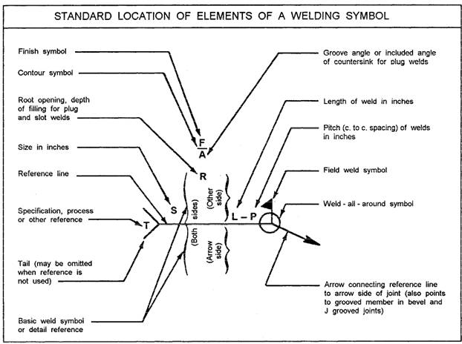
Figure 3-48.-Elements of a welding symbol.
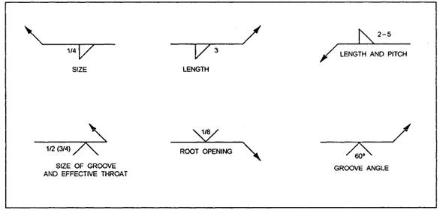
Figure 3-49.-Dimensions applied to weld symbols.
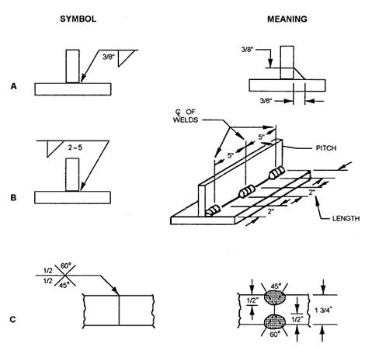
Figure 3-50.-Dimensioning of welds.
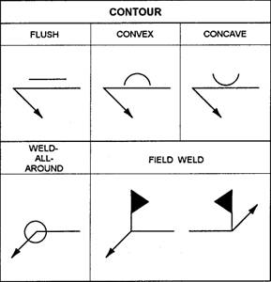
Figure 3-51.-Supplementary symbols.
Figure 3-50 shows the meaning of various welding dimension symbols. Notice that the size of a weld is shown on the left side of the weld symbol (fig. 3-50, view A). The length and pitch of a fillet weld are indicated on the right side of the weld symbol. View B shows a tee joint with 2-inch intermittent fillet welds that are 5 inches apart, on center. The size of a groove weld is shown in view C. Both sides are 1/2 inch, but note that the 60-degree groove is on the other side of the joint and the 45-degree groove is on the arrow side.
Supplementary Symbols
In addition to basic weld symbols, a set of supplementary symbols may be added to a welding symbol. Some of the most common supplementary symbols are shown in figure 3-51.
Contour symbols are used with weld symbols to show how the face of the weld is to be formed. In addition to contour symbols, finish symbols are used to indicate the method to use for forming the contour of the weld.
When a finish symbol is used, it shows the method of finish, not the degree of finish; for example, a C is used to indicate finish by chipping, an M means machining, and a G indicates grinding. Figure 3-52 shows how contour and finish symbols are applied to a weldng symbol. This figure shows that the weld is to be ground flush. Also, notice that the symbols are placed on the same side of the reference line as the weld symbol.
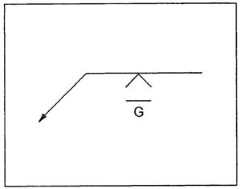
Figure 3-52.-Finish and contour symbols.
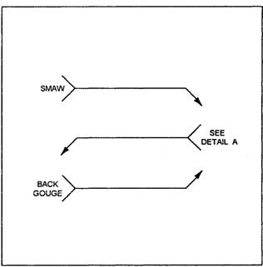
Figure 3-53.-Specifying additional welding information.
Another supplementary symbol shown in figure 3-51 is the weld-all-around symbol. When this symbol is placed on a welding symbol, welds are to continue all around the joint.
Welds that cannot be made in the shop are identified as field welds. Afield weld symbol is shown in figure 3-51. This symbol is a black flag that points toward the tail of the welding symbol.
Specifying Additional Information
It is sometimes necessary to specify a certain welding process, a type of electrode, or some type of reference necessary to complete a weld. In this case, a note can be placed in the tail of the reference line. (See
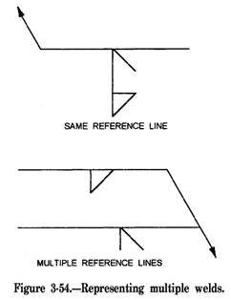
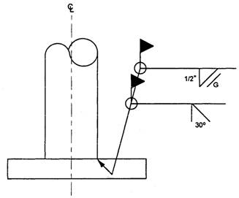
Figure 3-55.-Example of welding symbol in use.
fig. 3-53.) If additional information is not needed, then the tail is omitted.
Multiple-Weld Symbols
When you are fabricating a metal part, there are times when more than one type of weld is needed on the same joint; for example, a joint may require both a bevel groove weld and a fillet weld. Two methods of illustrating these weld symbols are shown in figure 3-54. Note that in each welding symbol, the bevel groove weld is to be completed first, followed by the fillet weld.
Applying a Welding Symbol
Figure 3-55 shows an example of how a welding symbol may appear on a drawing. This figure shows a
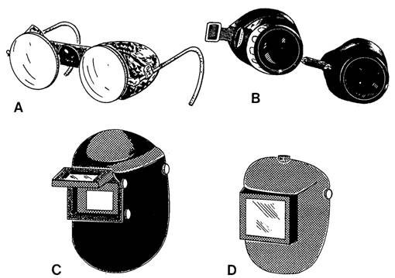
Figure 3-56.-Eye protection devices.
steel pipe column that is to be welded to a baseplate. The symbol tells the welder that the pipe is to be beveled at a 30-degree angle followed by a bevel groove weld all around the joint. This is followed by a 1/2-inch fillet weld that is also welded all around the joint. Finally, finish the fillet weld by grinding it to a flush contour. As the field weld symbol indicates, all welds are to be accomplished in the field.
For additional information about welding symbols, refer to Symbols for Welding and Nondestructive Testing, ANSI/AWS A2.4-86.
SAFETY
Mishaps frequently occur in welding operations. In many instances, they result in serious injury to the welder or other personnel working in the immediate area. In most cases, mishaps occur because of carelessness, lack of knowledge, and the misuse of available equipment. Precautions that apply to specific welding equipment are pointed out in the chapters that cover that equipment. In this section we are particularly interested in such topics as protective clothing, eye protection devices, and practices applicable to the personal safety of the operator and personnel working nearby.
Proper eye protection is of the utmost importance. This covers the welding operator and the other personnel, such as helpers, chippers, or inspectors, who are in the vicinity of the welding and cutting operations. Eye protection is necessary because of the hazards posed by stray flashes, reflected glare, flying sparks, and globules of molten metal. Devices used for eye protection include helmets and goggles.
NOTE: In addition to providing eye protection, helmets also provide a shield against flying metal and ultraviolet rays for the entire face and neck. Figure 3-56 shows several types of eye protection devices in common use.
Flash goggles (view A) are worn under the welder's helmet and by persons working around the area where welding operations are taking place. This spectacle type of goggles has side shields and may have either an adjustable or nonadjustable nose bridge.
Eyecup or cover type of goggles (view B) are for use in fuel-gas welding or cutting operations. They are contoured to fit the configuration of the face. These goggles must be fitted with a shade of filter lens that is suitable for the type of work being done.
NOTE: The eyecup or cover type of goggles are NOT to be used as a substitute for an arc-welding helmet.
For electric arc-welding and arc-cutting operations, a helmet having a suitable filter lens is necessary. The helmet shown in view C has an opening, called a
Table 3-l.-Recommended Filter Lenses for Various Welding Operations
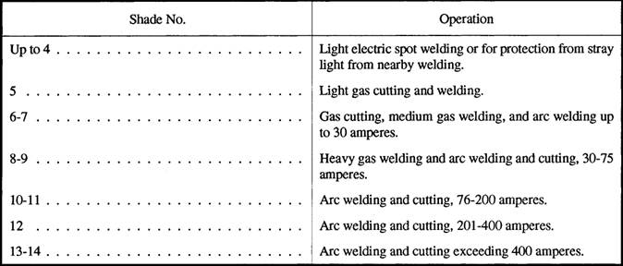
window, for a flip-up filter lens 2 inches by 4 1/4 inches in size. The helmet shown in view D has a 4 1/2-inch by 5 1/4-inch window. The larger window affords the welder a wider view and is especially useful when the welder is working in a confined place where head and body movement is restricted. When welding in locations where other welders are working, the welder should wear flash goggles beneath his helmet to provide protection from the flashes caused by the other welders' arcs. The flash goggles will also serve as eye protection when chipping the slag from a previous weld deposit.
Helmets and welding goggles used for eye protection are made from a nonflammable insulating material. They are fitted with a removable protective colored filter and a clear cover lens.
NOTE: The purpose of the clear cover lens is to protect the filter lens against pitting caused by sparks and hot metal spatter. The clear lens must be placed on the outside of the filter lens. The clear lens should be replaced when it impairs vision.
Filter lenses are furnished in a variety of shades, which are designated by number. The lower the number, the lighter the shade; the higher the number, the darker the shade. Table 3-1 shows you the recommended filter lens shade for various welding operations. The filter lens shade number selected depends on the type of work and somewhat on the preference of the user. Remember, a filter lens serves two purposes. The first is to diminish the intensity of the visible light to a point where there is no glare and the welding area can be clearly seen. The second is to eliminate the harmful infrared and ultraviolet radiations coming from the arc or flame; consequently, the filter lens shade number you select must not vary more than two shades from the numbers recommended in table 3-1.
Rule of thumb: When selecting the proper shade of filter lens for electric-arc welding helmets, place the lens in the helmet and look through the lens as if you were welding. Look at an exposed bare light bulb and see if you can distinguish its outline. If you can, then use the next darker shade lens. Repeat the test again. When you no longer see the outline of the bulb, then the lens is of the proper shade. Remember that this test should be performed in the same lighting conditions as the welding operation is to be performed. Welding in a shop may require a shade lighter lens than if the same job were being performed in bright daylight. For field operations, this test may be performed by looking at a bright reflective object.
WARNING
Never look at the welding arc without proper eye protection. Looking at the arc with the naked eye could lead to permanent eye damage. If you receive flash burns, they should be treated by medical personnel.
A variety of special welder's clothing is used to protect parts of the body. The clothing selected varies
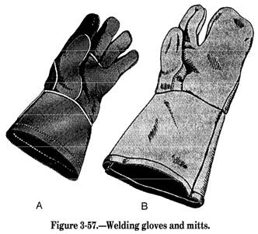
with the size, location, and nature of the work to be performed. During any welding or cutting operation, you should always wear flameproof gauntlets. (See fig. 3-57.) For gas welding and cutting, five-finger gloves like those shown in view A should be used. For electricarc welding, use the two-finger gloves (or mitts) shown in view B.
Both types of gloves protect the hands from heat and metal spatter. The two-finger gloves have an advantage over the five-finger gloves in that they reduce the danger of weld spatter and sparks lodging between the fingers. They also reduce finger chafing which sometimes occurs when five-finger gloves are worn for electric-arc welding.
Many light-gas welding and brazing jobs require no special protective clothing other than gloves and
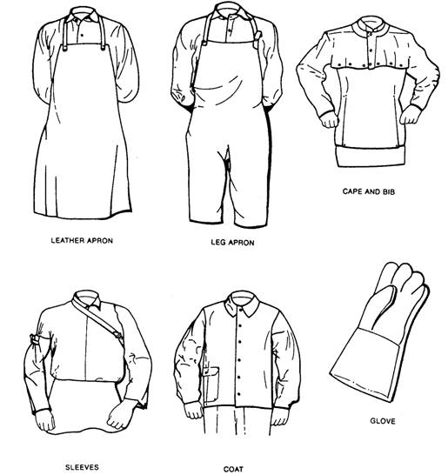
Figure 3-58.-Welder's protective clothing.
goggles. Even here, it is essential that you wear your work clothes properly. Sparks are very likely to lodge in rolled-up sleeves, pockets of clothing, or cuffs of trousers or overalls. Sleeves should be rolled down and the cuffs buttoned. The shirt collar, also, should be fully buttoned. Trousers should not be cuffed on the outside, and pockets not protected by button-down flaps should be eliminated from the front of overalls and aprons. All other clothing must be free of oil and grease. Wear high top-safety shoes; low-cut shoes are a hazard because sparks and molten metal could lodge in them, especially when you are sitting down.
Medium- and heavy-gas welding, all-electric welding, and welding in the vertical or overhead welding position require special flameproof clothing made of leather or other suitable material. This clothing is designed to protect you against radiated heat, splashes of hot metal, or sparks. This clothing consists of aprons, sleeves, combination sleeves and bib, jackets, and overalls. They afford a choice of protection depending upon the specific nature of the particular welding or cutting job. Sleeves provide satisfactory protection for welding operations at floor or bench level.
The cape and sleeves are particularly suited for overhead welding, because it protects the back of the neck, top of the shoulders, and the upperpart of the back and chest. Use of the bib, in combination with the cape and sleeves, gives added protection to the chest and abdomen. The jacket should be worn when there is a need for complete all-around protection to the upperpart of the body. This is especially true when several welders are working in close proximity to one another. Aprons and overalls provide protection to the legs and are suited for welding operations on the floor. Figure 3-58 shows some of the protective clothing available to welders.
To prevent head burns during overhead welding operations, you should wear leather or flameproof caps under the helmet. Earplugs also should be worn to keep sparks or splatter from entering and burning the ears. Where the welder is exposed to falling or sharp objects, combination welding helmet/hard hats should be used. For very heavy work, fire-resistant leggings or high boots should be worn. Shoes or boots having exposed nailheads or rivets should NOT be worn. Oilskins or plastic clothing must NOT be worn in any welding operation.
NOTE: If leather protective clothing is not available, then woolen clothing is preferable to cotton. Woolen clothing is not as flammable as cotton and helps protect the operator from the changes in temperature caused by welding. Cotton clothing, if used, should be chemically treated to reduce its flammability.
CHAPTER 4 GAS CUTTING
The common methods used in cutting metal are oxygas flame cutting, air carbon-arc cutting, and plasma-arc cutting. The method used depends on the type of metal to be cut and the availability of equipment. As a Steelworker, oxygas or air carbon-arc equipment is the most common type of equipment available for your use. Oxygas equipment is explained in this chapter and air carbon-arc cutting is covered in chapter 7.
The oxygas cutting torch has many uses in steelwork. At most naval activities, the Steelworker finds the cutting torch an excellent tool for cutting ferrous metals. This versatile tool is used for operations, such as beveling plate, cutting and beveling pipe, piercing holes in steel plate, and cutting wire rope.
When using the oxygas cutting process, you heat a spot on the metal to the kindling or ignition temperature (between 1400°F and 1600°F for steels). The term for this oxygas flame is the PREHEATING FLAME. Next, you direct a jet of pure oxygen at the heated metal by pressing a lever on the cutting torch. The oxygen causes a chemical reaction known as OXIDATION to take place rapidly. When oxidation occurs rapidly, it is called COMBUSTION or BURNING. When it occurs slowly, it is known as RUSTING.
When you use the oxygas torch method to cut metal, the oxidation of the metal is extremely rapid and part of the metal actually burns. The heat, liberated by the burning of the iron or steel, melts the iron oxide formed by the chemical reaction and accelerates the preheating of the object you are cutting. The molten material runs off as slag, exposing more iron or steel to the oxygen jet.
In oxygas cutting, only that portion of the metal that is in the direct path of the oxygen jet is oxidized. The narrow slit, formed in the metal as the cutting progresses, is called the kerf. Most of the material removed from the kerf is in the form of oxides (products of the oxidation reaction). The remainder of the material is molten metal that is blown or washed out of the kerf by the force of the oxygen jet.
The walls of the kerf formed by oxygas cutting of ferrous metals should be fairly smooth and parallel to each other. After developing your skills in handling the torch, you can keep the cut within close tolerances; guide the cut along straight, curved, or irregular lines; and cut bevels or other shapes that require holding the torch at an angle.
Partial oxidation of the metal is a vital part of the oxygas cutting process. Because of this, metals that do not oxidize readily are not suitable for oxygas cutting. Carbon steels are easily cut by the oxygas process, but special techniques (described later in this chapter) are required for the cutting of many other metals.
OXYGAS CUTTING EQUIPMENT
An oxygas cutting outfit usually consists of a cylinder of acetylene or MAPP gas, a cylinder of oxygen, two regulators, two lengths of hose with fittings, and a cutting torch with tips (fig. 4-1). An oxygas cutting outfit also is referred to as a cutting rig.
In addition to the basic equipment mentioned above, numerous types of auxiliary equipment are used in oxygas cutting. An important item is the spark igniter that is used to light the torch (fig. 4-2, view A). Another item you use is an apparatus wrench. It is similar in design to the one shown in figure 4-2, view B. The apparatus wrench is sometimes called a gang wrench because it fits all the connections on the cutting rig. Note that the wrench shown has a raised opening in the handle that serves as an acetylene tank key.
Other common accessories include tip cleaners, cylinder trucks, clamps, and holding jigs. Personal safety apparel, such as goggles, hand shields, gloves, leather aprons, sleeves, and leggings, are essential and should be worn as required for the job at hand. Information on safety apparel is also contained in chapter 3 of this text.
Oxygas cutting equipment can be stationary or portable. A portable oxygas outfit, such as the one shown in figure 4-3, is an advantage when it is necessary to move the equipment from one job to another.
To conduct your cutting requirements, you must be able to set up the cutting equipment and make the required adjustments needed to perform the cutting operation. For this reason it is important you understand the purpose and function of the basic pieces of equipment that make up the cutting outfit. But, before discussing the equipment, let's look at the gases most often used in cutting: acetylene, MAPP gas, and oxygen.
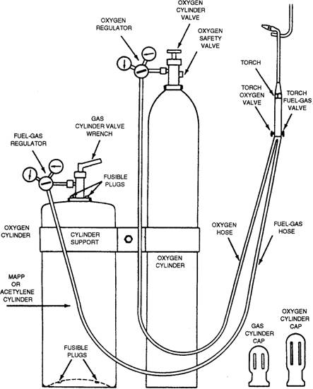
Figure 4-1.-Oxygas cutting outfit.
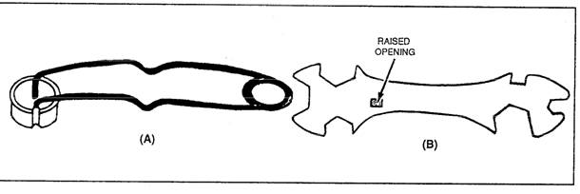
Figure 4-2.-(A)Spark igniter; (B) apparatus wrench.
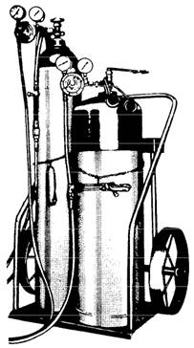
Figure 4-3.-A portable oxygas cutting and welding outfit.

