ROBUSTNESS of discrete
linear-quadratic controllers
Luis G. Bergh and John F. MacGregor
McMaster University
Hamilton, Ontario L8S 4L7
Jeffrey J. Siirola
Eastman Chemical Company
Kingsport, TN 37662
Abstract
This example document is a messy pastiche to illustrate style only. It is not meant to make any sense whatsoever from a technical standpoint! However, comments about proper formatting of your paper using the supplied Macintosh or PC Word document files are interspersed with the pseudo-technical stuff. Please scan through the entire example so that you don't miss anything. It is critical that you use the supplied document files and that every “paragraph” (any sequence of characters appearing between paragraph terminators - the Enter key on a PC or the return key on a Macintosh) be assigned one of the 29 preset styles (from the pulldown menu in the Style Box in the standard Word toolbar). For example, the lines starting at the top of this page are, respectively, in Title, Author, Affiliation, Location, Author, Affiliation, Location, and Abstract Heading styles. This paragraph is in Abstract Body style. The following “paragraphs” are in Keywords Heading, Keywords Body, and Main Heading styles. Note: Do not attempt to make your paper look like this sample without using the preset styles; every paragraph must be formatted with the proper preset style so that the final electronic version of the entire Proceedings will be properly formatted. Be especially careful to follow the proper form (described in the Author’s instructions) when entering figure and table captions (Figure Caption and Table Caption styles, respectively) and the Harvard form for both citing and listing references (in Reference style).
Keywords
Linear quadratic control, Minimum variance control, Internal model control, Robustness, Discrete time systems.
Introduction

Note: The first main heading (Introduction) appears as the last line of the single-column formatted section that also contains the title, abstract, and keywords, i.e., it is not part of the double-column section containing this paragraph. The very first paragraph in the paper body is in First Paragraph style and is not indented.
Other “standard” paragraphs in the paper body are in Normal style and are indented. No “extra” blank space is inserted between paragraphs. Most modern control theories are model based. A controller is said to be robust if the stability and performance of the closed-loop system are not severely compromised by moderate errors incorporated into the process model.
Process Conditions
That was a sub-heading (Sub Heading style); note that important words are capitalized. Process conditions do change with time and nonlinearities do change the process behavior in different operating regions.
Robustness and Performance
Consider the general discrete linear dynamic-stochastic model
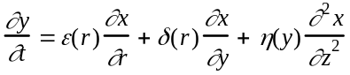 (1)
where the first term is the process transfer function. This paragraph is in Continuing Paragraph style - this unindented style is often needed after equations.
Assuming that the model of Eqn. (1) was used to design a minimum variance controller, the characteristic equation of the resulting closed-loop system would be given by something very strange:
(2)
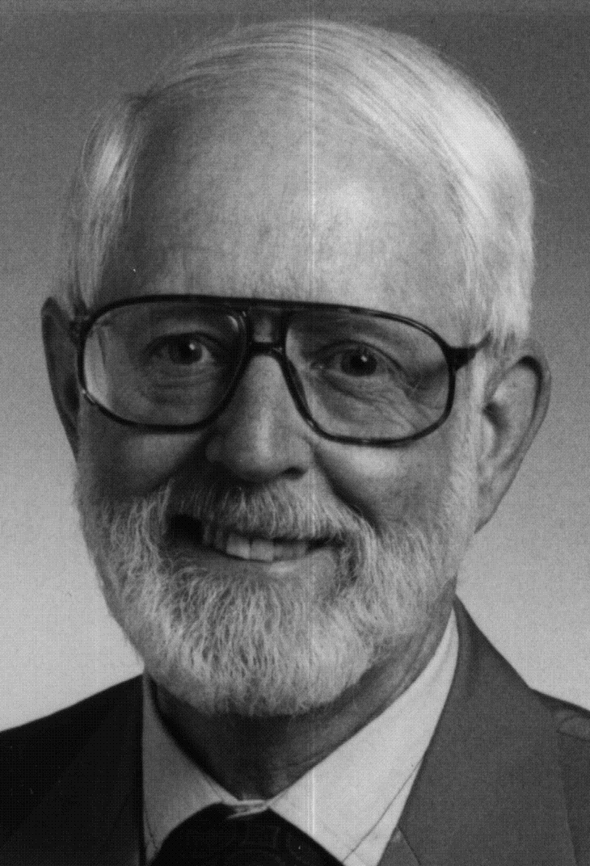
Figure 1. Scanned photo of an old chemical engineer.
Please avoid insertion of glossy photos in your manuscript if you can. Use a scanned image such as Fig. 1 instead (you can probably do better!).
The polynomial T(z-1) is the numerator term in the forecast expression for the disturbance (i.e., Nt+f+1 =
(T(z-1)/h(z-1)∇d)at). The stability of the closed-loop system depends on the roots of this characteristic equation. The second term of this equation in the square brackets is a model/process mismatch term, as is illustrated in Fig. 2. Try to insert figures near where they are referenced, not together at the end of the paper.
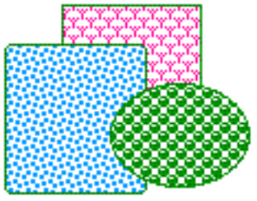
Figure 2. This is the figure caption for a typical OLE-embedded figure.
For comparison, Table 1 contains results determined by Hiebert (1980) using Powell's dogleg algorithm (HYBRD1, HYBRD2 from the MINPACK library) and by Chen and Stadherr (1981) using a modified version of Powell's dogleg algorithm.
Conclusions
The results indicate that the prototype algorithm generally had less difficulty solving the equations, and appears to be more robust for the solution of the chemical equilibrium problems found by Dog (1958). That was a reference! In this short paper we have presented a part of our work on the robustness of univariate LQG controllers.
Here is an example of a single item for inserting indented material in a paragraph:
A single item (Item Single style) is indented from both margins with no hanging indents on subsequent lines.
This is a continuing paragraph followed by three items:
1. Item First style has space above.
a. Item style. These three item styles each have hanging indents for subsequent lines.
• Item Last style has space below.
Back to a normal paragraph here. Position figures and tables so that they appear on a single page. Don’t leave large gaps in the text that will detract from the appearance of the final version of the paper (and, in addition, add pages to the paper by wasting allocated space). Minor gaps are acceptable. Your paper will be imported into a compound electronic document; we may make modest rearrangments in the final Proceedings.

Table 1. This is the Table Caption for a Page-Wide Table.
 |  | Number of Function Evaluations Required for Solution
SYSTEM | N | NEQLU1 | NEQLU2 | NEQLU3 | NEQLU4 | HYBRD1 | HYBRD2
1a | 2 | 31 | 45 | 7 | 6 | 23 | 26
2a | 4 | 43 | 49 | 47 | 47 | * | *
3a | 2 | 104 | 90 | 40 | 32 | 181 | 177
4a | 4 | 69 | 62 | 97 | 85 | 95 | 89
8a | 10 | 22 | 24 | 26 | 26 | 31 | 34
8b | 30 | 48 | 45 | 98 | 98 | 115 | 111
8c | 40 | 63 | 106 | 152 | 152 | 92 | 190
12a | 10 | 31 | 31 | 31 | 31 | 32 | 33
13a | 10 | 20 | 20 | 20 | 20 | 21 | 21
15a | 2 | * | * | * | * | * | *
15b | 2 | * | * | 67 | 54 | * | *
16a | 6 | * | * | * | * | * | *
16b | 6 | * | * | 114 | 117 | 51 | 86
16c | 6 | * | * | 36 | 36 | 23 | 103
16d | 6 | * | * | 84 | 84 | * | 75
17a | 10 | 45 | 30 | 41 | 41 | * | *
17b | 10 | 17 | 16 | 46 | 33 | * | *
17c | 10 | 43 | 42 | 45 | 45 | * | *
17d | 10 | 39 | 40 | 41 | 41 | 38 | 39
17e | 10 | 144 | 280 | 117 | 127 | * | *
17f | 10 | 80 | * | 94 | 156 | * | *
* indicates failure of the subroutine to solve the system of equation

Keep figures and tables within a singe column, if possible. For larger objects, such as the table above, Word requires that you create and format a new page-wide section that is identical in format to the first page-wide section (the one containing the title, author information, abstract, and keywords).
If you feel uncomfortable doing that, just include all such figures and tables in a single column page-wide section at the very end of your document template file, as shown on the next page. Then, in a printed copy of your paper, indicate where you would like these page-wide objects to appear in the final document. When we format the document as a whole, we will create new sections to position your page-wide material where you want it to appear.
Nomenclature
Vz = velocity in the axial direction, m/s
ρ = density, kg/m3
References
Abell, B. C. (1956). Nucleic acid content of microsomes. Nature, 135, 7-9.
Abell, B. C., R. G. Tagg, and M. Rush (1954). Enzyme-catalyzed cellular transaminations. In A. F. Round (Ed.), Advances in Enzymology, Vol. 2, 3rd ed. Academic Press, New York. pp. 125-247.
Baker, R. C. (1963a). Microscopic Staining Techniques. Butterworths, London.
Baker, R. C. (1963b). Methods of preparing thin-section slides. J. Brit. Med. Assoc., 34, 184-186.
Charlie, F. H., and M. B. Roth (1966). The chemical determination of toxins. J. Am. Chem. Soc., 66, 267-269.
Dog, P. R. (1958). In R. W. Brown (Ed.), Chemical Carcinogenesis, Vol. II. Chapman & Hall, London. Chap. 7, pp. 56-98.
Palmor, Z. and R. Shinnar (1970). Design of sampled data controllers. Ind. Eng. Chem., Proc. Des. Dev., 18, 8-30.
Palmor, Z. (1982). Properties of optimal stochastic control systems with dead-time. Automatica, 18, 1, 107-116.
Palmor, Z. (1982). On the practical stability of optimal stochastic control systems with dead-time. Automatica, 18, 4, 491-492.
Smith, J. A. (1988). Network programming from a Unix-based workstation using a process command paradigm, AIChE National Meeting, New Orleans.
Vandevan, G, L. T. Watson, and F. H. Lutze (1989). A homotopy approach for solving constrained optimization problems. Proceedings of the American Control Conf., Pittsburgh. pp.780-785.

Please be careful to enter all references using the Reference style illustrated in the preceding Reference list. The form of each reference and the form of citations to references in the body of the paper are described in detail in the document with Instructions for Authors. DO NOT USE A DIFFERENT SCHEME FOR REFERENCES; EVERY PAPER MUST USE THE SAME HARVARD NOTATION.
We strongly encourage you to make your figures and tables no wider than one column of the double-column format of the document body. However, if you wish, you may create a single-column page-wide Word section similar to this one at the very end of the paper template. There, you can save figures and tables that are too wide for reasonable positioning in one column of the double-column body. This feature will allow you to "pack" your paper into the minimum required space and make it easy to get an accurate measure of how long your final paper will be when it appears in the Proceedings.
When you return the template file containing your paper to the Editors, please include two printed copies of the paper. Leave one untouched. On the other, indicate (with pencil) where in the final document you would like each of the wide figures and/or tables in this section to appear.

This is a sample footnote that might appear in this column. It will be positioned under a separating two inch rule when you choose Footnote from the Insert menu.

