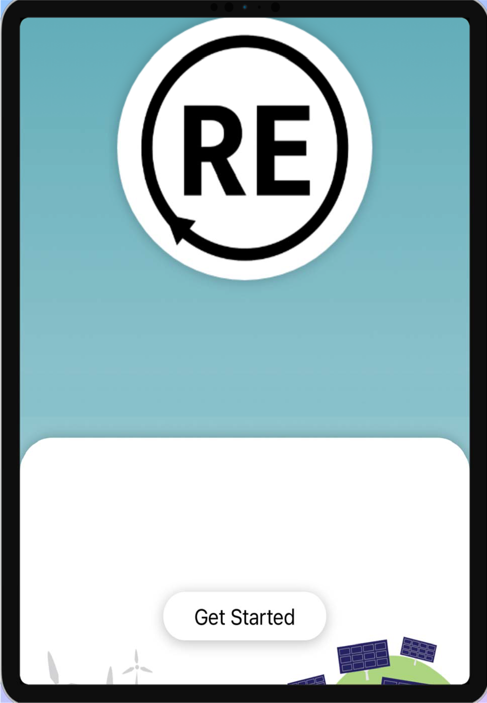

Project Design RE Habit Tracker

# CMSI 543/SYEG 557 Agile Project Management Rev ‐

February 2, 2021

*Product Owner: Marco Berardini SCRUM Master: Akhila Kaushal Documentation: Ambre Nash Developer: Kyle Cullinane*

Contents

Section 1.1 3

1. Project Description 3
2. Purpose 4
3. Project Management Style 4
4. Potential Users 5

Section 1.2 6

1. Preliminary Project Requirements 6

Functional Requirements 6

Nonfunctional Requirements 6

|  |  |
| --- | --- |
| **6 Deliverables** | **7** |
| ***Section 1.3*** | ***8*** |
| **7 Preliminary Design Description** | **8** |
| ***Section 1.4*** | ***1*** |
| **8 Preliminary Development Schedule** | **1** |
| ***Section 1.5*** | ***2*** |
| **9 Development Tools** | **2** |
| **10 Software & Libraries:** | **2** |
| **11 Next Steps** | **2** |

1. Project Description

# Section 1.1

When changing the world goes mobile, the RE Habit Tracker App helps users make the sustainable changes in their habit that impact our planet and ourselves while they’re on the go. The App shows the Environmental footprint/impact benefit of each choice made to both green/eco minded and general users alike, to make it easier to support environmental issues.

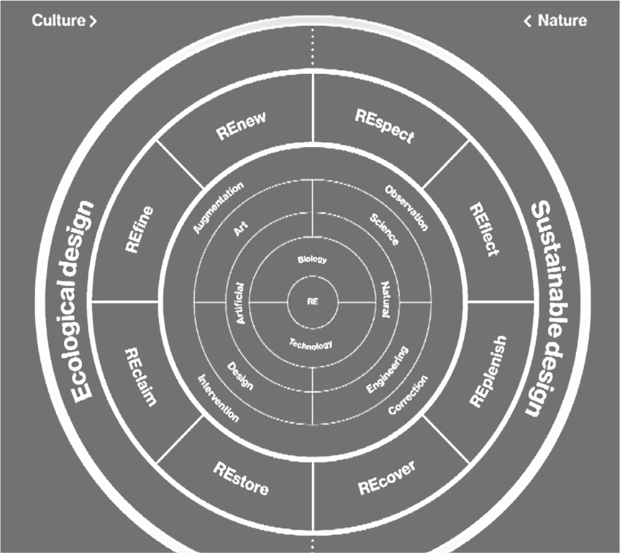

**Figure 1:** RE considerations of Culture and Nature

The RE Habit Tracker App, is a nod to Recycle, Renew, Replenish, Recover, Reimagine, Refine, Reclaim, Restore, Respond, Relate. Users of the app will find themselves Responsibly for Recording their activities and Realizing their goals.

This is done by RE Habit Tracker through *habit cards.* Each habit card defines a behavior that the user can check off each time they complete a specific action. The cards are organized into 3 different levels. The three levels of increasing difficulty for the habit cards are (1) curious, (2) concerned, and (3) actively engaged, and refer to the level of the user’s interest in environmental issues. These levels of difficulty have a positive connotation to create a more encouraging feeling when using the app. The 3 levels of difficulty according is organized per the following criteria:

* + How large is the quantifiable impact of this habit?
  + How much effort does the user need to use to complete this habit?
  + 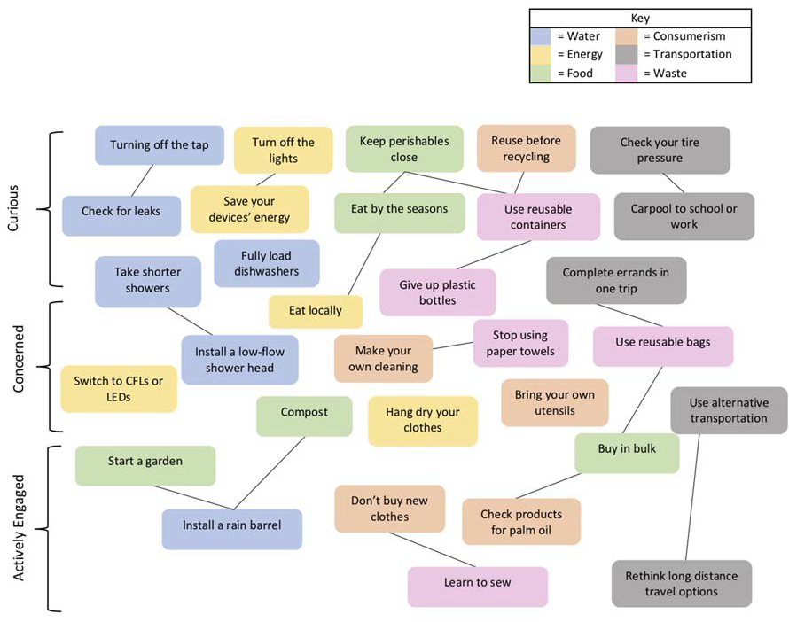Does this habit require a lifestyle change?

**Figure 2:** Flow chart of the habit cards planned. The cards are categorized by color and flow from top to bottom by increasing difficulty.

The purpose and goal is to have users utilize the habit tracker as a tool and resource to become more environmentally conscious.

## Purpose

The purpose of this Preliminary Design Document is to provide a design description for the RE Habit Tracker App. This includes, but is not restricted to, an overview of the system, a summary of the system functional and nonfunctional requirements, and the deliverables of the project.

## Project Management Style

This Project is developed using SCRUM methodology with Trello as a Software tool. We will start small but allow for change. App to market time is currently planned for a six- month time frame with an infrastructure which will be subsequently used to grow the project and scope.

The Development of this App will be in a self‐organized culture to accommodate design for a diverse and distributed audience (scalability is not linear). Weekly Stand up meetings will be held to check in on team progress, give assistance to each other where needed, and provide time for any updates. A schedule will be maintained at a top level in Microsoft Project and a more fluid Sprint tasking will be maintained in Trello.

## Potential Users

The intended audience and potential users of this app are high school students, ages 14 to 18, and people interested in addressing environmental change. Younger generations are becoming more environmentally conscious and active; however some may feel overwhelmed, discouraged, or under‐confident that they can make a difference. With busy academic and social schedules the habit tracker helps provide an easy and fun way to make environmentally friendly decisions throughout their day-to-day activities.

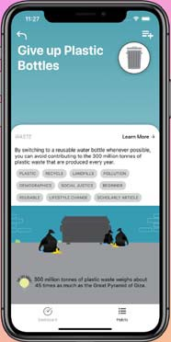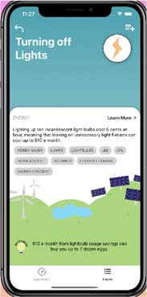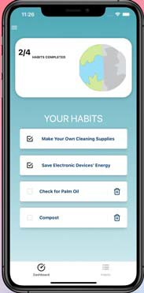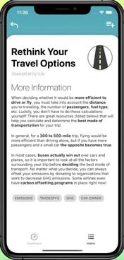

**Figure 3:** Some Use Case Sample for Users

Future potential users could expand to be students from any college campus, or eco-concerned citizens including influencers, non‐profit organizations, experts, policy makers and the community at large.

# Section 1.2

## Preliminary Project Requirements

Functional Requirements

Requirement 1: **Intuitive and comfortable user experience**

As a user (highschool age 14‐18) I want an app that encourages me to track my environmental habits and encourages me to be more mindful of my day.

* Engaging suggestions followed by information about a specific habit
* Positive language encouraging the conscious efforts and improvements that the user is making
* Has a *Connection Builder* (make people want to get involved)
* Is relatable, not preachy

Requirement 2: **Inclusivity and Relatability**

As a user (highschool age 14‐18) if I have limitation based on my location or personally situation I feel included and can find versions of habits that fit my individual needs

* Diverse habits to promote inclusivity
* Stresses *no right‐or‐wrong*: we want best decisions
* provide a comfortable and encouraging environment where the user will have incentives to track their environmental habits and if they are in a different type of situation have their needs heard and catered to
* Informs with reasonable mitigation actions and understandable **quantities**
* Speaks in different voices to different people, but is always encouraging and supportive

Requirement 3: **Fun and informative**

As a user (highschool age 14‐18) I want to use an application that is fun to use as well as informative and useful in order to motivate me to track my environmental habits

* Has great, accurate, meaningful content (from influencers, non‐profits, experts, and the community)
* Presents information and tips and suggestions in an engaging manner
* Is base on **badges**, rather than points (there is no single correct scale)
* Backed by evidence
* Includes a library of external resources, e.g. "Kerri's Reading List", "Kerri's Resources"
* Has great, accurate, meaningful content (from influencers, non‐profits, experts, and the community)
* Has a *Connection Builder* (make people want to get involved)
* Is relatable, not preachy

### Nonfunctional Requirements

### Performance Requirements:

* Application startup should be 3 seconds or less to load the initial screen.
* The app will not hinder the user's Input.

### Security:

* All authentication tokens will be saved on Firebase web service for comparison and need user permission to gain access.

### Availability:

* The App will be deployed on both IOS and Android.
* The App can be installed via Apple App Store and Google's Play Store.

### Reliability:

* The user can expect a reliable and stable product 99.9% of the time.

## Deliverables

* + Preliminary Project Design
  + Detailed Project Design
  + Project Demonstration

1. Preliminary Design Description

# Section 1.3

The RE application will be deployed on both IOS and Android mobile devices through the strategic use of React Native as a software library, and the use of Firebase as a backend user database. The application will have an interactive UI in order to captivate young users, and drive them toward repetitive environmental friendly habitual actions. To implement habit tracking, there must be a list of habits (Cards), there must be habits sorted into groups (Categories), and each habit will have a different difficulty (Level). Listed below in Table 1 is the list of all habit cards planned to be included in the App.

**Table 1:** List of Habit cards

|  |  |
| --- | --- |
| **Water** | **Consumerism** |
| * Turning of the tap * Install a lowflow shower head * Take shorter showers * Install a rain barrel * Check for leaks * Fully load dishwasher | * Buy secondhand clothing * Make your own cleaning supplies * Reuse before recycling * Bring your own utensils * Check for palm oil |
| **Food** | **Transportation** |
| * Eat by the seasons * Start a home garden * Keep perishables at the front of the fridge * Buy in bulk * Compost | * Rethink your travel options * Carpool to school or work * Complete errands in one trip * Use alternative transportation * Check your tire pressure |
| **Energy** | **Waste** |
| * Eat locally * Switch to CFLs or LEDs * Turning of lights (when leaving a room) * Hang dry your clothes * Save electronic devices energy | * Give up plastic bottles * Stop using paper towels * Use reusable grocery bags * Learn to sew * Use Tupperware instead of Ziploc bags |

Design characteristics for the above mentioned application items are described below to offer further insight.

* **Cards**: Once logged into the app, users learn and engage via cards, which provide quick information at a glance. Each card has a title, a category, a key takeaway, a description, an illustration, and links to resources. It may also have a level, an impact, and one or more tags. The initial version of the app includes several dozen cards.
* **Categories**: Our categorization system for cards and resources classifies human activities into six categories: (1) Water, (2) Energy, (3) Transportation, (4) Food, (5) Consumerism, and

(6) Waste. The set of categories is relatively stable and expected to change very, very rarely. Each category comes with a little icon image, a color, and is featured prominently on each card.

* **Habit Tracking**: A *habit* is something a user can do on an ongoing basis. Examples include buying local produce, not running water while brushing teeth. The in app habit tracker allows for an engaging (and hopefully “sticky”) user experience.
* **Levels**: A level describes how accessible, difficult, complex, or impactful a card is. Specific language and representation for increasing levels is under review. A lower level indicates a potentially convenient action an individual can take and represents the first steps in the direction of informed, sustainable living with respect to the category. A higher level indicates more difficulty and complexity along with potentially more significant, reaching impact.

This habit tracking design is intended to aid the user in sorting through cards to select the ones that most relate to their day to day lives. When a user selects a card it will move into their habit tracking interface where they can confirm that they have abided by the cards environmentally friendly requirements for the day. In the Figure 4 below the hardware and software communication architecture is shown at a top level.

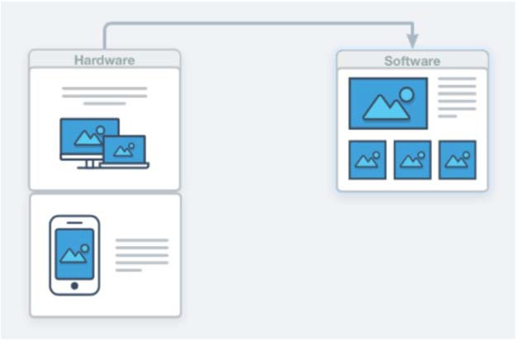

**Figure 4:** Interface between Hardware and Software

The network connections that link to the backend user data servers are depicted in Figure 5.

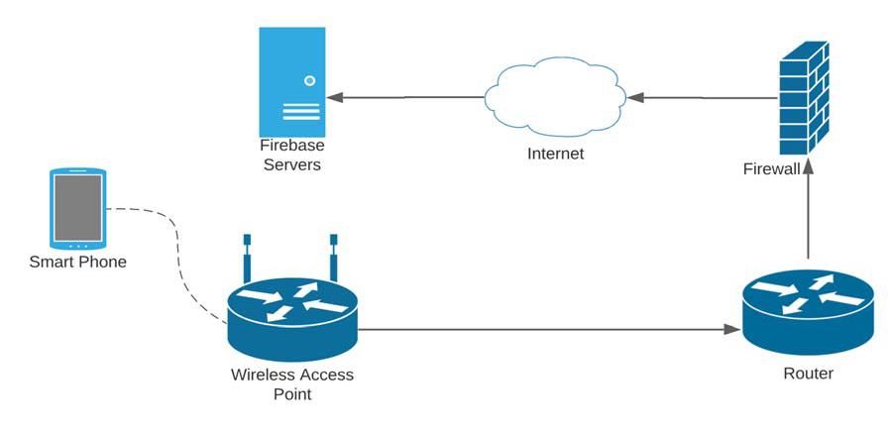

**Figure 5:** Connections from User Device to Backend Servers

The Habit Card structure will consist of a Title, Category, Definition, More Information and Equivalency. Below in Table 2 is an Example of a Habit Card

**Table 2:** Habit card Example

|  |
| --- |
| *Title:* Learn to Sew |
| *Category:* Waste |
| *Definition:*  By fixing up old clothes that still have plenty of wear left in them, you can avoid having to donate them or throw them away. So much of the clothing that we donate is not resold as secondhand items in our communities. Instead, these items are either landfill, sold off to a handful of East African countries, or recycled into industrial rags. |
| *More Information:*  Donating used clothing might seem like the perfect alternative to throwing it away but there are other implications that go along with the donation. Clothing donation centers actually receive more clothing than they can possibly sell, despite what we may be led to believe. Oftentimes the excess clothing (if not sent to textile recycling plants) is shipped off to other countries where it is resold. The US is shipping out so much of this secondhand clothing that it is actually impeding on these countries' ability to build up their own textile industry. In fact, Rwanda, Kenya, Uganda, Tanzania, South Sudan, and Burundi have all started to phase out or completely ban the import of secondhand clothing.  In 2017 alone, 11 million tons of textile waste was landfilled in the US. Due to this, we need to buy less and make the clothing we have last. We have to slow down enough so that the textile recycling industry can catch up with the sheer amount of waste created by fast fashion because dumping our unwanted clothes in other countries is simply not sustainable. |
| *Equivalency*: The EPA estimates that clothing recycling today has the same impact as removing 1 million cars off of the road. |

The following Figure 6 and Figure 7 show an overview of the user interface for the RE application

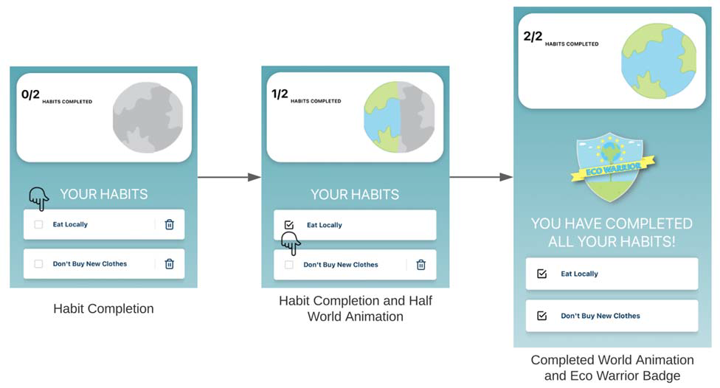

**Figure 6:** User Interface for Habit Completion

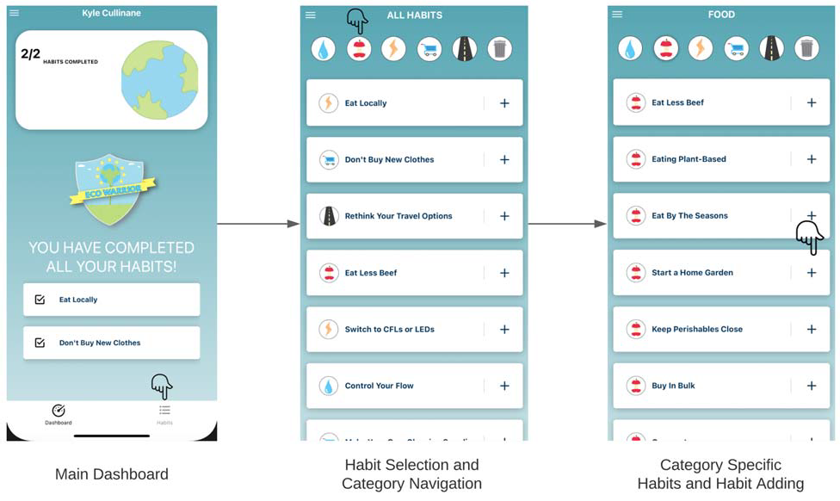

**Figure 7:** User Interface for Habit Selection and Category Navigation

The mobile app will eventually be available through the App Store for iOS users and through Google Play for Android users.

1. Preliminary Development Schedule

# Section 1.4

Baseline Schedule below outlines the project milestones to assist in tracking progress

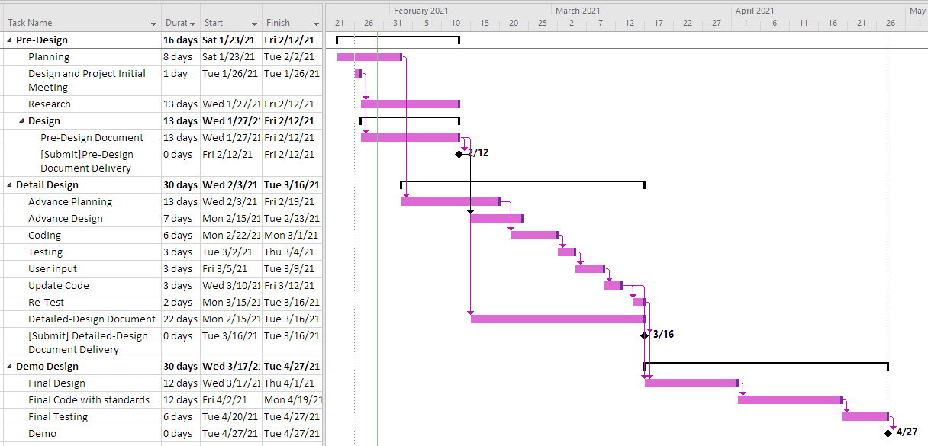

1. Development Tools

# Section 1.5

Listed below are the tools planned to be used for development

* VS code
* Chrome browser tools
* Test Flight
* Android Emulator
* IOS Emulator

## Software & Libraries:

Listed below are the software and libraries planned to be used for development

* JavaScript
* React
* React Native
* Firebase
* Node
* nmp
* Expo

## Next Steps

### Increased involvement of environmental science and computer science

Continue to develop new habit cards to the app, research more sources for the resource library. In this way, the team will be able to develop more content for the app.

Reach out to both Professors Eric Strauss (Urban Ecology) and Karina Johnston (Principles of Sustainability) to be advisors.

### Enhancements to the app

Survey results showed that young adults often engage with peers through social connections within apps, so we are considering adding additional features to our app. For example, features such as:

* + *Badge***:** An indicator of accomplishment, often awarded to actions related to a specific issue.
  + *Metrics (“Social Scores”)*: Quantitative, visual, indicators of accomplishment, for example:
    - I used the app for this many decisions
    - I recorded this many habits
    - I did this many tasks
    - I used the app for this many days straight
  + *Contribute Back*: Allow users to submit their thoughts, their ideas, why they will or won't want to do certain things.

### Tracking of actions other than habits

While habits focus on frequent activities, we are considering increasing the tracking features of our app for two new types of action:

* + *Task*: Something a user can do (generally once) such as install solar panels, get a low energy appliance, install a low flow shower head, buy water filters, donate to an organization
  + *Decision*: Something a user acts on as needed. Examples include whether to repair or replace an old appliance, whether to buy a new or used car, and what kind of car; how to vote.