**PUZZLES**

Sequence puzzle:

*A player is shown a sequence in the form of lights. They are then expected to replicate that sequence by stepping on buttons*

*TBD*

Telescope constellation puzzle:

1. Keypad 2. Rubiks cube 3. Observatory / stars: constellation name password & color sequence 4. Computer 5. Gun physics- targets and/or knocking box off shelf 6. Radio w/ sine graph 7. Unlock lab 8. Shoot light to activate lights Ordering thoughts: - Keypad first - Observatory / stars -> computer password to access puzzle, get info on being alone - Knock box off shelf with rubiks cube using gun -> unlock lab with cube?

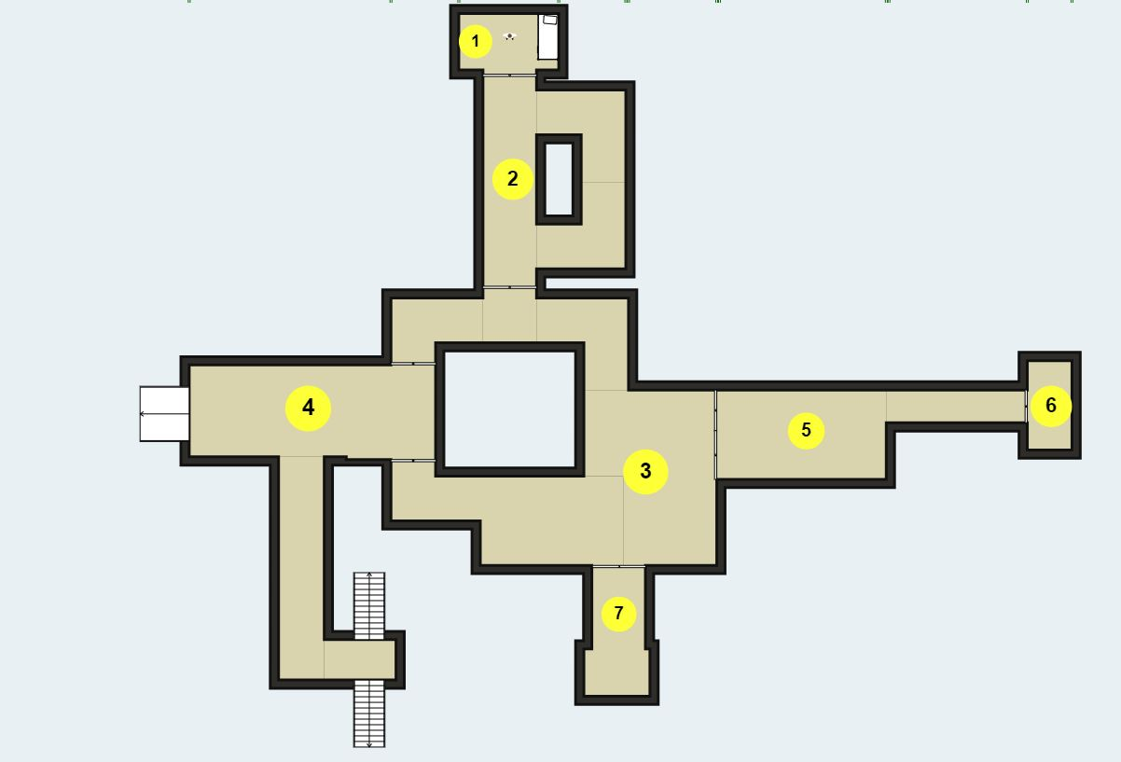

(Figure 1: Main Floor)

Room 1 (Starting room): Find 4 digit keypad code on the room to access room 2.

Room 2 (Decontamination): Search through trash cans and cabinets to find another 4 digit keypad code to access room 3.

Room 3 (Cafeteria):

Room 4 (Main Lobby):

Room 5 (Hallway 101):

Room 6 (Vestibule ):

Room 7 (Hallway 102):

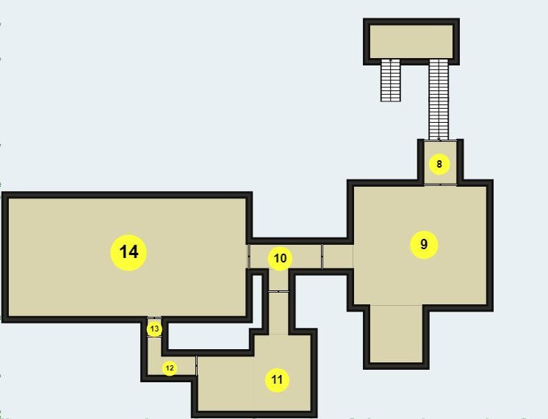

(Figure 2: Basement)

Room 8 (Mud room):

Room 9 (Sector D):

Room 10 (Cooridor 001):

Room 11 (Sector B):

Room 12 and 13 (Cooridor 002):

Room 14 (Sector A):

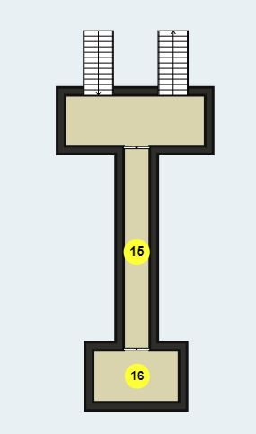

(Figure 3: Lookout)

Room 15 (Hallway 103):

Room 16 (Lookout):

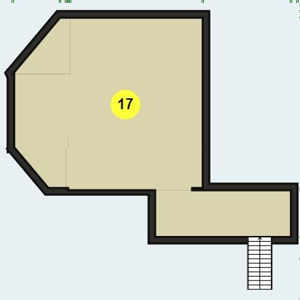

(Figure 5: Second Floor)

Room 17 (Control Center/Observitory):

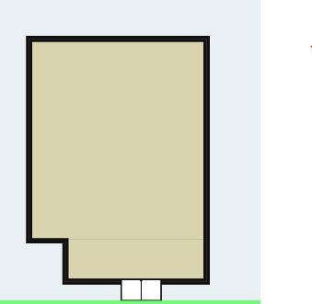

(Figure 6: Outside) *Room 18

Room 18 (Moon Surface):