1. Puzzle is The Descent in C++.

2. Worked on problem for 15.

3.The approach I went with was to begin immediately coding rather than planning things out. After I struggled, I went online to get help and found what I thought was a solution, this didn’t work so I looked again and found this. <https://gist.github.com/kYroL01/eeb7752ae71f6ae58a095ad74e989986>  
It still needed modification as it was in C rather than C++.

4.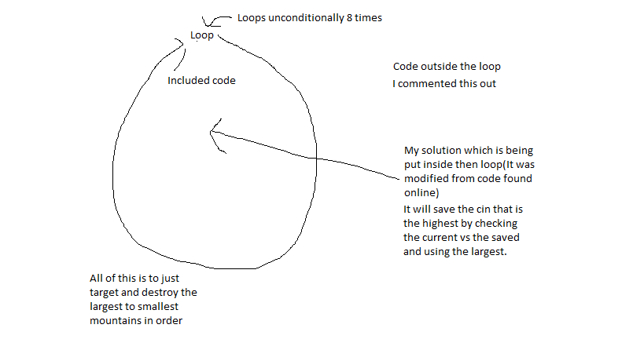

5. Solved

6. I did not solve this problem before step 3 though I was on the right track before the 15 minutes were up. After step 3 and drawing it out my approach did not change, though it IS useful for reference. It didn’t affect ,y approach as I was already heading in the right direction before step 3.