Changes in this backward compatible release of Version 8.1 Release at Q1/2014.
The following section describes new or changed functionality in AIS version 8.1

Background
This release is done due to the fact that ATG has decided that multiple leg bet types, (such as the various Vxy- or the Double bet types), can be shared between more than one racetrack. These kinds of pools are hereinafter named Multiple Track Pools.
Existing operations and return objects in this release of the AIS are not altered and therefore a recompilation of the client code is not a must.
A logical review of the client code regarding the new feature is however recommended.
There are additions to the service which can be found useful to identify Multiple Track Pools as well as getting more information about them.

Multiple Track Pools
A Multiple Track Pool is a pool where the legs, (races within the pool), are distributed to be run at more than one track. For example, the tracks Solvalla and Åby share the legs of a V86 pool. V86 leg 1 is run at Solvalla, V86-2 at Åby, V86-3 at Solvalla, V86-4 at Åby and so on.
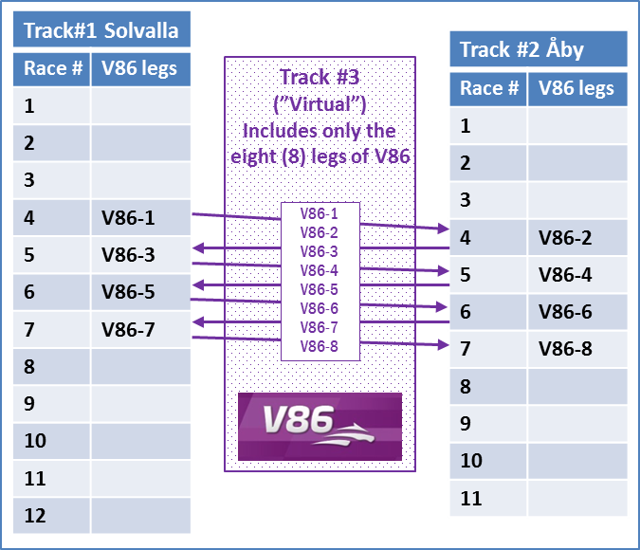
The V86 pool and virtual track #3 above is then a Multiple Track Pool.

Identifying Multiple Track Pools
In the existing unchanged RaceDayCalendar a multiple track pool is not explicitly marked as such. Each track that is involved in a multiple track pool will have the bet type listed as normal amongst the other bet types. The number of legs connected with the bet type will however not be complete. This is due to the fact that the rest of the legs are listed on the corresponding bet type at another track.
There are additions to the service which explicitly identifies Multiple Track Pools. The additions can be regarded as a complement to the RaceDayCalendar and consists of a new operation with a corresponding new return object.
The new operation is called fetchMultipleTrackPoolSetup and returns an array with MultipleTrackPoolSetup objects within the date interval for the Race Day Calendar.
A MultipleTrackPoolSetup object has the special betting system id used to identify the pool as track key. It also consists of useful information about which track each leg is run at. (In version 9 of the AIS API this information is to be found in the RaceDayCalendar itself.)
Fetching Multiple Track Pool information.
When fetching racing cards, poolinfo and results for a Multiple Track Pool the special betting system id should be used as track key. However, in this release of the AIS it is possible to fetch the information by using any betting system id amongst the participating tracks.
This means, (with the above example in mind), that the fetchV86PoolInfo/fetchV86RacingCard/fetchV86Result methods will return the same object regardless of calling it with the betting system id for Solvalla, Åby or the special Multiple Track Pool id.
Note that other methods such as fetchTrackBetInfo must be called with the track key for each participating track.
Note that all events regarding pool updates and pool results will have the special Multi Track Pool betting system id as an identifier, (track key).

New operation

fetchMultipleTrackPoolSetup.
This operation is a complement to the Race Day Calendar. (In version 9 of the AIS API the information received from this method can be found in the RaceDayCalendar).
It has no input parameters. It returns information for all multiple track pools within the date range of the Race Day Calendar. (Normally +/- 6 days from current date).
Return datatype: MultipleTrackPoolSetup
Information about a multiple leg pool connected with more than one track.

New return object

MultipleTrackPoolSetup
Holds information about a multiple leg pool connected with more than one track. The betting system id for the pool as well as information for each leg can be found here. The leg information consists of hosting track, leg number and corresponding race number.

