
AIS – ATG Information Service

Partner Info Emulator
Mock-up data for the AIS API
Intended for initial testing of partner web service client code

AIS version: 8
Revision date: 2012-10-23
Confidentiality Class: 2

Preface
AIS – ATG Information Service API.
Disclaimer
This document is provided for information purposes only. The contents hereof are subject to change without notice. This document is not warranted to be error-free, nor subject to any other warranties or conditions, whether expressed orally or implied in law, including implied warranties and conditions of merchantability or fitness for a particular purpose. We specifically disclaim any liability with respect to this document and no contractual obligations are formed either directly or indirectly by this document.
Copyright
This document may not reproduced or transmitted in any form or by any means, electronically or mechanical, for any purpose, without permission from ATG.

© 2012 AB Trav & Galopp, All rights reserved
Trademarks
ATG, the ATG logo and Harry Boy are trademarks of AB Trav & Galopp and may be registered in certain jurisdictions. The absence of a trademark from this list does not constitute a waiver of ATG's intellectual property rights concerning that trademark.
All other company, brand and product names may be trademarks or registered trademarks of their respective holders. ATG disclaims any responsibility for specifying which marks are owned by which companies or which organisations.
Contents
1 Introduction 1
1.1 Limitations 1
1.2 More Reading 1
2 Race Day Calendar 2
2.1 Operations 2
2.2 Emulated Response Data 2
2.3 Object Property Mapping 4
3 Event Objects 5
3.1 Operations 5
3.2 Emulated Response Data 5
fetchEventArray 5
fetchEventArrayFrom(int aSequenceNumber) 6
fetchCurrentEventSequenceNumber 6
4 Track Bet Info 7
4.1 Operations 7
4.2 Emulated Response Data 7
4.3 Object property mapping 8
5 Racing Cards 9
5.1 Operations 9
5.2 Emulated response data 9
5.3 Object Property Mapping 11
6 Pool Info 12
6.1 Operations 12
6.2 Emulated Response Data 12
6.3 Object Property Mapping 13
7 Results 14
7.1 Operations 14
7.2 Emulated Response Data 14
7.3 Object Property Mapping 15

Introduction
ATG has developed a web service application to provide their partners with easy acces to swedish horse betting information such as racing cards and results.
The API of this web service is referred to as the ATG Information Service (AIS).
The production version of the AIS web service can be found at:
https://media.atg.se/info/PartnerInfoService/version8
To assist partners in their development of web service clients, ATG also provides a stub (or mock-up) version of the real service with exactly the same API.
All responses to operations in the stub-version service are hardwired or emulated.
This document describes a selection of anticipated emulated responses when using the AIS API to access this testversion of the web service application, the PartnerInfoEmulator.
The emulated version of the AIS web service can be found at:
https://media.atg.se/infostub/PartnerInfoEmulator/version8
Test during client code development may be run against a gateway emulator (Stub). Please contact ATG for details on how to access the test instance at ATG.

Limitations
- Partners run these tests with only limited assistance from ATG.
- The emulator is not a complete information system.
- Responses on client requests are predefined and not tailored to suit a particular partner.

More Reading
For a more general discussion of the AIS API, please refer to the document AIS – ATG Information Service, Web Service API. For complete documentation of object-types (arguments and response objects) please refer to a separate documentation, ATGInformationServiceDO.zip. Every data object is documented as a xml schema file.

Race Day Calendar

Operations
- fetchRaceDayCalendarSimple
  - Fetch basic information about all available racedays/meetings.
- fetchRaceDayCalendar
  - Fetch comprehensive information about all available racedays/meetings.

Emulated Response Data
The calendar will contain information about race day events taking place between 2011-10-21 through 2011-10-23.
Race Day Info
DATE | TRACKID, CODE, NAME | No of Races |  | International? |  | CardAvailable?
2011-10-21 | 9, B, Bergsåker | 11 |  | False |  | True
Post time | Country code, name NAMTROT, MEETING NUMBER | Meeting nr Trot? Meeting type
18:20 | SE, Sweden | 47 True H, Huvudbana
 | BETTYPE CODE & NAME | RACES
 | DD, Dagens Dubbel | 7, 8
 | V3, V3 | 9, 10, 11
 | V65, V65 | 3, 4, 5, 6, 7, 8
 | TV, Tvilling | 1-11
 | T, Trio | 6, 11
 | VP, Vinnare & Plats | 1-11
DATE | TRACKID, CODE, NAME | No of Races |  | International? |  | CardAvailable?
2011-10-21 | 17, H, Hagmyren | 9 |  | False |  | True
Post time | Country code, name NAMTROT, MEETING NUMBER | Meeting nr Trot? Meeting type
13:49 | SE, Sweden | 19 True L, Lunchbana
 | BETTYPE CODE & NAME | RACES
 | LD, Lunch Dubbel | 2, 3
 | V3, V3 | 7, 8, 9
 | V4, V4 | 1, 2, 3, 4
 | V5, V5 | 5, 6, 7, 8, 9
 | TV, Tvilling | 1-9
 | T, Trio | 4, 9
 | VP, Vinnare & Plats | 1-9
DATE | TRACKID, CODE, NAME | No of Races |  | International? |  | CardAvailable?
2011-10-21 | 19, Kr, Kalmar | 10 |  | False |  | True
Post time | Country code, name NAMTROT, MEETING NUMBER | Meeting nr Trot? Meeting type
18:30 | SE, Sweden | 26 True S, Saxbana
 | BETTYPE CODE & NAME | RACES
 | V3, V3 | 8, 9, 10
 | V5, V5 | 4, 5, 6, 7, 8
 | TV, Tvilling | 1-10
 | T, Trio | 10
 | VP, Vinnare & Plats | 1-10
DATE | TRACKID, CODE, NAME | No of Races |  | International? |  |  | CardAvailable?
2011-10-21 | 5, S, Solvalla | 10 |  | False |  |  | True
Post time | Country code, name NAMTROT, MEETING NUMBER | Meeting nr Trot? Meeting type
11:00 | SE, Sweden | 63 True -,-
 | BETTYPE CODE & NAME | RACES
 | V86, V86 | 2, 3, 4, 5, 6, 7, 8, 9
 | VP, Vinnare & Plats | 1-10
DATE | TRACKID, CODE, NAME | No of Races |  | International? |  |  | CardAvailable?
2011-10-21 | 59, Fi, Finland | 8 |  | True |  |  | True
Post time | Country code, name NAMTROT, MEETING NUMBER | Meeting nr Trot? Meeting type
10:00 | FI, Finland | 83 True 605, Internat.
 | BETTYPE CODE & NAME | RACES
 | TV, Tvilling | 1-8
 | T, Trio | 8
 | VP, Vinnare & Plats | 1-8
DATE | TRACKID, CODE, NAME | No of Races |  | International? |  |  | CardAvailable?
2011-10-22 | 23, Ro, Romme | 13 |  | False |  |  | True
Post time | Country code, name NAMTROT, MEETING NUMBER | Meeting nr Trot? Meeting type
10:45 | SE, Sweden | 37 True H, Huvudbana
 | BETTYPE CODE & NAME | RACES
 | LD, Lunch Dubbel | 2, 3
 | DD, Dagens Dubbel | 10, 11
 | V3, V3 | 11, 12, 13
 | V4, V4 | 1, 2, 3, 4
 | V5, V5 | 7, 8, 9, 10, 11
 | V75, V75 | 5, 6, 7, 8, 9, 10, 11
 | TV, Tvilling | 1-13
 | T, Trio | 4, 9, 13
 | VP, Vinnare & Plats | 1-13
DATE | TRACKID, CODE, NAME | No of Races | International? |  | CardAvailable?
2011-10-23 | 11, Bo, Boden | 10 | False |  | True
Post time | Country code, name NAMTROT, MEETING NUMBER | Meeting nr Trot? Meeting type
14:55 | SE, Sweden | 30 True S, Saxbana
 | BETTYPE CODE & NAME | RACES
 | V3, V3 | 8, 9, 10
 | V5, V5 | 4, 5, 6, 7, 8
 | TV, Tvilling | 1-10
 | T, Trio | 10
 | VP, Vinnare & Plats | 1-10
DATE | TRACKID, CODE, NAME | No of Races | International? |  | CardAvailable?
2011-10-23 | 34, Jä, Jägersro Galopp | 9 | False |  | True
Post time | Country code, name NAMTROT, MEETING NUMBER | Meeting nr Trot? Meeting type
12:45 | SE, Sweden | 25 False L, Lunchbana
 | BETTYPE CODE & NAME | RACES
 | LD, Lunch Dubbel | 2, 3
 | V3, V3 | 7, 8, 9
 | V4, V4 | 1, 2, 3, 4
 | V5, V5 | 5, 6, 7, 8, 9
 | K, Komb | 1-2, 4-9
 | T, Trio | 4, 9
 | VP, Vinnare & Plats | 1-9
 | SK, SpecialKomb | 3
DATE | TRACKID, CODE, NAME | No of Races |  | International? |  | CardAvailable?
2011-10-23 | 5, S, Solvalla | 11 |  | False |  | True
Post time | Country code, name NAMTROT, MEETING NUMBER | Meeting nr Trot? Meeting type
14:00 | SE, Sweden | 64 True H, Huvudbana
 | BETTYPE CODE & NAME | RACES
 | DD, Dagens Dubbel | 8, 9
 | V3, V3 | 9, 10, 11
 | V65, V65 | 4, 5, 6, 7, 8, 9
 | TV, Tvilling | 1-11
 | T, Trio | 7, 11
 | VP, Vinnare & Plats | 1-11

Object Property Mapping
The picture below shows the mapping between a selection of the properties returned by the RaceDayInfo-object and the resulting information.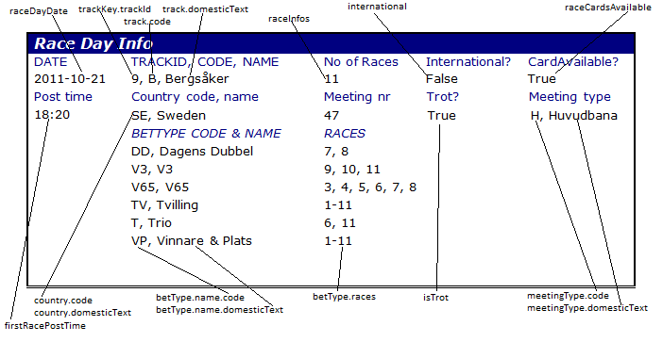

Event Objects

Operations
- fetchEventArray()
  - Fetch an array with the most recent EventObjects. Can contain up to 511 EventObjects.
- fetchEventArray(int aSequenceNumber)
  - Fetch an array with most recent EventObjects since the given event sequence number.
- fetchCurrentEventSequenceNumber
  - Fetch current event sequence number of the EventArray list (0-511)..

Emulated Response Data
These are the Event objects returned by the stub implementation.

fetchEventArray
Returns an array with four different EventObjects:
- BettingSystemOpen
  - EventSequenceNumber: 0
- DefaultRaceEvent
  - EventSequenceNumber: 1
  - TrackKey: 9
  - RaceDayDate: October 21 2011
  - RaceNumber: 10
  - TimeToStart local: 21:30:00
  - CurrentTime local: 21:20:00
  - TimeToStartUTC: 20:30:00
  - CurrentTimeUTC: 20:20:00
- VPPoolDefClosed
  - EventSequenceNumber: 2
  - TrackKey: 9
  - RaceDayDate: October 21 2011
  - RaceNumber: 9
  - Closed: True
  - Time: 21:20:00
- VPPoolResult
  - EventSequenceNumber: 3
  - TrackKey: 9
  - RaceDayDate: October 21 2011
  - RaceNumber: 10
  - Time: 21:38:00

fetchEventArrayFrom(int aSequenceNumber)
Returns the same Event Objects as the previos method with the only difference that it will only return those objects that are later/after the given sequence number.

fetchCurrentEventSequenceNumber
Will always return the number of 3.

Track Bet Info

Operations
- fetchTrackBetInfo(AtgDate aDate, TrackKey aTrack)
  - Fetch TrackBetInfo object for a chosen Date and Track. Contains information about scratchings, track condition, time to start and driver changes. If the arguments does not correspond to a race day present in the calendar above a NoDataFoundException will be thrown.

Emulated Response Data
This is an example of a TrackBetInfo object returned by the stub implementation. Each TrackBetInfo corresponds to a RaceDayInfo object in the calendar above.
Date: October 22 2011 – Track: 23 (Romme, Ro)
TrackBetInfo/Scratchings
RACE | HORSE | TIMESTAMP
2 | 8 | 20111022 08:58:53
3 | 8 | 20111022 10:12:21
4 | 8 | 20111021 12:00:05
5 | 11 | 20111018 10:22:23
10 | 7 | 20111022 10:55:55
12 | 4 | 20111022 10:12:28
12 | 8 | 20111021 13:36:25
13 | 4 | 20111022 11:27:47
13 | 6 | 20111022 08:51:10
TrackBetInfo/Driver changes
RACE | HORSE | TIMESTAMP |  |  | NEW DRVER
8 | 5 | 20111022 09:05:05 |  |  | Dagfinn Aarum
9 | 7 | 20111022 11:25:30 |  |  | Johan Untersteiner
TrackBetInfo/Track info
 |  | TIMESTAMP |  |  | TRACK STATE
 |  | 20110907 14:37:15 |  |  | L Lätt bana
TrackBetInfo/Default race
RACE | TIME TO START |  | TIMESTAMP | TIME TO START UTC |  |  |  | TIMESTAMP UTC
- | - |  | - | - |  |  |  | -
TrackBetInfo/Track info TrackBetInfo/Track info

Object property mapping
The picture below shows the mapping between the properties of the returned TrackBetInfo-object and the resulting information.
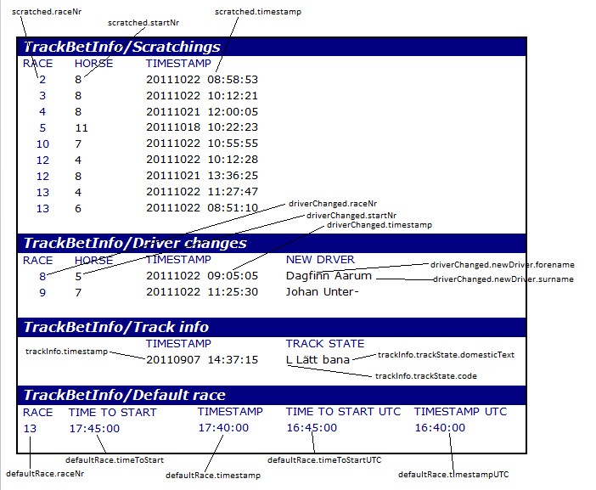

Racing Cards

Operations
- fetchRacingCardsSimple(AtgDate aDate, TrackKey aTrack)
  - Fetch basic information about the starting horses for all races on a race day. For each start in a race only the starting number, the horse name and the driver name are provided.
- fetchRacingCard(AtgDate aDate, TrackKey aTrack)
  - Fetch comprehensive information about the starting horses for all races on a race day.
- fetchBetTypeRacingCard(AtgDate aDate, TrackKey aTrack)
  - Convenience method that returns only the races for the requested bet type. For instance the request fetchV75RacingCard will only return the seven races that is included in the V75 betting pool and the fetchDDRacingCard will only return the two races in the DD betting pool.
  - NOTE 1: Some client applications might perform better if the fetchRacingCard operation is used to fetch all races on a race day and then use the BetType to Race mapping information provided in the RaceDayCalendar to show only the V75 races. If both the fetchRacingCard request and the fetchBetTypeRacingCard request is used by the client application – exactly the same information about the races in the bettype will be transferred as a SOAP/XML more than once.
  - NOTE 2: The request fetchVPRacingCard returns the exact same data as the fetchRacingCard.

Emulated response data
The RacingCards will contain information about race day events taking place between 2011-10-21 through 2011-10-23 corresponding to the information in the emulated RaceDayCalendar.
NOTE: We will show one complete Race with comprehensive information on all starting horses.
Complete Example – Date: 2011-10-21 Track: 9 Race: 3
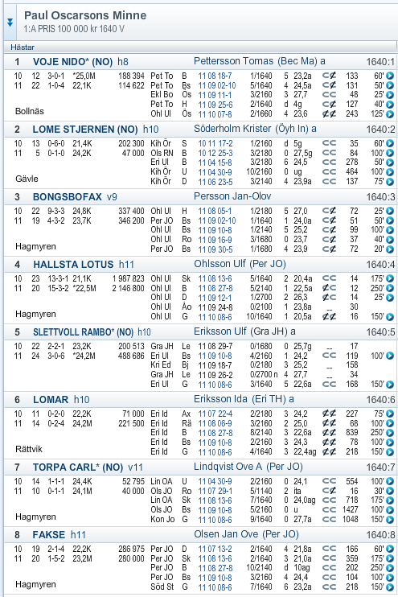

Object Property Mapping
The picture below shows the mapping between a selection of the properties returned in the Race-object and a common starting list.

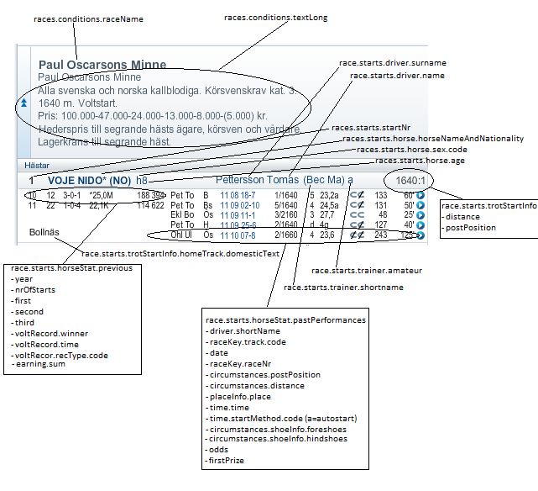

Pool Info

Operations
- fetchBetTypePoolInfo(AtgDate aDate, TrackKey aTrack)
  - Fetch pool information for the chosen bet type. The parameters and the bet type comes from the RaceDayCalendar or RaceDayCalendarSimple data objects

Emulated Response Data
The poolinformation returned refers to the race days taking place between 2011-10-21 through 2011-10-23 corresponding to the information in the emulated RaceDayCalendar.
This example shows the resulting information of a fetchMarkingBetPoolInfo request for the bettype V4.
MarkingBetPoolInfo - Date: October 23 2011 – Track: 34 (Jägersro Galopp, Jä) Bettype: V4

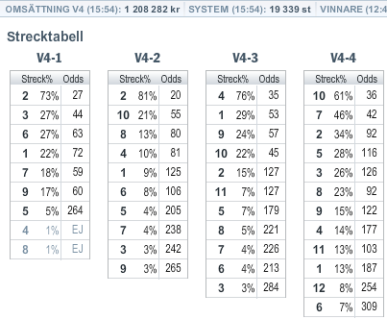

Object Property Mapping

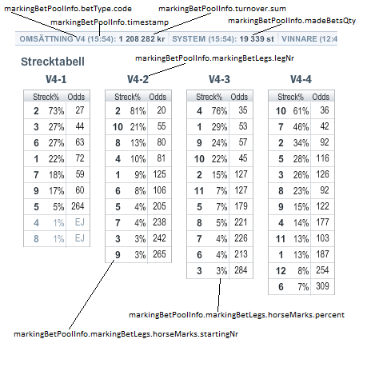

Results

Operations
- fetchBetTypeResult (AtgDate aDate, TrackKey aTrack)
  - Fetch tote result (the result of the betting pool) information for the chosen bet type.
- fetchRaceDayResult(AtgDate aDate, TrackKey aTrack)
  - Fetching a RaceDayResult gives a comprehensive result for all races at the race day.

Emulated Response Data
Since all results are present at the ATG website, please go to www.atg.se then choose Resultat – Kalender and step to the date of the race day for which you want to see the result.
NOTE: The results for the race day at Solvalla 2011-10-21 is not available at www.atg.se . This race day is only present in the mock up service.

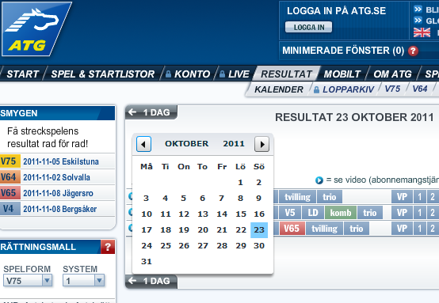

Object Property Mapping

