
AIS – ATG Information Service

Partner Info Emulator
Mock-up data for the AIS API
Intended for initial testing of partner web service client code

AIS version: 9
Revision date: 2012-12-17
Confidentiality Class: 2

Preface
AIS – ATG Information Service API.
Disclaimer
This document is provided for information purposes only. The contents hereof are subject to change without notice. This document is not warranted to be error-free, nor subject to any other warranties or conditions, whether expressed orally or implied in law, including implied warranties and conditions of merchantability or fitness for a particular purpose. We specifically disclaim any liability with respect to this document and no contractual obligations are formed either directly or indirectly by this document.
Copyright
This document may not reproduced or transmitted in any form or by any means, electronically or mechanical, for any purpose, without permission from ATG.

© 2013 AB Trav & Galopp, All rights reserved
Trademarks
ATG, the ATG logo and Harry Boy are trademarks of AB Trav & Galopp and may be registered in certain jurisdictions. The absence of a trademark from this list does not constitute a waiver of ATG's intellectual property rights concerning that trademark.
All other company, brand and product names may be trademarks or registered trademarks of their respective holders. ATG disclaims any responsibility for specifying which marks are owned by which companies or which organisations.
Contents
1 Introduction 1
1.1 Limitations 1
1.2 More Reading 1
2 Race Day Calendar 2
2.1 Operations 2
2.2 Emulated Response Data / RaceDayCalendar.RaceDayInfo 2
2.3 Object Property Mapping / RaceDayCalendar.RaceDayInfo 4
2.4 Emulated Response Data / RaceDayCalendar.MultipleTrackPoolSetup 5
2.5 Object property mapping / RaceDayCalendar.MultipleTrackPoolSetup 7
3 Event Objects 8
3.1 Operations 8
3.2 Emulated Response Data 8
fetchEventArray 8
fetchEventArrayFrom(int aSequenceNumber) 9
fetchCurrentEventSequenceNumber 9
4 Track Bet Info 10
4.1 Operations 10
4.2 Emulated Response Data 10
4.3 Object property mapping 11
5 Racing Cards 12
5.1 Operations 12
5.2 Emulated response data 12
5.3 Object Property Mapping 14
6 Pool Info 15
6.1 Operations 15
6.2 Emulated Response Data 15
6.3 Object Property Mapping 16
7 Results 17
7.1 Operations 17
7.2 Emulated Response Data 17
7.3 Object Property Mapping 18

Introduction
ATG has developed a web service application to provide their partners with easy acces to swedish horse betting information such as racing cards and results.
The API of this web service is referred to as the ATG Information Service (AIS).
The production version of the AIS web service can be found at:
https://media.atg.se/info/PartnerInfoService/version9
To assist partners in their development of web service clients, ATG also provides a stub (or mock-up) version of the real service with exactly the same API.
All responses to operations in the stub-version service are hardwired or emulated.
This document describes a selection of anticipated emulated responses when using the AIS API to access this testversion of the web service application, the PartnerInfoEmulator.
The emulated version of the AIS web service can be found at:
https://media.atg.se/infostub/PartnerInfoEmulator/version9
Test during client code development may be run against a gateway emulator (Stub). Please contact ATG for details on how to access the test instance at ATG.

Limitations
- Partners run these tests with only limited assistance from ATG.
- The emulator is not a complete information system.
- Responses on client requests are predefined and not tailored to suit a particular partner.

More Reading
For a more general discussion of the AIS API, please refer to the document AIS – ATG Information Service, Web Service API. For complete documentation of object-types (arguments and response objects) please refer to a separate documentation, ATGInformationServiceDO.zip. Every data object is documented as a xml schema file.

Race Day Calendar

Operations
- fetchRaceDayCalendarSimple
  - Fetch basic information about all available racedays/meetings.
- fetchRaceDayCalendar
  - Fetch comprehensive information about all available racedays/meetings.

Emulated Response Data / RaceDayCalendar.RaceDayInfo
The calendar will contain information about race days taking place between 2013-12-06 through 2013-12-09.
Only the race days at 2013-12-06 has a complete set of information. We will focus on these race days in the document.
Shown below are also the two race days at 2013-12-09 which have results. These two tracks are also the hosting tracks for the multiple track pools held this day.
The race days at 2013-12-07 and 2013-12-08 does not have any results. Nor does the race days at 2013-12-09 apart from those shown below.

Race Day Info
DATE | TRACKID, CODE, NAME | No of Races | International? | CardAvailable?
2013-12-06 | 22, Mp, Mantorp | 10 | False | True
Post time | Country code, name | Meeting nr Trot? Meeting type
18:30 | SE, Sweden | 33 True S, Saxbana
 | BETTYPE CODE & NAME | RACES
 | V4, V4 | 6, 7, 8, 9
 | V3, V3 | 8, 9, 10
 | V5, V5 | 4, 5, 6, 7, 8
 | TV, Tvilling | 1-10
 | T, Trio | 7, 10
 | VP, Vinnare & Plats | 1-10
DATE | TRACKID, CODE, NAME | No of Races | International? | CardAvailable?
2013-12-06 | 33, Ös, Östersund | 9 | False | True
Post time | Country code, name | Meeting nr Trot? Meeting type
12:20 | SE, Sweden | 27 True L, Lunchbana
 | BETTYPE CODE & NAME | RACES
 | LD, Lunch Dubbel | 2, 3
 | V3, V3 | 7, 8, 9
 | V4, V4 | 1, 2, 3, 4
 | V5, V5 | 5, 6, 7, 8, 9
 | TV, Tvilling | 1-9
 | T, Trio | 4, 9
 | VP, Vinnare & Plats | 1-9
DATE | TRACKID, CODE, NAME | No of Races | International? | CardAvailable?
2013-12-06 | 23, Ro, Romme | 11 | False | True
Post time | Country code, name | Meeting nr Trot? Meeting type
18:20 | SE, Sweden | 40 True H, Huvudbana
 | BETTYPE CODE & NAME | RACES
 | V64, V64 | 3, 4, 5, 6, 7, 8
 | DD, Dagens Dubbel | 7, 8
 | V3, V3 | 9, 10, 11
 | V4, V4 | 5, 6, 7, 8
 | TV, Tvilling | 1-11
 | T, Trio | 6, 11
 | VP, Vinnare & Plats | 1-11
DATE | TRACKID, CODE, NAME | No of Races | International? |  | CardAvailable?
2013-12-06 | 67, GB, Storbittanien | 8 | True |  | True
Post time | Country code, name | Meeting nr Trot? Meeting type
12:45 | GB, Great Britain | 33 False IX, Int. extra
 | BETTYPE CODE & NAME | RACES
 | K, Komb | 1-8
 | VP, Vinnare & Plats | 1-8
DATE | TRACKID, CODE, NAME | No of Races | International? |  | CardAvailable?
2013-12-09 | 5, S, Solvalla | 8 | True |  | True
Post time | Country code, name | Meeting nr Trot? Meeting type
18:10 | SE, Sweden | 77 True H, Huvudbana
 | BETTYPE CODE & NAME | RACES
 | V86 | 1, 2, 3, 4
 | V65 | 5, 6, 7
 | DD | 4
 | V4 | 1, 2, 3, 4
 | V3 | 6, 7, 8
 | TV, Tvilling | 1-8
 | T, Trio | 1-8
 | VP, Vinnare & Plats | 1-8
DATE | TRACKID, CODE, NAME | No of Races | International? |  | CardAvailable?
2013-12-09 | 9, B, Bergsåker | 8 | False |  | True
Post time | Country code, name | Meeting nr Trot? Meeting type
18:00 | SE, Sweden | 53 True LS, Lunch-Sax
 | BETTYPE CODE & NAME | RACES
 | V86 | 1, 2, 3, 4
 | V65 | 5, 6, 7
 | DD | 4
 | V5, V5 | 3, 4, 5, 6, 7
 | TV, Tvilling | 1-13
 | T, Trio | 4, 9, 13
 | VP, Vinnare & Plats | 1-13

Object Property Mapping / RaceDayCalendar.RaceDayInfo
The picture below shows the mapping between a selection of the properties returned by the RaceDayInfo-object and the resulting information.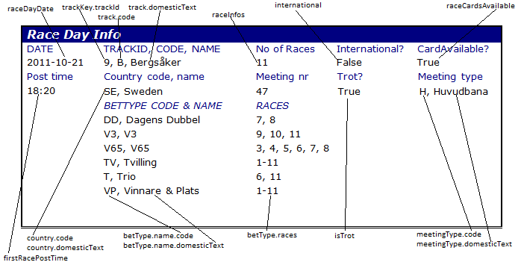

Emulated Response Data / RaceDayCalendar.MultipleTrackPoolSetup
The mock up service returns three objects.
Multiple Track Pool Setup Index 0:
- Date: 2013-12-09
- Trackid: 40
- Track: Xa, Xpress A
- Multiple track name: Solvalla/Bergsåker
- Bet type: DD, Dagens Dubbel
- Host tracks:
  - 5, S, Solvalla
  - 9, B, Bergsåker
- LegInfo:
  - Leg 1, Race 4, Bergsåker
  - Leg 2, Race 4, Solvalla

Multiple Track Pool Index 1:
- Date: 2013-12-09
- Trackid: 40
- Track: Xa, Xpress A
- Multiple track name: Solvalla/Bergsåker
- Bet type: V65
- Host tracks:
  - 5, S, Solvalla
  - 9, B, Bergsåker
- LegInfo:
  - Leg 1, Race 5, Solvalla
  - Leg 2, Race 6, Bergsåker
  - Leg 3, Race 6, Solvalla
  - Leg 4, Race 7, Bergsåker
  - Leg 5, Race 7, Solvalla
  - Leg 6, Race 8, Bergsåker

Multiple Track Pool Index 1:
- Date: 2013-12-09
- Trackid: 40
- Track: Xa, Xpress A
- Multiple track name: Solvalla/Bergsåker
- Bet type: V86
- Host tracks:
  - 5, S, Solvalla
  - 9, B, Bergsåker
- LegInfo:
  - Leg 1, Race 1, Bergsåker
  - Leg 2, Race 1, Solvalla
  - Leg 3, Race 2, Bergsåker
  - Leg 4, Race 2, Solvalla
  - Leg 5, Race 3, Bergsåker
  - Leg 6, Race 3, Solvalla
  - Leg 7, Race 4, Bergsåker
  - Leg 8, Race 4, Solvalla

Object property mapping / RaceDayCalendar.MultipleTrackPoolSetup
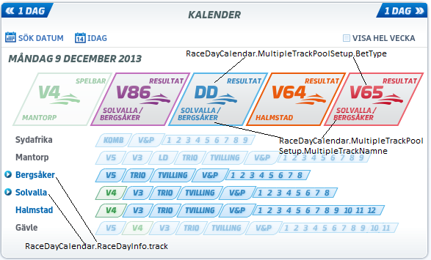
Note that the information regarding a multiple track pool is to be found in the RaceDayCalendar.MultipleTrackPoolSetup object.
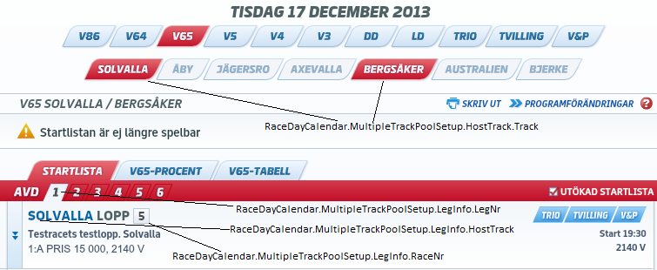
The MultipleTrackPoolSetupObject connects legs to races at the hosting tracks.

Event Objects

Operations
- fetchEventArray()
  - Fetch an array with the most recent EventObjects. Can contain up to 511 EventObjects.
- fetchEventArray(int aSequenceNumber)
  - Fetch an array with most recent EventObjects since the given event sequence number.
- fetchCurrentEventSequenceNumber
  - Fetch current event sequence number of the EventArray list (0-511)..

Emulated Response Data
These are the Event objects returned by the stub implementation.

fetchEventArray
Returns an array with four different EventObjects:
- MarkingBetPoolResult
  - EventSequenceNumber: 0
  - BetType: V86
  - RaceDayDate: December 9 2013
  - TimeStamp: 21:20:00
  - TrackKey: 40
- VPPoolDefClosed
  - EventSequenceNumber: 1
  - TrackKey: 5
  - RaceDayDate: December 9 2013
  - RaceNumber: 7
  - Closed: True
  - Time: 21:20:00

- DefaultRaceEvent
  - EventSequenceNumber: 2
  - TrackKey: 5
  - RaceDayDate: December 9 2013
  - RaceNumber: 8
  - TimeToStart local: 21:30:00
  - CurrentTime local: 21:20:00
  - TimeToStartUTC: 20:30:00
  - CurrentTimeUTC: 20:20:00
- VPPoolResult
  - EventSequenceNumber: 3
  - TrackKey: 9
  - RaceDayDate: December 9 2013
  - RaceNumber: 8
  - Time: 21:38:00

fetchEventArrayFrom(int aSequenceNumber)
Returns the same Event Objects as the previos method with the only difference that it will only return those objects that are later/after the given sequence number.

fetchCurrentEventSequenceNumber
Will always return the number of 3.

Track Bet Info

Operations
- fetchTrackBetInfo(AtgDate aDate, TrackKey aTrack)
  - Fetch TrackBetInfo object for a chosen Date and Track. Contains information about scratchings, track condition, time to start and driver changes. If the arguments does not correspond to a race day present in the calendar above a NoDataFoundException will be thrown.

Emulated Response Data
This is an example of a TrackBetInfo object returned by the stub implementation. Each TrackBetInfo corresponds to a RaceDayInfo object in the calendar above.
Date: December 6 2013 – Track: 33 (Östersund, Ös)
TrackBetInfo/Scratchings
RACE | HORSE | TIMESTAMP
1 | 1 | 20131206 08:34:01
1 | 4 | 20131206 08:29:33
1 | 10 | 20131206 09:34:54
2 | 4 | 20131206 12:11:37
2 | 6 | 20131206 08:29:40
2 | 10 | 20131206 10:17:52
2 | 12 | 20131206 08:29:44
3 | 2 | 20131206 10:20:20
3 | 5 | 20131206 10:18:00
3 | 6 | 20131206 13:02:43
3  3 | 7 | 20131206 13:03:00
3 | 12 | 20131206 08:34:13
4 | 1 | 20131206 08:40:25
4 | 2 | 20131206 08:29:53
4 | 4 | 20131205 11:56:15
4 | 5 | 20131206 08:29:57
4 | 12 | 20131206 10:18:17
5 | 3 | 20131206 08:30:06
7 | 7 | 20131206 08:57:33
8 | 3 | 20131206 13:45:07
9 | 6 | 20131206 08:34:26
TrackBetInfo/Driver changes
RACE | HORSE | TIMESTAMP |  |  | NEW DRVER
2 | 5 | 20131209 11:21:38 |  |  | Håkan Skoglund
3 | 3 | 20131209 11:23:13 |  |  | Stina Åström
3 | 7 | 20131209 11:24:07 |  |  | Jan-Olof Johansson
4 | 11 | 20131209 11:24:59 |  |  | Jan-Olof Johansson
TrackBetInfo/Track info
 |  | TIMESTAMP |  |  | TRACK STATE
 |  | 20131216 09:40:52 |  |  | L Lätt bana
TrackBetInfo/Default race
RACE | TIME TO START |  | TIMESTAMP | TIME TO START UTC |  |  |  | TIMESTAMP UTC
- | - |  | - | - |  |  |  | -
TrackBetInfo/Track info TrackBetInfo/Track info

Object property mapping
The picture below shows the mapping between the properties of the returned TrackBetInfo-object and the resulting information.
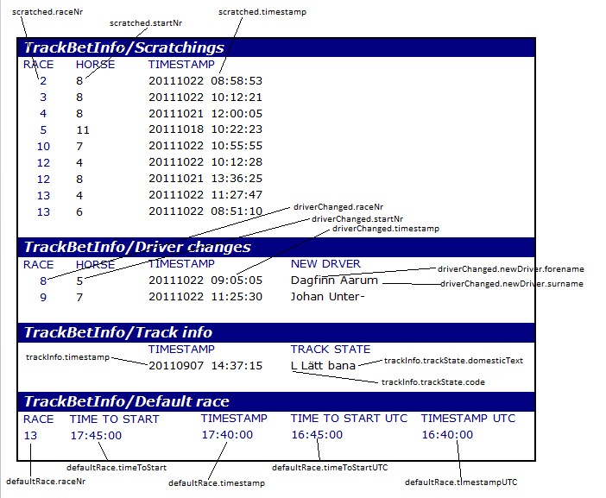

Racing Cards

Operations
- fetchRacingCardsSimple(AtgDate aDate, TrackKey aTrack)
  - Fetch basic information about the starting horses for all races on a race day. For each start in a race only the starting number, the horse name and the driver name are provided.
- fetchRacingCard(AtgDate aDate, TrackKey aTrack)
  - Fetch comprehensive information about the starting horses for all races on a race day.
- fetchBetTypeRacingCard(AtgDate aDate, TrackKey aTrack)
  - Convenience method that returns only the races for the requested bet type. For instance the request fetchV75RacingCard will only return the seven races that is included in the V75 betting pool and the fetchDDRacingCard will only return the two races in the DD betting pool.
  - NOTE 1: Some client applications might perform better if the fetchRacingCard operation is used to fetch all races on a race day and then use the BetType to Race mapping information provided in the RaceDayCalendar to show only the V75 races. If both the fetchRacingCard request and the fetchBetTypeRacingCard request is used by the client application – exactly the same information about the races in the bettype will be transferred as a SOAP/XML more than once.
  - NOTE 2: The request fetchVPRacingCard returns the exact same data as the fetchRacingCard.
  - NOTE 3: The fetchBetTypeRacingCard always returns the race array in leg order. This means that the race at at array index position 0 alwas contains leg number 1, pos 1 contains leg number 2 and so on.

Emulated response data
The RacingCards will contain information about race day events taking place between 2013-12-06 through 2013-12-09 corresponding to the information in the emulated RaceDayCalendar. We will show one complete Race with comprehensive information on all starting horses.
Complete Example – Date: 2013-12-06 Track: 33 Race: 9
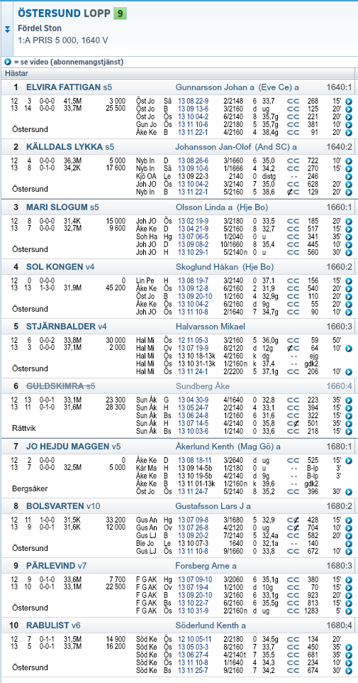

Object Property Mapping
The picture below shows the mapping between a selection of the properties returned in the Race-object and a common starting list.

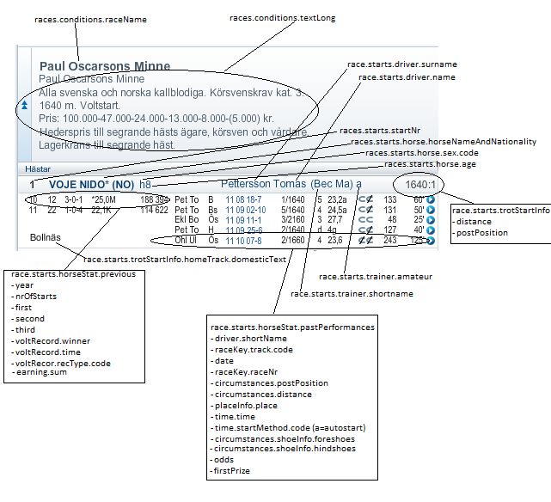

Pool Info

Operations
- fetchBetTypePoolInfo(AtgDate aDate, TrackKey aTrack)
  - Fetch pool information for the chosen bet type. The parameters and the bet type comes from the RaceDayCalendar or RaceDayCalendarSimple data objects

Emulated Response Data
The poolinformation returned refers to the race days taking place between 2013-12-06 through 2013-12-09 corresponding to the information in the emulated RaceDayCalendar.
This example shows the resulting information of a fetchMarkingBetPoolInfo request for the bettype V4.
MarkingBetPoolInfo - Date: December 6 2013 – Track: 33 (Östersund, Ös) Bettype: V4

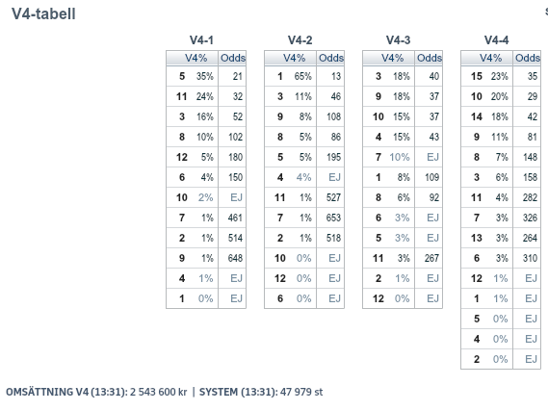

Object Property Mapping

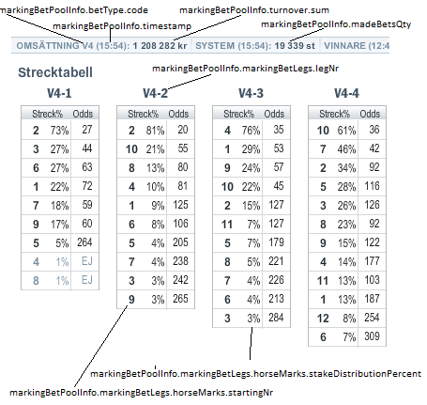

Results

Operations
- fetchBetTypeResult (AtgDate aDate, TrackKey aTrack)
  - Fetch tote result (the result of the betting pool) information for the chosen bet type.
- fetchRaceDayResult(AtgDate aDate, TrackKey aTrack)
  - Fetching a RaceDayResult gives a comprehensive result for all races at the race day.

Emulated Response Data
Since all results for 2013-12-06 are present at the ATG website, please go to www.atg.se then choose Resultat – Sök datum and step to the date of the race day for which you want to see the result.
NOTE: The results for the race day at Solvalla 2013-12-09 and Bergsåker 2013-12-09 are not available at www.atg.se . These race days are only present in the mock up service.

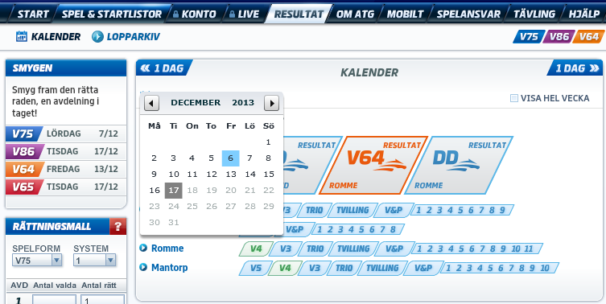

Object Property Mapping

