What’s New?
This document describes new features and changes between different versions of the ATG Information Service, the ATG Web Service application for Swedish horse betting information.

This document should be regarded as a quick introduction to added or changed functionality of the AIS. For complete documentation, we refer to the documents ATG Information Service, AIS – Partner Info Emulator, ATG Information Service DO and of course the WSDL of the current version.

Changes in Version 9. Release at Q1/2014.
The following section describes new or changed functionality in AIS version 9.
This version can be found at:
    - http://media.atg.se/info/PartnerInfoService/version9
    - http://media.atg.se/infostub/PartnerInfoEmulator/version9

Summary of new features
- Introduction of Multiple Track Pools in the race day calendar.
- New operation returning participating driver/trainer stats for a race day.
- Current distance statistics for every horse in the racing card.
- Slow track state statistics for every horse in the racing card.
- New events indicating if a race or a whole race day is canceled.
- Corresponding canceled flags in the race day calendar.
- Investment sums for each horse in the trio pool.
- Apprentice information in the racing card.

Introducing Multiple Track Pools
A Multiple Track Pool is a pool where the legs, (races within the pool), are distributed to be run at more than one track. For example, the tracks Solvalla and Åby share the legs of a V86 pool. V86 leg 1 is run at Solvalla, V86-2 at Åby, V86-3 at Solvalla, V86-4 at Åby and so on.
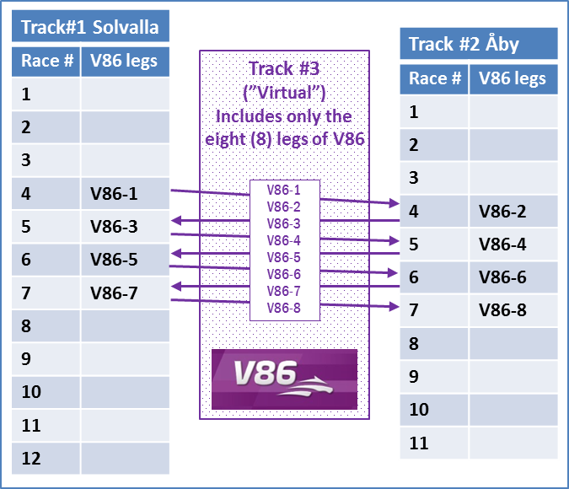
The V86 pool and virtual track #3 above is then a Multiple Track Pool.

Identifing Multiple Track Pools
In the RaceDayCalendar an array with Multiple Track Pool objects is added.
This array holds all the Multi Track Pools within the date interval of the calendar.
An array with Multi Track Pool objects is also added to each RaceDayInfo in the calendar holding all the MTP objects connected with that specific race day.
A MultipleTrackPoolSetup object has the special betting system id used to identify the pool as track key. It also consists of useful information about which track each leg is run at.

Fetching Multiple Track Pool information.
When fetching racing cards, pool info and results for a Multiple Track Pool the special betting system id should be used as track key. The methods in question are fetchBetTypeRacingCard, fetchBetTypePoolInfo and fetchBetTypeResult.
Note that other methods such as fetchTrackBetInfo must be called with the track key for each participating track.
Note that all events regarding pool updates and pool results will have the special Multi Track Pool betting system id as an identifier, (track key).

Major Changes
The major changes in this release are:

RaceDayCalendar changes

RaceDayCalendar
The attribute multipleTrackPoolSetups is added.
Datatype: Array of MultipleTrackPoolSetup
All the multiple track pool setups within the calendar from and to dates.
Note! If upgrading from AIS8.1, the fetchMultiTrackPoolSetup operation is removed.

RaceDayInfo
The attribute multipleTrackPoolSetups is added.
Datatype: Array of MultipleTrackPoolSetup
The multiple track pool setups connected with the race day.

The attribute sportSystemId is added.
Datatype: int
The numerical id in ATGs sport system for this track.

The attribute canceled is added.
Datatype: boolean
Notifies, when true, that the whole race day is off. No races will take place.

RaceInfo
The attribute canceled is added.
Datatype: boolean
Notifies, when true, that the race is off. The race will not take place.

TrioPoolInfo changes.

TrioInformation
The attribute investmentFirst added.
Datatype: Amount
The total sum invested on the horse as a winner.

The attribute investmentSecond added.
Datatype: Amount
The total sum invested on the horse as runner up.

The attribute investmentThird added.
Datatype: Amount
The total sum invested on the horse as coming in third.

New operations and return types added.

fetchRaceDayStats
Return datatype: RaceDayStats
A web service return type. Holds statistic information about participating drivers and trainers at a specific race day. The information is time stamped.

fetchExchangeRates
Return datatype: Array of ExchangeRate
A web service return type. Holds information about exchange rates for a number of currencies. This information is updated on a daily basis.

RacingCard changes.

HorseStat
The attribute totalCurrentDistance is added.
Datatype: YearStat
Life achievements, (wins, places, earnings), at the race distance.
When gallop: The information is valid for previous starts made at the exact race distance.
When trot: The information is valid for previous starts made within the distance interval that applies to the race distance. 0-1999 meters, 2000-2399 meters and 2400-9999 meters. For example, if the race distance is 2140 m, stats for all races within the distance interval 2000-2399 are returned.
This information is only valid for horses registrated as swedish. (Horse/swedenReg = true). For imported horses the information is based on races completed after the import date.
For horses not registered as Swedish the information is null.

The attribute totalSlowTrackState is added.
Datatype: YearStat
Life achievements, (wins, places, earnings), on a slow track state.
This information is only valid for horses registrated as swedish. (Horse/swedenReg = true). For imported horses the information is based on races completed after the import date.
For horses not registered as Swedish the information is null.

The attributes total, current, previous has changed their data type.
Datatype: YearStatHorse

YearStatHorse (new data type)
Base class: YearStat

LicenseOwner
The attribute apprenticePro is added.
Datatype: boolean
Shows if the driver is an apprentice for a professional trainer.

The attribute apprenticeAmateur is added.
Datatype: boolean
Shows if the driver is an apprentice for an amateur trainer.

Events

Event (the base class)
The attribute eventClassName is added.
Datatype: string
The event class name.

RaceCanceled (new event)
Base class: RaceEvent
Notifies that the race is off. The race will not take place.

RaceDayCanceled (new event)
Base class: Event
Notifies that the whole race day is off. No races will take place.

Resolved Issues

RaceDayResult
The attribute scratchedReason in PlaceInfo was always null.
This is now corrected.

Known Issues

YearStat.
The attribute voltRecord.
Datatype: Record
The information about track is missing.

The attribute autoRecord.
Datatype: Record
The information about track is missing.

The attribute amAutoRecord.
Datatype: Record
The information about track is missing

