GIT Help

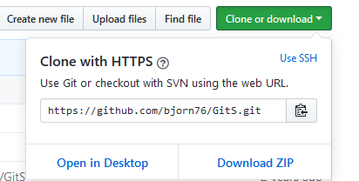

# git clone

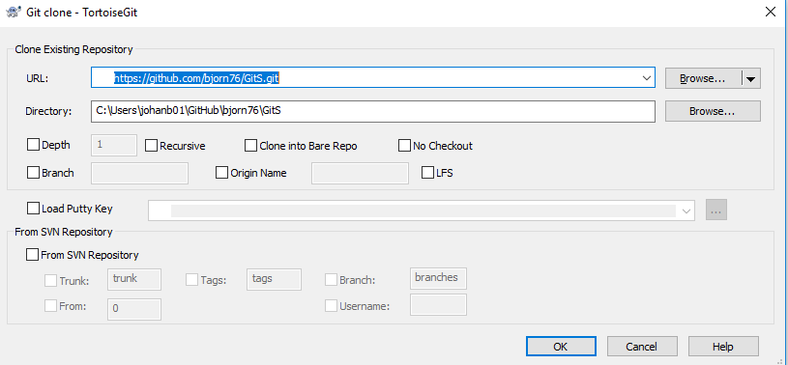

Retrieve an entire repository from a hosted location via URL

# git add

Add a file as it looks now to your next commit (stage)

# git commit -m “[Message]”

Commit your staged content as a new commit snapshot

# git push

Transmit local branch commits to the remote repository branch

# git pull

Fetch and merge any commits from the tracking remote branch

# git status

Show modified files in working directory, staged for your next commit

# git log

Show all commits in the current branch’s history

# git rm

Delete the file from project and stage the removal for commit.

# git mv

Links to online help:

<https://education.github.com/git-cheat-sheet-education.pdf>

## Tortoise Settings

