|  |  |
| --- | --- |
| **bc_back.png** | **HEALTH XCEL, Inc.** |

**Business Plan**

|  |
| --- |
| Confidentiality Statement  The contents embodied in this business plan are strictly confidential and are supplied with the understanding that they will be held confidentially and not disclosed to third parties without the prior written consent of Health XCEL, Inc. |

**OWNERS**

Bjorn Harvold

Health XCEL, Inc.

154 Atlantic Ave

3R

Brooklyn, NY 11201

917 494 6357

bjorn@hxcel.com

Executive Summary 6

General Company Description 6

The Team 8

Bjorn E. Harvold 8

Paul T. Fisher 8

Benjamin G. Taylor 8

Products and Services 10

Enterprise & Interoperability 11

Healthcare as a Service 13

Revenue sharing: Virtual practices 18

Professional consulting services 19

The Story 20

Before Globalhealth 20

After Globalhealth 20

Marketing Plan 26

Market research 26

Customers 28

Competition 29

Strategy 34

Sales Forecast 36

Operational Plan 37

Production 37

Location 38

Legal Environment 38

Personnel 39

Suppliers 39

Management 40

Professional and Advisory Support 40

Financial Plan 40

12-Month Profit and Loss Projection 40

Four-Year Profit Projection (Optional) 41

Projected Cash Flow 41

Opening Day Balance Sheet 42

Break-Even Analysis 42

Appendices 43

Technology 43

Refining the Plan 43

For Raising Capital 43

# Executive Summary

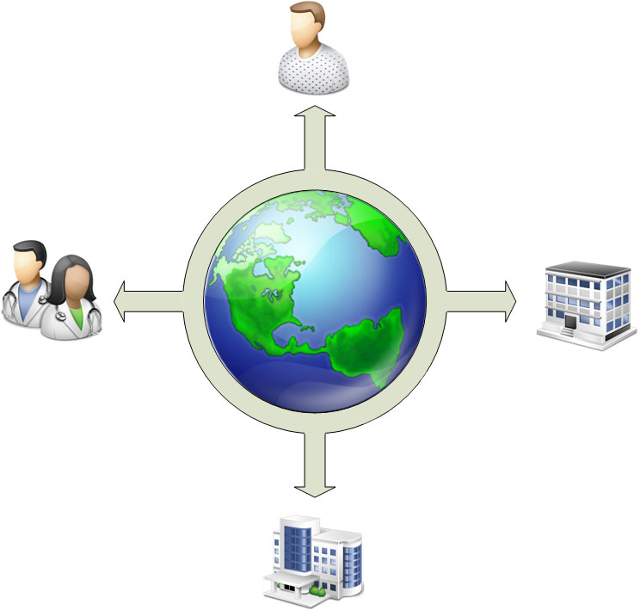Health XCEL, Inc. is an eHealth company with a focus on creating the most versatile and advanced Health Information Exchange in the world. By leveraging a great team and best practices open source frameworks as well as building on top of, already proven, cloud platforms, we are revolutionizing how patients and doctors are interacting. We are solving the biggest problem facing eHealth today: interoperability. We are doing that, first and foremost, by centralizing the solution, but also by using existing medical standards for sharing records. We coined this new model: Healthcare as a Service (HeCaaS). Where eHealth vendors can deploy their applications on a common, secure, healthcare platform and charge a subscription fee for their services.

Our customers are patients, doctors, hospitals, HMOs and insurance companies. In other words, everyone that, in some form, is associated with the lifecycle of health. By offering them an eco-system of applications geared to their needs in one, all-encompassing, package, large healthcare institutions can comfortably offload the IT part of health to us, and in the process, save hundreds of millions of dollars, while patients get the most personalized attention from any doctor or hospital in the world.

The vision is to establish a few HIE’s in a globally interconnected network, where everyone can have access to timely, secure, personalized medical information. The need for such a system is undeniable. eHealth is still in its infancy and our current 19th century approach is too costly to continue.

# General Company Description

Health XCEL, Inc., a 2004 Delaware corporation, is an enterprise health care software company that enables patients and physicians to securely exchange health related information. We offer an end-to-end medical management software solution that is smart, sophisticated, and powerful enough to manage an entire member population and empower their stakeholders to focus on the right patients at the right time with exactly the right interventions.   
  
We have built an eHealth solution called Globalhealth; a software system that combines advanced technologies, high quality medical management content, and the industry’s most respected thinking into an automated, configurable medical management solution that works just as well for the world’s largest health plans and providers as it does for smaller organizations and individual patients. We are taking a unique approach with a unique set of solutions we believe will lead to more effective change and empower our stakeholders.  
  
Driven by powerful patient identification tools and unparalleled clinical decision support capabilities, Globalhealth helps health providers, physicians and other risk bearers realize greater ROI while providing exceptional, life-improving care for everyone from at-risk patients to conscientious well people.   
  
To put it simply, Globalhealth compels your medical managers to be more efficient and productive than they’ve ever been, and will provide every patient with the most personalized, highest quality healthcare they’ve experienced; all while enhancing your bottom line.   
  
When it comes to medical management, Globalhealth is changing everything that needs to change. We deliver solutions that transform healthcare; shifting focus from provider to patient and offering unprecedented integration options with the enterprise. We’ve taken the lessons learned from the Platform as a Service (PaaS) and Software as a Service (SaaS) models, respectively, and geared it towards the special needs of the Healthcare sector. The new model has been affectionately termed “Healthcare as a Service” (HeCaaS). We consider the current leader of a PaaS solution to be salesforce.com, and their underlying force.com platform. With Globalhealth, we want to be the market leader of a HeCaaS solution.

The health care industry is poised to take off as it merges with the 21st century and eHealth becomes a reality. President George Bush said in his 2006 State of the Union that the U.S. is pushing hard for every citizen to have an Electronic Health Record by 2014. The awareness around eHealth is slowly accumulating as the baby boomers grow older and governments are facing huge budget increases in health care spending they cannot afford. “Obama health” is a direct result of these budget increases.

The opportunity for a software platform like Globalhealth is enormous. Presidential candidates for the 2008 election have health care on the very front of their agendas. Their goal is to completely revamp health care. Municipalities are already experimenting with smaller systems and the Federal government is handing out millions of dollars in grants to make it a reality. The push for eHealth has been going on longer in the European Union and they had already invested €500+ million by 1990. The health care informatics market is experiencing an unbelievable growth and will continue to do so for more than a decade to come.

There are no established market leaders in the eHealth space. The old monoliths that used to provide large complex systems to hospitals are scrambling to put eHealth on their agenda [and in their marketing brochures]. Health start-ups are trying to solve smaller tasks such as empowering the patient with PHRs and communicating via secure email and instant messaging. To be successful in this market one has to look at the big picture and take the lessons learned from the last decade of the Internet and apply it to the eHealth space. We believe we have that knowledge and the team to succeed in such an endeavor.

# The Team

## Bjorn E. Harvold

Bjorn founded Health XCEL Inc. in 2004. He saw a lack in the way health care was conducted in the U.S. and European countries. He has built a state-of-the-art application from the ground up aimed at revolutionizing the health care industry on a global scale. The application represents a system that should have been built a long time ago but would never have been because of the daunting scope, complexity, average user computer knowledge and price tag. It throws health care into the 21st century and sets the bar sky-high in an area with few competitors.

Bjorn found his love for technology at the age of 7 when his parents gave him a used Amstrad 64 to play with. Bjorn is a seasoned software architect and serial entrepreneur. He grew up in Oslo, Norway and moved to the U.S. at 18. He graduated with honors in Economics and Computer Science at Fordham University in New York City. Bjorn has over a decade of experience and has previously founded an entertainment company, a stock photography agency, a mobile payment solutions provider and co-founded a software architecture firm. He has done consulting work for financial institutions, banks, advertising and media companies. When Bjorn is not kayaking, racing his motorcycle, rollerblading, biking, skydiving, scuba diving, ballroom dancing, practicing gymnastics, yoga or playing tennis... he's probably sleeping

## Paul T. Fisher

Paul first started working with technology at the age of 7 when he tried rigging up his Commodore 64 to make prank calls around the neighborhood. Despite being a writing major in college, he was pulled back into the fray of technology at Johns Hopkins University, where he spent several years developing a distance learning application for neuroscience, while completing graduate school there. Soon thereafter, he co-founded SmartPants Media, Inc., a software development company that has created interactive software, kiosks, and games for organizations such as the IMF, Smithsonian Institution, and TrafficLand.com. Recently, Mr. Fisher formed another company, Dial M for Mercury, Inc., which develops telephony applications using VOIP and Java. Initially designed for government alerting and traffic solutions, Dial M for Mercury aspires to bridge disparate communication media and channels to help information move faster and more effectively between people and groups. Paul then moved over to Conde Nast to become the Director of Technology at wired.com. He is currently the chief engineer at Limewire.

## Benjamin G. Taylor

Ben is a career entrepreneur and consultant with extensive knowledge in the application of technology to new business models. His strengths are in the areas of technology visioning, software development methodologies, business operations, software architecture and development. He has over 12 years of experience and has worked with senior management at clients such as AT&T, MBNA, UPS, Nokia, Hallmark, Telstra and PacBell.

Ben’s last venture was as founder of Enpresence, a social networking site focused on connecting people via GPS and Bluetooth-based services.

Ben began his career at Cambridge Technology Partners (CTP) in Boston where he quickly took on practice management and project leadership roles. After CTP Ben co-founded NerveWire, a Boston based e-business consultancy now part of Wipro, and E5 Systems, an offshore application development and maintenance firm with operations in China and India.

Ben holds a BA in Art and Semiotics from Brown University.

# Products and Services

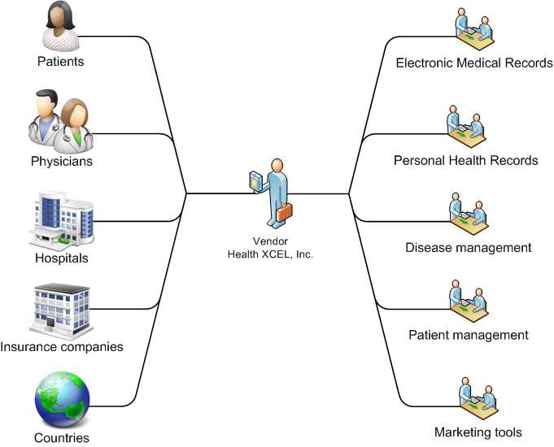At the onset of the Internet, people were just figuring out how to interact with it. The pioneers from that era were the ones who gave users the ability to “see” the web through a web browser and “find” information with the help of a search engine. Enabling users to send email forever changed the way business was conducted and how we keep in touch with friends. The last 5 years has seen an explosion in the way users are able to express themselves through posting pictures, blogs, in forums and instant messages. Social networks, such as Facebook, took that a step further by allowing users to create friends and groups of friends and like-minded people. Users were able to have a public and private life; restricting some information to a person or group, and broadcasting other parts of their life. The popularity of social networks shows that it’s a medium users enjoy and it makes sense to them to interact with in this way as it mimics real life to an extent. Most importantly, it has proven to be a medium in which millions freely participate and exchange information and ideas.

When talking about health and the Internet, or eHealth, in the same context, you have to take a step back to those pioneering days when users could mostly just retrieve basic information. Most information currently still resides in hard-to-get-to silos (a.k.a. paper documents in filing cabinets). The practice of health is as old as time and there are, understandably, many relics, cobwebs and antiquated ways of conducting business. We are proposing to change all of that and take the lessons learned from the current state of the Internet and apply them to the eHealth space.

We want to enable the secure sharing of sensitive patient information by leveraging what we now know about successful online relationship management and empower countries, hospitals, physicians, patients, insurance companies and support groups with the tools to manage such information. By creating a patient-centric health care network and putting the patient in charge of her own well-being, we are able to dramatically cut cost for physicians and providers, and at the same time increase efficiency. The overall result is a better service rendered to the patient. Patient and physicians will have access to health records when and where they need them and the patient controls the flow of information. Ultimately the healthcare related risks for both patients and physicians are reduced through improved communication and access to important healthcare related data.

## Enterprise & Interoperability

Before we can create the software applications people associate with eHealth, such as a PHR and EMR, we need to build the deeper foundation. There are fundamental issues that need to be solved to avoid becoming “just another health records vendor”.

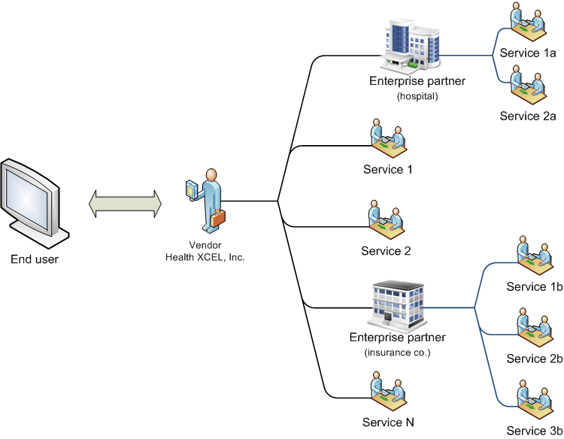

Figure . 3rd party enterprise interoperability

Globalhealth was built with the enterprise in mind. We don’t want to be another closed proprietary system. We want to be the “open framework” standard built on standards when it comes to storing and sharing Electronic Health Records online.

To make such a software platform a reality, we have chosen to leverage the Platform as a Service (PaaS) model, and by association, Software as a Service (SaaS), but to optimize and fine-tune it for the health care sector. We have affectionately termed the new model “Healthcare as a Service (HeCaaS)”. To understand HeCaaS, you first have to know the key characteristics of PaaS and SaaS.

Platform as a Service[[1]](#footnote-1):

* *“PaaS offerings facilitate deployment of applications without the cost and complexity of buying and managing the underlying hardware and software and provisioning hosting capabilities, providing all of the facilities required to support the complete life cycle of building and delivering web applications and services entirely available from the Internet.”*
* *“PaaS offerings may include facilities for application design, application development, testing, deployment and hosting as well as application services such as team collaboration, web service integration and marshalling, database integration, security, scalability, storage, persistence, state management, application versioning, application instrumentation and developer community facilitation. These services may be provisioned as an integrated solution over the web.”*
* *“PaaS offerings typically attempt to support use of the application by many concurrent users, by providing concurrency management, scalability, fail-over and security. The architecture enables defining the "trust relationship" between users in security, access, distribution of source code, navigation history, user (people and device) profiles, interaction history, and application usage.”*

Software as a Service[[2]](#footnote-2):

* *“SaaS is software that is deployed over the Internet and/or is deployed to run behind a firewall on a local area network or personal computer. With SaaS, a provider licenses an application to customers either as a service on demand, through a subscription, in a "pay-as-you-go" model, or (increasingly) at no charge. This approach to application delivery is part of the utility computing model where all of the technology is in the "cloud" accessed over the Internet as a service.”*
* *“Activities managed from central locations rather than at each customer's site, enabling customers to access applications remotely via the Web.”*
* *“Application delivery typically closer to a one-to-many model (single instance, multi-tenant architecture) than to a one-to-one model, including architecture, pricing, partnering, and management characteristics.”*
* *“Centralized feature updating, which obviates the need for end-users to download patches and upgrades.”*
* 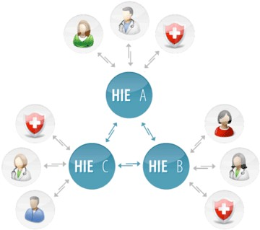*“Frequent integration into a larger network of communicating software—either as part of a mashup or a plugin to a platform as a service.”*
* *“SaaS providers generally price applications on a per-user basis and/or per business basis, sometimes with a relatively small minimum number of users and often with additional fees for extra bandwidth and storage. SaaS revenue streams to the vendor are therefore lower initially than traditional software license fees, but are also recurring, and therefore viewed as more predictable, much like maintenance fees for licensed software.”*
* *“Some SaaS applications are free to the user, with revenue being derived from alternate sources such as advertising, or upgrade fees for enhanced functionality (often referred to as "freemium").”*
* *“More feature requests from users, since there is frequently no marginal cost for requesting new features.”*
* *“Faster new feature releases, since the entire community of users benefits.”*
* *“Embodiment of recognized best practices, since the user community drives the software publisher to support best practice.”*

## Healthcare as a Service

The Globalhealth HIE starts with this premise of a centrally managed platform, where 3rd party vendors can install and manage their eHealth applications.

Healthcare as a Service adds its own characteristics on top of PaaS and SaaS:

* Interoperability.
* Security
* Customization

### Interoperability

*“Interoperability is a property of a product or system, whose interfaces are completely understood, to work with other products or systems, present or future, without any restricted access or implementation.”[[3]](#footnote-3)*

* ***Syntactic interoperability***
  + *If two or more systems are capable of communicating and exchanging data, they are exhibiting syntactic interoperability. Specified data formats, communication protocols and the like are fundamental. XML or SQL standards are among the tools of syntactic interoperability. This is also true for lower-level data formats, such as ensuring alphabetical characters are stored in ASCII format in all the communicating systems.*
* ***Syntactical interoperability***
  + *Beyond the ability of two or more computer systems to exchange information, semantic interoperability is the ability to automatically interpret the information exchanged meaningfully and accurately in order to produce useful results as defined by the end users of both systems. To achieve semantic interoperability, both sides must refer to a common information exchange reference model. The content of the information exchange requests are unambiguously defined: what is sent is the same as what is understood.*

The Globalhealth HIE was conceived, first and foremost, because eHealth applications today need to be always-on, super redundant and ultimately infinitely scalable and, most importantly, be able to communicate with each other and understand the data they use to communicate with. This is very different from the 2 existing models touted as interoperable today.

1. Microsoft HealthVault: HealthVault is a container for 3rd party vendors to submit entries into, about records patients have created at partner web sites. Most of these partner web sites require a paid membership by the patient. For the patient to be able to say they have a decent set of tools, they would do well to subscribe and keep accounts with at least 3 of these vendors. It is costly for the patient. It is not efficient. And it is definitely not interoperable.
2. Large existing implementations of Health IT software, custom or off-the-shelf, try to add extra functionality to desktop or server applications that tout “a connector” that will allow interoperability. 9 times out of 10, the connector will cost extra. It will only be able to talk to itself; meaning a 2nd computer running the same software and version but located within the same local network. This is also not interoperability.

With Globalhealth, applications created by different vendors and deployed onto the platform, can speak to each other over agreed upon transmission protocols and interfaces, internally to the platform and externally to other HIEs. The goal is to centralize health care records onto a few HIEs around the world, have the HIEs synchronize that data across themselves, and make them available to everyone, anywhere, without the need for anyone to install expensive systems locally. Data will be available, securely, from a laptop, smart phone or tablet computer.

### Security

Regular SaaS implementations already entertain the concepts of security and access control. HeCaaS extends this premise and adds to it a patient-centric rights approach that includes, but not limited to:

* Patient record level sharing
* Emergency record level sharing
* Provider to Provider access rights

### Platform Applications

The platform application market will be explosive. Once the platform is ready, and application vendors can create, test and deploy their applications on it, people will really start to understand the opportunities the platform has created and we foresee an exponential growth curve from vendors applying to be approved for the platform. Like Apple’s AppStore, there needs to be an approval process in place. To both ensure a level of quality but also to avoid duplication; we don’t need 10 PHR solutions.

And, like the applications that accompany the iPhone, we will create, what we believe to be, the most useful applications for everyone. Below we have outlined, in order of importance, the core applications accompanying Globalhealth at launch.

1. Electronic Medical Records (EMR)
2. Personal Health Record (PHR)
3. Emergency Records
4. Disease Management (DM)
5. Scheduling
6. Billing
7. Relationship Management
8. Professional tools
   1. Profile
   2. Ratings
   3. Blog
   4. Forum
   5. Chat
9. Messaging and Reminders
10. Revenue making opportunities

#### emr_data_sharing.pngElectronic Health Records (EHR)

When you go to your physician for a check-up, the physician will write down all the results from that meeting in your journal. A journal can contain past illnesses, some information on illnesses in your family, lab tests such as x-rays and anything else the physician deems important to build a solid health profile about you. Depending on your physician, this can be a completely paper based journal or saved on a computer somewhere. We empower physicians around the world with the ability to create electronic journals for their patients and store all information pertaining to the patient’s health online in a centralized and secure repository. The patient can manage these journals and choose to share them with other physicians in their network.

#### Personal Health Records (PHR)

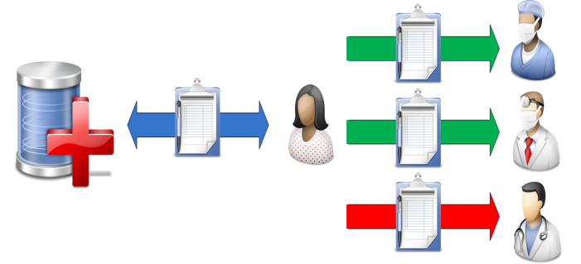A PHR is a piece of information retained by the patient who deems it relevant to save as part of the patient’s own medical history. When you go to a physician and are asked to fill out a piece of paper about your past history, that’s a simple version of a PHR in paper form. Now patients can facilitate the information gathering process usually done by their physicians by creating their own personal health records (PHRs). Information retained in a patient’s PHR is basic information the patient can fill in herself. Allergy, medication and immunization records are good examples of these. This saves health professionals time and money, as the information they usually would have to record is already available in electronic form. Patients can choose to share all or parts of this information with their health professionals.

#### ****Emergency Records****

Every record the patient can manage can be marked as an emergency record. An emergency record is a ”portable” piece of information that should be accessible to anyone in the case of emergency (break-the-glass scenario). Think of it as the patient’s public profile on a community site. In the event of an accident, a physician outside the patient’s trusted network can still have access to the most important information and avoid making misdiagnoses, which could have fatal consequences. E.g. the patient could be deadly allergic to a certain drug that the physician usually prescribes for his patients in similar situations. Emergency records would help prevent these unfortunate and easily avoidable cases from occurring due to lack of information.

#### Patient management

Patient management is features that make it easier for physicians and patients to communicate.

##### Scheduling

The calendar is at the heart of how patients and physicians interact. Any meeting begins with an appointment request. A meeting can be a single or group meeting. It can be a one-time meeting or it can recur over time. Both patient and physician can request an appointment with the other. They can access each other’s calendar and see what time works for both. If the time is convenient the other person confirms the meeting and both receive reminders a few days before via phone, SMS or email. If one party needs to cancel or reschedule, the other party will be notified of the cancellation or asked to confirm the new proposed meeting time. Our calendar and scheduler is one of our most advanced features and offers a lot of flexibility for our clients. Our users also have the ability to sync their schedules with MS Outlook, Mac iCal, Chandler and other iCalendar compatible calendar applications.

##### Messaging and reminders

We have created an enterprise messaging application that can monitor, alert and connect medical personnel with patients and their loved ones. Using the latest in IVR (Interactive Voice Response) and VOIP (Voice Over IP) and text messaging technologies. These features are a subset of the larger sector called Disease management and can be used to answer phone based questionnaires, send prescription refill reminders and get in them in touch with the right people should it be necessary.

We also use it to send out reminders and confirm appointments via email or text messages to our physicians and patients.

#### Relationship management

Social networking platforms are great tools for creating stickiness, promoting communities of likeminded people and encouraging new users to sign up. We’ve taken the core of social network functionality and named it relationship management. There are 3 levels of relationship management in our system:

##### Basic

Patients and physicians can seek each other out and request a relationship with the other. Patients will usually find a physician through their profile. Physicians also have a similar way to find patients. Once the connection is made, they can begin to make appointments and share documents.

##### Enterprise

Organizations, such as health providers, can easily manage their physicians and patients through us. The difference between this type of relationship and the basic patient-physician relationship is that the “ownership” of the patient lies with the provider and not with the physician. The patient is instead assigned to the physician rather than having a direct relationship.

##### Country

Countries have the ability to manage organizations, physicians and patients within their own country. The most important features that countries want are to be able to run statistics, track spending, sicknesses, flu outbreaks etc. They want the end result of the data that gets inputted on a daily basis from physicians and patients.

#### Promotional tools

Physicians are given a set of promotional tools. Their value lies in being able to create customer stickiness, giving them an online presence and being easily found when customers search for physicians.

##### Profile

The first thing a patient will see when searching for a physician is the physician’s profile. This page is the physician’s advertising banner and we’ve given them the utmost in flexibility by letting them create their profiles through text, images, sound and video.

There is also a structured section where they can enter in all their professional information such as education, certifications, specialties, published articles etc (*page 25*). The goal is for the profile to tell a story that is compelling to the potential patient.

##### Publications

Physicians can publish articles and other written material in this section. It can help establish credibility and give the physician another creative outlet.

##### rating.pngRatings

A feature we were especially keen on offering was the ability to rate a physician. Being able to browse customer feedback for a physician you are potentially interested can help people decide if this is the right physician for them. High rated physicians will have a greater volume of patients and help drive traffic and revenue for us. It gives the physician a greater incentive to offer a higher quality of service and the potential customer a clearer overview as to what is being offered and what she can expect.

##### Blog

Every physician has an optional blog they can use to write about anything of interest that doesn’t fit into the Publications section. Their blog is easily accessible and searchable from their profile. Blogging about news and events in their knowledge domain will lead to a higher likelihood of being found by potential customers.

##### Forum

The forum adds another level of interaction with the physician. Patients and potential customers can ask questions. Answers to previous posts can determine whether they need to make an appointment to see the physician in person or not.

##### Live chat

Patients and physicians who have an existing relationship can chat with each other. This functionality puts any one of our physician’s (or their assistants) at the patients’ fingertips for those urgent questions.

## Revenue sharing: Virtual practices

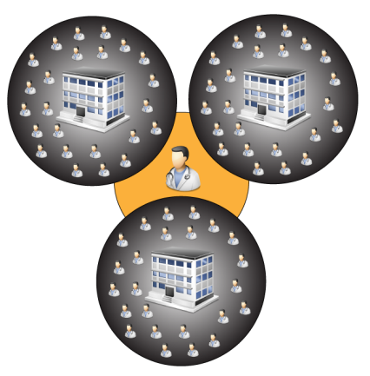This is a marketing and recruiting tool. Health professionals have the opportunity to create a “virtual practice” within our system. A virtual practice exists of a group of physicians who are paying for any of our monthly services. The owner’s goal is to recruit as many high paying physicians as possible. The reward is a percentage of the total monthly subscription fee of all the “employees”. The more members an owner can recruit, the higher the percentage rate she will receive. The goal for an owner is to recruit to the company’s maximum capacity but also to recruit the customers who pay the highest subscription fees.

The incentive for a physician to join such a company is the monthly discount she receives. She gets a greater discount based on how well the company is doing.

We’re charging a one-time fee for company owners to create a company. This price is set high so not everyone will want to create a company but not too high to deter motivated customers. A successful company owner can recoup her investment within 3 months and enjoy a steady income after that, and the new subscription fees they generate for us recoup the money we credit company owners.

Figure . Monthly company owner kick-back per employee

Figure . Monthly employee discount based on company size

## Professional consulting services

We offer professional services to our enterprise customers who need help with custom integration and migration procedures.

### Application creation

As described in the section below called “Enterprise & Interoperability”, enterprise users are able to deploy their applications onto Globalhealth. Many of our companies do not have the necessary resources to do this type of application development and would rather hand the work off to someone who has worked extensively with the platform.

### Migration

Migrating data is an intricate procedure and moving data from a legacy system to a new one is a bit of an art form. Enterprise users wishing to upgrade their system by putting their data onto our state-of-the-art framework can easily do so. We do all the necessary migration for them and create custom widgets for them, on an as-needed basis, to expose their data within Globalhealth.

# The Story

These stories are designed to show how both patient and physician can save valuable time and money and get an overall higher satisfaction by using Globalhealth.

## Before Globalhealth

Miss Yu is having pains in her kidney and decides to go to a physician to have it looked at. As she just switched jobs and her new job carries a different health insurance, she has to first find a new general practitioner. The insurance company has a large book from which to choose from and she picks a female physician in her area and calls to make an appointment. A few weeks later she is sitting in her new physician’s office. She completes the standard form the office assistant gives her. The form consists of general questions concerning her past and present health. The physician runs some standard tests on her and tells her the test results will be available the following week. The GP calls her up the following weeks to tell her that the test results show that she has a kidney stone and the physician recommends a specialist, Dr. K. Idney.

Miss Yu calls the specialist and makes an appointment. The specialist’s secretary calls Miss Yu a few days before to confirm the appointment and to remind her to bring her file from the GP. Miss Yu tells her GP she has to stop by and pick up a copy of her file before going to the specialist. As she enters the office of Dr. K. Idney, the office assistant asks her to fill out the same standard questionnaire about her current health. The assistant makes two copies and files one away in a file cabinet marked Y.

Dr. K. Idney invites her into his office and looks over her file. He also runs some quick tests on her and concludes that a minor operation will be necessary. He schedules an operation date and sends Miss Yu on her way. His assistant calls a few days before to confirm the operation date.

The operation is a success and Miss Yu is back on her feet a couple of days later.

## After Globalhealth

Miss Yu is having pains in her kidney and decides to go a physician to have it looked at. As she just switched jobs and her new job carries a different health insurance, she has to first find a new general practitioner. She goes to <http://globalhealth.hxcel.com> and searches for female physicians in her area that accepts her insurance. She finds one she likes based on the physicians’ online profile and patient ratings. She sees an available slot on the physician’s calendar and requests an appointment.

Miss Yu’s last GP recommended that she sign up with Globalhealth so she could see the results of her appointments with him online. Her GP also told her it would be wise to start creating her own Personal Health Record as are very helpful and save her time when visiting other physicians. Miss Yu is very concerned about her health and likes the idea of being able to manage her own records.

A few days before her appointment, our automated notification system calls Miss Yu to confirm her appointment. She accepts and goes online and gives her new GP access to her PHR records and the results of her previous appointments with her old GP. When she gets to the physician’s office they can see all her information online. She doesn’t have to fill in a paper based questionnaire and the physician only needs to run one specific test. The physician tells her the test results will be available online within 24 hours.

Globalhealth notifies Miss Yu that the test results are available. The test shows she has a kidney stone and the physician recommends the specialist, Dr. K. Idney. Miss Yu requests an appointment with Dr. K. Idney the same way she did with her new GP. She also shares her previous records, her PHR and the new test results with Dr. K. Idney. Dr. K. Idney responds that he has all the information he needs and immediately changes the appointment to be an operation. Our notification system informs Miss Yu that the specialist is ready to perform the operation and calls to confirm her appointment a few days beforehand. Miss Yu accepts and takes a few days off work.

The operation is a success and Miss Yu is back on her feet a couple of days later.

### Story outlines the following features

|  |  |  |
| --- | --- | --- |
| **Feature** | **Example** | **Value** |
| Online physician-patient relationships | *Miss Yu’s previous GP EHR records were available to her online* | Access old EHR records from past physicians. Learn about what the physician is doing currently through her blog and forum. Ask a question. Physician-Patient relationships have never been closer. |
| EHR based records | *Miss Yu’s previous GP, her new GP and the kidney specialist all made use of EHR records for her online journal* | Standardized diagnoses and record keeping. Misdiagnoses, based on lack of information, are severely reduced. |
| Searchable physicians by gender, insurance type, physician’s own profile text and her ratings | *Miss Yu needed to find a new GP* | Overall higher patient satisfaction and better service by giving the patient greater control of who she chooses. |
| Physician online calendar where patient can schedule/request an appointment | *Miss Yu scheduled 2 appointments with 2 different physicians* | Scheduling is no longer limited to physician’s office hours. Patient can request appointments 24/7 from anywhere in the world. Office assistant has an easy interface with which to manage appointments. Both parties can sync calendar with mobile phone or PDA and any other iCalendar compatible device. Leads to greater efficiency and higher satisfaction rates for both parties. |
| Notification system that alerts all parties to changes / confirmations / cancellations of an event (e.g. appointment) via email, automated phone and text messages | *Both the physicians and Miss Yu were notified of the appointment requests and both had to approve and confirm the appointment* | With information at your fingertips you will never forget another appointment. Both the physician and the patient will always be informed about events pertaining to their accounts. |
| PHR records that allow Miss Yu to manage allergies, medical conditions etc | *Miss Yu had already compiled a list of information pertaining to her own health* | Save time and money by allowing the patient to manage records she can easily track herself. |
| Shareable PHR and EHR records that are managed by the patient | *Miss Yu could share her own EHR and PHR records with her new physicians* | Patient medical journals are no longer contained and are available, online, 24/7 to anyone with the proper credentials. |

#### Online physician-patient relationships

Patients can request a relationship with any physician they find through our network. If the physician is not yet part of our network, the patient can invite the physician to join by the click of a button. Physicians can also initiate patient relationships and can invite patients who have not yet joined our network as well.



Figure 4 My physicians

#### EHR based records

Physicians keep electronic journals for their patients. The journal allows them to keep an accurate account of patient visits over time. The journal is managed by the physician but owned by the patient.

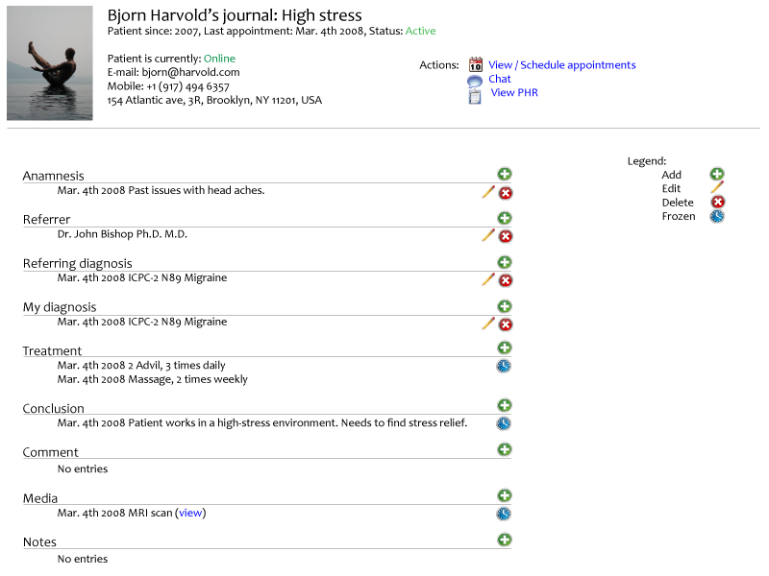

#### Searchable physicians by gender, insurance type, physician’s own profile text and her ratings

Physicians will be able to fill out a professional profile and their own “marketing profile”. A professional profile consists of a structured list recounting their career. A marketing profile is text that is meant to sell them to their prospective clients. This includes introduction text, blog entries, forum posts and other media such as images, video clips and audio that showcases who they are professionally and portray their character.

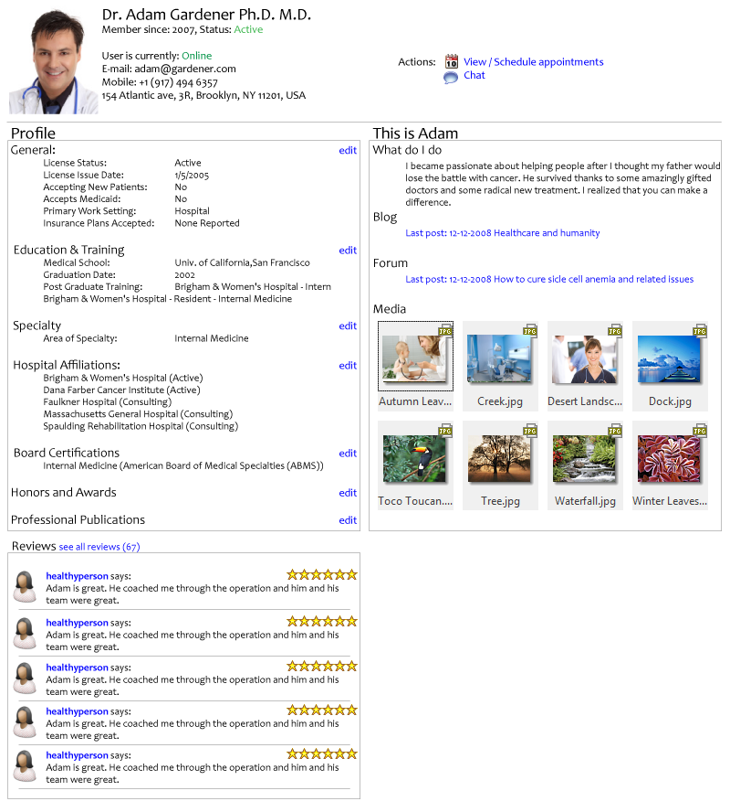

#### Physician online calendar where patient can schedule/request an appointment

Once a relationship has been established the patient and the physician can begin managing appointments with one another. There are always two views to a calendar, the owner view and the guest view. The guest viewer, usually the patient, only sees available and unavailable time. The owner will see a detailed view of the calendar.

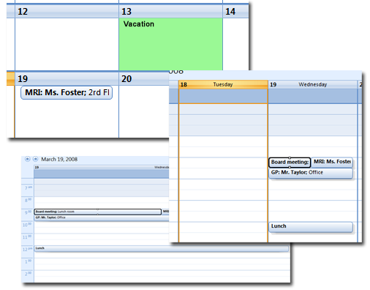

Figure 5. Physician calendar

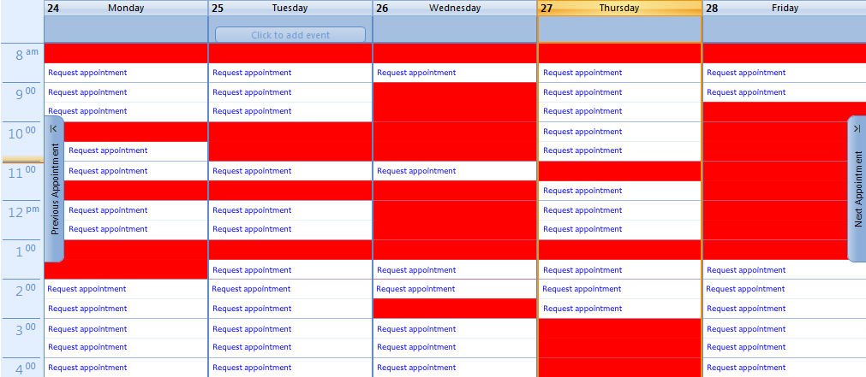

Figure 6. Patient viewing physician calendar

#### Notification system that alerts all parties to changes / confirmations / cancellations of an event (e.g. appointment) via email, automated phone and text messages

Our notification system makes use of email, text messaging and IVR to make sure you are always in the know about entries on your calendar. We use VOIP (Voice Over IP) to schedule conference calls, assist in connecting families with their loved ones during times of emergency and to send EMT personnel to where they are needed with a click of a button.

#### PHR records that allow Miss Yu to manage allergies, medical conditions etc

Miss Yu can create a wide variety PHR records for herself ranging from allergies, medical conditions to immunizations and eye exams. Paper-based records and x-ray results can be scanned, uploaded and associated with the PHR. The more details Miss Yu can add to her records the more valuable that information will be to her physicians and the less time physicians will spend collecting her past medical data.

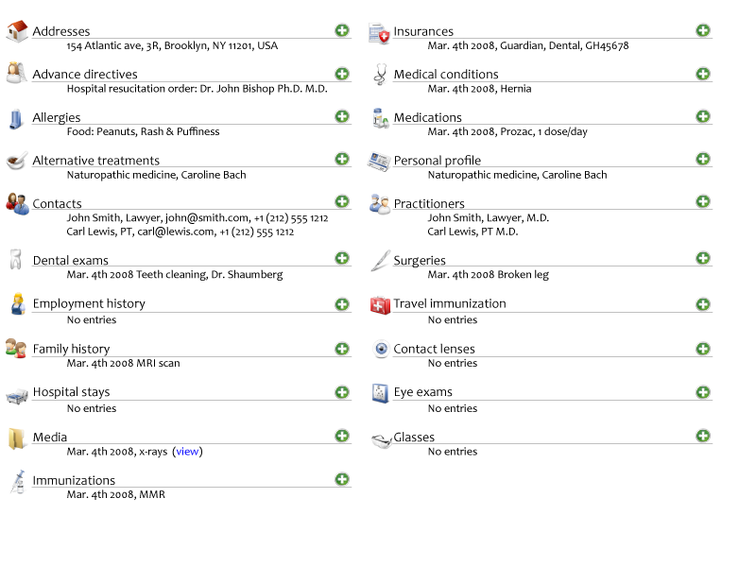

# Marketing Plan

## Market research

The last 5 years have shown a huge increase in awareness of the impact the merging of health care and the Internet will have on the world. The U.S. and the E.U. are pushing hard for unified systems of healthcare.

The main reason for this push is that neither the E.U. nor the U.S. can afford the rising costs of healthcare. The problem the industrialized countries are facing is the dramatic increase in the 50+ age group. The aging baby boomers are growing old and are putting a strain on the existing government health care services. EHealth is seen as the golden egg and the E.U. has already spent €500 million in research for the development of eHealth tools and systems since the early 1990s. They have allocated another €50 billion from 2007 to 2013. The U.S. is allotting $66 million, and rising, every year to ONCHIT (Office of the National Coordinator for Health Information Technology) via the CDC and HHS for research and development of eHealth solutions. They want every citizen to have an EHR by 2014. A specification was released by ONCHIT on May 17, 2006, with a roadmap with milestones as to how such a system should be implemented. They are lagging in efforts made by the E.U. but it’s a step in the right direction.

What everyone agrees on is “YES, we do need to push health care into the 21st century… but HOW?” E.U. member countries have agreed that legislation needs to be changed to help promote free flow of health care information across borders. The U.S. wrote HIPAA and the CCHIT specifications to help steer their vendors in the right direction.

EHealth IT expenditure in the U.S. was at $7.6 billion in 2006 and is expected to increase to $12 billion by 2011. E.U. expenditure represented €19 billion in 2006 and is expected to increase to €35 billion by 2013. That is equal to an 84% percent growth over less than 6 years.

Figure . Market size

William A. Yasnoff, MD, PhD, FACMI, HHS Sr. Advisor for health informatics policy, addressed in one of his keynote speeches that the U.S. could save 131 billion dollars by successfully implementing an eHealth care infrastructure with EHRs at its core. He also said that the U.S. government would not attempt to build a national eHealth application because of the high project failure rate. See under U.S. resources for a streaming presentation of W. Yasnoff.

The goals for implementing eHealth services on a country scale are ambitious and uncertain. Both the E.U. and the U.S. know it needs to be done but the U.S. is looking towards the municipalities to do it and the E.U. still has to overcome political hurdles such as allowing sensitive data to pass across borders. Since municipalities do not have the complete picture, the results are shortsighted and not in line with nationwide, and especially not global, expectations of interoperability. Politicians are trying to grasp what such standards would look like. The vision is too large for hospitals to implement. They lack the capital to see it through and already have an old infrastructure that will also cost millions to refactor or rewrite. The next few years will show a massive increase in eHealth spending but because of the inherent short-comings in how governments are approaching the problem, the ROI on those investments will be less than satisfactory.

Figure 8. Market segmentation

Globalhealth is two large baby steps in the right direction.

### Resources

We have included material compiled from U.S. and E.U. sources. They give the reader an idea of the business climate on two continents.

#### European Union

* [EU Information Portal](http://ec.europa.eu/information_society/activities/health/research/index_en.htm)
* [Accelerating the Development of the eHealth Market in Europe](http://ec.europa.eu/information_society/activities/health/docs/publications/lmi-report-final-2007dec.pdf" \t "_blank)
* [eHealth priorities and strategies in European countries](http://ec.europa.eu/information_society/activities/health/docs/policy/ehealth-era-full-report.pdf" \t "_blank)
* [eHealth](http://ec.europa.eu/information_society/activities/health/docs/unit/ict-for-health-1pager2007.pdf" \t "_blank) - Improving health while saving money
* [eHealth - making healthcare better for European citizens: An action plan for a European eHealth Area](http://www.hxcel.com/resources/COM_2004_0356_F_EN_ACTE.pdf)
* [Te@mwork 2007](http://www.hxcel.com/resources/teamwork_2007.pdf)
* [EHealth 2005](http://www.ehealth2005.org)
* [eHealth 2005 overview](http://www.hxcel.com/resources/ehealth_back.pdf)

#### United States

* [Five year growth expected for Federal IT budget](http://www.informationweek.com/news/management/showArticle.jhtml;jsessionid=H4WIPIEQLZOGOQSNDLPSKH0CJUNN2JVN?articleID=206800864&_requestid=644236)
* [Health IT spending to reach $12B by 2011](http://www.washingtontechnology.com/online/1_1/29047-1.html)
* [Gingrich calls for medical update](•%09http:/www.baltimoresun.com/news/health/bal-md.gingrich29apr29,0,7578180.story) (4-29-2008)
* [Gov. Tim Pawlenty: Health-care records lag technology](http://www.startribune.com/opinion/commentary/18189764.html) (4-27-2008)
* [Doctors don’t use email](http://news.yahoo.com/s/ap/20080423/ap_on_he_me/doctor_e_mail) (4-22-2008)
* [The Lehrer News Hour (3-24-2008)](http://www.pbs.org/newshour/bb/health/jan-june08/records_03-24.html) (3-24-2008)
* [The eHealth Landscape\_ A Terrain Map of Emerging Information](http://www.informatics-review.com/thoughts/rwjf.html)
* [EHealth: Market potential and business strategies](http://jcmc.indiana.edu/vol6/issue4/whitten.html)
* [ONCHIT proposed budget](http://www.govhealthit.com/online/news/350208-1.html)
* William A. Yasnoff Sep 2004 ([Real Player](http://realmedia.uic.edu/ramgen/depts/ahs/sbhis/HIM-DLS/yasnoff22sep2004.smil)) NHII – Dept of Health and Human Services

## Customers

### Patients

This system was built with the patient in mind. They are the ones who will benefit the most.

### Physicians

Second in line are the physicians. Globalhealth will make them more efficient, less prone to misdiagnoses, and give them access to more patient information than ever before.

#### Insurance companies

Insurance companies will be both a customer and a partner. Allowing patients to communicate directly with the insurance companies and have reimbursements and payments flow directly through Globalhealth will make it easier for the patient, the physician and the insurance providers. Giving insurance companies real-time access to their customers’ data will allow for quicker turn-around times, accurate assessments and more satisfied customers.

#### Health providers

Health providers, as well as insurance companies, are our enterprise customers. They are usually hospitals that comprise of a large number of physicians, administrative staff and nurses. Hospitals will require a large amount of support such as custom integration and data migration, but they will also become our biggest customers.

#### Non-profit health organizations

Institutions, such as the Red Cross, are a section of the industry that is mostly untouched. We want to empower these institutions with the same high technology we offer to our larger clients at the lowest price possible. We targeted this customer, not for their high profit potential, but for the goodwill and market acceptance we hope to gain. Giving these institutions our tools can also be world-changing as we bring 21st century health care to 3rd world nations.

### Countries

Integrating our services with countries is our main focus. Any country within our system can allow their health professionals to securely save sensitive client. Countries can choose the level of integration they are interested in. They can simply personalize our existing front-end application or create a new front-end from scratch.

Integrating with countries also makes it easier to determine client identity. Our application incorporates a “credentials ladder” where the customer moves up the ladder the more credentials she can provide. Managing user identity will be a great undertaking and having countries choose to integrate with us will solve some of those issues.

## Competition

First we have to make it clear that we have no competitors for the HIE market segment. No one has successfully created a platform such as this. Our competitors are within the applications segment.

We have competitors across several segments of the health care services industry. Below we have outlined 7 companies that fit into 2 different market segments; the B2B and the B2C markets. The institution-oriented competitors are companies that cater to hospitals and other large providers while patient oriented companies cater to the average user.

* ERIK! New HIE solutions
* <http://www.orionhealth.com/>
* <http://www.covisint.com/web/guest/home>
* <http://www.healthcareitnews.com/news/thomson-reuters-launches-new-hie-platform>
* http://www.bioportfolio.com/news/article/335580/Relayhealth-Expands-Saas-based-Hie-And-Phr-Platform-With-Certified-Ehr.html

### Institution oriented (B2B)

#### eClinicalWorks

[www.eclinicalworks.com](http://www.eclinicalworks.com)

eClinicalWorks offers an EHR solution and a Practice Management solution. Their EHR solution allows doctors to review complete patient histories, past visits, current medications, allergies, labs and diagnostic tests. Practice Management handles scheduling and billing.

eClinicalWorks was just awarded $8+ million in grant money, on top of an existing $19.2 million contract, from New York City and CDC (Center for Disease Control and Prevention) for an eHealth software solution to bring together 1000 providers on the same network to manage patient histories, lab results, current medications and patient reminders. Currently they have 200 providers signed up and 200,000 New Yorkers presently benefit from the system.[[4]](#footnote-4)

##### Competitive strengths

eClinicalWorks is gaining traction among hospitals. It was listed as one of the fastest growing companies in 2007 and is being used by more and more practices around the U.S. Revenue for 2007 exceeded $60 million. The word is out.

##### Competitive weaknesses

It’s a hospital-centric solution that doesn’t empower the patient. In order to save money on a large scale, it needs to be a client-centric one. Their software solution is not interoperable with other systems and it requires a local install.

#### Cerner

[www.cerner.com](http://www.cerner.com)

Cerner was recently featured on The Lehrer News Hour (3-24-2008)[[5]](#footnote-5) for having implemented an eHealth solution (Millennium) for Winona county general hospital. Physicians at Winona manage their patients’ information, lab reports and prescribe drugs using only the computer. According to the Lehrer report, this is currently the most advanced eHealth solution for a hospital in the U.S.

We have not been able to test the system ourselves.

##### Competitive strengths

Cerner is the leading U.S. supplier of healthcare information technology solutions with reported revenues of $1.38 billion in 2006 and 1500 clients. Their Millennium solution is the first large scale attempt at incorporating the patient as an active player. The patient can view their records securely online and request refills of prescription drugs.

##### Competitive weaknesses

Their solution is, as with eClinicalWorks, hospital-centric. The patient is still not in control but a minor player. The biggest obstacle for Cerner at this time is making the solution interoperable with other medical systems. Currently it only works for patients registered with the Winona county hospital.

#### MedSites

[www.med-sites.com](http://www.med-sites.com)

MedSites offers a desktop application, called ClinicGate, for physicians where they can create clients, schedule appointments, write invoices and track expenses. Their target market is small sized businesses. They also offer a smaller applications aimed at health spas and massage studios and they are working on a version for hospitals.

##### Competitive strengths

ClinicGate is a feature-rich desktop-based application with a web extension that allows physicians to easily do their appointment scheduling and expenses.

##### Competitive weaknesses

Their EHR support is weak and tracks only a small subset of the desired information available. The application is still buggy. We had it crash/fail on us several times during testing. Both the desktop application and the web extension are very slow and there is no security. Someone could easily get to their data which leaves the patients exposed. It is not interoperable with any other systems.

### Patient oriented (B2C)

#### WebMD

[www.webmd.com](http://www.webmd.com)

WebMD is, at heart, a health data aggregator. They provide symptoms and diagnoses to a plethora of common diseases as well as a wealth of other health related information. WebMD also offers a Health Manager application that allows users to save PHR records in a very limited form, a health tracker to track your body over time, a calendar where you can enter your medication schedule and other simple events, and gives parents the ability to keep a simple journal for their children.

Their revenue model seems to be ad-based.

##### Competitive strengths

WebMD offers a wealth of health related resources. Their users can read up on symptoms and treatments. They have a helpful “health A-Z dictionary” and there are several health trackers that can help the user with things like tracking calorie intake and blood pressure. WebMD manages 200+ million hits a month and is the leading source for health information on the web. We don’t intend to encroach on that market space to begin with.

##### Competitive weaknesses

Their PHR solution is the weakest of the ones reviewed, allowing the user to enter allergy, immunization and condition information only. They don’t give users the ability to share their records with their physicians and the system is completely proprietary. Their solution seems to be one based on promotional needs rather than usability. They cater to regular users and not to physicians and hospitals.

#### Revolution Health

[www.revolutionhealth.com](http://www.revolutionhealth.com)

Revolution Health is Steve Case’s last startup venture. RH has a variety of different health trackers and calculators. They offer information about medical conditions and suggest drugs to take. They also have a PHR section with an option to fax in information. As a user you can search for physicians, dentists and hospitals in your area, read user reviews about them and review them yourself. They also have a community side where all users have their own blog and there are professional blogs written by health experts.

Their revenue model seems to be ad-based.

##### Competitive strengths

Revolution Health offers a very nice PHR solution and the ability to enter 12 different kinds of information. The user can then choose to select some of their records and have it printed in a PDF document to bring to their physician. Every user has a blog and there are professional blogs from experts as well, which is a nice community feature they bought from CarePages. There is a “yellow pages” for finding physicians and hospitals. Users can compare health insurances through a partnership with extendhealth.com. RH also has the same kind of health related resources as WebMD.

##### Competitive weaknesses

Their number one weakness is not being enterprise. This is another proprietary platform, albeit with a nice interface, but with nowhere to go. As with WebMD, their focus is on the regular user and not on EHRs or hospital-wide deployment. They have a rating system for listed physicians but there are no rules for who can rate a physician which can lead to rampant abuse.

#### Microsoft HealthVault

[www.healthvault.com](http://www.healthvault.com)

HealthVault is Microsoft’s foray into the eHealth space. They don’t have their own service but partner up with other health related web sites and extract data from these web sites. Some of these services charge a subscription fee while others are free.

##### Partners

* American Heart Association ([www.americanheart.org](http://www.americanheart.org))
* CapMed ([www.capmed.com](http://www.capmed.com))
* HealthMedia ([www.myselfhelp.com](http://www.myselfhelp.com))
* HealthyCircles ([www.healthycircles.com](http://www.healthycircles.com))
* Kryptiq ([www.kryptiq.com](http://www.kryptiq.com))
* Limeade ([www.limeade.com](http://www.limeade.com))
* Peaksware ([www.peaksware.com](http://www.peaksware.com))
* PodFitness ([www.podfitness.com](http://www.podfitness.com))
* PureWellness ([www.purewellness.com](http://www.purewellness.com))
* Sound Health Solutions ([www.4shs.com](http://www.4shs.com))
* US Wellness ([www.uswellness.com](http://www.uswellness.com))

##### Competitive strengths

They have a very adequate marketing machine behind them.

##### Competitive weaknesses

It’s the least user friendly web site by our competitors. You have to leave the HealthVault every time you want to enter in information at a partner site. Their PHR solution, which resides with their partner CapMed, is a subscription site you have to pay for. The other partners offer up more or less the same health trackers and information as WebMD and Revolution Health. It’s an underwhelming experience, even for the B2C market they are in. Kryptiq seemed to be the only interesting partner; offering a way to securely share PHR records with your physician. However, it is site that allow you to only send secure email attachments via webmail and not very interesting.

#### Google Health

<http://health.google.com>

Still in the works, GH screenshots indicate that they will be offering a simple PHR solution for their users.

### Competitive matrix

## Strategy

We have divided our strategy into a few strategic milestones based on what functionality we want to build first and profitability.

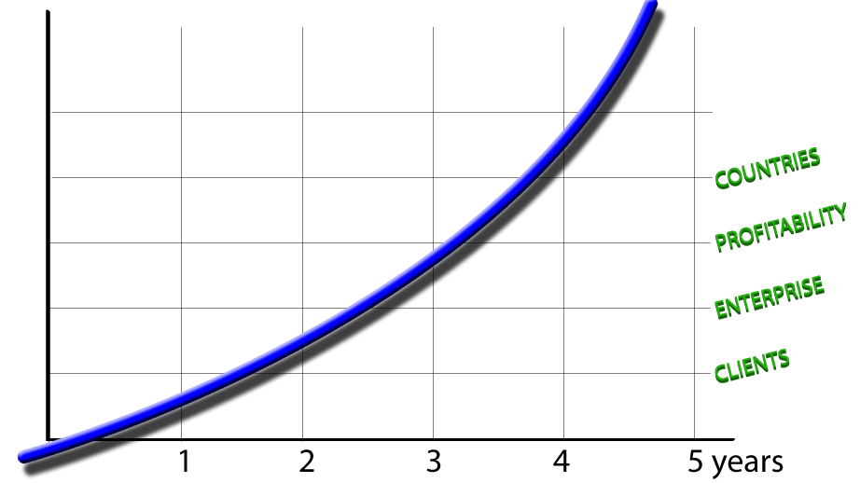

### Milestone 1: Traction, Stickiness

Globalhealth v1.0 launches. At this point our target audiences are 2nd tier health professionals (physical therapists, chiropractors), their patients and regular users who want to have an online PHR. All patient-physician features will be complete such as relationship management, scheduling, EHR, PHR, etc.

We want to spend this year promoting our platform to application vendors and just be as viral as possible without spending large sums of marketing money on a an audience that is targeted and known but that needs to be educated and catered to slowly.

We will promote the web site in trade magazines, through medical associations and medical journals that cater to our users. We want our first audience to be computer savvy without large elaborate antiquated systems or boxes of old paper-based records lying around. We want to target those who can immediately see our application as a solution to a problem and not as a tertiary nuisance. Physicians at hospitals are usually bogged down with old systems and paper based record keeping and will not want to embrace something new as quickly as our desired target audience.

Medical associations can also help us establish our integrity. With their “stamp of approval” their members will feel safe and as we accumulate these stamps of approval, a foundation will be made that we are a company that can be trusted. This is really a key point. Our marketing efforts go hand-in-hand with our goal of market acceptance.

As the network grows and starts to develop traction and user awareness, we will have become confident in the performance of the application on a wide array of users and locales.

*Expected duration: 1 – 2 years*

### Milestone 2: Enterprise integration

Globalhealth v2.0 will focus on satisfying the needs of our large customers, such as hospitals and insurance companies. We can leverage what we have already built and wrap it in the context of the institution. This would enable features such as automatic reimbursement from insurance companies and interoperable hospitals that can easily share data on a global scale. The impact will be huge on the populace and it won’t cost us much in contrast because our system has been set up from the get-go to expect constant new features such as these from a variety of different sources.

*Expected duration: 1 – 2 years*

### Milestone 3: Country integration

Globalhealth v3.0 will be the pinnacle of our long-term strategy for placing ourselves as the leader in the global health care industry market and at the forefront of health IT. We see the integration with countries will be more political than technical, but ultimately the “Holy Grail” for health care informatics. There will be privacy concerns and we will have to be ready to conform to different market expectations and regulations. Our system will have already proved itself to be secure and robust at this point and we can easily customize our application based on a per country specification.

*Expected duration: 1 – 2 years*

### Proposed Location

Our headquarters will be in New York City.

### Promotional Budget

How much will you spend on the items listed above?

Before startup? (These numbers will go into your startup budget.)

Ongoing? (These numbers will go into your operating plan budget.)

### Pricing

Our two main pricing strategies are licensing out seats on a monthly or upfront cost basis. Support contracts are included in the monthly but not the upfront price. The demand for custom widget creation is another revenue channel and something our professional consulting branch will manage. Consulting will usually be done on a Time & Materials (T&M) basis.

#### Licensing model

Insert data here

#### Professional consulting model

Insert data here

## Sales Forecast

Now that you have described your products, services, customers, markets, and marketing plans in detail, it’s time to attach some numbers to your plan. Use a sales forecast spreadsheet to prepare a month-by-month projection. The forecast should be based on your historical sales, the marketing strategies that you have just described, your market research, and industry data, if available.

You may want to do two forecasts: 1) a "best guess", which is what you really expect, and 2) a "worst case" low estimate that you are confident you can reach no matter what happens.

Remember to keep notes on your research and your assumptions as you build this sales forecast and all subsequent spreadsheets in the plan. This is critical if you are going to present it to funding sources.

# Operational Plan

Explain the daily operation of the business, its location, equipment, people, processes, and surrounding environment.

## Production

How and where are your products or services produced?

Explain your methods of:

• Production techniques and costs

• Quality control

• Customer service

• Inventory control

• Product development

## Location

What qualities do you need in a location? Describe the type of location you’ll have.

Physical requirements:

• Amount of space

• Type of building

• Zoning

• Power and other utilities

Access:

Is it important that your location be convenient to transportation or to suppliers?

Do you need easy walk-in access?

What are your requirements for parking and proximity to freeway, airports, railroads, and shipping centers?

Include a drawing or layout of your proposed facility if it is important, as it might be for a manufacturer.

Construction? Most new companies should not sink capital into construction, but if you are planning to build, costs and specifications will be a big part of your plan.

Cost: Estimate your occupation expenses, including rent, but also including maintenance, utilities, insurance, and initial remodeling costs to make the space suit your needs. These numbers will become part of your financial plan.

What will be your business hours?

## Legal Environment

Describe the following:

• Licensing and bonding requirements

• Permits

• Health, workplace, or environmental regulations

• Special regulations covering your industry or profession

• Zoning or building code requirements

• Insurance coverage

• Trademarks, copyrights, or patents (pending, existing, or purchased)

## Personnel

• Number of employees

• Type of labor (skilled, unskilled, and professional)

• Where and how will you find the right employees?

• Quality of existing staff

• Pay structure

• Training methods and requirements

• Who does which tasks?

• Do you have schedules and written procedures prepared?

• Have you drafted job descriptions for employees? If not, take time to write some. They really help internal communications with employees.

• For certain functions, will you use contract workers in addition to employees?

Inventory

• What kind of inventory will you keep: raw materials, supplies, finished goods?

• Average value in stock (i.e., what is your inventory investment)?

• Rate of turnover and how this compares to the industry averages?

• Seasonal buildups?

• Lead-time for ordering?

## Suppliers

Identify key suppliers:

• Names and addresses

• Type and amount of inventory furnished

• Credit and delivery policies

• History and reliability

Should you have more than one supplier for critical items (as a backup)?

Do you expect shortages or short-term delivery problems?

Are supply costs steady or fluctuating? If fluctuating, how would you deal with changing costs?

# Management

## Professional and Advisory Support

List the following:

• Board of directors

• Management advisory board

• Attorney

• Accountant

• Insurance agent

• Banker

• Consultant or consultants

• Mentors and key advisors

# Financial Plan

The financial plan consists of a 12-month profit and loss projection, a four-year profit and loss projection (optional), a cash-flow projection, a projected balance sheet, and a break-even calculation. Together they constitute a reasonable estimate of your company's financial future. More important, the process of thinking through the financial plan will improve your insight into the inner financial workings of your company.

## 12-Month Profit and Loss Projection

Many business owners think of the 12-month profit and loss projection as the centerpiece of their plan. This is where you put it all together in numbers and get an idea of what it will take to make a profit and be successful.

Your sales projections will come from a sales forecast in which you forecast sales, cost of goods sold, expenses, and profit month-by-month for one year.

Profit projections should be accompanied by a narrative explaining the major assumptions used to estimate company income and expenses.

Research Notes: Keep careful notes on your research and assumptions, so that you can explain them later if necessary, and also so that you can go back to your sources when it’s time to revise your plan.

## Four-Year Profit Projection (Optional)

The 12-month projection is the heart of your financial plan. This section is for those who want to carry their forecasts beyond the first year.

Of course, keep notes of your key assumptions, especially about things that you expect will change dramatically after the first year.

## Projected Cash Flow

If the profit projection is the heart of your business plan, cash flow is the blood. Businesses fail because they cannot pay their bills. Every part of your business plan is important, but none of it means a thing if you run out of cash.

The point of this worksheet is to plan how much you need before startup, for preliminary expenses, operating expenses, and reserves. You should keep updating it and using it afterward. It will enable you to foresee shortages in time to do something about them—perhaps cut expenses, or perhaps negotiate a loan. But foremost, you shouldn’t be taken by surprise.

There is no great trick to preparing it: The cash-flow projection is just a forward look at your checking account.

For each item, determine when you actually expect to receive cash (for sales) or when you will actually have to write a check (for expense items).

You should track essential operating data, which is not necessarily part of cash flow but allows you to track items that have a heavy impact on cash flow, such as sales and inventory purchases.

You should also track cash outlays prior to opening in a pre-startup column. You should have already researched those for your startup expenses plan.

Your cash flow will show you whether your working capital is adequate. Clearly, if your projected cash balance ever goes negative, you will need more start-up capital. This plan will also predict just when and how much you will need to borrow.

Explain your major assumptions, especially those that make the cash flow differ from the Profit and Loss Projection. For example, if you make a sale in month one, when do you actually collect the cash? When you buy inventory or materials, do you pay in advance, upon delivery, or much later? How will this affect cash flow?

Are some expenses payable in advance? When?

Are there irregular expenses, such as quarterly tax payments, maintenance and repairs, or seasonal inventory buildup, that should be budgeted?

Loan payments, equipment purchases, and owner's draws usually do not show on profit and loss statements but definitely do take cash out. Be sure to include them.

And of course, depreciation does not appear in the cash flow at all because you never write a check for it.

## Opening Day Balance Sheet

A balance sheet is one of the fundamental financial reports that any business needs for reporting and financial management. A balance sheet shows what items of value are held by the company (assets), and what its debts are (liabilities). When liabilities are subtracted from assets, the remainder is owners’ equity.

Use a startup expenses and capitalization spreadsheet as a guide to preparing a balance sheet as of opening day. Then detail how you calculated the account balances on your opening day balance sheet.

Optional: Some people want to add a projected balance sheet showing the estimated financial position of the company at the end of the first year. This is especially useful when selling your proposal to investors.

## Break-Even Analysis

A break-even analysis predicts the sales volume, at a given price, required to recover total costs. In other words, it’s the sales level that is the dividing line between operating at a loss and operating at a profit.

Expressed as a formula, break-even is:

Breakeven Sales = Fixed Costs

1- Variable Costs

(Where fixed costs are expressed in dollars, but variable costs are expressed as a percent of total sales.)

Include all assumptions upon which your break-even calculation is based.

# Appendices

## Technology

### Standards

Our custom software framework was made from the ground up using open-source technologies and is completely internationalized and ready for a global audience. We use the latest versions of globally accepted health standards such as ICD-10, ICPC-2, SNOMED, DSM-IV, HL7, DICOM and LOINC, to help our health professionals give fast and correct diagnoses to their clients that can be shared without misinterpretation.

### Security & Reliability

Our system was designed from the ground up with security in mind. All our data is encrypted using an AES 256-bit encryption algorithm and our system uses several layers of security checks, such as WS-Security, SSL, to facilitate the sharing of data between two users. Our system complies with NATO level 4 security standards marked RESTRICTED, which is the highest legal security level for non-military use. We are HIPAA compliant in the United States and we have received seals of approval from CCHIT, URAC, Trust-e and HON (Health On the Net)

CCHIT.gifhon.giftruste_seal_web.gif

A system such as this requires a 99.99% responsive uptime globally. Our application and databases are cached and clustered on an Internet backbone trunk to obtain the highest speed and dependability for our customers 24/7. Our application is self-healing and will always direct the user to the fastest, most available server.

# Refining the Plan

The generic business plan presented above should be modified to suit your specific type of business and the audience for which the plan is written.

## For Raising Capital

### For Investors

• Investors have a different perspective. They are looking for dramatic growth, and they expect to share in the rewards:

o Funds needed short-term

o Funds needed in two to five years

o How the company will use the funds, and what this will accomplish for growth.

o Estimated return on investment

o Exit strategy for investors (buyback, sale, or IPO)

o Percent of ownership that you will give up to investors

o Milestones or conditions that you will accept

o Financial reporting to be provided

o Involvement of investors on the board or in management

### For Type of Business

#### High Technology Companies

• Economic outlook for the industry

• Will the company have information systems in place to manage rapidly changing prices, costs, and markets?

• Will you be on the cutting edge with your products and services?

• What is the status of research and development? And what is required to:

o Bring product/service to market?

o Keep the company competitive?

• How does the company:

o Protect intellectual property?

o Avoid technological obsolescence?

o Supply necessary capital?

o Retain key personnel?

High-tech companies sometimes have to operate for a long time without profits and sometimes even without sales. If this fits your situation, a banker probably will not want to lend to you. Venture capitalists may invest, but your story must be very good. You must do longer-term financial forecasts to show when profit take-off is expected to occur. And your assumptions must be well documented and well argued.

1. http://en.wikipedia.org/wiki/Platform\_as\_a\_service [↑](#footnote-ref-1)
2. http://en.wikipedia.org/wiki/Software\_as\_a\_service [↑](#footnote-ref-2)
3. http://en.wikipedia.org/wiki/Interoperability [↑](#footnote-ref-3)
4. [Information Week, Feb 26th, 2008](http://www.hxcel.com/resource/eclinicalworks.pdf) [↑](#footnote-ref-4)
5. [The Lehrer News Hour (3-24-2008)](http://www.pbs.org/newshour/bb/health/jan-june08/records_03-24.html) [↑](#footnote-ref-5)