

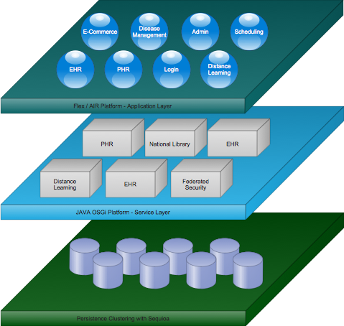

Each content delivery and service platform (HIE) contains a set of clustered databases that synchronizes data across all our HIEs seamlessly through a clustered database driver solution called Sequioa. This clustering is transparent to our service layer. The driver takes care of persisting data across co-located databases. Services, such as an EHR or PHR are deployed on top of our OSGi service platform. These services can be swapped and versioned at runtime, which is critical for a system that needs a guaranteed update of 99.99%. Every service leverages the latest standards that pertain to it, which enables it to interoperate with external services that speak the same standard. Data interoperability is handled through an Enterprise Service Bus that supports multiple data transfer protocols.

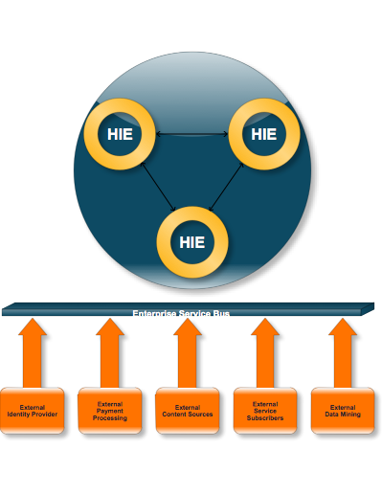

Health Information Exchanges keep common data in sync through clustered databases, data querying, and cron jobs. Services deployed on the HIE platform that rely on external services can easily “dial out”. Identity management is a great candidate for externalization. The HIE should be concerned with its services and not with whether the user is who he says he is, especially in a nationwide system such as this. Its corresponding HIE service will be utilized by nearly every other service deployed on the platform.