
Water
Drink lots of water, it keeps your body going!
Water is important because it helps your body:
- Fight sickness
- Digest food
- Cool down

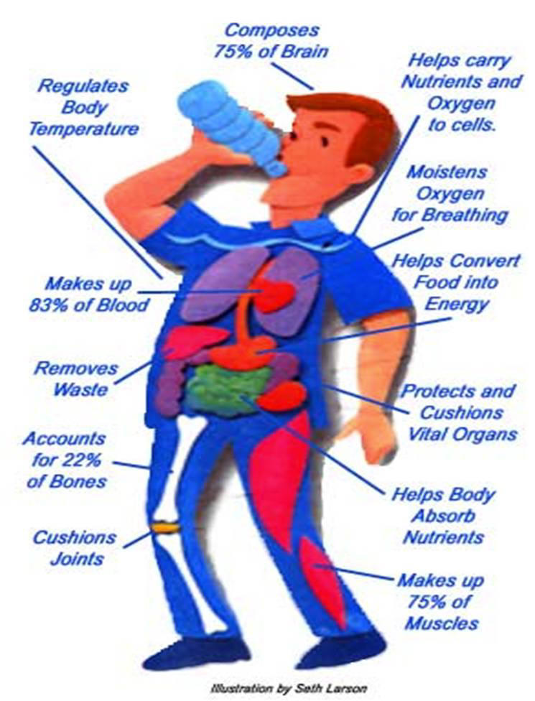
Do you know how much water you should be drinking every day?
5-8 years old = 5 cups
9-13 years old = 7-8 cups

Vitamin C
Aids in healing when you get a cut and helps your body resist infections.

Eat the following foods to get the Vitamin C your body needs to stay healthy:
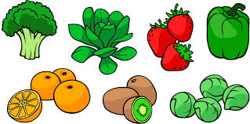

Sleep
Sleep keeps your brain sharp! Sleep is a mini-vacation for your body and brain.
When you sleep:
- Your brain stores information (memory)
- Your body grows
- Your brain and body are energized
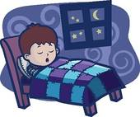
Do you know how many hours of sleep your body needs each night?
5-12 years old =10 hours
Teens =8.5 to 9 hours

Water
Without water, your body would stop working properly. Water makes up more than half of your body weight and a person can't survive for more than a few days without it. Why? Your body has lots of important jobs and it needs water to do many of them. For instance, your blood, which contains a lot of water, carries oxygen to all the cells of your body. Without oxygen, those tiny cells would die and your body would stop working.
Water is also in lymph (say: limf), a fluid that is part of your immune system, which helps you fight off illness. You need water to digest your food and get rid of waste, too. Water is needed for digestive juices, urine (pee), and poop. And you can bet that water is the main ingredient in perspiration, also called sweat.
In addition to being an important part of the fluids in your body, each cell depends on water to function normally.
When your body doesn't have enough water, that's called being dehydrated. Dehydration also can keep you from being as fast and as sharp as you'd like to be. A bad case of dehydration can make you sick. So keep that water bottle handy when the weather warms up! Not only does water fight dehydration, but it's awfully refreshing and has no calories.
Your body can help you stay properly hydrated by regulating the amount of water in your system. The body can hold on to water when you don't have enough or get rid of it if you have too much. If your pee has ever been very light yellow, your body might have been getting rid of excess water. When your pee is very dark yellow, it's holding on to water, so it's probably time to drink up.

Vitamins
Your body is one powerful machine, capable of doing all sorts of things by itself. But when it comes to vitamins, it can use some help. That's where food comes in. Your body is able to get the vitamins it needs from the foods you eat because different foods contain different vitamins. The key is to eat different foods to get an assortment of vitamins. Though some kids take a daily vitamin, most kids don't need one if they're eating a variety of healthy foods.
Vitamin C
This vitamin is important for keeping body tissues, such as gums and muscles in good shape. C is also key if you get a cut or wound because it helps you heal.
This vitamin also helps your body resist infection. This means that even though you can't always avoid getting sick, vitamin C makes it a little harder for your body to become infected with an illness.
Which foods are rich in vitamin C?
- citrus fruits, like oranges
- cantaloupe
- strawberries
- tomatoes
- broccoli
- cabbage
- kiwi fruit
- sweet red peppers

Sleep
Just like eating, sleep is necessary for survival.
Sleep gives your body a rest and allows it to prepare for the next day. It's like giving your body a mini-vacation. Sleep also gives your brain a chance to sort things out. Scientists aren't exactly sure what kinds of organizing your brain does while you sleep, but they think that sleep might be the time when the brain sorts and stores information, replaces chemicals, and solves problems.

Skipping 1 night's sleep makes a person cranky and clumsy. After missing 2 nights of sleep, a person will have problems thinking and doing things; his or her brain and body can't do their normal tasks nearly as well. After 5 nights without sleep, a person will hallucinate (this means seeing things that aren't actually there). Eventually, it becomes impossible for the brain to give its directions to the rest of the body without sleep — the brain needs to spend time in bed and catch its ZZZs!

Babies need 14-15 hours of sleep a day
5-12 years need 10-11 hours a night
Teens need 8.5-9.25 hours a night
Adults need 7-8 hours a night

