**Abdominals**

Say: ab-**da**-mun-uls

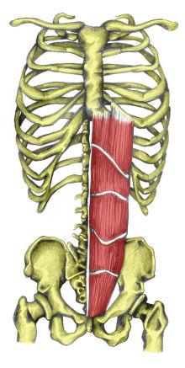

Sometimes called abs, these are the [muscles](http://kidshealth.org/kid/body/muscles_noSW.html) in front of your abdomen, the area below your chest and above your belly button.