**Dehydration**

Say: dee-hy-**dray**-shun

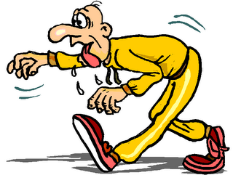

Don't sweat this long word!

It describes what happens when there's not enough water

in your body.

Be sure to [drink a lot of water](http://kidshealth.org/kid/stay_healthy/food/water.html) to stay happily hydrated.