**Germs and Hand Washing**

There is a group of tiny invaders that can make our bodies sick — they're called **GERMS**.

Washing your hand is the best way to stop germs from spreading.

This week I would like to challenge you to wash your hands with warm water (not hot or cold) and soap. While washing your hands I would like you to sing the “happy birthday” song to yourself. The length of this song lets you know you have washed your hands long enough to wash the germs away.

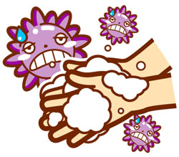

**Germs and Hand Washing**

There is a group of tiny invaders that can make our bodies sick — they're called **GERMS**.

Washing your hand is the best way to stop germs from spreading.

This week I would like to challenge you to wash your hands with warm water (not hot or cold) and soap. While washing your hands I would like you to sing the “happy birthday” song to yourself. The length of this song lets you know you have washed your hands long enough to wash the germs away.

