**Joints**

Say: **joynts**

Joints are the places in your body where [bones](http://kidshealth.org/kid/body/bones_noSW.html) meet or connect. You have big joints - like the ones in your hips, shoulders, and legs; and itty, bitty ones - like the ones in your hands and feet.

Some joints move and other joints don’t… An example of joints that don’t move are the joints in your skull. The joints that do move are your shoulder joint, knee joint or ankle joint. Let’s try to move them now!

Keeping your joints healthy will allow you to run, walk, jump, play sports, and do the other things you like to do. Physical activity, a balanced diet, avoiding injuries, and getting plenty of sleep will help you stay healthy and keep your 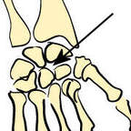joints healthy too.