**Pulse** 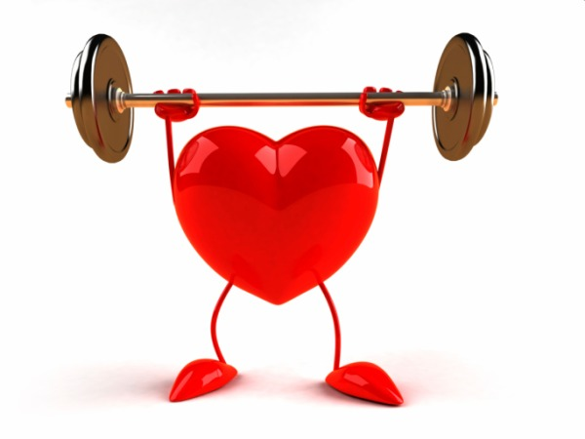

Your beating heart creates a pulse. Your [heart](http://kidshealth.org/kid/body/heart_noSW.html) has to push so much blood through your body that you can feel a little thump in your arteries each time the heart beats! Wow! The most common places to feel a pulse is on your wrist and your neck. So try to find your pulse and feel the beat!



Your beating heart creates a pulse. Your [heart](http://kidshealth.org/kid/body/heart_noSW.html) has to push so much blood through your body that you can feel a little thump in your arteries each time the heart beats! Wow! The most common places to feel a pulse is on your wrist and your neck. So try to find your pulse and feel the beat!