**The Three Elements of Fitness**

**Strength, Endurance, Flexibility**

Cardiovascular endurance is developed when we regularly do an aerobic activity. The heart beats faster and a person breathes harder! The more you do… the more you can do!



Try one of these fun activities!

Basketball, Biking, Dancing, Soccer, Swimming

**The Three Elements of Fitness**

**Strength, Endurance, Flexibility**



Strength is being able to do something without fear of being injured!

**The Three Elements of Fitness**

**Strength, Endurance, Flexibility**

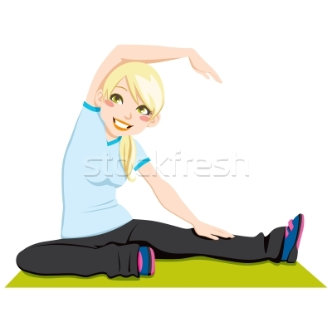

Stretching will improve your flexibility!