**Vertebrae**

Say: **ver**-tuh-bray

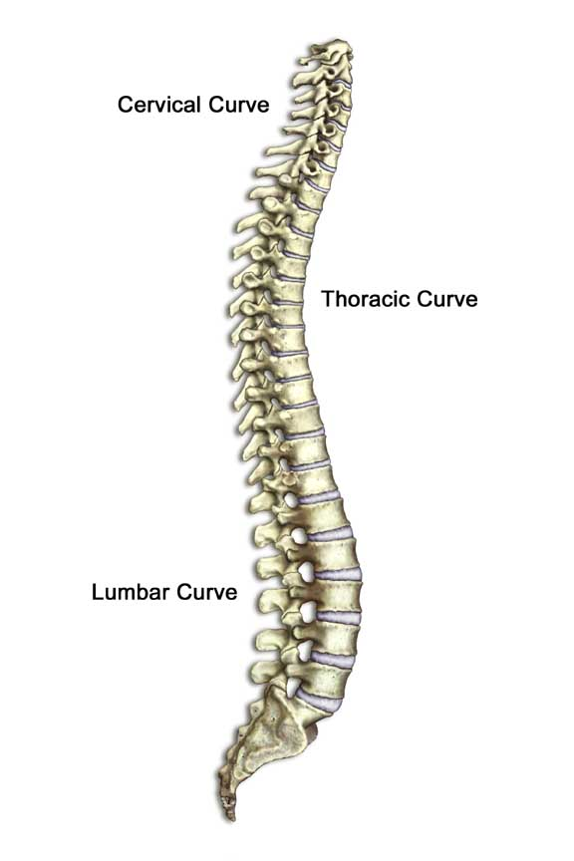

Reach around and feel those bumps in the center of your back. Each bump is a [bone](http://kidshealth.org/kid/body/bones_noSW.html) called a vertebra and there are 33 vertebrae that make up your spine. Without your vertebrae, you couldn't stand tall!