Serial protocol to send building information to Arduino

Byte # | Type | Description | Value or Example
0 | uint8_t | First byte of the envlope start | 0xA5
1 | uint8_t | Second byte of the envlope start | 0x5A
2 | uint8_t | Number of building packets | 0-255
3 | uint8_t | ~Number of buildings | 0-255
4 | BuildingStatusRecord_t | Status of building N | See below (current length is 28 bytes)
Last | uint8_t | CRC | XOR of all bytes starting with byte 2.  Initial value 0x10101010
typedef struct {
uint32_t id;
UtilityStatusRecord_t grid;
UtilityStatusRecord_t solar;
UtilityStatusRecord_t battery;
UtilityStatusRecord_t generator;
} BuildingStatusRecord_t;

typedef struct {
uint8_t id;
uint8_t status; // combination of UtilityStatus_t 's
uint8_t capacity; // 0-100%
uint16_t output; // kWh
} UtilityStatusRecord_t;

Total payload for 16 buildings is 453 bytes.

Both esp32 and Arduino are little-endian

Serial Comms btw esp32 and Arduino:
1. Using level shifter

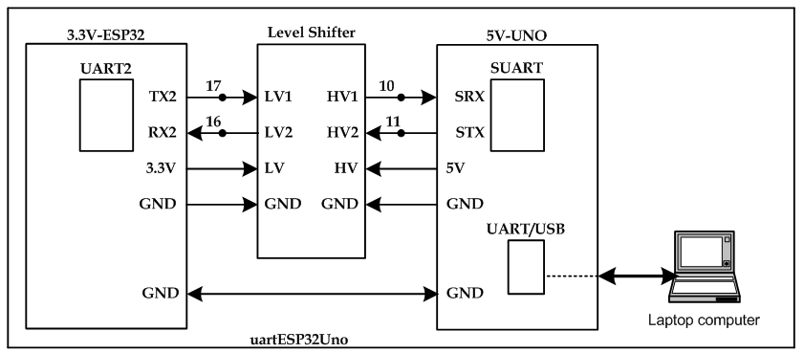
2. Using voltage divider
