BPOS Setup – v1.0

Step – 1 : download and install git on your system.
https://git-scm.com/downloads

Step – 2: Open your workspace path , and right click and 'Git Bash Here'. Or open git directly and reach to following path by cd command
C:\wamp64\www

Step – 3: git clone https://github.com/bjt-00/-bps-.git
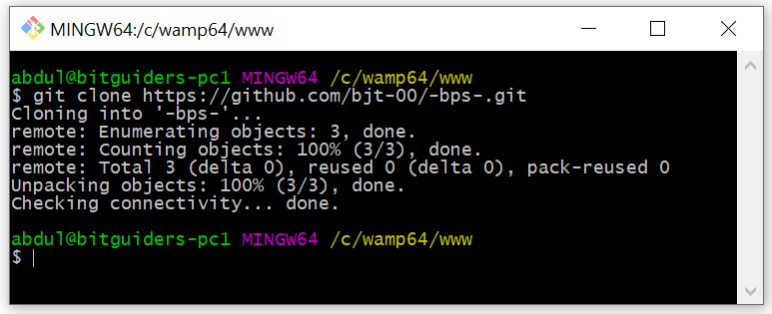

Step – 4: cd .. and then cd www/-bps-/
