Fundamentals of Materials Science

Homework 21, SS 2017

Name: Du Yihui Date: 05/12/2017 Student #: 15090211
This homework assignment continues with a practice on homogenous nucleation for its thermodynamic and structural conditions. The derivation of the critical radius and activation energy for nucleation is very important with the assumption of a spherical solid as the starting nucleation piece. It is also desirable that you understand the concepts of critical undercooling and its relationship with the nuclei radius. The problem statements seem to be longer than usual, but it is a context for which each problem is posed.

- Do it again and again for it is very important. Below Tm, Gv is positive so that the free energy change associated with the formation of a small volume of solid has a negative contribution due to the lower free energy of a bulk solid, but there is also a positive contribution due to the creation of a solid/liquid interface. The excess free energy associated with the solid particle can be minimized by the correct choice of particle shape. If γSL is isotropic this is a sphere of radius r. Then we can arrive at the equation discussed in class like
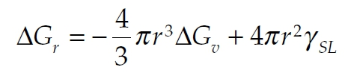

! (Eq. 1) Show that differentiation of Equation 1 leads to Equations 2 and 3 below.
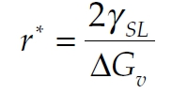
! (Eq. 2)
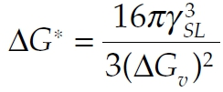

" (Eq. 3)

Solution

When the differentiation of Equation 1 is equal to 0, we can get r*,
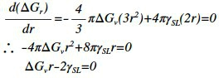

Thus,
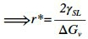
Substitute r* into Equation 1, we can get △G*,
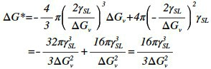
- To understand how it is possible for a stable solid nucleus to form homogeneously from the liquid it is first necessary to examine the atomic structure of the liquid phase. From dilatometric measurements it is known that at the melting point the liquid phase has a volume 2–4% greater than the solid. Therefore, there is a great deal more freedom of movement of atoms in the liquid and when averaged over a period of time the atom positions appear completely random. However, an instantaneous picture of the liquid would reveal the presence of many small close-packed clusters of atoms which are temporarily in the same crystalline array as in the solid, as shown in Fig. 1 below. On average the number of spherical clusters of radius r is given by
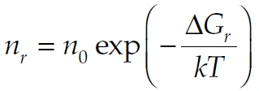

" (Eq. 4)

where n0 is the total number of atoms in the system, Gr is the excess free energy associated with

the cluster, Equation 1, and k is Boltzmann’s constant. For a liquid above Tm this relationship applies for all values of r. Below Tm it only applies for r ≤ r* because clusters greater than the critical size are stable nuclei of solid and no longer part of the liquid. Since nr decreases exponentially with Gr (which itself increases rapidly with r) the probability of finding a given cluster decreases very rapidly as the cluster size increases. For example, by combining Equations 1 and 4 it can be shown that 1 mm³ of copper at its melting point (∼10²⁰ atoms) should on average contain ∼10¹⁴ clusters of 0.3 nm radius (i.e. ∼10 atoms) but only ∼10 clusters with a radius of 0.6 nm (i.e. ∼60 atoms). These numbers are of course only approximate. Such small clusters of atoms cannot be considered to be spherical, and even more important the effective value ofγused in calculating Gr (equation 1) is very probably a function of the cluster size. However, the above calculations do illustrate how sensitively cluster density depends on their size.
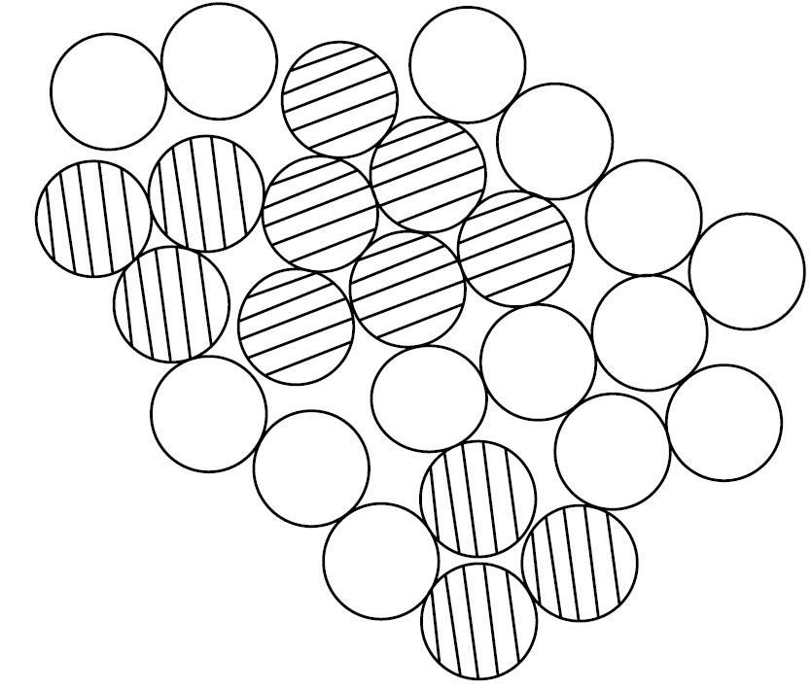

!

Figure 1 A two-dimensional representation of an instantaneous picture of the liquid structure. Many close-packed crystal-like clusters (shaded) are present.

Use Equations 1 and 4 to estimate the number of crystal-like clusters in 1 mm³ of copper at its melting point for spherical clusters containing (a) 10 atoms, (b) 60 atoms. What volume of liquid copper is likely to contain one cluster of 100 atoms? The atomic volume of liquid copper is 1.6X10⁻²⁹ m³, γSL is 0.177 J m⁻², k = 1.38X10⁻²³ J K⁻¹, Tm = 1356 K.
Solution

Since it is at melting point for spherical clusters, △Gv is equal to 0, thus,
r can be calculated by
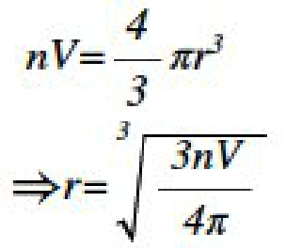
Thus, △Gv is equal to,
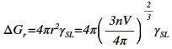

(a)When n is equal to 10,
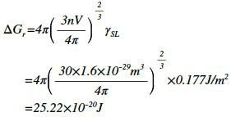

Thus, according to the Equation 4, the number of clusters per mm³ is equal to,
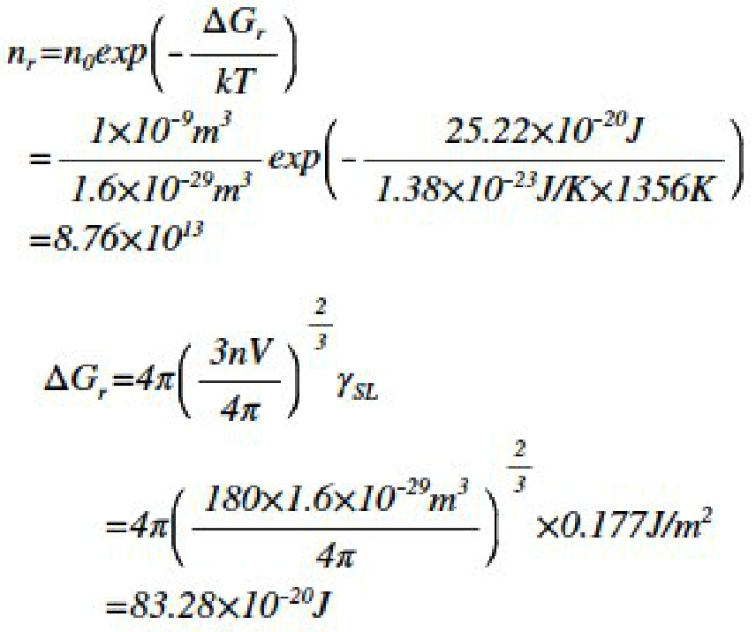

(b)When n is equal to 60,

Thus, according to the Equation 4, the number of clusters per mm³ is equal to,
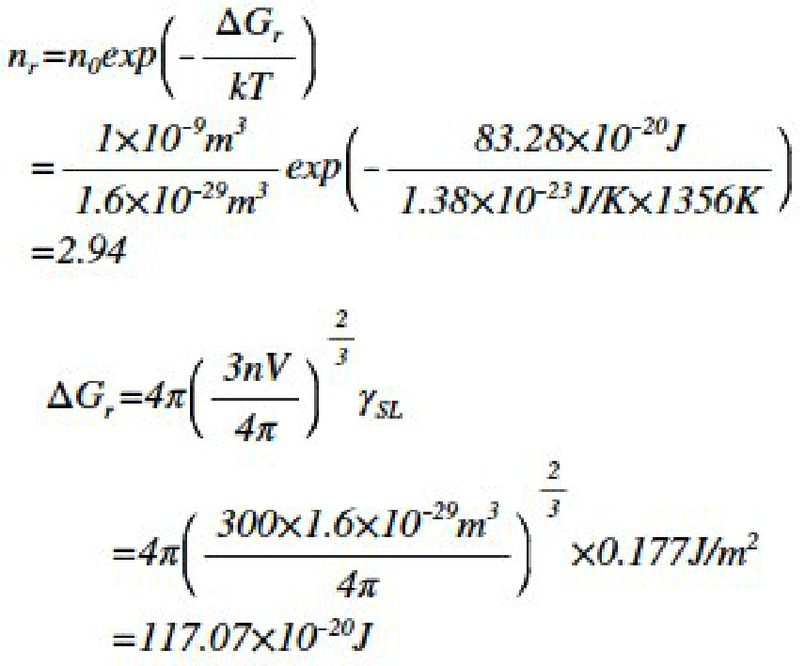

(c)When n is equal to 100,

Thus, according to the Equation 4, the number of clusters per mm³ is equal to,
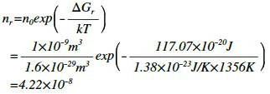

The volume of liquid copper contain one cluster of 100 atoms is,
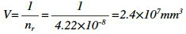

- Continued from Problem 2, it can be seen that there is effectively a maximum cluster size, ∼100

atoms, which has a reasonable probability of occurring in the liquid. The same sort of calculations can be made at temperatures other than Tm. Below Tm there is an increasing contribution from

Gv in Equation 1 as the solid becomes progressively more stable and this has the effect of increasing the ‘maximum’ cluster size somewhat. Figure 2 shows schematically how rmax varies with T. Of course larger clusters than rmax are possible in large enough systems or given sufficient time, but the probability of finding clusters only slightly larger than rmax is extremely small. The critical nucleus size r* is also shown in Fig. 2. It can be seen that at small undercoolings, r* is so large that there will be virtually no chance of forming a stable nucleus. But as T increases r* and G* decrease, and for supercoolings of TN or greater there is a very good chance of some clusters reaching r* and growing into stable solid particles. In the small droplet experiment, therefore, homogeneous nucleation should occur when the liquid is undercooled by ∼ TN. The question to this problem is thus: Why does rmax in Fig. 2 vary with

T?
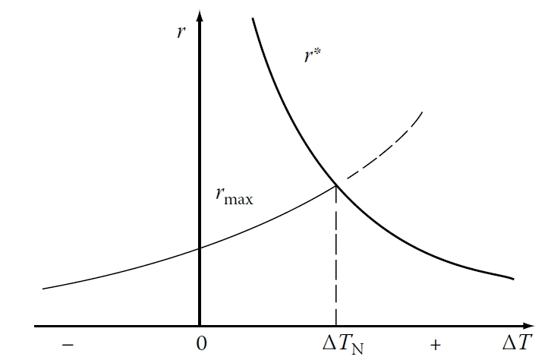

!

Figure 2 The variation of r* and rmax with undercooling T.

(?) Solution

rmax is considered as the biggest radius particle that can exist at the given temperature, the figure shows when the r* curve is beyond the critical undercooling, the critical radii of nuclei becomes smaller than the clusters that would form because of the thermal fluctuations. Thus, the probability of these clusters turning into nuclei are large.
- Calculate the homogeneous nucleation rate in liquid copper at undercoolings of 180, 200 and 220 K, using the following data:
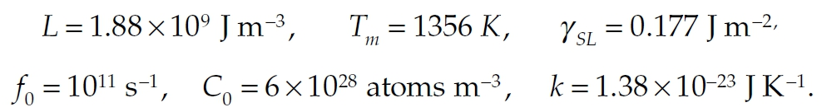

!

Solution
The homogeneous nucleation rate N can be calculated by
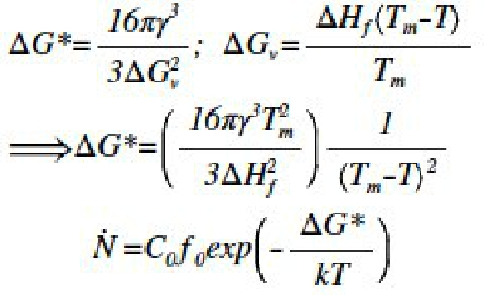

(a) When the homogeneous nucleation rate in liquid copper at undercoolings of 180K,
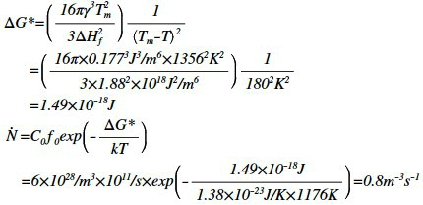

(b) When the homogeneous nucleation rate in liquid copper at undercoolings of 200K,
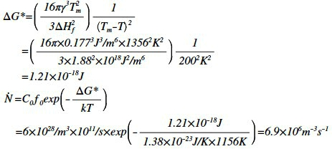

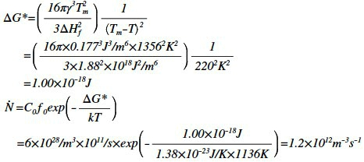
(c) When the homogeneous nucleation rate in liquid copper at undercoolings of 220K,

