**Genetic Algorithm**

**Fitness Function**

The fitness function implemented for this assignment is the inverse of the cost function from assignment 1, question 3. It calculates the total cost by multiplying the values in flow matrix and permutations of the current work placement. Thus, lower total cost equates to higher fitness.

**Parent Selection**

The parent selection strategy implemented for this assignment basically uses the roulette wheel technique as described in class. We spin roulette wheel (population – 1) number of times to pick out (population – 1) parents. The individuals with the higher fitness will take up more space on the roulette wheel; thus, will have higher probability of getting picked.

**Crossover Operator**

The GA algorithm uses the order-1 crossover technique. Since the solution heavily depends on the order of permutation for work placement, order-1 crossover best suits this problem. The idea of order-1 crossover is to preserve the relative order of elements.

**Mutation Operator**

Insert mutation operator is used in this assignment, as insert mutation preserve most of the order and adjacency information.

**Survival Selection**

Elite survival scheme is used for survival selection as will always ensure the solution will only get better and not worse. Elite survival scheme will always keep the best individual in every generation. The remaining of the population is replaced with the new generation of children.

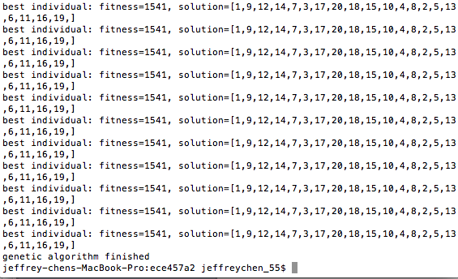

Figure : 50 Population, 1000 Generations

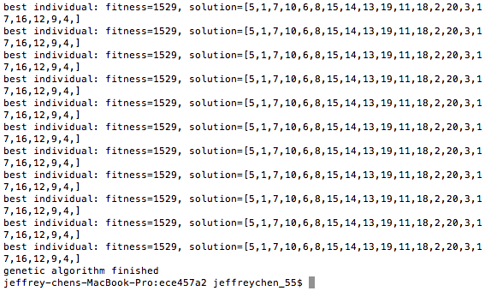

Figure : 500 Population, 100 Generations

In generation, using a bigger population and smaller generations, the computation time is much longer. However, in comparison to a smaller population, the solution is usually a little bit better.

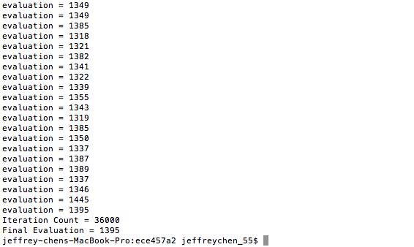

Figure : GA algorithm with Initial temperature of 100, and final temperature of 0.01

The SA algorithm runs much faster than genetic algorithm, and it usually results with better solution than GA algorithm. This makes sense, as the SA algorithm implemented for this assignment is much simpler than GA. It is complicated to create the roulette wheel and perform the crossover techniques. The runtime significantly slows down with greater populations. This doesn’t really matter with SA algorithm. The runtime of SA and small population of GA algorithm is similar.