Figure 1: Regional poverty dynamics

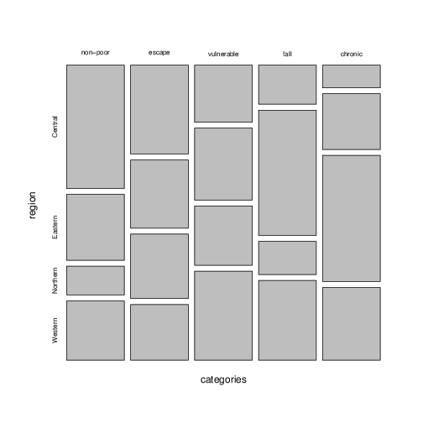

Source: Author's calculations from the UNPS.

Figure 2: Time to fetch water

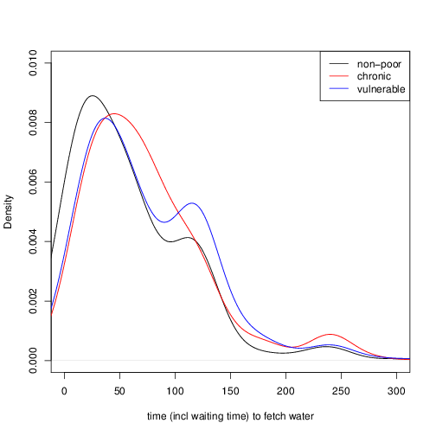

Source: Author's calculations from the UNPS.

Figure 3: Household size and child dependency ratios

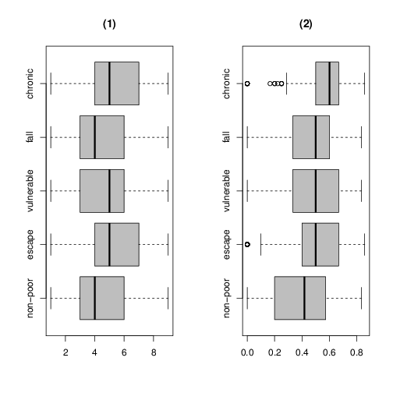

Source: Author's calculations from the UNPS.

Figure 4: Distance to health infrastructure

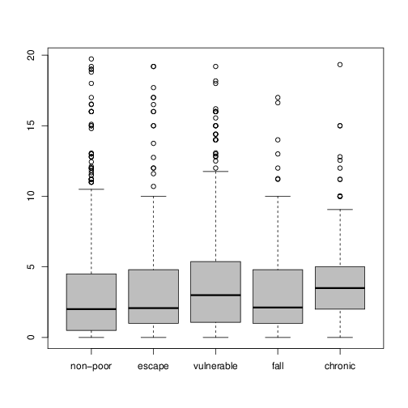

Source: Author's calculations from the UNPS.

Figure 5: Days inactive

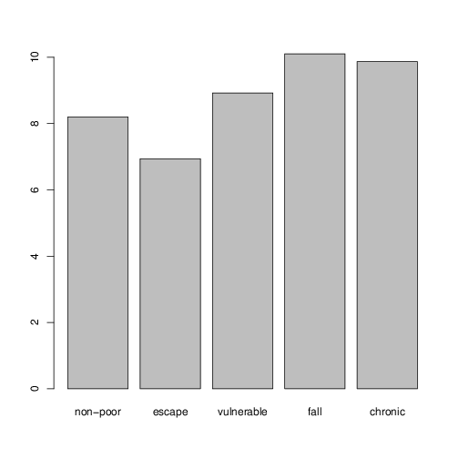

Source: Author's calculations from the UNPS.

Figure 6: Coping with adverse shocks

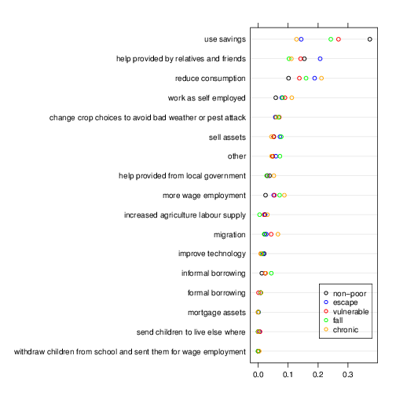

Source: Author's calculations from the UNPS.