Figure 1: Regional distribution of households in different poverty dynamics categories

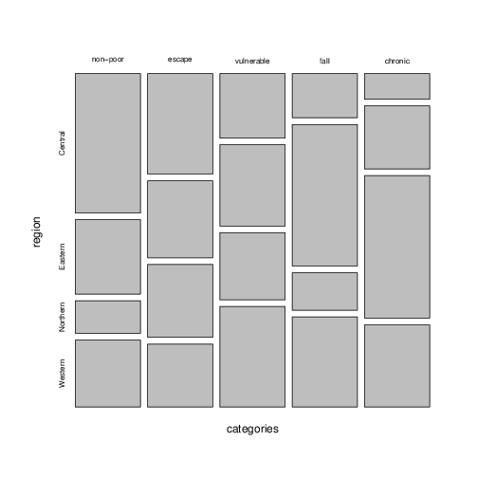

Source: Author's calculations from the UNPS.

Figure 2: Time to fetch water in 2005/06 and poverty dynamics



Source: Author's calculations from the UNPS.

Figure 3: Household size and child dependency ratios in 2005/06



Source: Author's calculations from the UNPS.

Figure 4: Distance (in kilometers) to health infrastructure in 2005/06

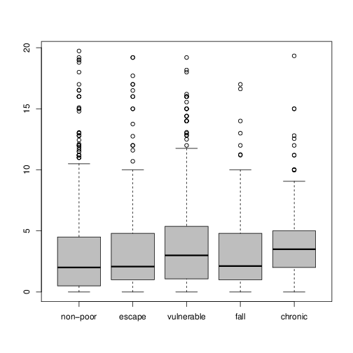

Source: Author's calculations from the UNPS.

Figure 5: Average number of days per year inactive due to illness reported in 2005/06

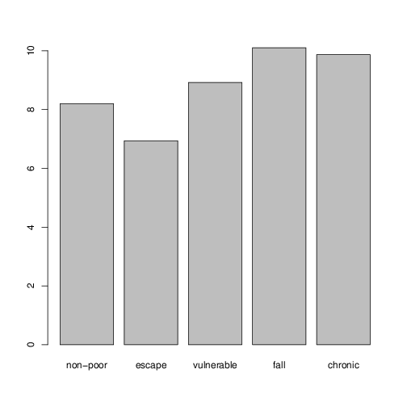

Source: Author's calculations from the UNPS. Includes household heads that did not report illness with days inactive set to zero.

Figure 6: Coping with adverse shocks reported in 2005/06

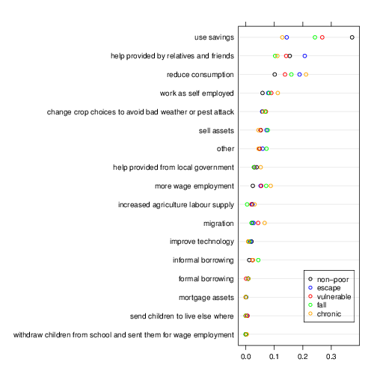

Source: Author's calculations from the UNPS. Points are proportions of households reporting item as main way to cope with shocks.