When Quality (doesn't) Pay: Evidence from Two Experiments in Ugandan Dairy
Bjorn Van Campenhout, Richard Ariong, Sarah Wairimu Kariuki, Jordan Chamberlin
Abstract
Quality in agri-food supply chains is often unobservable at first sale, and early aggregation limits traceability, weakening incentives for quality provision. We study whether improving measurement and traceability induces quality-based incentives in Uganda's dairy sector. In a cluster randomized trial with 125 milk collection centers and over 2,000 farmers, we introduce digital milk analyzers and record-keeping systems. The intervention improves milk quality, primarily by reducing adulteration, but does not raise prices. Randomized quality premiums further improve quality when binding, yet are not passed through to farmers, highlighting frictions in vertical transmission within smallholder value chains.
Keywords: quality measurement, dairy value chains, enforcement, quality premiums, Uganda
JEL Classification: O13, L15, D82

Introduction
Quality of commodities transacted within value chains, and the preservation of that quality throughout the chain, is central to value chain development (Verhoogen 2023). Higher-quality inputs improve efficiency by yielding more output per unit and reducing waste (Bold et al. 2017). Consistent quality fosters trust and reputation, supports compliance with standards, and facilitates access to higher-value markets (Atkin, Khandelwal, and Osman 2017; Fieler, Eslava, and Xu 2018).
For quality to drive behavior, actors must be properly incentivized. In many markets, price premiums for higher-quality products reward additional effort or investment (Shapiro 1983). Yet the emergence of quality premia is often hindered by difficulties in observing and verifying quality at the point of transaction. When quality attributes are costly to discover, buyers face asymmetric information (Akerlof 1970): without credible verification, high- and low-quality products trade at similar prices, resulting in adverse selection. Aggregation across suppliers introduces a further impediment. When buyers observe only a group-level quality signal, the shared reputational stock functions as a common-pool resource (Tirole 1996; Winfree and McCluskey 2005): individual producers can free-ride on the group's standing by supplying below-optimal quality at the pool price. This incentive-dilution logic is reinforced by moral hazard in teams (Holmstrom 1982): when only aggregate output is contractible, no individual agent fully internalizes returns to effort.
These challenges are particularly salient in Uganda's emerging dairy sub-sector. Over the past decade, the industry has undergone rapid transformation in the southwestern milk shed around Mbarara, where foreign direct investment has spurred modern value chains (Van Campenhout, Minten, and Swinnen 2021). A dense network of milk collection centers (MCCs) connects dairy farmers to processors. Yet there is generally no functioning market for quality: prices are typically fixed per liter, irrespective of compositional quality attributes such as butterfat or solids-not-fat. Most MCCs limit testing to freshness and basic adulteration checks, and farmers rarely have access to test results. Without the ability to credibly observe and attribute quality at the farm level, the informational preconditions for quality-based pricing are absent.
We use this setting to test whether strengthening quality observability can enable quality premia. We implement a cluster randomized controlled trial across four districts, randomly assigning 125 MCCs to receive milk analyzer equipment, digital record-keeping infrastructure, and farmer-facing quality information. Following a one-year intervention period, we measure outcomes at three levels: MCC-level testing practices and pricing, farmer-level prices and quality bonuses, and objective milk quality through supervised testing of all incoming deliveries at endline.
The intervention substantially increased quality-testing infrastructure and day-to-day use. The probability that an MCC tests incoming deliveries rose by over 50 percentage points. Despite this, the intervention did not affect prices or quality premia at any stage. Most importantly, analyzer installation improved milk quality itself: butterfat increased by 0.11 percentage points, added water fell by nearly half a percentage point, and an overall quality index improved by 0.21 standard deviations, while biologically determined components (SNF, protein) were unchanged. This pattern is consistent with reduced adulteration and handling improvements rather than deeper shifts in production practices.
The pattern of results (testing up, quality up, prices unchanged) is consistent with an enforcement channel. The acceptance threshold MCCs apply functions as a floor: once quality measurement makes it credible and binding, adulteration falls, but there is no incentive to invest beyond what is needed to clear it. The enforcement channel disciplines the bottom of the quality distribution without rewarding the top.
To test whether activating the pricing channel can shift the chain higher, we conduct a follow-up experiment at 20 MCCs where measurement infrastructure is already operational, randomly assigning quality premiums to traders. Treated traders receive UGX 100 per liter for each 0.1 percentage point of butterfat and SNF above East African standards, paid daily via mobile money. The experiment proceeds in two stages: Stage 1 sets thresholds at East African standards (3.3% fat, 8.5% SNF) during the rainy season; Stage 2 raises the fat threshold to 3.9%, simulating dry-season scarcity.
When thresholds are easily met (Stage 1), treated traders expand volume without improving quality. When the threshold tightens (Stage 2), traders shift to active quality-based sourcing, delivering milk with significantly higher fat content (+0.17 percentage points). Yet the most striking finding concerns price transmission: despite receiving explicit quality premiums, treated traders do not pass value upstream to farmers; if anything, farm-gate prices move slightly downward. This underscores the central finding: even when price incentives are injected into the chain, the structure of intermediation prevents them from reaching farmers.
The paper contributes to three literatures. First, on informational preconditions for quality markets: we show that observability is necessary but not sufficient, since despite large increases in testing, no quality premia materialized (cf. Saenger et al. 2013; Xu 2024). Second, on quality incentive design: our follow-up demonstrates how incentive structure interacts with scarcity of the rewarded attribute, connecting to Treurniet (2021) and the margin-of-response logic in Verhoogen (2023). Third, on price transmission through intermediaries: unlike Casaburi and Reed (2022), who find competitive pass-through of unconditional subsidies, quality-contingent premiums induce traders to expand supplier networks and screen for quality rather than raise prices, echoing findings in Bold et al. (2022) on how supply chain organization blocks upstream gains.

Context: Dairy Supply Chains in Uganda
Dairy is the most commercially organized livestock subsector in Uganda, contributing an estimated 4.3 percent of national GDP and 17 percent of agricultural GDP. The 2021 National Livestock Census recorded 1.9 million milked cows producing 3.7 billion liters annually, a fivefold increase from 2008. Over 2.5 million farming households depend on dairy cattle for income, nutrition, and productive labor. Export revenues rose from USD 131.5 million in 2018 to USD 264.5 million in 2022/23, with Kenya absorbing over 80 percent of shipments.
A typical value chain comprises five main actors. Dairy farmers deliver milk daily to milk collection centers (MCCs) either personally or through intermediaries. Transporters collect milk from farms for a fee; traders purchase milk from farmers to resell at MCCs. MCCs are critical nodes that bulk and chill milk, marking the start of the cold chain. They vary from farmer-owned cooperatives (which may resist quality differentiation in favor of uniform pricing) to privately owned commercial entities. Large traders then transport chilled milk to processors concentrated around Mbarara, who convert raw milk into UHT milk, powdered milk, and infant formula. This layered structure, in which milk passes through multiple intermediaries, means traceability from individual producer to final buyer is lost early, weakening the link between individual quality effort and price received.
Milk quality remains a persistent challenge. Evidence from neighboring Kenya suggests 5 to 10 percent of milk samples show signs of water addition, with higher rates during the dry season (Wanjohi et al. 2020). Traders are paid per liter with no adjustment for composition, creating incentives to dilute. Pricing along the chain reinforces this low-quality equilibrium: prices at MCCs are typically fixed per liter with no compositional differentiation, and processors announce fixed procurement prices for two-week periods.
Most MCCs rely on two low-cost tests: the lactometer (detecting added water through density) and the alcohol test (detecting sourness). Neither provides compositional information on butterfat, SNF, or protein. Electronic milk analyzers measure these attributes in under one minute but cost USD 1,000 to 1,500 and require regular calibration. When paired with digital record-keeping, analyzers can enable systematic quality tracking across deliveries and over time. This combination of measurement technology and digital monitoring infrastructure forms the basis of our intervention.

Quality Measurement and Digital Monitoring Experiment

Design
We use a cluster-randomized controlled trial to test whether making quality observable and traceable at the MCC level improves quality outcomes and generates quality-based pricing. The unit of randomization is the MCC catchment area. Of the 125 MCCs enrolled, about half were randomly assigned to receive the quality measurement and digital monitoring system, while the rest served as controls. The design estimates treatment effects at multiple levels: MCC-level testing and pricing, farmer-level prices and practices, and objective milk quality through supervised testing at endline.

Intervention
The intervention bundle, developed with the Dairy Development Authority (DDA), consists of three components. First, milk analyzers were installed at treatment MCCs. These machines assess compositional parameters (butterfat, SNF, added water) non-destructively in under one minute. MCC owners and managers received separate training sessions, and the DDA conducted periodic monitoring visits throughout the intervention year. Second, an Android record-keeping application replaced paper notebooks, enabling digital tracking of quantities, prices, and quality parameters, with cloud-based synchronization. Third, posters at MCCs publicized the new testing capacity and encouraged farmers to request free quality tests, mitigating potential information asymmetries.

Sample and Timeline
The experiment was conducted in four districts of southwestern Uganda: Ntungamo, Mbarara, Kazo, and Kirihura. We sampled 125 MCCs and randomly selected 20 farmers per MCC for baseline and endline surveys. Baseline data were collected in late 2022. Milk analyzers were installed at treatment MCCs in the second half of 2023, with one year of supported implementation including recalibration after six months. Endline data, including supervised milk quality testing, were collected in December 2024.

Outcome Variables
We measure outcomes at three levels. At the MCC level: whether the MCC uses an analyzer to test incoming and outgoing milk, average prices paid and received, and whether quality premiums are given or received. At the farmer level: an index of dairy management practices, whether the buyer tests milk quality, quantity-weighted average price, and whether the farmer receives a quality bonus. For objective quality measures, enumerators conducted unannounced supervised testing of all incoming deliveries over one full day at each MCC, yielding measurements of butterfat, SNF, protein, added water, and density.

Estimation and Inference
We estimate intent-to-treat (ITT) effects using OLS with ANCOVA specifications controlling for baseline values where available. At the MCC level, we regress endline outcomes on treatment assignment and baseline values. At the farmer level, we include MCC-level treatment assignment. For supervised milk samples, we estimate quantity-weighted regressions without baseline controls. We report CR2 cluster-robust standard errors (Imbens and Kolesar 2016) clustered at the MCC catchment area level and construct Anderson (2008) indices to summarize effects across outcome families. Statistical inference is based on Fisher randomization inference (RI) from 5,000 permutations, with Westfall-Young stepdown adjustments (Westfall and Young 1993) for multiple testing.

Baseline Balance
Tables 1 and 2 report balance on pre-registered baseline variables at the MCC and farmer levels, respectively. Among control MCCs, 63 percent are cooperatives, average storage capacity is about 4,000 liters, and 27 percent report paying quality premiums. Control farmers have herds of about 62 animals and sell roughly 60 liters per day. Only one individual difference is significant at the 5 percent level. Joint F-tests do not reject equality of covariates at either level, confirming that randomization achieved balanced groups.
Table 1: Balance of Baseline Characteristics Between Treatment and Control MCCs
 | mean ctrl | analyzer | nobs
2-4  MCC is cooperative? (1=yes) | 0.633 | -0.086 | 124
 | (0.486) | (0.090)
Total Capacity of milk tanks (in liters) | 4053.2 | 1031.1 | 124
 | (1809.6) | (433.3)
MCC pays quality premium (1=yes) | 0.267 | -0.029 | 123
 | (0.446) | (0.082)
MCC age in years of operation | 9.32 | 0.235 | 123
 | (7.63) | (1.59)
Facilitates supply of acaricides? (1=yes) | 0.583 | -0.068 | 124
 | (0.497) | (0.093)
2-4 F-statistic |  | 1.93
p-value |  | 0.113
Note: Control means (SD) in Column 1; treatment-control differences (robust SE) in Column 2. + p < 0.10, * p < 0.05, ** p < 0.01.
Table 2: Baseline Balance of Farmer Characteristics by MCC Treatment Assignment
 | mean ctrl | treatment | nobs
2-4  Household Head Age (years) | 54.47 | -0.052 | 2261
 | (12.63) | (0.819)
Current Total herd size (number) | 62.30 | 4.98 | 1976
 | (54.01) | (6.13)
Number of improved animals in total herd (share) | 0.932 | -0.007 | 1976
 | (0.171) | (0.012)
Liters milk sold per day (on average in the rainy season) (liters) | 59.70 | 5.82 | 2261
 | (56.33) | (6.05)
Average monthly expense (USD) on chemical purchases | 65.55 | 12.08 | 904
 | (91.10) | (11.48)
2-4 F-statistic |  | 0.268
p-value |  | 0.927
Note: Control means (SD) in Column 1; treatment-control differences (CR2 cluster-robust SE) in Column 2. + p < 0.10, * p < 0.05, ** p < 0.01.

Attrition and Compliance
At baseline, we surveyed 2,261 farmers across 124 MCCs (87% of planned farmer sample, 99% of planned MCC sample). By endline, 4 MCCs had attrited (1 control, 3 treatment; Fisher exact p = 0.62), leaving 120 MCCs and 2,059 farmers connected to interviewed MCCs. Attrition is unrelated to treatment assignment at both levels.
Compliance was imperfect. At endline, 14 of 59 control MCCs had a milk analyzer on site, and 14 of 61 treatment MCCs did not have a machine readily available. The first-stage relationship between assignment and actual analyzer availability is 0.37: treatment increases the probability of having a functioning analyzer from 24 percent (control) to 61 percent (treatment). ITT estimates should therefore be interpreted as averaging over substantial non-compliance, and are likely attenuated relative to the effect of actual use.

Results

Milk Samples
Table 3 reports results from supervised testing. Average butterfat content at control MCCs was 3.88 percent; this increased to approximately 4.00 percent at treated MCCs. SNF shows a similar directional increase but is not statistically distinguishable from zero. Protein shows no detectable change. Milk delivered to treated MCCs contains significantly less added water, with a reduction of nearly half a percentage point relative to the control mean of 1.63 percent. Density (CLR) rises by 0.44 units, consistent with lower dilution. The composite index indicates a significant improvement of 0.21 standard deviations in overall quality.
These results suggest that analyzers reduced adulteration and improved butterfat content, with limited effects on biologically determined components, consistent with handling adjustments rather than deeper shifts in feeding or production management. The distributional pattern of added water (Figure 4) is informative: approximately 29 percent of control deliveries test positive for water addition, and 11 percent show more than 5 percent added water. In the treatment group, serious adulteration (>5% added water) falls to 5 percent, roughly half the control rate. The treatment effect is concentrated in the right tail: the intervention disciplines the most egregious adulterators.
Table 3: Milk Quality
 | mean ctrl | analyzer | nobs
2-4  Butter fat (%) | 3.88 | 0.114 | 2518
 | (0.539) | (0.036)
SNF (%) | 8.58 | 0.081 | 2518
 | (0.490) | (0.050)
Added Water (%) | 1.63 | -0.488 | 2518
 | (3.68) | (0.213)
Protein (%) | 3.16 | 0.029 | 2518
 | (0.194) | (0.022)
Density (CLR) | 27.93 | 0.435 | 2518
 | (2.31) | (0.197)
Index | -0.103 | 0.209 | 2518
 | (0.817) | (0.054)
Note: Control means (SD) in Column 1; treatment effects (cluster-robust SE) in Column 2. Index is Anderson (2008) with added water entering negatively. + p < 0.10, * p < 0.05, ** p < 0.01.
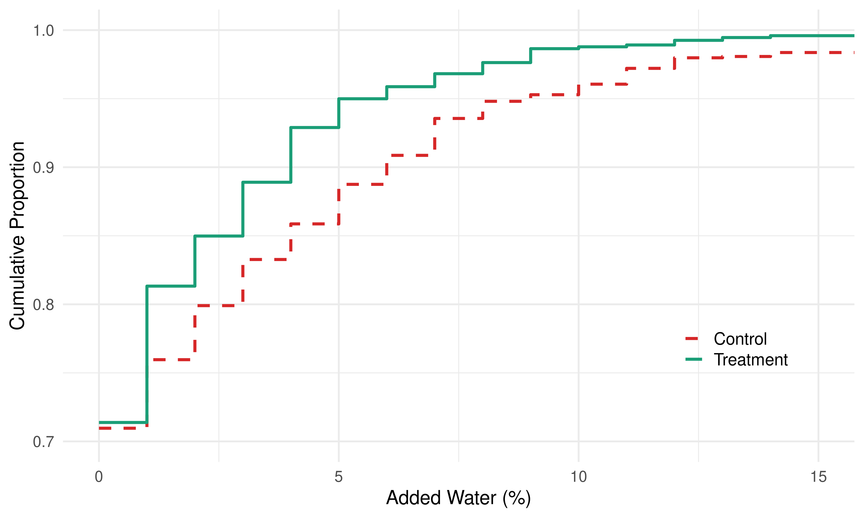
Figure 4: Empirical CDF of added water (%) by treatment status.

Farmer Level
Table 4 reports treatment effects on four primary farmer outcomes plus a composite index. We do not find evidence that the intervention affected production investments and management practices. Among control farmers, 16 percent report quality testing with an analyzer; treatment farmers report roughly 7 percentage points more, though not statistically significant. We find no evidence that the intervention affected milk prices (control mean: UGX 1,020 per liter) or the likelihood of receiving quality premiums. While no individual outcome reaches conventional significance, the composite index is marginally significant (p < 0.10), driven primarily by buyer quality testing.
Table 4: Primary Outcomes for Farmers
 | mean ctrl | analyzer | nobs
2-4  Production investment and management (Index) | 0.014 | -0.020 | 2054
 | (0.562) | (0.039)
Buyer checked for quality (1=yes) | 0.157 | 0.071 | 1337
 | (0.364) | (0.047)
Price received for milk sold | 1020.1 | 11.31 | 1254
 | (97.59) | (9.94)
Get quality premium | 0.081 | -0.016 | 1281
 | (0.274) | (0.023)
Index of primary farmer outcomes | -0.036 | 0.080 | 1202
 | (0.490) | (0.047)
Note: Control means (SD) in Column 1; treatment effects (cluster-robust SE) in Column 2. Prices in UGX. + p < 0.10, * p < 0.05, ** p < 0.01.

MCC Level
Table 5 reports treatment effects on six pre-registered MCC outcomes. MCCs in the treatment group were substantially more likely to test incoming deliveries: the probability rose by 53 percentage points relative to a control mean of 29 percent, a large and highly significant increase. Testing of outgoing deliveries also increased significantly. However, we find no evidence that the intervention affected prices on either side of the market. Control farm-gate prices averaged UGX 1,075 per liter, and buyer prices averaged UGX 2,200 per liter, with no significant treatment effects. About 19 percent of control MCCs reported paying or receiving quality premiums; these shares were unaffected by treatment. The composite index shows marginal improvement, driven entirely by increased testing.
Table 5: Primary Outcomes for Milk Collection Centers (MCCs)
 | mean ctrl | analyzer | nobs
2-4  Tested incoming milk using MA (1=yes) | 0.288 | 0.530 | 120
 | (0.457) | (0.081)
Testing outgoing milk using MA (1=yes) | 0.203 | 0.288 | 120
 | (0.406) | (0.089)
Price at which milk was bought from farmers (UGX) | 1075.0 | -15.21 | 115
 | (92.56) | (16.36)
Price at which milk was sold (UGX) | 1199.6 | 3.44 | 108
 | (106.3) | (19.22)
Does the MCC pay a quality premium to suppliers? | 0.186 | -0.032 | 119
 | (0.393) | (0.066)
Did the buyer pay a quality premium? | 0.186 | 0.031 | 119
 | (0.393) | (0.071)
Index of primary MCC outcomes | -0.077 | 0.174 | 115
 | (0.477) | (0.096)
Note: Control means (SD) in Column 1; treatment effects (robust SE) in Column 2. Prices in UGX. + p < 0.10, * p < 0.05, ** p < 0.01.

Secondary Outcomes
At the MCC level, the treatment produced large effects on technology presence and use, including digital record-keeping adoption. At the farmer level, secondary uptake outcomes (seed usage, understanding of compositional quality) were unaffected, consistent with the intervention operating through enforcement at the MCC level rather than farmer behavioral change.

A Model of Quality Infrastructure and Quality Incentives
We develop a simple analytical framework to rationalize the experimental findings, formalizing two channels through which quality infrastructure can affect outcomes. In the model, farmers choose effort that affects milk quality, and MCCs decide whether to accept or reject each delivery based on a (possibly noisy) quality signal. Accepted milk is aggregated and sold to a processor that may pay a quality premium.
The enforcement channel operates through measurement precision. Without analyzers, the MCC observes quality with substantial noise, so its acceptance threshold is only weakly enforced. Reducing measurement noise makes the threshold credibly binding: farmers near the margin face a sharper probability of rejection and increase effort accordingly. Crucially, this mechanism operates entirely through the acceptance probability and does not require any price differentiation. Quality improves (particularly through reduced adulteration near the threshold) while prices remain unchanged.
The price channel operates when quality-differentiated payments reward quality above the threshold. Higher quality premiums increase the value of quality for the MCC, leading to tighter acceptance standards and, if premiums are passed through, increased farmer effort. The behavioral response depends on the threshold level relative to the prevailing quality distribution. When quality is abundant and the threshold easily met, the volume margin dominates. When the threshold binds (because it is raised or quality becomes scarce), the quality margin activates as the acceptance probability falls below one for many suppliers.
The model yields five testable predictions summarized in Table 6: (1) improved measurement improves quality through enforcement without changing prices; (2) quality gains concentrate in the lower tail; (3) quality-based pricing increases quality and raises prices when passed through; (4) behavioral responses to pricing depend on threshold stringency; and (5) with positive pass-through, stronger downstream incentives raise farmer effort and prices. The enforcement channel explains Experiment 1 results. To test the pricing channel, we designed the follow-up experiment.
Table 6: Model Predictions and Empirical Tests
Prediction | Channel | Parameter | Test | Result
Main experiment: measurement technology () | Main experiment: measurement technology () | Main experiment: measurement technology () | Main experiment: measurement technology () | Main experiment: measurement technology ()
Adulteration falls | Enforcement |  | Milk samples | Fat +0.11pp, Water 0.49pp
Prices unchanged | Credibility, bargaining | insufficient for | Farmer/MCC prices | All null
Follow-up experiment: quality-based pricing () | Follow-up experiment: quality-based pricing () | Follow-up experiment: quality-based pricing () | Follow-up experiment: quality-based pricing () | Follow-up experiment: quality-based pricing ()
Quality and/or volume response | Intensive | , low | Stage 1 | Qty +126L, Fat null
Stronger quality response | Extensive | , high | Stage 2 | Fat +0.17pp
Limited pass-through | Price | , | Farmer prices | 17 UGX

Follow-up Experiment: Activating the Price Channel

Design
The main experiment established that measurement improved enforcement but did not generate quality-based pricing. The follow-up tests whether introducing explicit price incentives targeted to traders can activate the price channel, building on the infrastructure already deployed.
The intervention targets traders for three reasons. First, qualitative data suggested quality gains were smaller when milk passed through intermediaries, indicating the trader link is where the largest unrealized improvements remain. Second, providing the premium at the trader level creates a testable pass-through margin: we can observe whether traders share bonuses with supplying farmers. Third, working with approximately 100 traders balances cost-effectiveness with statistical power.
We focus on 19 MCCs in Kazo district where the digital monitoring system remained operational. Within each MCC, traders were randomized to treatment or control (47 treated, 52 control), stratified by MCC. Both groups had milk tested and received quality feedback after each delivery; treated traders additionally received quality-contingent cash bonuses via mobile money. This isolates the price incentive from the information channel.
The design exploits the high-frequency, repeated-transaction structure of dairy supply chains. Milk is collected daily, generating a dense behavioral panel. A surprise mid-experiment threshold shift provides within-subject variation in the stringency of quality requirements. Prior to randomization, all traders were informed of the 50 percent chance of receiving bonuses and provided informed consent.

Intervention
Treated traders receive UGX 100 per liter for each 0.1 percentage point of fat and SNF above East African Community standards (3.3% fat, 8.5% SNF). The incentives are economically significant: a trader delivering 270 liters at 4.0% fat and 8.5% SNF would earn approximately UGX 19,000 daily (roughly USD 5), meaningful relative to typical margins of UGX 100 per liter. Bonuses are paid daily via mobile money with SMS reporting quality readings and bonus amounts.
The experiment proceeds in two stages. In Stage 1 (November 1 to 14, 2025), thresholds are set at East African standards (3.3% fat, 8.5% SNF), coinciding with the rainy season when high-quality milk is abundant. In Stage 2 (beginning November 15), the fat threshold is raised without prior announcement to 3.9%, while SNF remains unchanged. Under Stage 2 thresholds, roughly 40 percent of deliveries would fall below the fat cutoff, transforming the premium from easy to earn to actively contested.

Sample and Timeline
Power calculations following DeclareDesign (Blair et al. 2019) indicated that 100 traders with approximately 5 farmers per trader would provide 80 percent power. The experiment ran from November 1 to December 1, 2025, generating 5,596 daily milk quality observations and endline surveys of 99 traders and 494 farmers.

Estimation and Inference
For the daily panel, we estimate treatment effects using OLS with MCC fixed effects and trader-clustered standard errors. For trader and farmer endline surveys, analogous specifications with MCC fixed effects. Inference uses Fisher RI from 5,000 within-MCC permutations with Westfall-Young adjustments. Attrition is minimal: daily data are administrative records, and 99 of 100 traders and 494 of 500 targeted farmers completed endline surveys.

Results

Daily Submission Outcomes
Table 7 reports treatment effects on daily milk submissions for the full period (Panel A) and separately for Stage 1 (Panel B) and Stage 2 (Panel C). Over the full period, treated traders deliver milk with 0.109 percentage points higher fat (RI p = 0.003, WY p = 0.007) and 0.030 percentage points higher SNF (RI p = 0.119). Treated traders also deliver marginally more milk (about 60 liters, not significant after multiple testing correction).
The Stage 1 vs. Stage 2 contrast reveals the central finding. During Stage 1, when the threshold is easily met, treated traders expand volume by 126 liters (nearly 50% above the control mean, RI p = 0.012) without meaningful improvement in fat content (+0.048 pp, insignificant). When the threshold increases to 3.9% in Stage 2, the response shifts: fat content rises by 0.169 percentage points (RI p < 0.001, WY p < 0.001) and SNF improves by 0.059 pp (RI p = 0.013), while volume expansion disappears. The margin of adjustment changes when the margin that is rewarded changes.
Figures 5 and 6 plot daily average quantity and fat content by treatment status. The divergence in fat content becomes visually apparent after the threshold shift, while quantity effects are concentrated in Stage 1.
Table 7: Follow-up Experiment: Treatment Effects on Daily Milk Quality
 | Fat (%) | SNF (%) | Quantity (L) | Bonus (1000 UGX)
Panel A: Full period | Panel A: Full period | Panel A: Full period | Panel A: Full period | Panel A: Full period
Treatment | 0.108 | 0.029 | 124.3 | 13
 | (0.031) | (0.016) | (48.51) | (3.9)
N | 2425 | 2425 | 2425 | 2425
Panel B: Stage 1 (fat threshold 3.3%) | Panel B: Stage 1 (fat threshold 3.3%) | Panel B: Stage 1 (fat threshold 3.3%) | Panel B: Stage 1 (fat threshold 3.3%) | Panel B: Stage 1 (fat threshold 3.3%)
Treatment | 0.035 | 0.004 | 126.1 | 13.8
 | (0.027) | (0.023) | (39.18) | (4.3)
N | 1074 | 1074 | 1074 | 1074
Panel C: Stage 2 (fat threshold 3.9%) | Panel C: Stage 2 (fat threshold 3.9%) | Panel C: Stage 2 (fat threshold 3.9%) | Panel C: Stage 2 (fat threshold 3.9%) | Panel C: Stage 2 (fat threshold 3.9%)
Treatment | 0.169 | 0.051 | 122.9 | 12.7
 | (0.041) | (0.016) | (59.04) | (4)
N | 1351 | 1351 | 1351 | 1351
Note: OLS with MCC fixed effects and trader-clustered SE. Bonus column applies premium formula to control deliveries. + p < 0.10, * p < 0.05, ** p < 0.01.
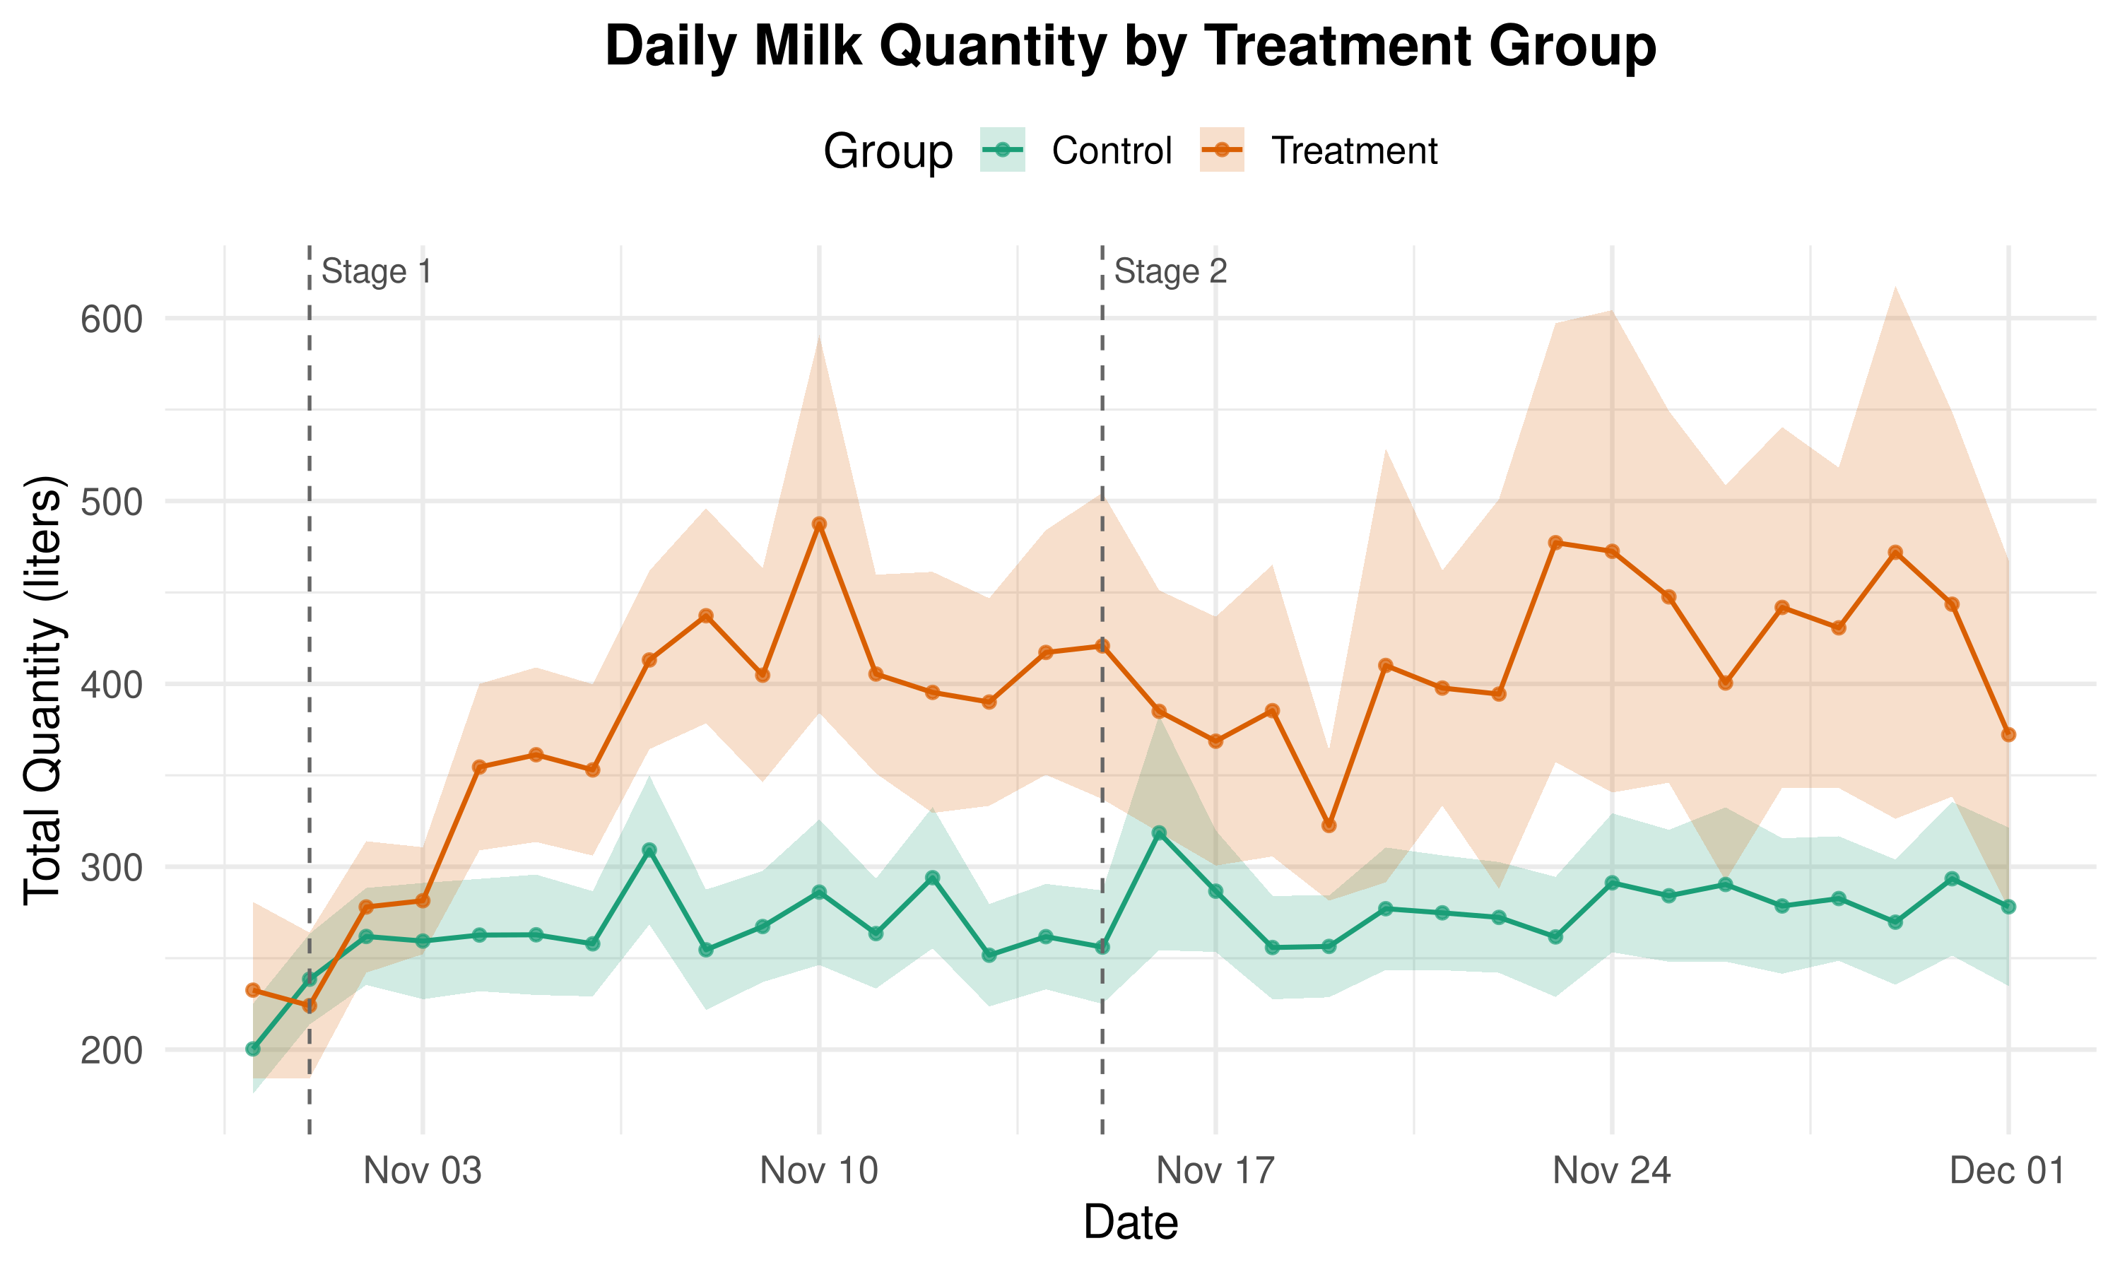
Figure 5: Daily Average Quantity by Treatment Status
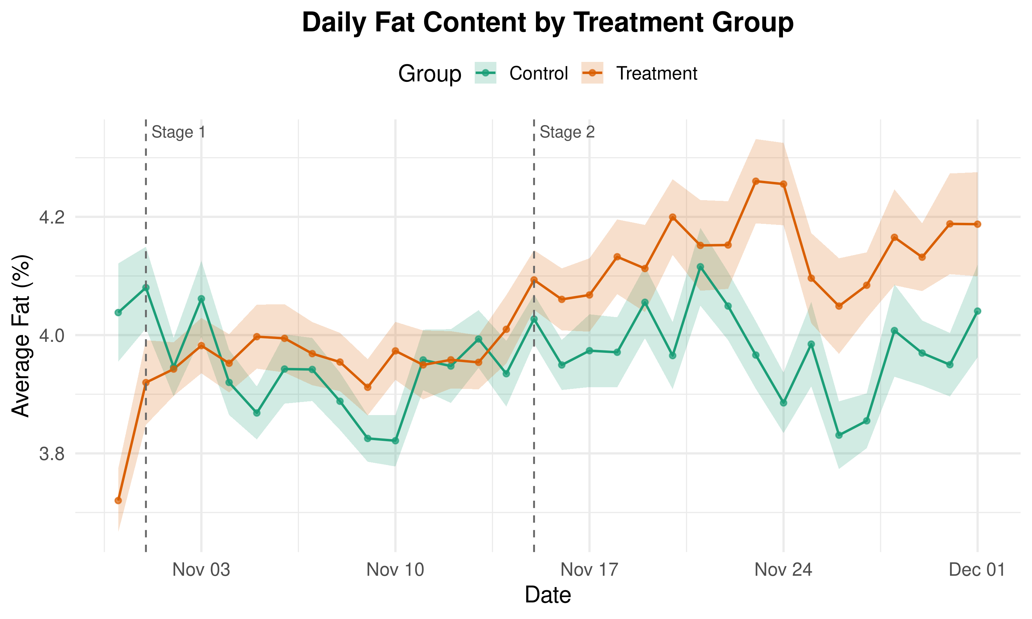
Figure 6: Daily Average Fat Content by Treatment Status

Trader Endline Survey
Despite strong daily submission effects, the trader endline survey (Table 8) shows no significant treatment effects across liters delivered, rejection incidence, quality premium payments, or the Anderson index. The small sample (99 traders) limits power for survey-based detection, and daily submission data more precisely capture the margin of adjustment.
Table 8: Follow-up Experiment: Trader Endline Survey Results
 | Control Mean | Treatment Effect | N
2-4  Delivered quantity (liters) | 389.3 | -36.26 | 99
 |  | (40.62)
Any milk rejected (past month) | 0.500 | -0.039 | 99
 |  | (0.079)
Pays quality premium to farmers | 0.058 | 0.088 | 99
 |  | (0.061)
Average purchase price (UGX/liter) | 899.4 | -6.80 | 99
 |  | (7.84)
Anderson index | 0.003 | -0.007 | 99
 |  | (0.086)
Note: OLS with CR2 cluster-robust SE. + p < 0.10, * p < 0.05, ** p < 0.01.

Farmer-Level Outcomes
Table 9 examines whether trader-level treatment generates upstream effects. The most striking finding is a negative effect on farmer prices: farmers selling to treated traders receive approximately 17 UGX per liter less (marginally significant), despite treated traders receiving explicit quality bonuses. Quality checking is unaffected. The feeding practices index shows a marginally significant positive effect, suggesting some behavioral transmission, but overall the composite index shows no significant treatment effect. The results indicate that quality premiums at the trader level do not propagate to the farmers whose behavior ultimately determines raw milk quality.
Table 9: Follow-up Experiment: Farmer Level Outcomes
 | Control Mean | Treatment Effect | N
 |  | (SE)
Average price received (UGX/liter) | 906.1 | -16.89 | 422
 |  | (6.36)
Quality checked by trader | 0.618 | -0.027 | 422
 |  | (0.061)
Feeding practices index | -0.069 | 0.134 | 422
 |  | (0.064)
Used bran/concentrates | 0.093 | -0.002 | 422
 |  | (0.031)
Used crop residues | 0.093 | 0.054 | 422
 |  | (0.032)
Used salt/mineral lick | 0.511 | 0.081 | 422
 |  | (0.061)
Controlled grazing | 0.364 | 0.093 | 422
 |  | (0.054)
Anderson index | 0.016 | -0.036 | 422
 |  | (0.059)
Note: OLS with CR2 cluster-robust SE. + p < 0.10, * p < 0.05, ** p < 0.01.

Discussion and Conclusion
The results point to three findings that merit interpretation: the dominance of the threshold over the gradient in the follow-up experiment, the negative effect on farm-gate prices, and the broader implications of the two experiments viewed together.
Traders in the follow-up experiment responded to the threshold, not the gradient. When a low threshold made the quality bonus easy to earn (Stage 1), traders expanded volume without improving quality. Only when the threshold tightened did quality improve. Three mechanisms could generate this pattern: loss aversion (traders perceiving the higher threshold as a loss), reference dependence (anchoring on Stage 1 earnings), or a simple cost structure where quality sourcing only becomes worthwhile when it is necessary for bonus eligibility. For incentive design, this suggests that threshold-based contracts with binding cutoffs may generate stronger behavioral responses than smooth gradients, though we note this rests on a single threshold change rather than a direct comparison of contract structures.
The negative effect on farm-gate prices is the most striking welfare finding. Three mechanisms may contribute: a composition effect (treated traders shifting to higher-quality but lower-priced sources), market power (traders expanding supplier networks, increasing their bargaining position), or quality screening substituting for price competition. Whatever the mechanism, the result indicates that value created downstream can be captured by intermediaries rather than transmitted to producers. This contrasts with Casaburi and Reed (2022), where unconditional subsidies generated competitive pass-through, and clarifies that quality-contingent premiums create fundamentally different incentives for intermediaries than volume-based transfers.
The two experiments together illuminate the structure of quality incentives. The main experiment shows that measurement alone activates enforcement but not pricing: quality improves through more credible rejection threats, but the market for quality does not emerge. The follow-up shows that even when pricing is exogenously activated at the intermediary level, value does not reach farmers. The enforcement result confirms recent findings (Bold et al. 2022; Xu 2024) that quality information disciplines the lower tail of the quality distribution without activating the continuous gradient that higher-value markets require.
Several limitations warrant discussion. The follow-up experiment ran 31 days in a single district, limiting inference about longer-run dynamics and external validity. Traders self-selected into the experiment, raising concerns about generalizability to less motivated participants. Within-MCC randomization creates potential spillovers. The 24 percent adoption rate of analyzers among control MCCs demonstrates demand for measurement technology but complicates interpretation of ITT effects.
For policy, the results suggest that quality measurement infrastructure has clear value for enforcement, even absent quality-differentiated pricing. However, the missing market for quality cannot be created by measurement alone, and injecting price incentives at the intermediary level does not solve the transmission problem. Achieving quality-differentiated markets may require interventions that simultaneously address measurement, pricing, and the structure of intermediation, a coordination challenge that connects to the broader argument in Verhoogen (2023) that quality upgrading in developing-country value chains demands action across multiple margins simultaneously.

Acknowledgments
We thank Denis Athua and Benon Byarugaba of the Ministry of Agriculture, Animal Industries and Fisheries (MAAIF), Leocardia Nabwire, Wilberforce Walukano, and Mercy Mbegya for their contributions to the project. This research was supported by the CGIAR Research Initiative on Livestock and Climate. Ethics clearance was obtained from Makerere's MAKSSREC (MAKSSREC-10.2022.594/AR) and IFPRI IRB (DSGD-22-1057). The research was registered at the AEA RCT Registry (AEARCTR-0009938) and the pre-analysis plan is available at https://doi.org/10.23846/pw42308.

References
Akerlof, George A. 1970. "The Market for 'Lemons': Quality Uncertainty and the Market Mechanism." Quarterly Journal of Economics 84 (3): 488-500.
Anderson, Michael L. 2008. "Multiple Inference and Gender Differences in the Effects of Early Intervention: A Reevaluation of the Abecedarian, Perry Preschool, and Early Training Projects." Journal of the American Statistical Association 103 (484): 1481-95.
Antras, Pol, and Davin Chor. 2013. "Organizing the Global Value Chain." Econometrica 81 (6): 2127-2204.
Ashraf, Nava, Xavier Gine, and Dean Karlan. 2009. "Finding Missing Markets (and a Disturbing Epilogue): Evidence from an Export Crop Adoption and Marketing Intervention in Kenya." American Journal of Agricultural Economics 91 (4): 973-90.
Atkin, David, Amit K. Khandelwal, and Adam Osman. 2017. "Exporting and Firm Performance: Evidence from a Randomized Experiment." Quarterly Journal of Economics 132 (2): 551-615.
Bai, Jie. 2024. "Melons as Lemons: Asymmetric Information, Consumer Learning and Quality Provision."
Bai, Jie, Lauren Falcao Bergquist, Ameet Morjaria, Russell Morton, and Yulu Tang. 2025. "Quality Incentives and Upgrading in Uganda's Coffee Supply Chain."
Bergquist, Lauren Falcao, and Michael Dinerstein. 2020. "Competition and Entry in Agricultural Markets: Experimental Evidence from Kenya." American Economic Review 110 (12): 3705-47.
Blair, Graeme, Jasper Cooper, Alexander Coppock, and Macartan Humphreys. 2019. "Declaring and Diagnosing Research Designs." American Political Science Review 113 (3): 838-59.
Bold, Tessa, Selene Ghisolfi, Frances Nsonzi, and Jakob Svensson. 2022. "Market Access and Quality Upgrading: Evidence from Four Field Experiments." American Economic Review 112 (8): 2518-52.
Bold, Tessa, Kayuki C. Kaizzi, Jakob Svensson, and David Yanagizawa-Drott. 2017. "Lemon Technologies and Adoption: Measurement, Theory and Evidence from Agricultural Markets in Uganda." Quarterly Journal of Economics 132 (3): 1055-1100.
Casaburi, Lorenzo, and Tristan Reed. 2022. "Using Individual-Level Randomized Treatment to Learn about Market Structure." American Economic Journal: Applied Economics 14 (4): 58-90.
Fieler, Ana Cecilia, Marcela Eslava, and Daniel Yi Xu. 2018. "Trade, Quality Upgrading, and Input Linkages: Theory and Evidence from Colombia." American Economic Review 108 (1): 109-46.
Hansman, Christopher, Jonas Hjort, Gianmarco Leon-Ciliotta, and Matthieu Teachout. 2020. "Vertical Integration, Supplier Behavior, and Quality Upgrading Among Exporters." Journal of Political Economy 128 (9): 3570-3625.
Hoffmann, Vivian, Sarah Kariuki, Janneke Pieters, and Mark Treurniet. 2023. "Upside Risk, Consumption Value, and Market Returns to Food Safety." American Journal of Agricultural Economics 105 (3): 914-38.
Holmstrom, Bengt. 1982. "Moral Hazard in Teams." Bell Journal of Economics 13 (2): 324-40.
Imbens, Guido W., and Michal Kolesar. 2016. "Robust Standard Errors in Small Samples: Some Practical Advice." Review of Economics and Statistics 98 (4): 701-12.
Macchiavello, Rocco, and Josepa Miquel-Florensa. 2019. "Buyer-Driven Upgrading in GVCs: The Sustainable Quality Program in Colombia."
Macchiavello, Rocco, Josepa Miquel-Florensa, Nicolas de Roux, Eric Verhoogen, Mario Bernasconi, and Patrick W. Farrell. 2026. "Quality Upgrading in Global Supply Chains: Evidence from Colombian Coffee."
Minten, Bart, Lalaina Randrianarison, and Johan F. M. Swinnen. 2009. "Global Retail Chains and Poor Farmers: Evidence from Madagascar." World Development 37 (11): 1728-41.
Minten, Bart, and Thomas Reardon. 2008. "Food Prices, Quality, and Quality's Pricing in Supermarkets Versus Traditional Markets in Developing Countries." Review of Agricultural Economics 30 (3): 480-90.
Park, Albert, Nguyen Viet Cuong, Nhat Anh Tran, and Nghiem Hoang Trung. 2023. "Quality Upgrading for Smallholder Farmers: Evidence from Vietnam."
Rao, Manaswini, and Ashish Shenoy. 2023. "Got (Clean) Milk? Organization, Incentives, and Management in Indian Dairy Cooperatives." Journal of Economic Behavior & Organization 212: 708-22.
Saenger, Christoph, Matin Qaim, Maximo Torero, and Angelino Viceisza. 2013. "Contract Farming and Smallholder Incentives to Produce High Quality: Experimental Evidence from the Vietnamese Dairy Sector." Journal of Agricultural Economics 64 (3): 607-24.
Shapiro, Carl. 1983. "Premiums for High Quality Products as Returns to Reputations." Quarterly Journal of Economics 98 (4): 659-79.
Tirole, Jean. 1996. "A Theory of Collective Reputations (with Applications to the Persistence of Corruption and to Firm Quality)." Review of Economic Studies 63 (1): 1-22.
Treurniet, Mark. 2021. "The Potency of Quality Incentives: Evidence from the Indonesian Dairy Value Chain." American Journal of Agricultural Economics 103 (5): 1661-78.
Van Campenhout, Bjorn, Els Lecoutere, and Ben D'Exelle. 2015. "Inter-Temporal and Spatial Price Dispersion Patterns and the Well-Being of Maize Producers in Southern Tanzania." Journal of African Economies 24 (2): 218-41.
Van Campenhout, Bjorn, Bart Minten, and Johan F. M. Swinnen. 2021. "Leading the Way: Foreign Direct Investment and Dairy Value Chain Upgrading in Uganda." Agricultural Economics 52 (4): 607-31.
Verhoogen, Eric. 2023. "Firm-Level Upgrading in Developing Countries." Journal of Economic Literature 61 (4): 1410-64.
Wanjohi, Martin, Lucy Gitonga, Karen Marshall, George Njoroge, Ahmed I. Abdi, and Bernard Bett. 2020. "Milk Quality Along Dairy Farming Systems and Associated Value Chains in Kenya: An Analysis of Composition, Contamination and Adulteration." East African Agricultural and Forestry Journal 84 (2): 83-95.
Westfall, Peter H., and S. Stanley Young. 1993. Resampling-Based Multiple Testing: Examples and Methods for p-Value Adjustment. New York: Wiley.
Winfree, Jason A., and Jill J. McCluskey. 2005. "Collective Reputation and Quality." American Journal of Agricultural Economics 87 (1): 206-13.
Xu, Guanghong. 2024. "Farm to Fridge: Digital Traceability and Quality Upgrading in the Kenyan Dairy Value Chain."

