Accelerating Quality Upgrading in Ugandan Dairy Value Chains: Lessons for Quantitative Development Economics
Uganda’s dairy sector has grown significantly over the past two decades, yet challenges in milk quality continue to hinder its potential. A recent study by Richard Ariong and colleagues explores interventions to address these challenges through field experiments targeting Milk Collection Centers (MCCs) and farmers that deliver to these MCCs. The findings provide valuable insights on quality upgrading in value chains in developing countries.

Persistent Challenges in Milk Quality
Low butterfat and Solids-Not-Fat (SNF) levels are major issues in Uganda’s dairy sector. Farmers lack incentives to adopt quality-enhancing practices due to a system where milk is bulked at MCCs, making it difficult to attribute quality to individual suppliers. Processors, although willing to pay premiums for high-quality milk, are constrained by this lack of traceability. Moreover, farmers often equate quality with sanitation, while processors prioritize compositional attributes, further misaligning market incentives.

Interventions and Experimental Design
The study introduced two interventions:
- MCC-Level Innovations: These included installing milk analyzers for rapid quality testing, an Android-based record-keeping app, and poster campaigns to raise awareness about free milk quality testing for farmers. These measures aimed to enhance transparency and encourage adherence to quality standards.
- Farmer-Level Support: Farmers received educational videos explaining compositional quality and practical ways to improve it, cartoon handouts summarizing key points, and improved pasture seeds to enhance feeding practices.
A randomized split-plot design was employed across 130 MCCs in Southwestern Uganda (see Figure 1). Half of the MCCs implemented the MCC-level interventions (T1), while the others served as controls. Within each MCC, 20 farmers were selected, with half receiving the farmer-level interventions (T2). This design enabled the assessment of impacts at both the MCC and farmer levels. The design was further stratified by the way in which a farmer was linked to the MCC---directly or through an intermediary---as this is likely to affect the agree to which price signals are passed through the value chain.
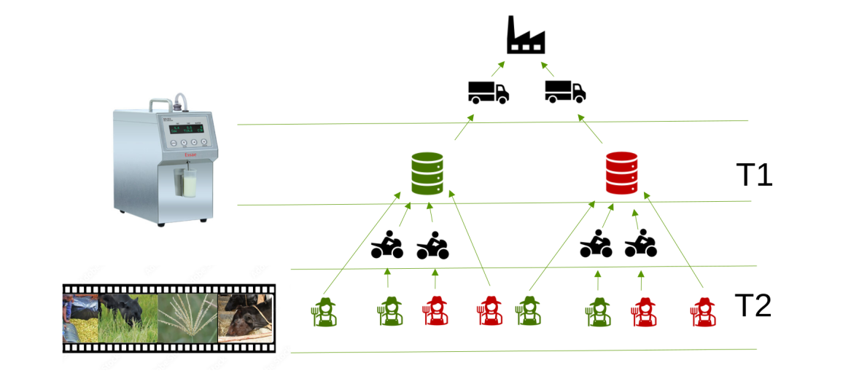

Key Findings
One of the study’s most significant results was the measurable improvement in milk quality at treatment MCCs, as shown in Figure 2. Butterfat, SNF levels and milk density (Corrected Lactometer Reading) were notably higher in treatment MCCs compared to controls, with a concurrent reduction in adulteration (lower levels of added milk). These results underline the effectiveness of milk analyzers in enforcing stricter quality standards and promoting compositional quality.

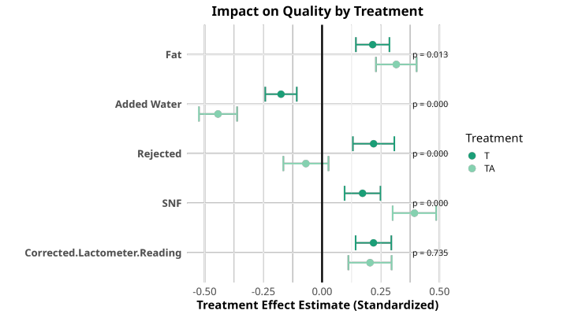
The significant increase in quality contrasts with a lack of impact on prices at both the MCC and farmer levels. Despite improvements in milk quality, processors continued to offer uniform prices, undermining the financial incentives for farmers to invest in quality enhancements. Even with stricter quality standards at treatment MCCs, there was only a marginal increase of about 1.5% in farmer-reported prices, which is unlikely to drive substantial behavioral change.
Conclusion
These findings highlight both the progress made and the challenges that remain. While the interventions successfully improved milk quality and increased transparency, systemic changes—particularly in pricing mechanisms—are essential to sustain and scale these improvements. Future efforts should focus on supporting emerging market trends, addressing adoption barriers, and ensuring that economic incentives align with quality-based practices, ultimately benefiting all stakeholders across the dairy value chain.

