INSTRUCTIONS:

Today date:
Hour:

Participants present

brokers - 2 individuals
transporters - 2 individuals
buyers - 2 individuals
livestock sellers - 2 individuals
market official - 1 individual

What is the full official name of this market? Adama
What is it informally known as? Nazreth
GPS coordinates?

Please give a narrative account of what the livestock value chain looks like, paying attention to:
-agents involved
-tertiary products (eg. veterenary services, entertainment (khat),...)
-processing
-assets used in value chain
-seasonality

What type is it? Primary market, secondary market, bush market
What are the market days? Wednesdays and Thursdays

How big is this market?
What is daily turnover?

What facilities are available?

Is there access to water? At what price? Describe the process.

Is there access to fodder? At what price? Describe the process.

Is there overnight storage facility? At what price? Describe the process.

Are there veterinary services?

Cow dip?

What other livestock markets is this market connected to?

Cattle traded on this market usually come from:
1.
2.
3.
4.
And go to:
1.
2.
3.
4.

Insert a google maps snapshot of the market configuration we are looking at.

Look at a graph of prices here?

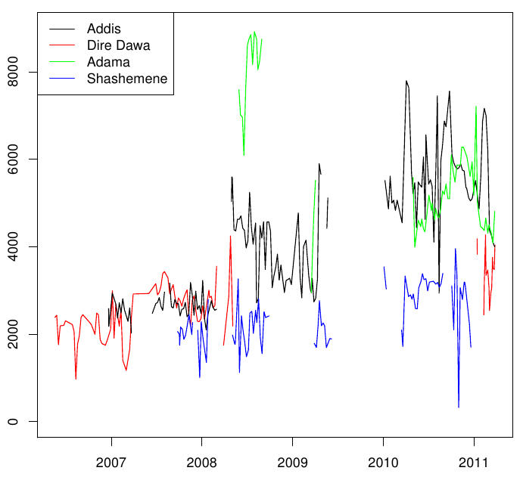
Traders available
2006 | 2007 | 2008 | 2009 | 2010 | 2011 | 2012

Brokers available
2006 | 2007 | 2008 | 2009 | 2010 | 2011 | 2012
Trucks/transporters avilable

2006 | 2007 | 2008 | 2009 | 2010 | 2011 | 2012

Seasonality in trade:
jan | feb | mar | apr | may | jun | jul | aug | sept | oct | nov | dec

when did this market/town get mobile phone coverage?
Please estimate the percentage of :
livestock sellers with mobile phone for each year

2006 | 2007 | 2008 | 2009 | 2010 | 2011 | 2012
livestock buyers with mobile phone for each year

2006 | 2007 | 2008 | 2009 | 2010 | 2011 | 2012
livestock brokers with mobile phone for each year

2006 | 2007 | 2008 | 2009 | 2010 | 2011 | 2012
livestock transporters with mobile phone for each year

2006 | 2007 | 2008 | 2009 | 2010 | 2011 | 2012

Trade routes:
Adama – Addis
Think about the Adama – Addis traderoute now. Below we plot the difference in cattle prices in Adama and Addis at different points in time. For example, halfway 2008, prices in Adama were 20 percent higher than in Addis. In 2010/2011, prices in Adama are lower than in Addis, as we would expect.
Please try to explain this?
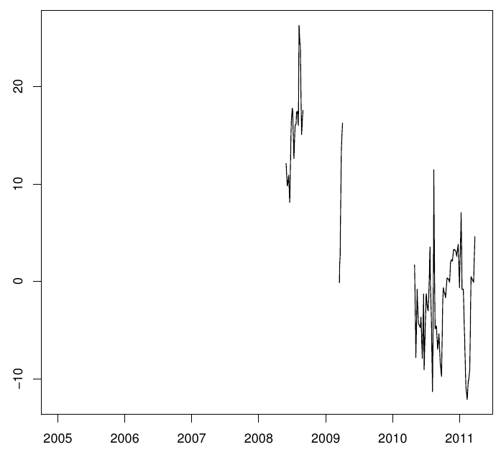

road condition 1 – non-existent or very bad

4 – mostly asphalted, some bad parts or potholes
5 – very good, all the way asphalted, no potholes
2006 | 2007 | 2008 | 2009 | 2010 | 2011 | 2012

Estimated time to ship cattle on this route
2006 | 2007 | 2008 | 2009 | 2010 | 2011 | 2012

Estimated cost to ship 1 head cattle on this route
2006 | 2007 | 2008 | 2009 | 2010 | 2011 | 2012

Adama – Dire Dawa
2011– 02 – 17
2011-02-16
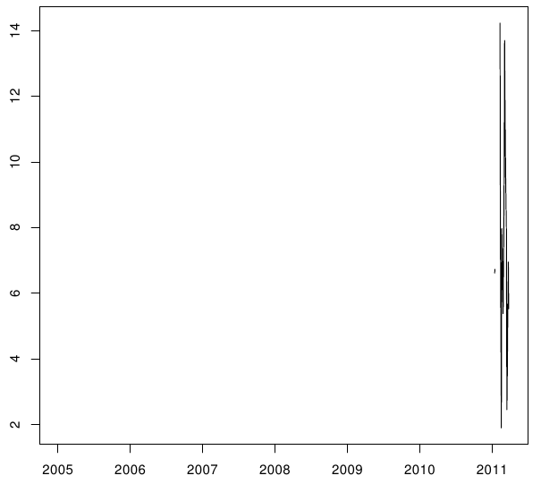
Adama - Shashemene
2010 -06 -18
2010-07-17
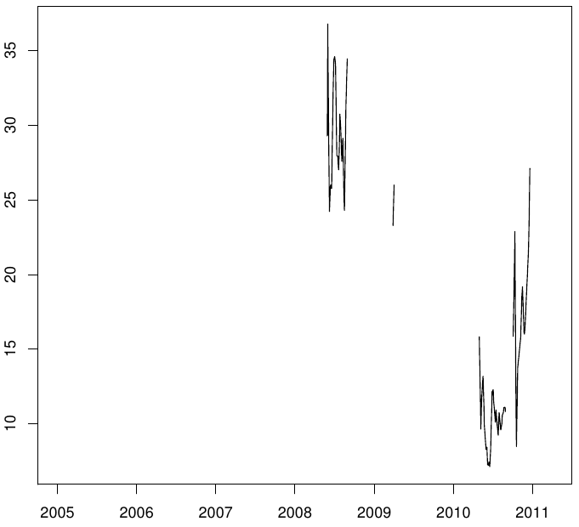

Adama - wednesday and thursday

shashemene - saturday

