INSTRUCTIONS: This is a questionnaire to guide semi-structured interviews to help the interpretation of a market integration study that focuses on structural changes.

Today date:
Hour:

Participants present

brokers - 2 individuals – record names and cell phone numbers
transporters - 2 individuals – record names and cell phone numbers
buyers - 2 individuals – record names and cell phone numbers
livestock sellers - 2 individuals – record names and cell phone numbers
market official - 1 individual – record names and cell phone numbers

What is the full official name of this market? Shashemene
What is it informally known as? Nazreth
GPS coordinates?

Please give a narrative account of what the typical livestock value chain looks like, paying attention to:
-agents involved (eg start with livestock herder, where does he get his cattle? Are there brokers?)
-tertiary products (eg. veterinary services, entertainment (khat),...)
-processing
-assets and inputs used in value chain
Are there other types of livestock value chains operating through this market (eg.vertically integrated, livestock chains with less links (eg. No brokers involved))

What type is it? Primary market, secondary market, bush market
What are the market days? Saturdays

How big is this market are? Has this changed over the last decade?
What is daily turnover? i.e. on an average market day, how much cattle get transacted? Please try to

2000 | 2001 | 2002 | 2003 | 2004 | 2005 | 2006
2007 | 2008 | 2009 | 2010 | 2011 | 2012 | 2013

What facilities are available?

Is there access to water? At what price? Describe the process.

Is there access to fodder? At what price? Describe the process.

Is there overnight storage facility? At what price? Describe the process.

Are there veterinary services? At what price?
Cow dip?
Is there access to credit for brokers?
Is there access to credit for traders?
Is there access to credit for sellers?
Is there access to credit for buyers?
Is there access to credit for transporters?

Are there per-arranged contracts between any parties?

What other livestock markets is this market connected to?

Cattle traded on this market usually come from:
1.
2.
3.
4.
And go to:
1.
2.
3.
4.

Let participants look at the town and the different trade routes to other markets.
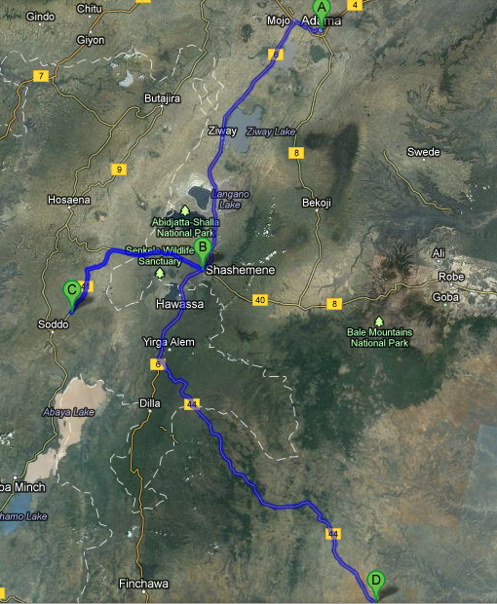

Look at a graph of prices here?

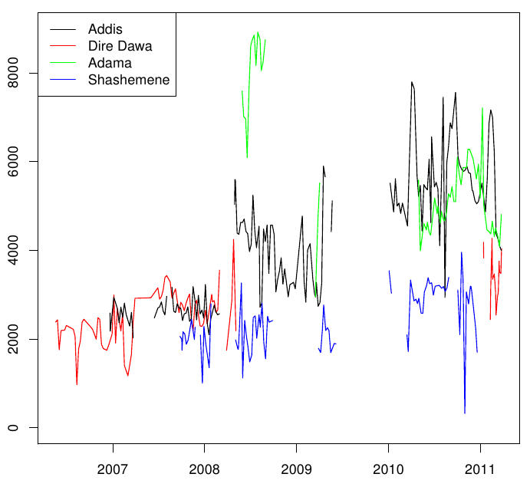
Traders available in this market
2000 | 2001 | 2002 | 2003 | 2004 | 2005 | 2006
2007 | 2008 | 2009 | 2010 | 2011 | 2012 | 2013

Brokers available in this market
2000 | 2001 | 2002 | 2003 | 2004 | 2005 | 2006
2007 | 2008 | 2009 | 2010 | 2011 | 2012 | 2013
Trucks/transporters available in this market
2000 | 2001 | 2002 | 2003 | 2004 | 2005 | 2006
2007 | 2008 | 2009 | 2010 | 2011 | 2012 | 2013

Seasonality in trade:
jan | feb | mar | apr | may | jun | jul | aug | sept | oct | nov | dec

when did this market/town get mobile phone coverage? Month + year
Please estimate the percentage of :
livestock sellers with mobile phone for each year

2000 | 2001 | 2002 | 2003 | 2004 | 2005 | 2006
2007 | 2008 | 2009 | 2010 | 2011 | 2012 | 2013
livestock buyers with mobile phone for each year

2000 | 2001 | 2002 | 2003 | 2004 | 2005 | 2006
2007 | 2008 | 2009 | 2010 | 2011 | 2012 | 2013
livestock brokers with mobile phone for each year

2000 | 2001 | 2002 | 2003 | 2004 | 2005 | 2006
2007 | 2008 | 2009 | 2010 | 2011 | 2012 | 2013
livestock transporters with mobile phone for each year

2000 | 2001 | 2002 | 2003 | 2004 | 2005 | 2006
2007 | 2008 | 2009 | 2010 | 2011 | 2012 | 2013

Trade routes:
Shashemene – Adama (trade to the North)

Please give a narrative account of what the typical livestock value chain looks like on this trade route, paying attention to:
-agents involved (eg start with livestock herder, where does he get his cattle? Are there brokers?)
-tertiary products (eg. veterinary services, entertainment (khat),...)
-processing
-assets and inputs used in value chain
Are there other types of livestock value chains operating through this market (eg.vertically integrated, livestock chains with less links (eg. No brokers involved))

What is the condition of the road between Shashemene and Adama

road condition 1 – non-existent or very bad
2 – poor quality
3 – average quality
4 – mostly asphalted, some bad parts or potholes
5 – very good, all the way asphalted, no potholes

2000 | 2001 | 2002 | 2003 | 2004 | 2005 | 2006
2007 | 2008 | 2009 | 2010 | 2011 | 2012 | 2013

Estimated time to ship cattle on this route
2000 | 2001 | 2002 | 2003 | 2004 | 2005 | 2006
2007 | 2008 | 2009 | 2010 | 2011 | 2012 | 2013

Estimated cost to ship 1 head cattle on this route
2000 | 2001 | 2002 | 2003 | 2004 | 2005 | 2006
2007 | 2008 | 2009 | 2010 | 2011 | 2012 | 2013

Shashemene – Boditi (trade route to the west)

Please give a narrative account of what the typical livestock value chain looks like on this trade route, paying attention to:
-agents involved (eg start with livestock herder, where does he get his cattle? Are there brokers?)
-tertiary products (eg. veterinary services, entertainment (khat),...)
-processing
-assets and inputs used in value chain
Are there other types of livestock value chains operating through this market (eg.vertically integrated, livestock chains with less links (eg. No brokers involved))

What is the condition of the road between Shashemene and Boditi
road condition 1 – non-existent or very bad
2 – poor quality
3 – average quality
4 – mostly asphalted, some bad parts or potholes
5 – very good, all the way asphalted, no potholes

2000 | 2001 | 2002 | 2003 | 2004 | 2005 | 2006
2007 | 2008 | 2009 | 2010 | 2011 | 2012 | 2013
Estimated time to ship cattle on this route
2000 | 2001 | 2002 | 2003 | 2004 | 2005 | 2006
2007 | 2008 | 2009 | 2010 | 2011 | 2012 | 2013

Estimated cost to ship 1 head cattle on this route
2000 | 2001 | 2002 | 2003 | 2004 | 2005 | 2006
2007 | 2008 | 2009 | 2010 | 2011 | 2012 | 2013

Shashemene – Negele Borena (trade to the South)

Please give a narrative account of what the typical livestock value chain looks like on this trade route, paying attention to:
-agents involved (eg start with livestock herder, where does he get his cattle? Are there brokers?)
-tertiary products (eg. veterinary services, entertainment (khat),...)
-processing
-assets and inputs used in value chain
Are there other types of livestock value chains operating through this market (eg.vertically integrated, livestock chains with less links (eg. No brokers involved))

What is the condition of the road between Shashemene and Negele Borena

road condition 1 – non-existent or very bad
2 – poor quality
3 – average quality
4 – mostly asphalted, some bad parts or potholes
5 – very good, all the way asphalted, no potholes

2000 | 2001 | 2002 | 2003 | 2004 | 2005 | 2006
2007 | 2008 | 2009 | 2010 | 2011 | 2012 | 2013
Estimated time to ship cattle on this route
2000 | 2001 | 2002 | 2003 | 2004 | 2005 | 2006
2007 | 2008 | 2009 | 2010 | 2011 | 2012 | 2013

Estimated cost to ship 1 head cattle on this route
2000 | 2001 | 2002 | 2003 | 2004 | 2005 | 2006
2007 | 2008 | 2009 | 2010 | 2011 | 2012 | 2013

Adama - wednesday and thursday

shashemene - saturday

