

ELECTRICAL AND COMPUTER
ENGINEERING DEPARTMENT

115.611 Engineering Project (Electronic) Development Project
Progress Report 2018

Autonomous Robot

Object detection and movement

By : Ben Joseph Hombrebueno
180005719
Supervisor : Dr. Snjezana Soltic

Abstract

In robotics, object detection and object movement are some of the most common tasks for autonomous robots. The robot developed in this study is part of a robotics competition that aims to detect a target object, specifically a blue cube from within the circular area and move it while avoiding obstacles in the process. In this study, visual data from the environment was provided by the Pixy2 camera module. Processing of data was done by the Arduino Mega microcontroller, which also will interact with the motor drivers to control the wheels. To move the object, a gripper was used. This report documents the various progresses on circuit design, selection of components, hardware and software development, testing and the results of the study. The final product was able to meet the expected outcomes.

Acknowledgments

I would like to thank our advisor Dr. Snjezana Soltic for providing valuable guidance and feedback for this project.
I would like to thank Dr.Zulfikar Hossain and Anthony Simmonds who provided support in the course.
I would also like to thank my colleagues and friends in Manukau Institute of Technology for their comments and suggestions for the improvement of the project.
I would also like to thank the Hombrebueno and De Ramos family for their support for this graduate study.
Finally, I would like to thank the Lord, for without Him, this would not have been possible.
.

Contents
Abstract ii
Acknowledgments iii
Contents iv
List of Figures v
List of tables v
1 Introduction 1
2 Description of Research and Final Specifications 2
3 System Description 3
3.1 Block Diagram 3
4 Hardware Description 5
4.1.1 Pixy2 CMUcam5 5
4.1.2 Arduino Mega 5
4.1.3 Gripper with servomotor 6
4.1.4 L298N Motor Drive Board Module 6
4.1.5 Motors and wheels 6
4.1.6 Infrared sensor 6
4.2 Pin connection diagram 6
5 Software Description 10
5.1.1 Main Loop 10
5.1.2 Acquire Block Function 12
5.1.3 Moving Robot Function 14
5.1.4 Scanning for Block Function 16
5.1.5 Moving to Block Function 17
5.1.6 Moving out of the area Function 19
6 Results 21
7 Time plan and Budget 21
8 Conclusion 22
9 References 23

List of Figures

Figure 1: Block Diagram 2
Figure 2: Pin connection diagram 4
Figure 3: Pan-tilt servo control test flowchart ................................................................8
Figure 4: Camera test flowchart......................................................................................8
Figure 5: Servo (Gripper) test flowchart.........................................................................9
Figure 6: DC motor (Wheel) test flowchart....................................................................9

List of tables

Table 1: Pin Table 5
Table 2: DC motor code and function table....................................................................6
Table 3: Servo motor code and function table................................................................7
Table 4: Pixy 2 code and function table..........................................................................7

Introduction

An autonomous robot was developed in the course of the study. An object can be detected by the said robot and will be moved from its position from inside the working area while avoiding obstacles. The robot was provided visual data from a camera. This data was processed to move the wheels toward the direction of the object at an appropriate speed. The object was moved using a gripper. Instructions and sensor data was processed through an appropriate microcontroller. Both hardware and software development of the object detection and movement was done. Both members worked on integration of the software for the movement of the robot within the area.

This robot is part of a competition where the fastest robot to move the cube from the area will win. There will be other merits for

Description of Research and Final Specifications

First, research has been done for the appropriate circuits for object detection and object movement. Next, an initial circuit design was developed and here the necessary components were determined. Suitable components to match the specifications were selected and purchased. Software coding for the camera and motor control testing was done while waiting for the parts delivery. Hardware assembly was done when the parts arrived. Testing and debugging of both the hardware and software took place as soon as the robot is being built; from the individual modules leading up to the integrated, final product. Tuning for the sensors to compensate for the lighting effects, the speed control and checking the robot clearances took most of the test time.

The final specifications include the following:
- The robot should be autonomous.
- It should be able to detect the target object, specifically a blue cube, within the circular area of 1.5m in diameter and move it out of the area.
- It should also be able to detect the colour of the obstacles, specifically red.
- A camera will be used as a visual sensor to detect the object within 30cm.
- A gripper will be used to move the object along with the robot.
- The microcontroller will be used to control the motors to run a pair of wheels in moving to the target location.
- To add more stability, a third uncontrolled caster wheel was added.
- The system will be supplied by batteries.

System Description

Block Diagram
The initial system was composed of the following blocks: the Camera, the Ultrasonic sensor, the Microcontroller, the Motor Driver, the Gripper and the Servomotor for the ultrasonic sensor. Inputs from the camera and ultrasonic sensor blocks will be processed by the microcontroller and then turned into actions though the motor driver, the servomotor controlling the ultrasonic sensor and the gripper. The block diagram is shown in Figure 1, with the white blocks assigned in this part of the study.
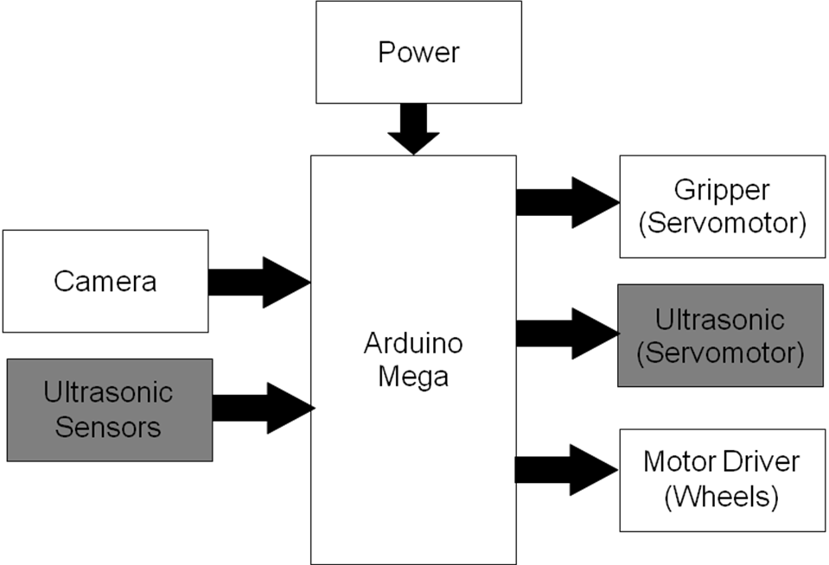
Figure 1: Initial Block Diagram
During the course of testing, some issues were encountered which resulted in the modification of the original system. The robot is required to constantly monitor the cube while avoiding the border so it was not practical for the camera to switch modes from the Colour connected components mode to the Line tracking mode constantly. For this reason, infrared sensors were added in front left and right sides of the robot. As most of the sensors had to be placed in front, the ultrasonic sensor with servomotor assembly was difficult to place in between the plates of the chassis and will not be able to detect the cube if placed too high. To solve this, the servomotor was removed and two additional ultrasonic sensors to cover the left and right sides of the robot were placed. The additional sensors cannot fit on the Arduino Uno, so the microcontroller was changed to Arduino Mega. The 8 battery pack was not able to power up the wheels properly when connected to the supply powering the Arduino; another battery pack was required. Figure 2 shows the final system after the revisions.
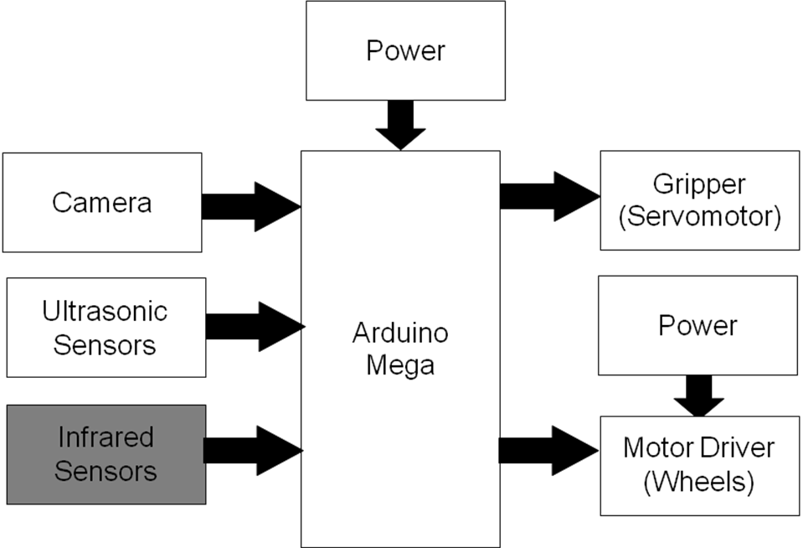
Figure 2: Final Block Diagram
The final assembled robot is seen in figure 3. The positions of the camera, ultrasonic sensors, infrared sensors, and gripper in front of the robot are shown. The battery pack is located near the centre at the top of the wheels to balance the weight, while the lighter microcontroller is placed at the back. The motor driver and the second battery pack are placed in the middle layer along with the proto board.
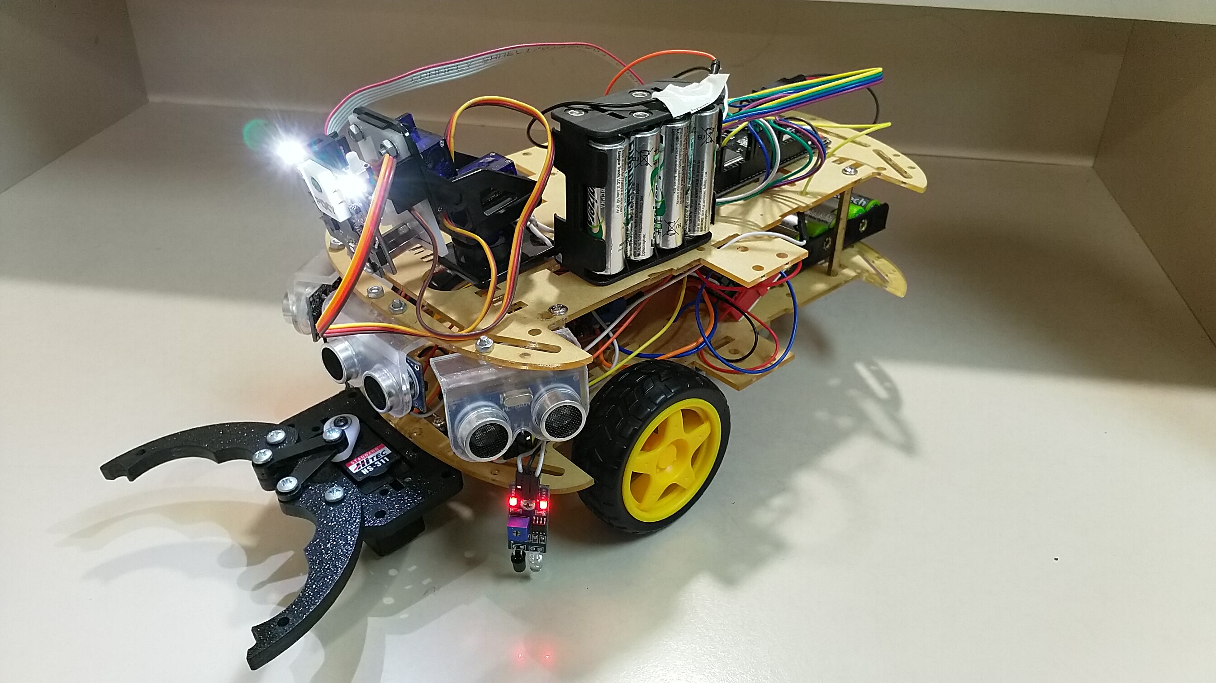
Figure 3: Final Product

Hardware Description

Pixy2 CMUcam5
A camera was chosen as it provides a single sensor solution to the task of visual detection [1]. If a normal camera sensor was used, it might output a lot of data which the chosen microprocessor might not be able to handle and may consume a lot of memory resources. It is for these reasons that Pixy2 CMUcam5 was selected as the vision sensor for this project. A dedicated processor is combined with the image sensor to processes images directly and only sends the useful information to the microcontroller. Interfacing to the microcontroller can be done through SPI which leaves the microcontroller free to do other tasks. Libraries are available for the Arduino which facilitates programming.
The Colour Connected Components (CCC) algorithm, a colour-based filtering algorithm is used by Pixy2 to detect objects. This algorithm was already included with the Pisy2 camera. The Pixy2 filtering algorithm is fast, efficient and robust when lighting and exposure changes are concerned, as the hue remains largely unchanged even with differences in these two parameters. This results in better performance when using the sensor as compared to others.

Arduino Mega
The Arduino Mega board was chosen for this project implementation due to its ease of use and availability of resources. Arduino is an open-source physical computing platform based on a simple I/O board. It has a specialized development environment that implements the Processing/Wiring language. Arduino can be used to develop stand-alone interactive objects or can be connected to software on your computer [2].
Based on the ATmega2560, it has a 16 MHz crystal oscillator, 16 analog inputs, 54 digital input/output pins (of which 14 can be used as PWM outputs), 4 UARTs (hardware serial ports), a USB connection, an ICSP header, a power jack, and a reset button. It has 28 KB of flash memory for storing code (of which 4 KB is used for the bootloader), 8 KB of SRAM and 4 KB of EEPROM. It can be programmed with the Arduino IDE. It is also compatible with shields, extension boards which provide additional functionality to the microcontroller [3].

Gripper with servomotor
The Acrobotics Standard Gripper Kit A driven by a Hitec HS-422 servomotor was chosen for this project. Standard Gripper is capable of opening an 5" wide, and has an overall body dimension of 5" long by 3" wide [4]. It will be driven by the Hitec HS-422 servo which provides delivery of 57 oz-in. of maximum torque at 0.16 sec/60°. Its standard 3-pin power and control cable will be supplied by 6V input [5].

L298N Motor Drive Board Module
The L298N Motor Drive Board Module was chosen for this project for its ease of use and compatibility with Arduino. This Dual H Bridge DC stepper motor drive controller has a logical voltage of 5V and a driving voltage of 0-35V. The logical current can range from 0mA - 36mA and its driving current can be as high as 2A for a single bridge. The maximum power that can be delivered is 25W. [6]

Motors and wheels
For its compatibility with Arduino, the Dagu DC geared motor with rubber wheel was chosen for this project. Able to work with up to 10VDC max, the motor has a gear ratio of 48:1. It has free running current of 70mA at 3V and stall current of 250mA, with 800gf.cm torque. It is 66mm in diameter and 28mm in width. [7]

Infrared sensor
The DIY Smart Car / Robot IR Obstacle Avoidance Sensor Module for Arduino was chosen for this project for its compatibility with Arduino and its availability. It has the ability to work with 3.3-6V DC power supply modules and its output port OUT of the sensor module can be directly connected to the microcontroller IO port. It has a detection distance of 2 - 50cm and can be adjusted through a potentiometer. [8]

Pin connection diagram

The pin diagram has been revised to include the updated parts due to the changes in the proposed design. In summary, these are the changes made:
- Change from Arduino Uno to Arduino Mega to accommodate the additional components.
- IR sensors were added to detect the black border of the area.
- Change from 1 ultrasonic sensor to 3 as the original plan with the servomotor and 1 ultrasonic sensor setup was placed too high and was not able to detect objects in front.
- Additional 8 pack battery was needed as a source for the wheels. One battery pack was not able to supply the current consumed by the other parts resulting in the robot not being able to move.

The pin connection diagram is shown in Figure 2. The figure shows the components included in the system. The Microcontroller, Arduino Mega will be responsible for the control of the 3 ultrasonic sensors on the front, left and right sides of the robot, the 2 infrared sensors on the front left and right, the gripper in front and the motor driver at the centre of the robot. The camera will be connected to the Arduino through its In-Circuit Serial Programming (ICSP) port. The infrared sensors’ OUT pins and the ultrasonic sensors’ ECHO pins are connected to pins 3, 18-21, for them to be assigned to interrupts. The gripper and the ENA and ENB pins were connected to pins 9,5,6 respectively as these pins are capable of PWM output. The pan and tilt servos will not be connected directly to the Arduino, but through the camera. Out of the available 70 pins on the Arduino Mega,18 pins were used. The selected components in the red dashed boxes will be focused on this study. I Pin roles are explained in the pin table as shown in Table 1.

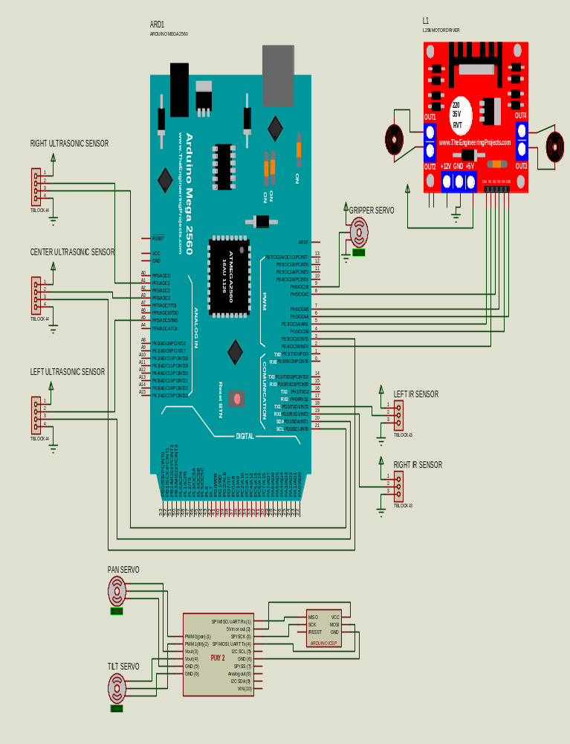
ICSP
Figure 2: Pin connection diagram

Table 1. Pin Table
 | Pin Assign-ment | Analog/  Digital | I/O from  Arduino | Pin Role
Pixy2 Camera
SPI MISO, UART Rx (1) | 50 | D | I | Communication for SPI commands Master In Slave Out pin. Data I coming from Slave (Pixy 2) to the Master (Arduino)
5V in or out (2) | 5V | A | IO | Supply to camera (5V)
SPI SCK (3) | 52 | D | I/O | Communication pin for SPI commands. Gives the clock signal
SPI MOSI, UART Tx (4) | 51 | D | O | Communication for SPI commands Master In Slave Out pin. Data Output coming from the Master (Arduino) to Slave (Pixy 2)
GND (6) | GND | A | O | Ground connection
VIN (10) | 5V | A | O | Supply to camera
Pan/Tilt servo
PWM0 (pan) (1) | 11 | D | O from Pixy2 to pan servo | Controls the left/right camera movement
PWM1 (tilt) (2) | 12 | D | O from Pixy2 to tilt servo | Controls the up/down camera movement
Vout (3) | 5V | A | O | Supply to servo (5V)
Vout (4) | 5V | A | O | Supply to servo (5V)
GND (5) | GND | A | O | Ground connection
GND (6) | GND | A | O | Ground connection
Gripper servo
Input | 9 | D | O | Controls the open/close mechanism
VCC | 5V | A | O | Supply to servo (5V)
GND | GND | A | O | Ground connection
Ultrasonic sensor
Trigger | A3 | D | O | Trigger pin to send pulse
Echo | 3 | D | I | Echo pin to receive pulse
VCC | 5V | A | O | Supply to sensor
GND | GND | A | O | Ground connection
Motor Driver
ENA | 5 | A | O | Pulse modulated I to control the motor speed
ENB | 6 | A | O | Pulse modulated I to control the motor speed
IN1 | 2 | D | O | Controls the motor direction, paired with IN2
IN2 | 8 | D | O | Controls the motor direction, paired with IN1
IN3 | 7 | D | O | Controls the motor direction, paired with IN4
IN4 | 4 | D | O | Controls the motor direction paired with  IN3
VCC | 9.6V | A | O | Separate supply to the motor driver
GND | GND | A | O | Ground connection
Table 1: Pin Table

Software Description
In this section, flowcharts of the program will be presented, along with the appropriate code. Explanation of each block will follow to

Main Loop
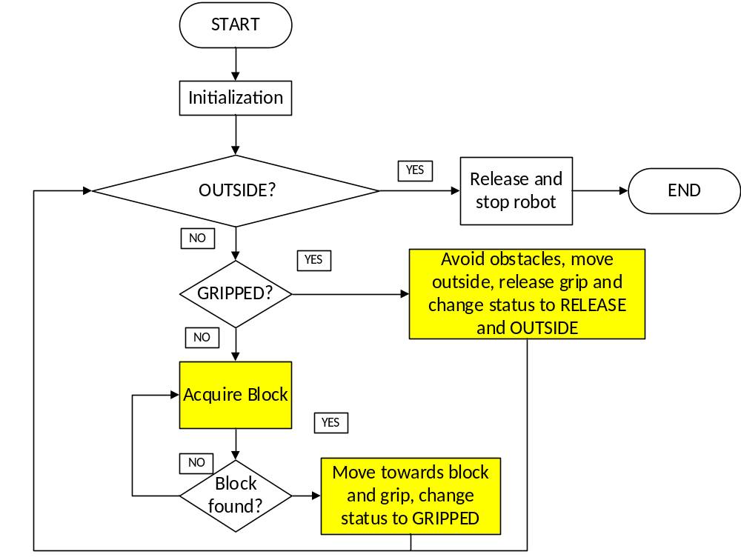
Figure 3. Main Loop Flowchart

Code listing:

void loop()
{
...

if ((gripped==0) && (robot_outside==1))
{
robot_stop();
}

else if ((gripped==1)&&(robot_outside==0))
{
gripper_servo.write(140);
...

if ((sensorLeftOut==HIGH)||(sensorRightOut==HIGH))
{
robot_outside=1;
}
if (robot_outside)
{
gripped=0;
...
}

}
else if ((gripped==0) && (robot_outside==0))
{
pixy.ccc.getBlocks();

if (index==-1) // search....
{
Serial.println("Searching for block...");
index = acquireBlock();

if (index>=0)
Serial.println("Found block!");
}
// If we've found a block, find it, track it
if (index>=0)
{
block = trackBlock(index);
}
// If we're able to track it, move motors toward block
if (block)
{
...

}
else // no object detected, stop motors, go into search state
{
robot_stop();
index = -1; // set search state
}
}

else // no object detected, stop motors, go into search state
{
robot_stop();
index = -1; // set search state
}

}

The code which controls the current state the robot is in and the appropriate actions that it takes are shown in Figure 3 flowchart and code listing above. At first, all the settings are initialized. The robot then checks which state is it in. If the grip is released and the robot has already detected the border, the robot will stop. If the robot is still holding the object and has not yet detected the border, then it will search for the border while pushing the object and using the ultrasonic sensors and the camera to avoid obstacles. Once it detects the border, it will change state to “outside and released”, and release the object, meaning change gripped to 0. If the robot has not yet grabbed the object and is still inside, then it will search for the block. Once it finds the object, it will change state to “gripped”.

Acquire Block Function

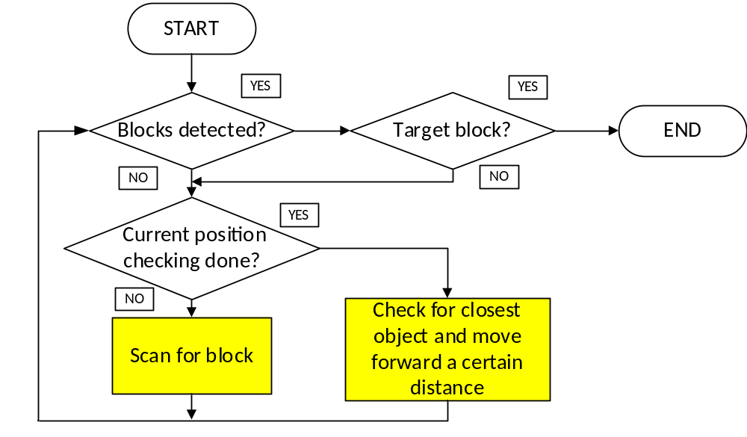
Figure 4. Acquire Block Function Flowchart

Code listing:

//Look for the block
int16_t acquireBlock()
{
uint8_t i;
if (pixy.ccc.getBlocks())
{
for (i=0; i<pixy.ccc.numBlocks; i++)
{
if (pixy.ccc.blocks[i].m_signature==signatureToFind)
{
robot_stop;
return pixy.ccc.blocks[i].m_index;
}
else
{
moving_robot();
robot_stop();
delay(100);
pixy.ccc.getBlocks();
if (pixy.ccc.getBlocks())
{
for (i=0; i<pixy.ccc.numBlocks; i++)
{
if (pixy.ccc.blocks[i].m_signature==signatureToFind)
{
robot_stop;
return pixy.ccc.blocks[i].m_index;
}
}
}
scanningforblocks();
}
}
}
else
{

moving_robot();
robot_stop();
delay(100);
pixy.ccc.getBlocks();
if (pixy.ccc.getBlocks())
{
for (i=0; i<pixy.ccc.numBlocks; i++)
{
if (pixy.ccc.blocks[i].m_signature==signatureToFind)
{
robot_stop;
return pixy.ccc.blocks[i].m_index;
}
}
}
scanningforblocks();

}

return -1;

}
In this function, the camera checks if there are blocks whose colour signatures are detected. If there are blocks, then it checks whether the target block’s signature is detected. If detected, then it exits the block. If not, it continues to search in its current position or moves a little to the closest block and then scans from that position.

Moving Robot Function

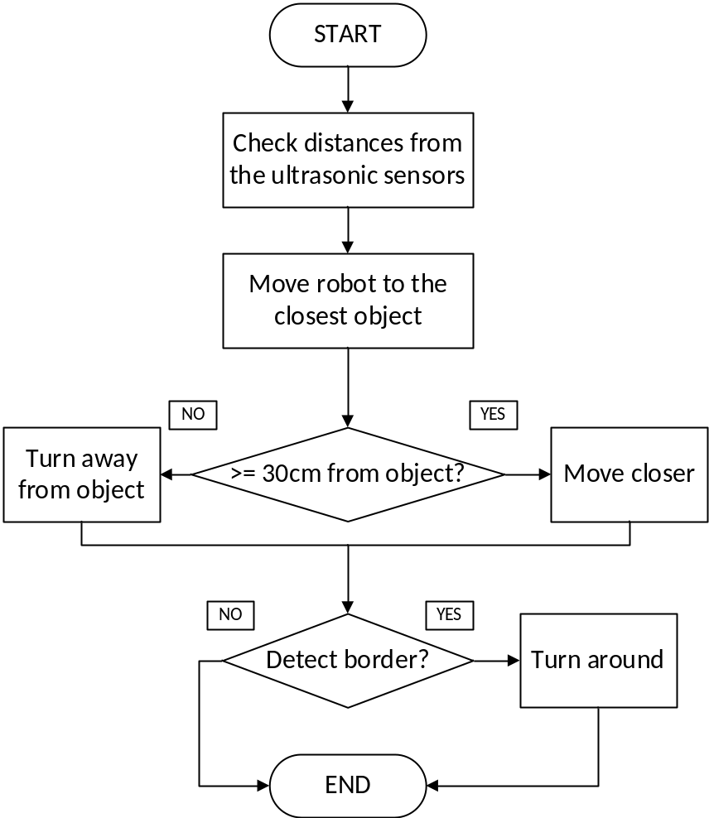
Figure 5. Moving Robot Function Flowchart

Code listing:

void moving_robot(){
int i=0;
if (scantimes==3)
{
distance_front = ultrasonic_front.Ranging(CM);
distance_left = ultrasonic_left.Ranging(CM);
distance_right = ultrasonic_right.Ranging(CM);
sensorLeftOut = digitalRead(irLeftPin);
sensorRightOut = digitalRead(irRightPin);
if ((distance_left<distance_right)&&(distance_left<distance_front))
{
if (distance_left<=30)
{
robot_right();
delay(200);
}
else
{
robot_left();
delay(200);
}
}
else if((distance_right<distance_left)&&(distance_right<distance_front))
{
...

}
else if((distance_front<distance_left)&&(distance_front<distance_right))
{
...
}

if ((distance_front>=30)&&(distance_left>=30)&&(distance_right>=30)&&(sensorLeftOut==LOW)&&(sensorRightOut==LOW))
{
distance_front = ultrasonic_front.Ranging(CM);
distance_left = ultrasonic_left.Ranging(CM);
distance_right = ultrasonic_right.Ranging(CM);
sensorLeftOut = digitalRead(irLeftPin);
sensorRightOut = digitalRead(irRightPin);
motors.setLeftSpeed(+100);
motors.setRightSpeed(+100);
delay(1000);

}
scantimes=0;
if (hitborder==1)
{
robot_back();
delay(1000);
turnaround();
hitborder=0;
}
}

}

In this function, the program checks first if the robot has finished scanning the current position, If it has finished, then the ultrasonic sensors are checked and then they are compared with each other to get to decide what direction the robot will be facing. If the robot’s distance is less than 30cm then it faces the opposite direction, otherwise it will continue moving in the current direction. The border detection is actually in an external interrupt and will be activated once the border is detected. But since there cannot be delays in the actual interrupt service routine, then the actual process of turning around is written in this block.

Scanning for Block Function

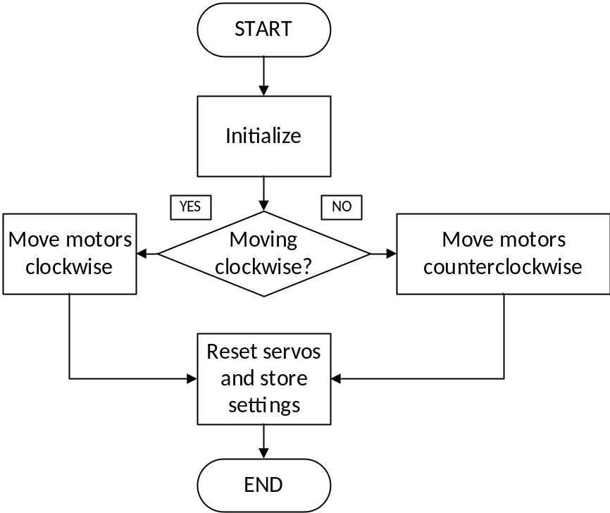
Figure 6. Scanning for Block Function Flowchart

Code listing:

void scanningforblocks(){
panLoop.m_command=550;
tiltLoop.m_command=550;
if (scantimes%2==0)
{
motors.setLeftSpeed(+100);
motors.setRightSpeed(-100);
}
else
{
motors.setLeftSpeed(-100);
motors.setRightSpeed(+100);
}
delay(random(200,1000));
analogWrite(ENA, 0); //set PWM to Motor 1
analogWrite(ENB, 0); //set PWM to Motor 2
delay(2000);
pixy.setServos(panLoop.m_command, tiltLoop.m_command);
scantimes++;

}
This function checks if the current direction to scan for the object is clockwise or counterclockwise and then turns in that direction for some random time. It then resets the servos of the pan tilt mechanism and stores the current direction so that it will scan on the opposite direction the next time that the function is called.

Moving to Block Function

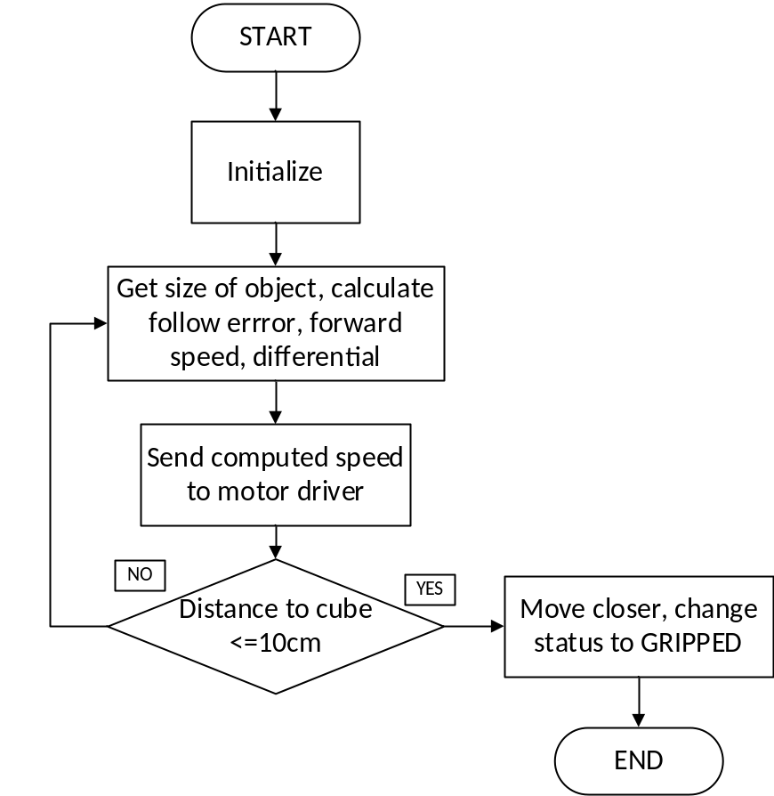
Figure 7. Moving to Block Function Flowchart
Code listing:

if (block)
{
robot_stop;
//check distance
distance = ultrasonic_front.Ranging(CM);
if ((block->m_signature==signatureToFind)&& (gripped==0))
{
distance = ultrasonic_front.Ranging(CM);
if ((distance <= 10)&&(block->m_y>(((int32_t)pixy.frameHeight*0.5))))
{
motors.setLeftSpeed(+100);
motors.setRightSpeed(+100);
delay(1000);
robot_stop();
//grip object
gripped=1;
signatureToFind=3;
panLoop.m_command = 550;
tiltLoop.m_command = 400;
pixy.setServos(panLoop.m_command, tiltLoop.m_command);
delay(2000);
}
// calculate translate and rotate errors
int32_t obj_size = 400;
int32_t followError = (int32_t)pixy.frameWidth/2 - block->m_x; // How far off-center are we looking now?
int32_t trackedBlock=block->m_index;
// Size is the area of the object.
// We keep a running average of the last 8.
obj_size += pixy.ccc.blocks[trackedBlock].m_width * pixy.ccc.blocks[trackedBlock].m_height;
obj_size -= obj_size >> 3;
// Forward speed decreases as we approach the object (size is larger)
int32_t forwardSpeed = constrain(120 - (obj_size/600), 0, 120);
// Steering differential is proportional to the error times the forward speed
int32_t differential = (followError + (followError * forwardSpeed))>>8;
// Adjust the left and right speeds by the steering differential.
int32_t leftSpeed = constrain(forwardSpeed + differential, 0, 120);
int32_t rightSpeed = constrain(forwardSpeed - differential, 0, 120);
// And set the motor speeds
motors.setLeftSpeed(leftSpeed);
motors.setRightSpeed(rightSpeed);
}

}

This function first computes the area of the cube that the camera is currently seeing, then the follow error or how far off the centre of the object is from the centre of the camera. The object size is computed as the average of the last 8 sizes. The forward speed is computed by dividing the object size by a certain number and subtracting it from the set speed, in this case 120. This is actually the maximum speed set for the motors. Then the steering differential is computed and is proportional to the follow error times the forward speed divided by 8. The left and right speeds are then adjusted by the steering differential; the left speed is computed as the forward speed plus the differential while the right speed is computed as the forward speed minus the differential. The computed speeds are sent to the left and right motors. This is actually an implementation of proportional and derivative control on the motors, the speed is dependent on some factors that the robot is sensing, and in this case as the robot moves closer to the object it moves at a slower speed. Once the robot’s distance is enough, then it will change state to GRIPPED, then change target colour to avoid and tilt the camera upward to increase the range of vision.

Moving out of the area Function
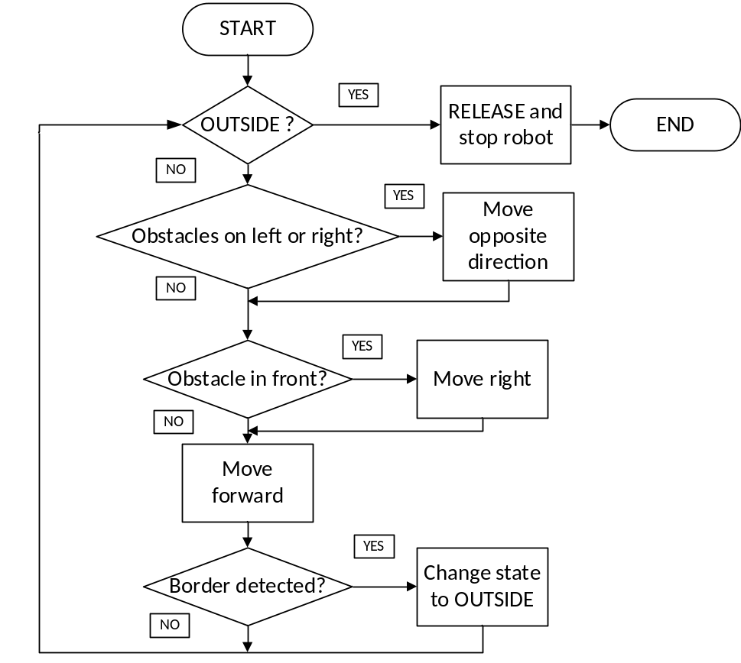
Figure 8. Moving out of the area Function Flowchart

Code listing:

else if ((gripped==1)&&(robot_outside==0))
{
gripper_servo.write(140);
if((sensorLeftOut==LOW)&&(sensorRightOut==LOW))
{
distance_left = ultrasonic_left.Ranging(CM);
distance_right = ultrasonic_right.Ranging(CM);
sensorLeftOut = digitalRead(irLeftPin);
sensorRightOut = digitalRead(irRightPin);
if (distance_right<=30)
{
robot_left();
delay(300);
}
else if(distance_left<=30)
{
robot_right();
delay(300);
}
else
{
robot_forward();
}

robot_stop();
delay(2000);
pixy.ccc.getBlocks();
if (pixy.ccc.getBlocks())
{
for (i=0; i<pixy.ccc.numBlocks; i++)
{
if ((pixy.ccc.blocks[i].m_signature==3)&& (gripped==1))
{
robot_right;
delay(1000);
}
}
}
motors.setLeftSpeed(+100);
motors.setRightSpeed(+100);
delay(1000);
}
if (robot_outside)
{
gripped=0;
motors.setLeftSpeed(+100);
motors.setRightSpeed(+100);
delay(1000);
robot_stop();
gripper_servo.write(180);
delay(1000);
}
}

Results
The robot was able to detect the blue cube object and move it out of the area and stop after releasing the cube. However during testing,it can be noted that the camera had a hard time detecting colour when lighting changes, and sometimes loses the object upon close range. One solution was to cover all the windows in the room to control the light. The algorithm developed for movement was slow to allow the camera to detect colours for a sufficient time. The inclusion of randomness in the scanning does not help the whole process to go faster, it seems at times that the robot is only going around in circles detecting the object. The speed of the robot moving towards the object is when the object is not in the centre of the camera also is a little difficult to control as it is difficult to find the correct combination for the forward speed and differential; increasing forward speed might cause the robot to overshoot and miss the target, decreasing it might cause the robot to stop in the middle of the area. In this regard, the speed was adjusted so that the motors will keep on moving at a minimum speed to avoid stopping during its movement. The gripper, due to it being beyond the range of the sensors on the left and right, sometimes hits obstacles during the scanning state even when checked. The angle at which the robot approaches the object is also an issue as sometimes the gripper does not grab the object completely and slides out of the gripper. To solve this, the cube is pushed forward more so that the cube’s face is inside the gripper; however, this is not very accurate as sometimes the cube does not turn as expected, so the gripper will close without the object.

Time plan and Budget
The time plan is updated to reflect the changes to the schedule and the actual hours that were utilized. In the calculation, the total number of hours that were consumed is now at 381, exceeding the budget by 61 hours and incurring a loss of $1220 when computed at the rate of $20 per hour. This is due to the issues concerning the camera testing and the work for the additional infrared sensors. Some of the components were also changed and these are reflected in the current budget. The current cost of the project is now $432.28, an additional $113.59 from the original budget. Please see the appendix for the detailed time plan and budget.

Conclusion
This paper presents the development of an autonomous robot for the robotics competition. The robot developed in this study is capable of meeting its objective of object detection and movement. However, there are limitations to this, as the lighting affects the colour recognition of the camera and the causes the robot to lose sight of the object at closer distances. The speed is also difficult to control, and may cause the robot to miss the object or stop unnecessarily. The gripper extending beyond the sensing range of the ultrasonic sensors is also difficult to consider when moving and avoiding obstacles; sometimes the robot still hits some obstacles even if there are checks in place.

References
[1]Pixy2 "Pixy2 Overview”Docs.pixycam.com, 2018. [Online]. Available: https://docs.pixycam.com/wiki/doku.php?id=wiki:v2:overview. [Accessed: 12- Nov- 2018].
[2]MindKits "Arduino Mega 2560 R3", MindKits, 2018. [Online]. Available: http://www.mindkits.co.nz/store/p/6056-Arduino-Mega-2560-R3.aspx. [Accessed: 28- Mar- 2019.
[3]Arduino "Arduino - ArduinoBoardMega", Arduino.cc, 2018. [Online]. Available: https://www.arduino.cc/en/Main/arduinoBoardMega/. [Accessed: 28- Mar- 2019].
[4] SparkFun Electronics "Standard Gripper Kit A - Channel Mount - ROB-13174 - SparkFun Electronics", Sparkfun.com, 2018. [Online]. Available: https://www.sparkfun.com/products/13174. [Accessed: 12- Nov- 2018].
[5] SparkFun Electronics "Servo - Hitec HS-422 (Standard Size) - ROB-11884 - SparkFun Electronics", Sparkfun.com, 2018. [Online]. Available: https://www.sparkfun.com/products/11884. [Accessed: 12- Nov- 2018].
[6] Gearbest "L298N Motor Drive Board Module", gearbest.com, 2018. [Online]. Available: https://www.gearbest.com/other-accessories/pp_226466.html. [Accessed: 12- Nov- 2018].
[7] TechBrands "TechBrands New Zealand - DC Geared Motor with Rubber Wheel", Techbrands.co.nz, 2018. [Online]. Available: https://www.techbrands.co.nz/store/product/yg2900.aspx. [Accessed: 12- Nov- 2018].
[8] Gearbest "DIY Smart Car / Robot IR Obstacle Avoidance Sensor Module for Arduino", gearbest.com, 2019. [Online]. Available: https://www.gearbest.com/other-accessories/pp_009214597666.html?wid=1433363. [Accessed: 10- Jun- 2019].

Gantt Chart
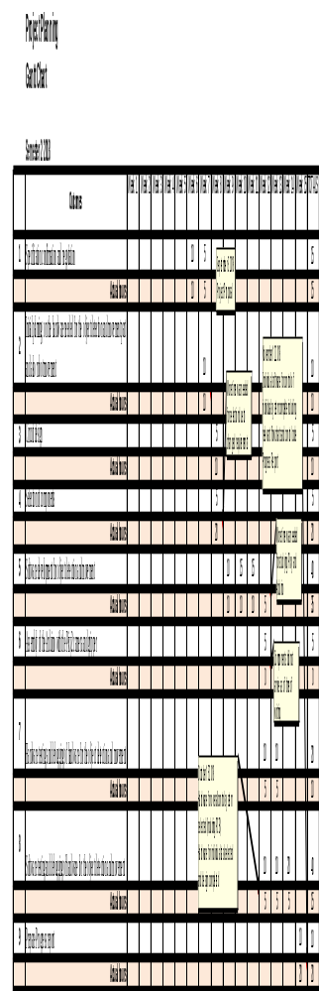

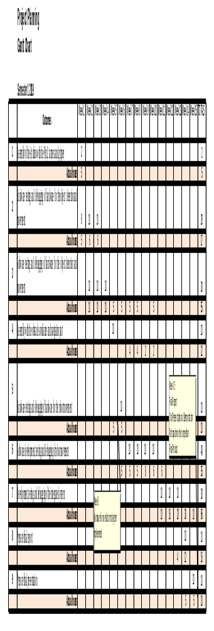

Budget

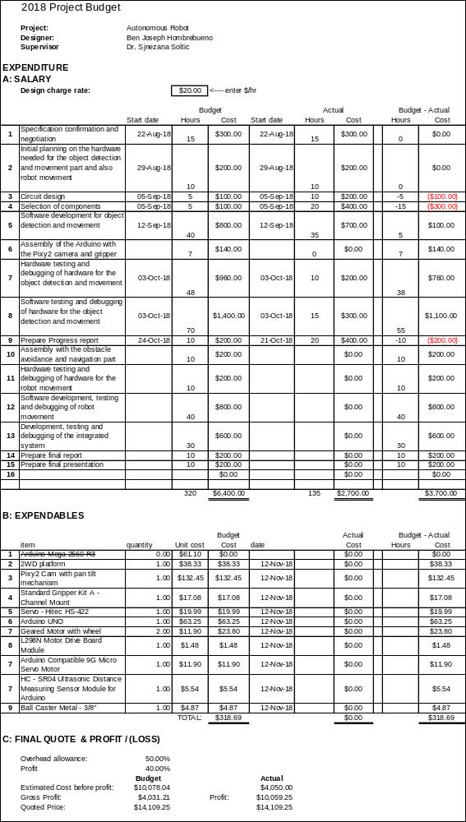
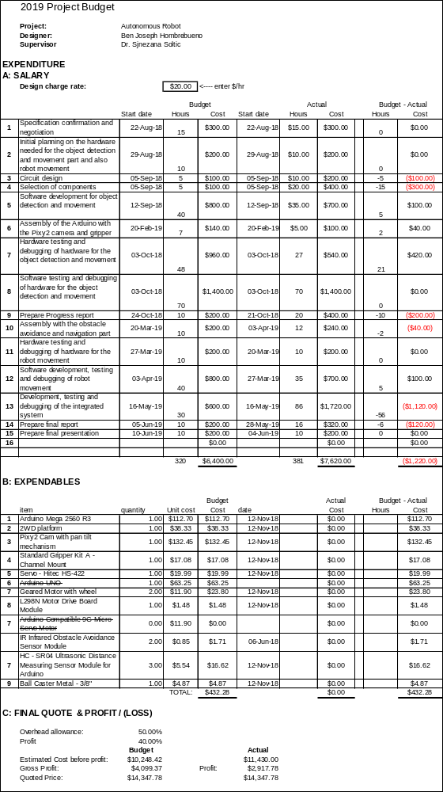

Code Listing

#include <SPI.h>
#include <Servo.h>
#include <Wire.h>
#include "Ultrasonic.h"
#include "PIDLoop.h"
#include "Motors.h"
#include "Pixy2.h"

#define X_CENTER 160L
#define Y_CENTER 100L
#define RCS_MIN_POS 0L
#define RCS_MAX_POS 1000L
#define RCS_CENTER_POS ((RCS_MAX_POS-RCS_MIN_POS)/2)
#define MAX_TRANSLATE_VELOCITY 250
//define motor A related pins
#define IN1 2
#define IN2 8
#define ENA 5
//define motor B related pins
#define IN3 7
#define IN4 4
#define ENB 6
//define servo pin
#define GRIPPER_SERVO 9

Pixy2 pixy;
Servo gripper_servo;
Servo ultrasonic_servo;
int irLeftPin = 18;
int irRightPin = 19;
volatile int sensorLeftOut = LOW;
volatile int sensorRightOut = LOW;
Ultrasonic ultrasonic_front(A3 ,3);
Ultrasonic ultrasonic_left(A5 ,20);
Ultrasonic ultrasonic_right(A1 ,21);
Motors motors;
volatile int gripped=0;
volatile int signatureToFind=2;
volatile int scantimes=0;
volatile int distance_front=0;
volatile int distance_left=0;
volatile int distance_right=0;
volatile int robot_outside=0;
volatile int hitborder=0;
PIDLoop panLoop(350, 0, 600, true);
PIDLoop tiltLoop(500, 0, 700, true);

void setup()
{
Serial.begin(9600);
Serial.print("Starting...\n");

pixy.init();

//initialize servo
gripper_servo.attach(GRIPPER_SERVO);
gripper_servo.write(180);

//set output for motor 1 related pins
pinMode(IN1, OUTPUT);
pinMode(IN2, OUTPUT);
pinMode(ENA, OUTPUT);

//set output for motor 2 related pins
pinMode(IN3, OUTPUT);
pinMode(IN4, OUTPUT);
pinMode(ENB, OUTPUT);

//initialize IR sensor pins
pinMode(irLeftPin, INPUT);
pinMode(irRightPin, INPUT);
attachInterrupt(digitalPinToInterrupt(irLeftPin), IR_ISR, CHANGE);
attachInterrupt(digitalPinToInterrupt(irRightPin), IR_ISR, CHANGE);

//initialize Ultrasonic sensor pins
pinMode(3,INPUT);
pinMode(20,INPUT);
pinMode(21,INPUT);
}

void loop()
{
static int16_t index = -1;
int32_t panOffset, tiltOffset, headingOffset, left, right;
Block *block=NULL;

volatile int distance;
int i=0;

pixy.setLamp(255,0);

if ((gripped==0)&& (robot_outside==1))
{
robot_stop();
}

else if ((gripped==0) && (robot_outside==0))
{
pixy.ccc.getBlocks();

if (index==-1) // search....
{
Serial.println("Searching for block...");
index = acquireBlock();

if (index>=0)
Serial.println("Found block!");
}
// If we've found a block, find it, track it
if (index>=0)
{
block = trackBlock(index);
}
// If we're able to track it, move motors
if (block)
{
robot_stop;
//check distance
distance = ultrasonic_front.Ranging(CM);
if ((block->m_signature==signatureToFind)&& (gripped==0))
{
distance = ultrasonic_front.Ranging(CM);
if ((distance <= 10)&&(block->m_y>(((int32_t)pixy.frameHeight*0.5))))
{
motors.setLeftSpeed(+100);
motors.setRightSpeed(+100);
delay(1000);
robot_stop();
//grip object
gripped=1;
signatureToFind=3;
panLoop.m_command = 550;
tiltLoop.m_command = 400;
pixy.setServos(panLoop.m_command, tiltLoop.m_command);
delay(2000);
}
// calculate translate and rotate errors
int32_t obj_size = 400;
int32_t followError = (int32_t)pixy.frameWidth/2 - block->m_x; // How far off-center are we looking now?
int32_t trackedBlock=block->m_index;
// Size is the area of the object.
// We keep a running average of the last 8.
obj_size += pixy.ccc.blocks[trackedBlock].m_width * pixy.ccc.blocks[trackedBlock].m_height;
obj_size -= obj_size >> 3;
// Forward speed decreases as we approach the object (size is larger)
int32_t forwardSpeed = constrain(120 - (obj_size/600), 0, 120);
// Steering differential is proportional to the error times the forward speed
int32_t differential = (followError + (followError * forwardSpeed))>>8;
// Adjust the left and right speeds by the steering differential.
int32_t leftSpeed = constrain(forwardSpeed + differential, 0, 120);
int32_t rightSpeed = constrain(forwardSpeed - differential, 0, 120);
// And set the motor speeds
motors.setLeftSpeed(leftSpeed);
motors.setRightSpeed(rightSpeed);

}

}
else // no object detected, stop motors, go into search state
{
robot_stop();
index = -1; // set search state
}
}
else if ((gripped==1)&&(robot_outside==0))
{
gripper_servo.write(140);
if((sensorLeftOut==LOW)&&(sensorRightOut==LOW))
{
distance_left = ultrasonic_left.Ranging(CM);
distance_right = ultrasonic_right.Ranging(CM);
sensorLeftOut = digitalRead(irLeftPin);
sensorRightOut = digitalRead(irRightPin);
if (distance_right<=30)
{
robot_left();
delay(300);
}
else if(distance_left<=30)
{
robot_right();
delay(300);
}
else
{
robot_forward();
}

robot_stop();
delay(2000);
pixy.ccc.getBlocks();
if (pixy.ccc.getBlocks())
{
for (i=0; i<pixy.ccc.numBlocks; i++)
{
if ((pixy.ccc.blocks[i].m_signature==3)&& (gripped==1))
{
robot_right;
delay(1000);
}
}
}
motors.setLeftSpeed(+100);
motors.setRightSpeed(+100);
delay(1000);
}

if (robot_outside)
{
gripped=0;
motors.setLeftSpeed(+100);
motors.setRightSpeed(+100);
delay(1000);
robot_stop();
gripper_servo.write(180);
delay(1000);
}

}

else // no object detected, stop motors, go into search state
{
robot_stop();
index = -1; // set search state
}

}

void robot_stop()
{
digitalWrite(IN1, LOW);
digitalWrite(IN2, LOW);
digitalWrite(IN3, LOW);
digitalWrite(IN4, LOW);
analogWrite(ENA, 0); //set PWM to Motor 1
analogWrite(ENB, 0); //set PWM to Motor 2
}

void robot_forward()
{
motors.setLeftSpeed(100);
motors.setRightSpeed(100);
}

void robot_back()
{
motors.setLeftSpeed(-100);
motors.setRightSpeed(-100);
}
void robot_right()
{
motors.setLeftSpeed(+100);
motors.setRightSpeed(-100);
}

void robot_left()
{
motors.setLeftSpeed(-100);
motors.setRightSpeed(+100);
}

void turnaround()
{
motors.setLeftSpeed(+100);
motors.setRightSpeed(-100);
delay(300);
motors.setLeftSpeed(-100);
motors.setRightSpeed(-100);
delay(300);
motors.setLeftSpeed(100);
motors.setRightSpeed(100);
delay(1000);
}

void IR_ISR()
{
sensorLeftOut = digitalRead(irLeftPin);
sensorRightOut = digitalRead(irRightPin);
if ((sensorLeftOut == HIGH)||(sensorRightOut == HIGH))
{
if (gripped==0)
{
hitborder=1;
}
else if (gripped==1)
{
robot_outside=1;
}

}

}
//Check for the block in current position
void scanningforblocks(){
panLoop.m_command=550;
tiltLoop.m_command=550;
if (scantimes%2==0)
{
motors.setLeftSpeed(+100);
motors.setRightSpeed(-100);
}
else
{
motors.setLeftSpeed(-100);
motors.setRightSpeed(+100);
}
delay(random(200,1000));
analogWrite(ENA, 0); //set PWM to Motor 1
analogWrite(ENB, 0); //set PWM to Motor 2
delay(2000);
pixy.setServos(panLoop.m_command, tiltLoop.m_command);
scantimes++;
}

//Look for the block
int16_t acquireBlock()
{
uint8_t i;
if (pixy.ccc.getBlocks())
{
for (i=0; i<pixy.ccc.numBlocks; i++)
{
if (pixy.ccc.blocks[i].m_signature==signatureToFind)
{
robot_stop;
return pixy.ccc.blocks[i].m_index;
}
else
{
moving_robot();
robot_stop();
delay(100);
pixy.ccc.getBlocks();
if (pixy.ccc.getBlocks())
{
for (i=0; i<pixy.ccc.numBlocks; i++)
{
if (pixy.ccc.blocks[i].m_signature==signatureToFind)
{
robot_stop;
return pixy.ccc.blocks[i].m_index;
}
}
}
scanningforblocks();
}
}
}
else
{
moving_robot();
robot_stop();
delay(100);
pixy.ccc.getBlocks();
if (pixy.ccc.getBlocks())
{
for (i=0; i<pixy.ccc.numBlocks; i++)
{
if (pixy.ccc.blocks[i].m_signature==signatureToFind)
{
robot_stop;
return pixy.ccc.blocks[i].m_index;
}
}
}
scanningforblocks();

}

return -1;

}

void moving_robot(){
int i=0;
if (scantimes==3)
{
distance_front = ultrasonic_front.Ranging(CM);
distance_left = ultrasonic_left.Ranging(CM);
distance_right = ultrasonic_right.Ranging(CM);
sensorLeftOut = digitalRead(irLeftPin);
sensorRightOut = digitalRead(irRightPin);
if ((distance_left<distance_right)&&(distance_left<distance_front))
{
if (distance_left<=30)
{
robot_right();
delay(200);
}
else
{
robot_left();
delay(200);
}
}
else if((distance_right<distance_left)&&(distance_right<distance_front))
{
if (distance_right<=30)
{
robot_left();
delay(200);
}
else
{
robot_right();
delay(200);
}

}
else if((distance_front<distance_left)&&(distance_front<distance_right))
{
if (distance_front<=30)
{
robot_back();
delay(400);
turnaround();
}
else
{
robot_forward();
delay(200);
}
}

if ((distance_front>=30)&&(distance_left>=30)&&(distance_right>=30)&&(sensorLeftOut==LOW)&&(sensorRightOut==LOW))
{
distance_front = ultrasonic_front.Ranging(CM);
distance_left = ultrasonic_left.Ranging(CM);
distance_right = ultrasonic_right.Ranging(CM);
sensorLeftOut = digitalRead(irLeftPin);
sensorRightOut = digitalRead(irRightPin);
motors.setLeftSpeed(+100);
motors.setRightSpeed(+100);
delay(1000);

}
scantimes=0;
if (hitborder==1)
{
robot_back();
delay(1000);
turnaround();
hitborder=0;
}
}

}

// Find the block with the given index. In other words, find the same object in the current
// frame -- not the biggest object, but he object we've locked onto in acquireBlock()
// If it's not in the current frame, return NULL
Block *trackBlock(uint8_t index)
{
uint8_t i;

for (i=0; i<pixy.ccc.numBlocks; i++)
{
if (index==pixy.ccc.blocks[i].m_index)
return &pixy.ccc.blocks[i];
}

return NULL;
}

Motors.cpp

#include "Motors.h"

//#define PWM_L 10
//#define PWM_R 9
//#define DIR_L 8
//#define DIR_R 7

//#if defined(__AVR_ATmega168__) || defined(__AVR_ATmega328P__) || defined (__AVR_ATmega32U4__)
// #define USE_20KHZ_PWM
//#endif

//define motor A related pins
#define IN1 2
#define IN2 8
#define ENA 5

//define motor B related pins
#define IN3 7
#define IN4 4
#define ENB 6

static boolean flipLeft = false;
static boolean flipRight = false;

// constructor (doesn't do anything)
Motors::Motors()
{
}

// initialize timer1 to generate the proper PWM outputs to the motor drivers
void Motors::init2()
{
//set output for motor 1 related pins
pinMode(IN1, OUTPUT);
pinMode(IN2, OUTPUT);
pinMode(ENA, OUTPUT);

//set output for motor 2 related pins
pinMode(IN3, OUTPUT);
pinMode(IN4, OUTPUT);
pinMode(ENB, OUTPUT);

/* #ifdef USE_20KHZ_PWM
// Timer 1 configuration
// prescaler: clockI/O / 1
// outputs enabled
// phase-correct PWM
// top of 400
//
// PWM frequency calculation
// 16MHz / 1 (prescaler) / 2 (phase-correct) / 400 (top) = 20kHz
TCCR1A = 0b10100000;
TCCR1B = 0b00010001;
ICR1 = 400;
#endif */
}

// enable/disable flipping of left motor
void Motors::flipLeftMotor(boolean flip)
{
flipLeft = flip;
}

// enable/disable flipping of right motor
void Motors::flipRightMotor(boolean flip)
{
flipRight = flip;
}

// set speed for left motor; speed is a number between -400 and 400
void Motors::setLeftSpeed(int speed)
{
init(); // initialize if necessary

boolean reverse = 0;
int sendspeed=0;
if (speed < 0)
{
speed = -speed; // make speed a positive quantity
reverse = 1; // preserve the direction
}
if (speed > 400) // Max
speed = 400;

// #ifdef USE_20KHZ_PWM
// OCR1B = speed;
//else
//sendspeed=speed * 51 / 80;
// sendspeed=speed;
// if ((sendspeed>50) && (sendspeed<100)){
// sendspeed=100;
// }

//sendspeed=map(speed,0, 120, 80,120);
if (speed<100)
{
sendspeed=speed+30;
}
else
{
sendspeed=speed;
}

analogWrite(ENA, sendspeed); // default to using analogWrite, mapping 400 to 255
//#endif

if (reverse ^ flipLeft){ // flip if speed was negative or flipLeft setting is active, but not both
//digitalWrite(DIR_L, HIGH);

digitalWrite(IN1, HIGH);
digitalWrite(IN2, LOW);
}

else
{
//digitalWrite(DIR_L, LOW) ;
digitalWrite(IN1, LOW);
digitalWrite(IN2, HIGH);
}
}

// set speed for right motor; speed is a number between -400 and 400
void Motors::setRightSpeed(int speed)
{
init(); // initialize if necessary

boolean reverse = 0;
int sendspeed=0;
if (speed < 0)
{
speed = -speed; // Make speed a positive quantity
reverse = 1; // Preserve the direction
}
if (speed > 400) // Max PWM dutycycle
speed = 400;

//#ifdef USE_20KHZ_PWM
// OCR1A = speed;
//#else
//sendspeed=speed * 51 / 80;

// if ((sendspeed>50) && (sendspeed<100)){
// sendspeed=100;
// }
// sendspeed=map(speed,0, 120, 80,120);
if (speed<100)
{
sendspeed=speed+30;
}
else
{
sendspeed=speed;
}

analogWrite(ENB, sendspeed); // default to using analogWrite, mapping 400 to 255
//#endif

if (reverse ^ flipRight){ // flip if speed was negative or flipRight setting is active, but not both
//digitalWrite(DIR_R, HIGH);
digitalWrite(IN3, HIGH);
digitalWrite(IN4, LOW);
Serial.println("right reverse");
}
else
{
//digitalWrite(DIR_R, LOW);
digitalWrite(IN3, LOW);
digitalWrite(IN4, HIGH);
}
}
// set speed for both motors
void Motors::setSpeeds(int leftSpeed, int rightSpeed)
{
setLeftSpeed(leftSpeed);
setRightSpeed(rightSpeed);
}
Motors.h

#ifndef Motors_h
#define Motors_h

#include <Arduino.h>

class Motors
{
public:

// constructor (doesn't do anything)
Motors();

// enable/disable flipping of motors
static void flipLeftMotor(boolean flip);
static void flipRightMotor(boolean flip);

// set speed for left, right, or both motors
static void setLeftSpeed(int speed);
static void setRightSpeed(int speed);
static void setSpeeds(int leftSpeed, int rightSpeed);

private:

static inline void init()
{
static boolean initialized = false;

if (!initialized)
{
initialized = true;
init2();
}
}

// initializes timer1 for proper PWM generation
static void init2();
};

#endif
//
// begin license header
//
// This file is part of Pixy CMUcam5 or "Pixy" for short
//
// All Pixy source code is provided under the terms of the
// GNU General Public License v2 (http://www.gnu.org/licenses/gpl-2.0.html).
// Those wishing to use Pixy source code, software and/or
// technologies under different licensing terms should contact us at
// cmucam@cs.cmu.edu. Such licensing terms are available for
// all portions of the Pixy codebase presented here.
//
// end license header
//

#include "TPixy2.h"

#define PID_MAX_INTEGRAL 2000
//#define ZUMO_BASE_DEADBAND 20
#define ZUMO_BASE_DEADBAND 100

class PIDLoop
{
public:
PIDLoop(int32_t pgain, int32_t igain, int32_t dgain, bool servo)
{
m_pgain = pgain;
m_igain = igain;
m_dgain = dgain;
m_servo = servo;

reset();
}

void reset()
{
if (m_servo)
m_command = PIXY_RCS_CENTER_POS;
else
m_command = 0;

m_integral = 0;
m_prevError = 0x80000000L;
}

void update(int32_t error)
{
int32_t pid;

if (m_prevError!=0x80000000L)
{
// integrate integral
m_integral += error;
// bound the integral
if (m_integral>PID_MAX_INTEGRAL)
m_integral = PID_MAX_INTEGRAL;
else if (m_integral<-PID_MAX_INTEGRAL)
m_integral = -PID_MAX_INTEGRAL;

// calculate PID term
pid = (error*m_pgain + ((m_integral*m_igain)>>4) + (error - m_prevError)*m_dgain)>>12;

if (m_servo)
{
m_command += pid; // since servo is a position device, we integrate the pid term
if (m_command>PIXY_RCS_MAX_POS)
m_command = PIXY_RCS_MAX_POS;
else if (m_command<PIXY_RCS_MIN_POS)
m_command = PIXY_RCS_MIN_POS;
}
else
{
// Deal with Zumo base deadband
if (pid>0)
pid += ZUMO_BASE_DEADBAND;
else if (pid<0)
pid -= ZUMO_BASE_DEADBAND;
m_command = pid; // Zumo base is velocity device, use the pid term directly
}
}

// retain the previous error val so we can calc the derivative
m_prevError = error;
}

int32_t m_command;

private:
int32_t m_pgain;
int32_t m_igain;
int32_t m_dgain;

int32_t m_prevError;
int32_t m_integral;
bool m_servo;
};

Pixy2.h

//
// begin license header
//
// This file is part of Pixy CMUcam5 or "Pixy" for short
//
// All Pixy source code is provided under the terms of the
// GNU General Public License v2 (http://www.gnu.org/licenses/gpl-2.0.html).
// Those wishing to use Pixy source code, software and/or
// technologies under different licensing terms should contact us at
// cmucam@cs.cmu.edu. Such licensing terms are available for
// all portions of the Pixy codebase presented here.
//
// end license header
//
// Arduino ICSP SPI link class

#ifndef _PIXY2_H
#define _PIXY2_H

#include "TPixy2.h"
#include "SPI.h"

#define PIXY_SPI_CLOCKRATE 2000000

class Link2SPI
{
public:
int8_t open(uint32_t arg)
{
SPI.begin();
SPI.beginTransaction(SPISettings(PIXY_SPI_CLOCKRATE, MSBFIRST, SPI_MODE3));
return 0;
}

void close()
{
SPI.endTransaction();
}

int16_t recv(uint8_t *buf, uint8_t len, uint16_t *cs=NULL)
{
uint8_t i;
if (cs)
*cs = 0;
for (i=0; i<len; i++)
{
buf[i] = SPI.transfer(0x00);
if (cs)
*cs += buf[i];
}
return len;
}

int16_t send(uint8_t *buf, uint8_t len)
{
uint8_t i;
for (i=0; i<len; i++)
SPI.transfer(buf[i]);
return len;
}
};

typedef TPixy2<Link2SPI> Pixy2;

#endif

Pixy2CCC.h
//
// begin license header
//
// This file is part of Pixy CMUcam5 or "Pixy" for short
//
// All Pixy source code is provided under the terms of the
// GNU General Public License v2 (http://www.gnu.org/licenses/gpl-2.0.html).
// Those wishing to use Pixy source code, software and/or
// technologies under different licensing terms should contact us at
// cmucam@cs.cmu.edu. Such licensing terms are available for
// all portions of the Pixy codebase presented here.
//
// end license header
//
// This file is for defining the Block struct and the Pixy template class version 2.
// (TPixy2). TPixy takes a communication link as a template parameter so that
// all communication modes (SPI, I2C and UART) can share the same code.
//

#ifndef _PIXY2CCC_H
#define _PIXY2CCC_H

#define CCC_MAX_SIGNATURE 7

#define CCC_RESPONSE_BLOCKS 0x21
#define CCC_REQUEST_BLOCKS 0x20

// Defines for sigmap:
// You can bitwise "or" these together to make a custom sigmap.
// For example if you're only interested in receiving blocks
// with signatures 1 and 5, you could use a sigmap of
// PIXY_SIG1 | PIXY_SIG5
#define CCC_SIG1 1
#define CCC_SIG2 2
#define CCC_SIG3 4
#define CCC_SIG4 8
#define CCC_SIG5 16
#define CCC_SIG6 32
#define CCC_SIG7 64
#define CCC_COLOR_CODES 128

#define CCC_SIG_ALL 0xff // all bits or'ed together

struct Block
{
// print block structure!
void print()
{
int i, j;
char buf[128], sig[6], d;
bool flag;
if (m_signature>CCC_MAX_SIGNATURE) // color code! (CC)
{
// convert signature number to an octal string
for (i=12, j=0, flag=false; i>=0; i-=3)
{
d = (m_signature>>i)&0x07;
if (d>0 && !flag)
flag = true;
if (flag)
sig[j++] = d + '0';
}
sig[j] = '\0';
sprintf(buf, "CC block sig: %s (%d decimal) x: %d y: %d width: %d height: %d angle: %d index: %d age: %d", sig, m_signature, m_x, m_y, m_width, m_height, m_angle, m_index, m_age);
}
else // regular block. Note, angle is always zero, so no need to print
sprintf(buf, "sig: %d x: %d y: %d width: %d height: %d index: %d age: %d", m_signature, m_x, m_y, m_width, m_height, m_index, m_age);
Serial.println(buf);
}

uint16_t m_signature;
uint16_t m_x;
uint16_t m_y;
uint16_t m_width;
uint16_t m_height;
int16_t m_angle;
uint8_t m_index;
uint8_t m_age;
};

template <class LinkType> class TPixy2;

template <class LinkType> class Pixy2CCC
{
public:
Pixy2CCC(TPixy2<LinkType> *pixy)
{
m_pixy = pixy;
}

int8_t getBlocks(bool wait=true, uint8_t sigmap=CCC_SIG_ALL, uint8_t maxBlocks=0xff);

uint8_t numBlocks;
Block *blocks;

private:
TPixy2<LinkType> *m_pixy;
};

template <class LinkType> int8_t Pixy2CCC<LinkType>::getBlocks(bool wait, uint8_t sigmap, uint8_t maxBlocks)
{
blocks = NULL;
numBlocks = 0;

while(1)
{
// fill in request data
m_pixy->m_bufPayload[0] = sigmap;
m_pixy->m_bufPayload[1] = maxBlocks;
m_pixy->m_length = 2;
m_pixy->m_type = CCC_REQUEST_BLOCKS;

// send request
m_pixy->sendPacket();
if (m_pixy->recvPacket()==0)
{
if (m_pixy->m_type==CCC_RESPONSE_BLOCKS)
{
blocks = (Block *)m_pixy->m_buf;
numBlocks = m_pixy->m_length/sizeof(Block);
return numBlocks;
}
// deal with busy and program changing states from Pixy (we'll wait)
else if (m_pixy->m_type==PIXY_TYPE_RESPONSE_ERROR)
{
if ((int8_t)m_pixy->m_buf[0]==PIXY_RESULT_BUSY)
{
if(!wait)
return PIXY_RESULT_BUSY; // new data not available yet
}
else if ((int8_t)m_pixy->m_buf[0]!=PIXY_RESULT_PROG_CHANGING)
return m_pixy->m_buf[0];
}
}
else
return PIXY_RESULT_ERROR; // some kind of bitstream error

// If we're waiting for frame data, don't thrash Pixy with requests.
// We can give up half a millisecond of latency (worst case)
delayMicroseconds(500);
}
}

#endif

Pixy2SPI_SS.h
//
// begin license header
//
// This file is part of Pixy CMUcam5 or "Pixy" for short
//
// All Pixy source code is provided under the terms of the
// GNU General Public License v2 (http://www.gnu.org/licenses/gpl-2.0.html).
// Those wishing to use Pixy source code, software and/or
// technologies under different licensing terms should contact us at
// cmucam@cs.cmu.edu. Such licensing terms are available for
// all portions of the Pixy codebase presented here.
//
// end license header
//
// Arduino SPI with slave select link class

#ifndef _PIXY2SPI_SS_H
#define _PIXY2SPI_SS_H

#include "TPixy2.h"
#include "SPI.h"

#define PIXY_SPI_CLOCKRATE 2000000

class Link2SPI_SS
{
public:
int8_t open(uint32_t arg)
{
if (arg==PIXY_DEFAULT_ARGVAL)
ssPin = SS; // default slave select pin
else
ssPin = arg;
pinMode(ssPin, OUTPUT);
SPI.begin();
SPI.beginTransaction(SPISettings(PIXY_SPI_CLOCKRATE, MSBFIRST, SPI_MODE1));
return 0;
}

void close()
{
SPI.endTransaction();
}

int16_t recv(uint8_t *buf, uint8_t len, uint16_t *cs=NULL)
{
uint8_t i;
if (cs)
*cs = 0;
digitalWrite(ssPin, LOW);
for (i=0; i<len; i++)
{
buf[i] = SPI.transfer(0x00);
if (cs)
*cs += buf[i];
}
digitalWrite(ssPin, HIGH);
return len;
}

int16_t send(uint8_t *buf, uint8_t len)
{
uint8_t i;
digitalWrite(ssPin, LOW);
for (i=0; i<len; i++)
SPI.transfer(buf[i]);
digitalWrite(ssPin, HIGH);
return len;
}

void setArg(uint16_t arg)
{
}

private:
uint16_t ssPin;
};

typedef TPixy2<Link2SPI_SS> Pixy2SPI_SS;

#endif

TPixy2.h

//
// begin license header
//
// This file is part of Pixy CMUcam5 or "Pixy" for short
//
// All Pixy source code is provided under the terms of the
// GNU General Public License v2 (http://www.gnu.org/licenses/gpl-2.0.html).
// Those wishing to use Pixy source code, software and/or
// technologies under different licensing terms should contact us at
// cmucam@cs.cmu.edu. Such licensing terms are available for
// all portions of the Pixy codebase presented here.
//
// end license header
//
// Main Pixy template class. This class takes a link class and uses
// it to communicate with Pixy over I2C, SPI, UART or USB using the
// Pixy packet protocol.

#ifndef _TPIXY2_H
#define _TPIXY2_H

// uncomment to turn on debug prints to console
#define PIXY_DEBUG

#define PIXY_DEFAULT_ARGVAL 0x80000000
#define PIXY_BUFFERSIZE 0x104
#define PIXY_CHECKSUM_SYNC 0xc1af
#define PIXY_NO_CHECKSUM_SYNC 0xc1ae
#define PIXY_SEND_HEADER_SIZE 4
#define PIXY_MAX_PROGNAME 33

#define PIXY_TYPE_REQUEST_CHANGE_PROG 0x02
#define PIXY_TYPE_REQUEST_RESOLUTION 0x0c
#define PIXY_TYPE_RESPONSE_RESOLUTION 0x0d
#define PIXY_TYPE_REQUEST_VERSION 0x0e
#define PIXY_TYPE_RESPONSE_VERSION 0x0f
#define PIXY_TYPE_RESPONSE_RESULT 0x01
#define PIXY_TYPE_RESPONSE_ERROR 0x03
#define PIXY_TYPE_REQUEST_BRIGHTNESS 0x10
#define PIXY_TYPE_REQUEST_SERVO 0x12
#define PIXY_TYPE_REQUEST_LED 0x14
#define PIXY_TYPE_REQUEST_LAMP 0x16
#define PIXY_TYPE_REQUEST_FPS 0x18

#define PIXY_RESULT_OK 0
#define PIXY_RESULT_ERROR -1
#define PIXY_RESULT_BUSY -2
#define PIXY_RESULT_CHECKSUM_ERROR -3
#define PIXY_RESULT_TIMEOUT -4
#define PIXY_RESULT_BUTTON_OVERRIDE -5
#define PIXY_RESULT_PROG_CHANGING -6

// RC-servo values
#define PIXY_RCS_MIN_POS 0
#define PIXY_RCS_MAX_POS 1000L
#define PIXY_RCS_CENTER_POS ((PIXY_RCS_MAX_POS-PIXY_RCS_MIN_POS)/2)

#include "Pixy2CCC.h"
#include "Pixy2Line.h"
#include "Pixy2Video.h"

struct Version
{
void print()
{
char buf[64];
sprintf(buf, "hardware ver: 0x%x firmware ver: %d.%d.%d %s", hardware, firmwareMajor, firmwareMinor, firmwareBuild, firmwareType);
Serial.println(buf);
}

uint16_t hardware;
uint8_t firmwareMajor;
uint8_t firmwareMinor;
uint16_t firmwareBuild;
char firmwareType[10];
};

template <class LinkType> class TPixy2
{
public:
TPixy2();
~TPixy2();

int8_t init(uint32_t arg=PIXY_DEFAULT_ARGVAL);

int8_t getVersion();
int8_t changeProg(const char *prog);
int8_t setServos(uint16_t s0, uint16_t s1);
int8_t setCameraBrightness(uint8_t brightness);
int8_t setLED(uint8_t r, uint8_t g, uint8_t b);
int8_t setLamp(uint8_t upper, uint8_t lower);
int8_t getResolution();
int8_t getFPS();

Version *version;
uint16_t frameWidth;
uint16_t frameHeight;

// Color connected components, color codes
Pixy2CCC<LinkType> ccc;
friend class Pixy2CCC<LinkType>;

// Line following
Pixy2Line<LinkType> line;
friend class Pixy2Line<LinkType>;

// Video
Pixy2Video<LinkType> video;
friend class Pixy2Video<LinkType>;

LinkType m_link;

private:
int16_t getSync();
int16_t recvPacket();
int16_t sendPacket();

uint8_t *m_buf;
uint8_t *m_bufPayload;
uint8_t m_type;
uint8_t m_length;
bool m_cs;
};

template <class LinkType> TPixy2<LinkType>::TPixy2() : ccc(this), line(this), video(this)
{
// allocate buffer space for send/receive
m_buf = (uint8_t *)malloc(PIXY_BUFFERSIZE);
// shifted buffer is used for sending, so we have space to write header information
m_bufPayload = m_buf + PIXY_SEND_HEADER_SIZE;
frameWidth = frameHeight = 0;
version = NULL;
}

template <class LinkType> TPixy2<LinkType>::~TPixy2()
{
m_link.close();
free(m_buf);
}

template <class LinkType> int8_t TPixy2<LinkType>::init(uint32_t arg)
{
uint32_t t0;
int8_t res;

res = m_link.open(arg);
if (res<0)
return res;

// wait for pixy to be ready -- that is, Pixy takes a second or 2 boot up
// getVersion is an effective "ping". We timeout after 5s.
for(t0=millis(); millis()-t0<5000; )
{
if (getVersion()>=0) // successful version get -> pixy is ready
{
getResolution(); // get resolution so we have it
return PIXY_RESULT_OK;
}
delayMicroseconds(5000); // delay for sync
}
// timeout
return PIXY_RESULT_TIMEOUT;
}

template <class LinkType> int16_t TPixy2<LinkType>::getSync()
{
uint8_t i, j, c, cprev;
int16_t res;
uint16_t start;

// parse bytes until we find sync
for(i=j=0, cprev=0; true; i++)
{
res = m_link.recv(&c, 1);
if (res>=PIXY_RESULT_OK)
{
// since we're using little endian, previous byte is least significant byte
start = cprev;
// current byte is most significant byte
start |= c << 8;
cprev = c;
if (start==PIXY_CHECKSUM_SYNC)
{
m_cs = true;
return PIXY_RESULT_OK;
}
if (start==PIXY_NO_CHECKSUM_SYNC)
{
m_cs = false;
return PIXY_RESULT_OK;
}
}
// If we've read some bytes and no sync, then wait and try again.
// And do that several more times before we give up.
// Pixy guarantees to respond within 100us.
if (i>=4)
{
if (j>=4)
{
#ifdef PIXY_DEBUG
Serial.println("error: no response");
#endif
return PIXY_RESULT_ERROR;
}
delayMicroseconds(25);
j++;
i = 0;
}
}
}

template <class LinkType> int16_t TPixy2<LinkType>::recvPacket()
{
uint16_t csCalc, csSerial;
int16_t res;

res = getSync();
if (res<0)
return res;

if (m_cs)
{
res = m_link.recv(m_buf, 4);
if (res<0)
return res;

m_type = m_buf[0];
m_length = m_buf[1];

csSerial = *(uint16_t *)&m_buf[2];

res = m_link.recv(m_buf, m_length, &csCalc);
if (res<0)
return res;

if (csSerial!=csCalc)
{
#ifdef PIXY_DEBUG
Serial.println("error: checksum");
#endif
return PIXY_RESULT_CHECKSUM_ERROR;
}
}
else
{
res = m_link.recv(m_buf, 2);
if (res<0)
return res;

m_type = m_buf[0];
m_length = m_buf[1];

res = m_link.recv(m_buf, m_length);
if (res<0)
return res;
}
return PIXY_RESULT_OK;
}

template <class LinkType> int16_t TPixy2<LinkType>::sendPacket()
{
// write header info at beginnig of buffer
m_buf[0] = PIXY_NO_CHECKSUM_SYNC&0xff;
m_buf[1] = PIXY_NO_CHECKSUM_SYNC>>8;
m_buf[2] = m_type;
m_buf[3] = m_length;
// send whole thing -- header and data in one call
return m_link.send(m_buf, m_length+PIXY_SEND_HEADER_SIZE);
}

template <class LinkType> int8_t TPixy2<LinkType>::changeProg(const char *prog)
{
int32_t res;

// poll for program to change
while(1)
{
strncpy((char *)m_bufPayload, prog, PIXY_MAX_PROGNAME);
m_length = PIXY_MAX_PROGNAME;
m_type = PIXY_TYPE_REQUEST_CHANGE_PROG;
sendPacket();
if (recvPacket()==0)
{
res = *(uint32_t *)m_buf;
if (res>0)
{
getResolution(); // get resolution so we have it
return PIXY_RESULT_OK; // success
}
}
else
return PIXY_RESULT_ERROR; // some kind of bitstream error
delayMicroseconds(1000);
}
}

template <class LinkType> int8_t TPixy2<LinkType>::getVersion()
{
m_length = 0;
m_type = PIXY_TYPE_REQUEST_VERSION;
sendPacket();
if (recvPacket()==0)
{
if (m_type==PIXY_TYPE_RESPONSE_VERSION)
{
version = (Version *)m_buf;
return m_length;
}
else if (m_type==PIXY_TYPE_RESPONSE_ERROR)
return PIXY_RESULT_BUSY;
}
return PIXY_RESULT_ERROR; // some kind of bitstream error
}

template <class LinkType> int8_t TPixy2<LinkType>::getResolution()
{
m_length = 1;
m_bufPayload[0] = 0; // for future types of queries
m_type = PIXY_TYPE_REQUEST_RESOLUTION;
sendPacket();
if (recvPacket()==0)
{
if (m_type==PIXY_TYPE_RESPONSE_RESOLUTION)
{
frameWidth = *(uint16_t *)m_buf;
frameHeight = *(uint16_t *)(m_buf+sizeof(uint16_t));
return PIXY_RESULT_OK; // success
}
else
return PIXY_RESULT_ERROR;
}
else
return PIXY_RESULT_ERROR; // some kind of bitstream error
}

template <class LinkType> int8_t TPixy2<LinkType>::setCameraBrightness(uint8_t brightness)
{
uint32_t res;

m_bufPayload[0] = brightness;
m_length = 1;
m_type = PIXY_TYPE_REQUEST_BRIGHTNESS;
sendPacket();
if (recvPacket()==0) // && m_type==PIXY_TYPE_RESPONSE_RESULT && m_length==4)
{
res = *(uint32_t *)m_buf;
return (int8_t)res;
}
else
return PIXY_RESULT_ERROR; // some kind of bitstream error
}

template <class LinkType> int8_t TPixy2<LinkType>::setServos(uint16_t s0, uint16_t s1)
{
uint32_t res;

*(int16_t *)(m_bufPayload + 0) = s0;
*(int16_t *)(m_bufPayload + 2) = s1;
m_length = 4;
m_type = PIXY_TYPE_REQUEST_SERVO;
sendPacket();
if (recvPacket()==0 && m_type==PIXY_TYPE_RESPONSE_RESULT && m_length==4)
{
res = *(uint32_t *)m_buf;
return (int8_t)res;
}
else
return PIXY_RESULT_ERROR; // some kind of bitstream error
}

template <class LinkType> int8_t TPixy2<LinkType>::setLED(uint8_t r, uint8_t g, uint8_t b)
{
uint32_t res;

m_bufPayload[0] = r;
m_bufPayload[1] = g;
m_bufPayload[2] = b;
m_length = 3;
m_type = PIXY_TYPE_REQUEST_LED;
sendPacket();
if (recvPacket()==0 && m_type==PIXY_TYPE_RESPONSE_RESULT && m_length==4)
{
res = *(uint32_t *)m_buf;
return (int8_t)res;
}
else
return PIXY_RESULT_ERROR; // some kind of bitstream error
}

template <class LinkType> int8_t TPixy2<LinkType>::setLamp(uint8_t upper, uint8_t lower)
{
uint32_t res;

m_bufPayload[0] = upper;
m_bufPayload[1] = lower;
m_length = 2;
m_type = PIXY_TYPE_REQUEST_LAMP;
sendPacket();
if (recvPacket()==0 && m_type==PIXY_TYPE_RESPONSE_RESULT && m_length==4)
{
res = *(uint32_t *)m_buf;
return (int8_t)res;
}
else
return PIXY_RESULT_ERROR; // some kind of bitstream error
}

template <class LinkType> int8_t TPixy2<LinkType>::getFPS()
{
uint32_t res;

m_length = 0; // no args
m_type = PIXY_TYPE_REQUEST_FPS;
sendPacket();
if (recvPacket()==0 && m_type==PIXY_TYPE_RESPONSE_RESULT && m_length==4)
{
res = *(uint32_t *)m_buf;
return (int8_t)res;
}
else
return PIXY_RESULT_ERROR; // some kind of bitstream error
}

#endif

Ultrasonic.cpp

#include "Arduino.h"
#include "Ultrasonic.h"

Ultrasonic::Ultrasonic(int TP, int EP)
{
pinMode(TP,OUTPUT);
pinMode(EP,INPUT);
Trig_pin=TP;
Echo_pin=EP;
}

long Ultrasonic::Timing()
{
digitalWrite(Trig_pin, LOW);
delayMicroseconds(2);
digitalWrite(Trig_pin, HIGH);
delayMicroseconds(10);
digitalWrite(Trig_pin, LOW);
duration = pulseIn(Echo_pin,HIGH);
return duration;
}

long Ultrasonic::Ranging(int sys)
{
Timing();
// Distance = (Time x SpeedOfSound) / 2.
//29.412µs (microseconds) per centimeter.
distacne_cm = (duration/2) / 29 ;
distance_inc = duration / 74 / 2;
if (sys)
return distacne_cm;
else
return distance_inc;
}

Ultrasonic.h

#ifndef Ultrasonic_h
#define Ultrasonic_h

#include "Arduino.h"

#define CM 1
#define INC 0

class Ultrasonic
{
public:
Ultrasonic(int TP, int EP);
long Timing();
long Ranging(int sys);

private:
int Trig_pin;
int Echo_pin;
long duration,distacne_cm,distance_inc;

};

#endif

