pele DOCX 시제품 (light-literal)

13-classdef-style
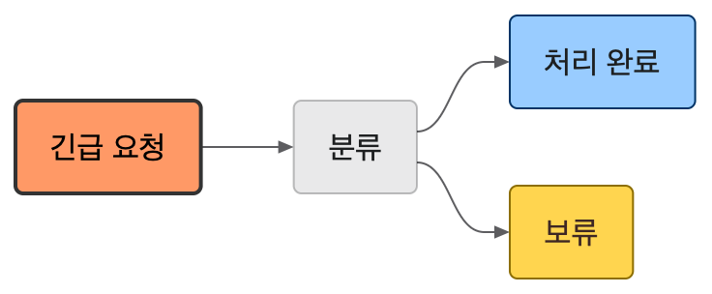

09-preset-pie
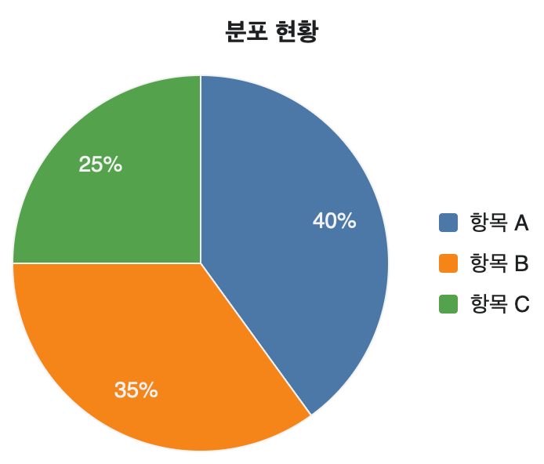

05-preset-sequenceDiagram
