**COPSE model description**

As published in Tostevin and Mills (2020), Royal Society Interface Focus. This version combines various extensions of the most recent major COPSE model version (Lenton et al. 2018). Full list of additions:

* Extension of forcings into Neoproterozoic and improved weathering-climate relationships (Mills et al., 2019).
* Introduction of reduced gas flux as a sink for O2 and parallel Monte-Carlo ensemble computation (Williams et al. 2019).
* Added bioturbation effects on C burial and P recycling (van de Velde et al. 2018).
* Added marine DOC reservoir, DOC oxidation flux and input of sulfur in the Ediacaran (Shields et al. 2019)

**1. Model structure**

The model uses a single box to represent the atmosphere and ocean, and boxes to represent the sedimentary inventories of the different chemical species. There are no spatial dimensions.

**2. Model species**

Model species are shown in table 1 below. Each inventory is allowed to evolve during the model run. A schematic representation of the model is shown in Figure 1.

|  |  |  |  |
| --- | --- | --- | --- |
| **Description** | **Name** | **Exists in box** | **Size at present** |
| Atmospheric CO2 | A | Hydrosphere | $3.193×{10}^{18}$ mol C |
| Buried organic C | G | Crust | $1.25×{10}^{21}$ mol C |
| Buried carbonate C | C | Crust | $5.0×{10}^{21}$ mol C |
| Ocean sulfate | S | Hydrosphere | $4×{10}^{19}$ mol S |
| Buried pyrite sulfur | PYR | Crust | $1.8×{10}^{20}$ mol S |
| Buried gypsum sulfur | GYP | Crust | $2.0×{10}^{20}$ mol S |
| Ocean phosphate | P | Hydrosphere | $3.1×{10}^{15}$ mol P |
| Ocean nitrate | N | Hydrosphere | $4.35×{10}^{16}$ mol N |
| Atmospheric oxygen | O | Hydrosphere | $3.7×{10}^{19}$ mol O |
| Marine dissolved organic carbon | DOC | Hydrosphere | $1.5×{10}^{20}$ mol C |

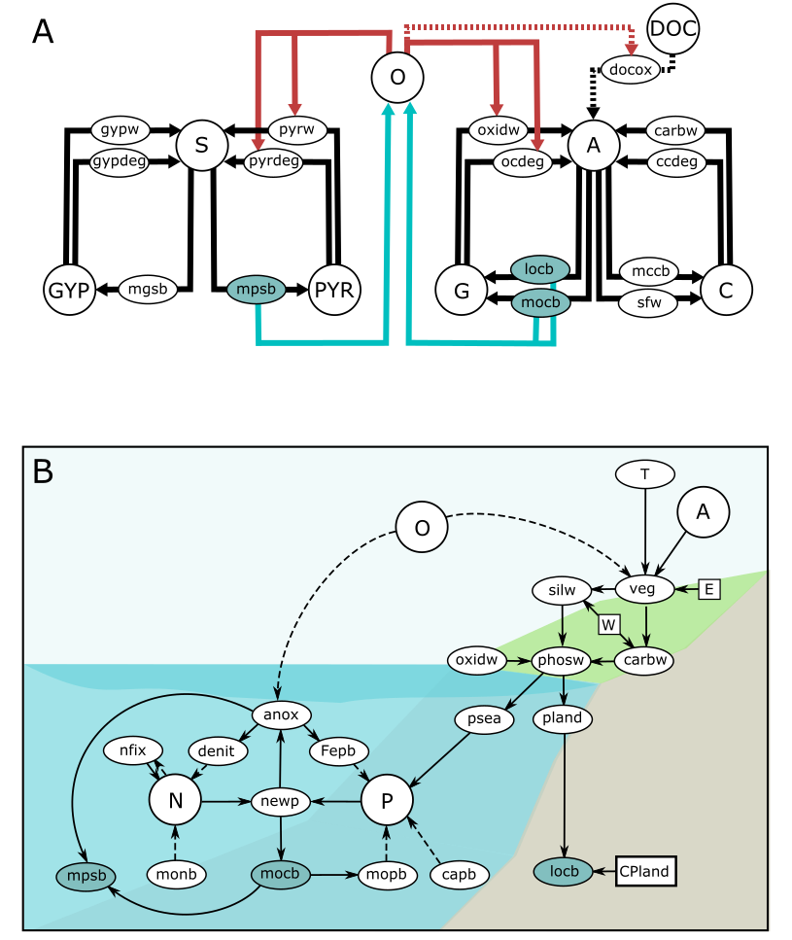

***Figure 1. COPSE model schematic:******a****. Carbon, Sulphur and Oxygen cycle fluxes. Here arrows show mass fluxes, blue arrows show oxygen sources and red arrows show oxygen sinks. Dashed lines show DOC reservoir fluxes.* ***B****. Dynamic nutrient and biosphere system. Here arrows show positive/direct (solid) or negative/inverse (dashed) relationships between major model processes. In both diagrams blue ovals show burial fluxes of organic carbon and pyrite sulphur, which are the long-term sources of free oxygen.*

**3. Differential equations**

The following equations dictate the inputs and outputs of each of the model reservoirs.

Marine phosphate: $$\frac{dP}{dx}=psea-f_{mopb}-f_{capb}-f_{fepb}$$

Atmosphere and ocean oxygen: $$\frac{dO}{dx}=f_{locb}+f_{mocb}-f_{oxidw}-f_{ocdeg}+2\left(f_{mpsb}-f_{pyrw}-f_{pyrdeg}-{PYR}_{input}\right)-f_{DOC_{ox}}-f_{reduct}$$

Hydrosphere carbon:

$$\frac{dA}{dx}=f_{oxidw}+f_{carbw}+f_{ocdeg}+f_{ccdeg}-f_{locb}-f_{mocb}-f_{mccb}-f_{sfw}+DOC_{ox}+f_{reduct}$$

Marine sulfate: $$\frac{dS}{dx}=f_{gypw}+f_{pyrw}+f_{gypdeg}+f_{pyrdeg}-f_{mpsb}-f_{mgsb}+{PYR}_{input}+{GYP}_{input}$$

Buried organic carbon: $\frac{dG}{dx}=f_{locb}+f_{mocb}-f_{oxidw}-f_{ocdeg}$

Buried carbonate carbon: $\frac{dC}{dx}=f_{mccb}+f_{sfw}-f_{carbw}-f_{ccdeg}$

Buried pyrite S: $\frac{dPYR}{dx}=f_{mpsb}-f_{pyrw}-f_{pyrdeg}-{PYR}_{input}$

Buried gypsum S: $\frac{dGYP}{dx}=f_{mgsb}-f_{gypw}-f_{gypdeg}-{GYP}_{input}$

Marine nitrate: $\frac{dN}{dx}=f_{nfix}-f_{denit}-f_{monb}$

Marine DOC: $\frac{dDOC}{dx}=-{DOC}_{ox}$

**4. Model fluxes**

Model fluxes are described below. They generally take the form of a present day rate multiplied by a series of scalings, which include the size of the parent reservoir, forcing factors, and non-flux calculations such as temperature or the degree of marine anoxia.

**Degassing: sediment to hydrosphere**

Carbonate C degassing: $f_{ccdeg}=k_{ccdeg}∙D∙B∙\left(\frac{C}{C_{0}}\right)$

Organic C degassing: $f_{ccdeg}=k_{ocdeg}∙D∙\left(\frac{G}{G_{0}}\right)$

Pyrite S degassing: $f_{pyrdeg}=k_{pyrdeg}∙D∙\left(\frac{PYR}{{PYR}_{0}}\right)$

Gypsum S degassing: $f_{gypdeg}=k_{gypdeg}∙D∙\left(\frac{GYP}{{GYP}_{0}}\right)$

**Weathering: sediment to hydrosphere**

Oxidative C weathering: $f_{oxidw}=k_{oxidw}∙U^{Usil}∙\left(\frac{G}{G_{0}}\right)∙{\left(\frac{O}{O_{0}}\right)}^{0.5}$

Carbonate C weathering: $f_{carbw}=k_{carbw}∙U^{Ucarb}∙\left(\frac{C}{C_{0}}\right)∙CA∙PG∙f_{biota}∙g_{T}$

Pyrite S weathering: $f_{pyrw}=k_{pyrw}∙U^{Usil}∙\left(\frac{PYR}{{PYR}_{0}}\right)$

Gypsum S weathering: $f_{gypw}=k_{gypw}∙\frac{f_{carbw}}{k_{carbw}}∙\left(\frac{GYP}{{GYP}_{0}}\right)$

Pyrite S additional input: ${PYR}_{input}=k_{pyrw}∙EVAP$

Gypsum S additional input: ${GYP}_{input}=k_{gypw}∙EVAP$

Phosphorus weathering:

$$f_{phosw}=k_{phosw}∙EP∙\left\{{kp}_{sil}\left(\frac{f_{silw}}{k_{silw}}\right)+{kp}_{carb}\left(\frac{f_{carbw}}{k_{carbw}}\right)+{kp}_{ox}\left(\frac{f_{oxidw}}{k_{oxidw}}\right)\right\}$$

**Burial: hydrosphere to sediment**

Marine organic C burial: $f_{mocb}=k_{mocb}∙{\left(\frac{newp}{newp_{0}}\right)}^{2}∙CB$

Land organic C burial: $f_{locb}=k_{locb}∙\left(\frac{p_{land}}{{P_{land}}_{0}}\right)∙CP_{land}$

Marine carbonate burial: $f_{mccb}=f_{silw}+f_{carbw}$

Seafloor weathering: $f_{sfw}={k_{sfw}∙f_{T}}_{sfw}∙D$

Marine pyrite S burial: $$f_{mpsb}=k_{mpsb}∙\left(\frac{S}{S_{0}}\right)∙\left(\frac{O_{0}}{O}\right)∙\left(\frac{f_{mocb}}{k_{mocb}}\right)+\frac{4}{5}(PYR_{input}+{GYP}_{input})$$

Marine gypsum S burial:

$$f_{mgsb}=k_{mgsb}∙\left(\frac{S}{S_{0}}\right)+\frac{1}{5}(PYR_{input}+{GYP}_{input})$$

Fe-phosphate burial: $f_{fepb}=k_{fepb}∙\left(\frac{1-ANOX}{k_{oxfrac}}\right)∙\left(\frac{P}{P_{0}}\right)$

Ca-phosphate burial: $f_{capb}=k_{capb}∙\left(\frac{f_{mocb}}{k_{mocb}}\right)$

Organic P burial: $f_{mopb}=f_{mocb}\left(\left(\frac{f_{biot}}{CP_{biot}}\right)+\left(\frac{1-f_{biot}}{CP_{lam}}\right)\right)$

Organic N burial: $f_{monb}= \left(\frac{f_{mocb}}{CN_{sea}}\right)$

**Internal fluxes:**

Granite weathering: $f_{granw}=k_{granw}∙U^{kw_{sil}}∙GA∙PG∙f_{biota}∙{f_{T}}_{gran}$

Basalt weathering: $f_{basw}=k_{basw}∙BA∙PG∙f_{biota}∙{f_{T}}_{bas}$

Silicate weathering: $f_{silw}=f_{granw}+f_{basw}$

Denitrification: $f_{denit}=k_{denit}∙\left(1+\left(\frac{ANOX}{1-k_{oxfrac}}\right)\right)∙\left(\frac{N}{N_{0}}\right)$

Nitrogen fixation:

$f_{nfix}=\left\{\begin{aligned}k_{nfix}∙{\left(\frac{P-\frac{N}{16}}{P_{0}-\frac{N_{0}}{16}}\right)}^{2} , \frac{N}{16}<P \\ 0 , &\frac{N}{16}≥P\end{aligned}\right.$

Marine new production: $newp=117∙\min\left(\frac{[N]}{16},[P]\right)$

P flux to land: $p_{land}=k_{landfrac}∙VEG∙f_{phosw}∙\left(k_{aq}+\left(1-k_{aq}\right)∙COALF\right)$

P flux to sea: $p_{sea}=f_{phosw}-p_{land}$

**5. Non-flux calculations**

Carbon atmospheric fraction $atfrac=atfrac_{0}∙\left(\frac{A}{A_{0}}\right)$

Relative atmospheric CO2:

Atmospheric O2 mixing ratio: ${O_{2}}_{mr}=\frac{\frac{O}{O_{0}}}{\frac{O}{O_{0}}+k_{mr}}$

Global average surface temperature: $T_{gast}=15+climsens∙\frac{\log{RCO_{2}}}{\log\left(2\right)}-k_{l}∙\left(\frac{t}{570 }\right)$

Average temperature for weathering: $T_{surf}=T_{gast}∙k_{Tgradm}+k_{Tgradc}$

Granite weathering T effect:

$${f_{T}}_{gran}=e^{0.0724\left(T_{surf}-15\right)}∙{\left(1+0.038∙\left(T_{surf}-15\right)\right)}^{0.65}$$

Basalt weathering T effect:

$${f_{T}}_{bas}=e^{0.0608\left(T_{surf}-15\right)}∙{\left(1+0.038∙\left(T_{surf}-15\right)\right)}^{0.65}$$

Carbonate weathering T effect: $g_{T}=1+0.087\left(T_{surf}-15\right)$

Seafloor weathering T effect: ${f_{T}}_{sfw}=e^{0.0608\left(T_{surf}-15\right)}$

Temperature effect on vegetation:

CO2 effect on vegetation: $V_{CO_{2}}=\frac{CO_{2}ppm-p_{minim}}{p_{half}+p_{atm}-p_{minim}}$

Oxygen effect on vegetation: $V_{O_{2}}=1.5-0.5\left(\frac{O}{O_{0}}\right)$

Overall limitation of terrestrial NPP: $V_{NPP}=2∙EVO∙V_{T}∙V_{CO_{2}}∙V_{O_{2}}$

Fire ignition probability scaling: $ignit=\min\left(\max\left(48∙{O_{2}}_{mr}-9.08 , 0\right) \right)$

Fire effect on terrestrial biomass: $firef=\frac{k_{fire}}{k_{fire}-1+ignit}$

Mass of terrestrial biota: $VEG=V_{NPP}∙firef$  
Terrestrial biota weathering effect:

$$f_{biota}=\left\{1-\min\left(V∙W, 1\right)\right\}∙k_{plantenhance}∙{{RCO}_{2}}^{0.5}+V∙W$$ Marine P concentration: $\left[P\right]=2.2\left(\frac{P}{P_{0}}\right)$

Marine N concentration: $\left[N\right]=30.9\left(\frac{N}{N_{0}}\right)$

Marine anoxic fraction: $ANOX=\frac{1}{1+e^{-k_{anox}∙\left(k_{u}\left(\frac{newp}{newp_{0}}\right)-\left(\frac{O}{O_{0}}\right)\right)}}$

Hydrothermal reductant input: $f_{reduct}=k_{reduct}∙D$

Marine DOC oxidation: $$f_{DOC_{ox}}=\left\{\begin{aligned} 0 , &DOC<1×{10}^{12} mol \\ -\frac{k_{DOC}}{1+e^{-a_{DOC}\left(1-ANOX-c_{DOC}\right)}}\left(\frac{DOC}{DOC_{0}}\right) , &DOC≥1×{10}^{12} mol\end{aligned}\right.$$

**6. Forcing factors**

All model forcing factors are detailed below. All have the value of 1 at the present day and are nondimensional.

|  |  |  |
| --- | --- | --- |
| **Description** | **Name** | **Based on** |
| Tectonic degassing | $$D$$ | Reconstructed subduction zone and rift lengths |
| Continental uplift | $$U$$ | Sediment abundance |
| Carbonate burial depth | $$B$$ | Fossil record |
| Basalt silicate exposed area | $$BA$$ | Degassing and flood basalt emplacements |
| Granite silicate exposed area | $$GA$$ | Paleogeographic reconstruction |
| Land plant evolution | $$EVO$$ | Fossil record |
| Land plant weathering effect | $$W$$ | Experimental and field studies |
| Land plant C:P ratio | $$CP_{land}$$ | Sedimentary coal deposition record |
| Selective P weathering | $$EP$$ | Experimental studies |
| Paleogeog. weathering effect | $$PG$$ | Climate modelling |
| Coal basin depositional fraction | $$COALF$$ | Coal basin depositional area |
| Evaporite weathering spike | $$EVAP$$ | Evidence for evaporite exposure |
| Bioturbation | $$f_{biot}$$ | Burrowing depth reconstruction |
| Bioturbation effect on C burial | $$CB$$ | Field studies |

**7. Fixed parameters**

Fixed parameters are shown in the table below.

|  |  |  |
| --- | --- | --- |
| **Description** | **Name** | **Value** |
| Present day marine organic carbon burial | $$k_{mocb}$$ | $2.5×{10}^{12}$ mol C yr-1 |
| Present day land organic carbon burial | $$k_{locb}$$ | $2.5×{10}^{12}$ mol C yr-1 |
| Present day organic carbon degassing | $$k_{ogdeg}$$ | $1.25×{10}^{12}$ mol C yr-1 |
| Present day organic carbon weathering | $$k_{oxidw}$$ | $3.35×{10}^{12}$ mol C yr-1 |
| Present day carbonate burial | $$k_{mccb}$$ | $2.125×{10}^{13}$ mol C yr-1 |
| Present day carbonate degassing | $$k_{ccdeg}$$ | $1.5×{10}^{13}$ mol C yr-1 |
| Present day carbonate weathering | $$k_{carbw}$$ | $8×{10}^{12}$ mol C yr-1 |
| Present day seafloor weathering | $$k_{sfw}$$ | $1.75×{10}^{12}$ mol C yr-1 |
| Present day basalt weathering | $$k_{basw}$$ | $3.975×{10}^{12}$ mol C yr-1 |
| Present day granite weathering | $$k_{granw}$$ | $9.275×{10}^{12}$ mol C yr-1 |
| Present day silicate weathering | $$k_{sil}$$ | $1.325×{10}^{13}$ mol C yr-1 |
| Present day phosphorus weathering | $$k_{phosw}$$ | $4.25×{10}^{10}$ mol P yr-1 |
| Present day pyrite burial |  | mol S yr-1 |
| Present day gypsum burial |  | mol S yr-1 |
| Present day pyrite weathering | $$k_{pyrw}$$ | $4.5×{10}^{11}$ mol S yr-1 |
| Present day gypsum weathering | $$k_{gypw}$$ | $1×{10}^{12}$ mol S yr-1 |
| Present day pyrite degassing | $$k_{pyrdeg}$$ | $2.5×{10}^{11}$ mol S yr-1 |
| Present day gypsum degassing | $$k_{gypdeg}$$ | $5×{10}^{11}$ mol S yr-1 |
| Present day Ca-P burial |  | mol P yr-1 |
| Present day Fe-P burial |  | mol P yr-1 |
| Present day nitrogen fixation | $$k_{nfix}$$ | $8.67×{10}^{12}$ mol N yr-1 |
| Present day denitrification | $$k_{denit}$$ | $4.3×{10}^{12}$ mol N yr-1 |
| Present day hydrothermal reductant input |  | mol O2 eq. yr-1 |
| Present day ocean oxic fraction | $$k_{oxfrac}$$ | $$0.9975$$ |
| Atmospheric O2 mixing ratio conversion | $$k_{mr}$$ | $$3.762$$ |
| Pre-plant weathering enhancement factor | $$k_{preplant}$$ | $$0.25$$ |
| Uplift effect on carbonate weathering | $${kw}_{carb}$$ | $$0.9$$ |
| Uplift effect on silicate weathering | $${kw}_{sil}$$ | $$0.33$$ |
| Phosphorus input from silicate weathering | $${kp}_{sil}$$ | $$0.8$$ |
| Phosphorus input from carbonate weathering | $${kp}_{carb}$$ | $$0.14$$ |
| Phosphorus input from organic carbon oxidation | $${kp}_{ox}$$ | $$0.06$$ |
| Fraction of phosphorus buried on land | $$k_{landfrac}$$ | $$0.0588$$ |
| C:P ratio of buried marine organics | $$CP_{sea}$$ | $$250$$ |
| C:N ratio of buried marine organics | $$CN_{sea}$$ | $$37.5$$ |
| Present day atmospheric fraction of CO2 |  |  |
| Long-term climate sensitivity | $$climsens$$ | $5$ K |
| Solar luminosity difference at 570 Ma |  | W m-2 |
| Latitudinal temperature gradient slope | $$k_{Tgradm}$$ | $$0.66$$ |
| Latitudinal temperature gradient constant | $$k_{Tgradc}$$ | $$4.95$$ |
| Vegetation CO2 minimum |  | ppm |
| Vegetation CO2 half saturation | $$p_{half}$$ | $183.6$ ppm |
| Fire effect on vegetation biomass | $$k_{fire}$$ | $$3$$ |
| Terrestrial-aquatic organic matter burial fraction | $$k_{aq}$$ | 0.8 |
| Steepness of anoxia transition | $$k_{anox}$$ | $$10$$ |
| Marine oxygen utilization parameter | $$k_{u}$$ | $$0.4$$ |
| DOC oxidation slope parameter | $$a_{DOC}$$ | 300 |
| DOC oxidation threshold parameter | $$c_{DOC}$$ | 0.5 |
| DOC oxidation rate parameter | $$k_{DOC}$$ | $1×{10}^{14}$ mol C yr-1 |
| C:P burial ratio bioturbated sediment | $$CP_{biot}$$ | 250 |
| C:P burial ratio laminated sediment | $$CP_{lam}$$ | 1000 |

**8. References**

Lenton TM, Daines SJ, Mills BJW. COPSE reloaded: an improved model of biogeochemical cycling over Phanerozoic time. *Earth-Science Reviews* **178,** 1-28 (2018).

Mills BJW, Krause AJ, Scotese CR, Hill DJ, Shields GA, Lenton TM. Modelling the long-term carbon cycle, atmospheric CO2, and Earth surface temperature from late Neoproterozoic to present day. *Gondwana Research* **67,** 172-186 (2019).

Shields GA, Mills BJW, Zhu M, Raub TD, Daines SJ, Lenton TM. Unique Neoproterozoic carbon isotope excursions sustained by coupled evaporite dissolution and pyrite burial. *Nature Geoscience* **12,** 823-827 (2019).

van de Velde S, Mills BJW, Meysman FJR, Lenton TM, Poulton SW. Early Palaeozoic ocean anoxia and global warming driven by the evolution of shallow burrowing. *Nature Communications*. **9,** 2554 (2018).

Williams JJ, Mills BJW, Lenton TM. A Tectonically Driven Ediacaran Oxygenation Event. *Nature Communications* **10,** 2690 (2019).