INFOTAINMENT ECU
Design Document
CAN Bus Multi-ECU System | Version 1.0

1. Project Overview
This document describes the design and responsibilities for the Infotainment ECU within a multi-ECU automotive system connected via a CAN Bus network. The Infotainment ECU acts as the central display controller, receiving signals from all other ECUs and presenting real-time vehicle status to the driver on an LCD/OLED panel.

2. Developer Roles & Responsibilities
The following sections detail each responsibility assigned in this project.
2.1. CAN Bus Rich Panel
Design and implement a rich display panel on the CAN bus. The panel receives signals from all ECUs in real time and renders them on the infotainment screen with visual indicators, alerts, and status widgets.
2.2. CAN Bus — Up to 12-Channel Support
Design and implement a CAN bus supporting up to 12 nodes/ECUs. Key design decisions:
- Each channel is assigned a dedicated message ID band
- Lowest message ID = highest priority (safety signals always win arbitration)
- Scalable architecture to add future ECU nodes without redesign
2.3. IR Sensor — Passenger Presence Detection
Integrate an IR sensor with the STM32 microcontroller to detect passenger seat occupancy.
- Passenger detected → panel displays "Passenger Present"
- No passenger → panel displays "Seat Empty"
- Output is forwarded over CAN to the Infotainment ECU for display
2.4. Touch Sensor — Passenger Seatbelt Detection
Integrate a touch sensor with the STM32 to detect seatbelt fastening status.
- Touched → "Seatbelt Fastened" displayed on panel
- Not touched → "Seatbelt Not Fastened" displayed on panel
- Combined logic: if Passenger Present AND Seatbelt Not Fastened → trigger warning alert on infotainment panel
2.5. CAN Database (DBC File)
Create and maintain the master CAN database file covering all 12 ECU nodes.
- Define all message IDs, signal names, data types, and scaling factors
- Assign lowest message IDs to highest-priority safety signals
- DBC file serves as the single source of truth for the entire network
2.6. GitHub Repository
Create and maintain the project GitHub repository.
- Version control for all firmware, configurations, and documentation
- Branching strategy and code review workflow
- README and onboarding documentation for team members

3. CAN Network — ECU Node Reference
The table below lists all ECU nodes in the network. Message IDs are assigned in priority order — lower ID = higher arbitration priority on the CAN bus.

ECU Node | CAN ID | Function | Priority
Airbag ECU | 0x100 | Crash detection & airbag deployment | Highest
ABS ECU | 0x101 | Active safety / brake control | High
Engine ECU | 0x103 | Powertrain management | High
Transmission ECU | 0x104 | Gear shifting (directly linked to Engine) | Medium-High
Battery ECU | 0x105 | Power management | Medium
Body ECU | 0x106 | Comfort & access control | Medium
Telematics ECU | 0x107 | Communication & data logging | Low
Infotainment ECU | 0x108 | Display & user interface | Lowest

Note: ID 0x102 is reserved for future expansion.

4. Block Diagram
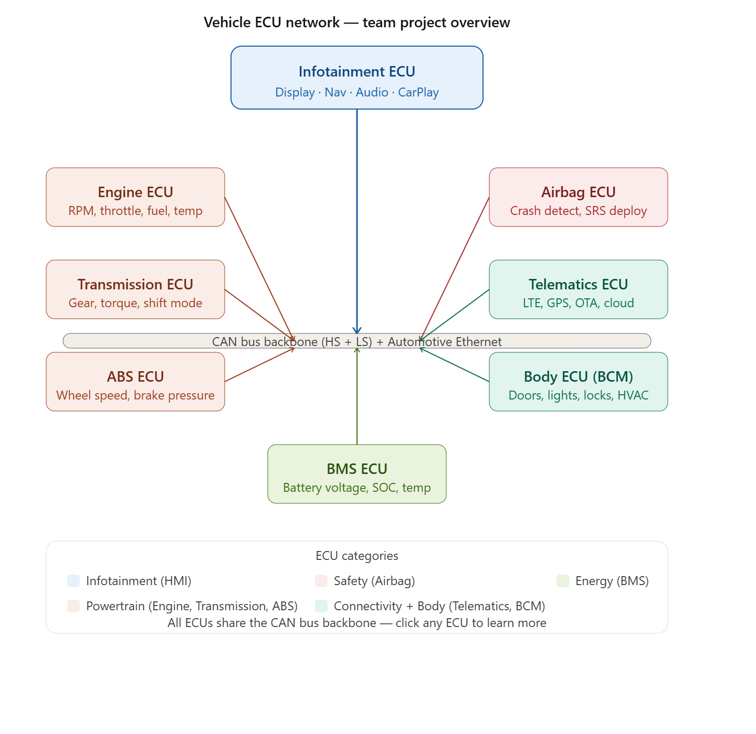

5. Sensor Logic — Combined Alert Conditions

5.1 Passenger Presence + Seatbelt State Matrix

IR Sensor State | Touch Sensor State | Infotainment Action
Passenger Present | Seatbelt Fastened | Show: OK status — no alert
Passenger Present | Seatbelt Not Fastened | ALERT: Warning icon + buzzer
Seat Empty | Seatbelt Fastened | Show: Seat Empty
Seat Empty | Seatbelt Not Fastened | Show: Seat Empty — no alert

6. Deliverables Summary
- CAN Bus Rich Panel — real-time display of all ECU signals
- 12-channel CAN bus design with priority-based arbitration
- IR sensor integration (STM32) for passenger presence detection
- Touch sensor integration (STM32) for seatbelt status detection
- Combined alert logic for passenger + seatbelt conditions
- Master DBC file for all 12 ECU nodes
- GitHub repository with full version history and documentation

