Diagnostic performance of quantitative measures from FDG-PET/CT, FEC-PET/CT and DW-MRI in the detection of lymph node metastases in endometrial and cervical cancer.

Introduction
The prognosis for both cervical and endometrial cancers is associated with presence of lymph node metastasis. In endometrial cancer the 5-year disease free survival is estimated at 90% for patients without lymph node metastasis, 60-70% for those with malignant pelvic lymph nodes and 30-40% with malignant para-aortic lymph nodes . In cervical cancer the 5-year overall survival is estimated at 92% with localised disease and 58% with regional disease such as lymph nodes metastasis . Treatment options differ for patients with metastatic lymph nodes. Patients with localised disease will receive surgery as their primary treatment whereas patients with malignant lymph nodes will typically be referred for chemoradiotherapy.
Accurate staging of lymph nodes is therefore critical in treatment planning and improving prognosis for patients. Although surgical lymphadenectomy is considered the most accurate technique for the detection of lymph node metastases, systematic lymphadenectomy is controversial as the procedure carries significant risks of lymphoedema, lymphocyst formation, and injury to surrounding organs and tissues . Furthermore, this procedure has not been shown to reliably convey any significant survival benefit and is therefore not widely recommended as a therapeutic option . Accurate pre-operative staging of lymph nodes would therefore have a significant impact on reducing morbidity of unnecessary lymphadenectomy procedures, surgical time, and cost of staging.
Multi parametric magnetic resonance imaging (MRI) is currently considered the optimal imaging technique for local tumour staging of endometrial cancer through assessment of myometrial and cervical invasion but the major limitation of all imaging techniques is poor detection of metastatic lymph nodes . Morphological signs of nodal involvement, including size criteria, on CT and MRI vary and have been found to be unreliable markers of malignancy . Tumour may have spread to non-enlarged nodes (micrometastases) and nodes can enlarge due to benign conditions. Functional imaging techniques that can detect changes in the microenvironment and metabolic properties of tissues pose an alternative strategy for diagnosis of lymph node status.
Integrated positron emission tomography/computed tomography (PET/CT) with ¹⁸F-fluoro-2-deoxy-D-glucose (¹⁸F-FDG), a glucose analogue, allows combined anatomical and functional imaging. Visual diagnosis of nodal status in endometrial and cervical using FDG-PET has been evaluated in a number of small, mainly retrospective, clinical trials. Reported sensitivities of FDG-PET/CT for nodal involvement are heterogeneous (63%-80%) whilst specificities are high (93%-97%) . Low sensitivity of FDG-PET/CT is considered to be the main limitation of the imaging modality due to the limited spatial resolution of PET imaging .
Maximum standardised uptake value (SUVmax) is a semi-quantitative measure derived from FDG-PET/CT scans that represents relative glucose uptake in tissues. SUVmax of the primary tumour has been shown to be higher in patients with higher grade endometrial cancer, myometrial invasion, cervical invasion, and lymph node metastasis . Reports on the utility of SUVmax in the detection of nodal involvement are limited and most studies to date have used visual assessment of the level of uptake in nodes compared to background. Kim et al. retrospectively assessed SUVmax in histologically confirmed benign and malignant lymph nodes and reported moderate sensitivity (69%) and high specificity (92%) when using an SUVmax cut-off of 2.8 .
Diffusion-weighted MRI (DW-MRI) detects changes in the diffusion properties of water in tissues which is primarily influenced by cellular density and the nuclear-to-cytoplasm ratio and can therefore enhance subtle underlying abnormalities in tissues. DW-MRI is established for routine use in endometrial cancer staging and is shown to be promising in diagnosing extent of myometrial invasion adjunct to conventional T2-weighted imaging . There has been some research investigating the utility of the quantitative DW-MRI measure, the apparent diffusion coefficient (ADC), in the diagnosis of lymph node metastasis. The measurement of ADC from DW-MRI allows for quantitative assessment of cellular density. Whilst some studies report metastatic nodes have a lower ADCmean than benign nodes, other studies have not suggesting there is a significant overlap in ADCmean values between benign and malignant notes with no reliable cut-off . Furthermore, in endometrial cancer, retrospective studies have also produced heterogeneous results with some showing ADC is significantly different in metastatic and benign lymph nodes and others finding no difference .
Choline is a critical component of cell membranes. In rapidly dividing endometrial cancer cell lines increased uptake of choline has been observed . Radiolabelled choline (¹¹C or ¹⁸F choline) can be incorporated with PET for functional imaging of cell membrane metabolism in vivo and has established use in detection of malignant lymph nodes in prostate cancer exhibiting a high specificity and moderate sensitivity . In small feasibility studies, ¹¹C-choline PET has shown similar diagnostic performance to FDG-PET/CT in the identification of gynaecologic tumours . Additionally, ¹¹C-choline PET/CT had high accuracy for nodal staging in uterine carcinoma . Despite positive early findings no large prospective studies have reported the performance of ¹⁸F-fluoroethyl-choline-PET/CT (FEC-PET/CT) in the diagnosis of nodal involvement in endometrial or cervical cancer. Furthermore, no investigations into the diagnostic utility of nodal SUVmax on FEC-PET/CT in gynaecological cancers have been conducted to date.
The present study aims to investigate the ability of quantitative measurements from FDG-PET/CT, FEC-PET/CT and DW-MRI in differentiation of metastatic and benign lymph nodes and determine the diagnostic utility of these imaging techniques.
This study forms part of the secondary analysis of the prospective UK MAPPING study .

Methods

Patients
This study analyses data from the MAPPING study: a multicentre, prospective study evaluating the diagnostic accuracy of FDG-PET/CT, FEC-PET/CT and DW-MRI in the detection of nodal metastases. A full summary of the Materials and Methods can be found in Rockall et al. (2021); key methods are detailed here .
Participants were recruited from 5 gynae-oncology tertiary referral centres in National Health Service (NHS) hospitals in England. Eligible patients were over the age of 18 years and had newly diagnosed, histologically confirmed cervical or endometrial cancer. Age, tumour grade, pre-and post-treatment FIGO stage and the final treatment received were collected.
One-hundred and sixty-two patients were enrolled in the study. Of these, thirty-three cervical cancer and 66 endometrial cancer patients met the primary reference standard of nodal histology, had quantitative imaging data, and were therefore eligible for analysis (Fig. 1).

FDG-PET/CT and FEC-PET/CT protocol
FDG and FEC PET/CT scans were acquired using a standardised protocol based on UK NCRI PET Research Network guidance at accredited centres. Participants were injected with FDG and FEC and scans were acquired at a median of 60 mins post injection on separate days. Low dose CT was performed followed by emission study (base of skull to upper thighs) as 3D acquisitions. Images were reconstructed using ordered subset expectation maximisation and the PET images were attenuation corrected using the CT data.

DW-MRI protocol
Standard of care conventional MRI scan for staging was performed as per local protocol which included a minimal dataset of MR sequences. The MRI field of view included the pelvis and para-aortic regions up to the level of the left renal vein. For nodal evaluation, readers had a minimal dataset that included axial T1, axial T2 and axial diffusion weighted MRI (b values 0, 300, 600, 900 and 1200) with associated calculated ADC maps.

Surgical staging and pathologic evaluation
The primary reference standard was confirmed nodal histology by surgical lymphadenectomy. The surgical lymphadenectomy was undertaken as per the MAPPING study protocol and anatomical location, presence of metastatic disease, and lymph node dimensions in each region (right pelvis, left pelvis, and para-aortic) were recorded . A region was determined to be positive for nodal metastases with the presence of at least one malignant node at histology.

Image evaluation
All images were read by two central MRI and PET readers; the central reads were co-ordinated through the UK NCRI PET core lab and the trials unit. A third central PET reader reviewed all PET measurements, and recorded additional readings. All readers were accredited radiologists that were core members of the gynae-oncology multi-disciplinary team and/or PET/CT experts. Readers were made aware of the clinical diagnosis (endometrial or cervical cancer) from the pre-operative biopsy results, as per standard clinical practice. Readers were masked to other imaging studies and the final nodal histology.

FDG-PET/CT and FEC-PET/CT image evaluation
The anatomical location of any focally increased tracer uptake that was higher than background adjacent tissue corresponding to a node of any size on the CT was recorded. An elliptical ROI was manually placed on the slice with the highest activity and a measurement of SUVmax was recorded. Short-axis and long-axis diameter was recorded for each identified node. SUVmax of the primary tumour was also measured by a single central expert PET reader by placing a regular ROI over the primary tumour on the slice with the highest activity on a dedicated PET/CT workstation (Hermes Medical Solutions).

DW-MRI image evaluation
Readers were aware of the nodal size from the standard of care MRI, and DW-MRI was additive to the standard conventional imaging. Nodes were identified on the high b-value (b = 1200 mm2/s) DW-MRI as non-continuous high signal intensity (SI) round or ovoid structures that corresponded with a node on the anatomical images. SA diameter on MRI was measured for each identified node. The ADCmean of identified nodes were measured by manually placing a regular ROI over nodes greater than 5 mm short axis diameter, avoiding the margin and noted with anatomical location. ADCmean of the primary tumour, if visible, was also measured in each patient by both readers in an identical fashion.

Dataset
The highest SUVmax, for FDG-PET/CT and FEC-PET/CT, and lowest ADCmean, for DW-MRI, from the left pelvis, right pelvis, and para-aortic regions from each reader was selected for analysis. In cases where both readers provided measurements in a region, the readings were averaged and included in the final analysis. Where only one reader provided a measurement in a region, this measurement was included in the final analysis. Where no central readers provided a measurement in a region, the third external reader’s measurement was included in the final analysis. The mean SUVmax from FDG-PET/CT, SUVmax from FEC-PET/CT, and ADCmean of the primary tumour from both readers was calculated and included in the final analysis. Reads in regions that had corresponding nodal histology were included in the analysis.
Where data for both were recorded, nodal-to-tumour ratio (NTR) was calculated by dividing nodal by tumour SUVmax or ADCmean for all measurement methods. SUVmax:ADCmean ratio (STAR) was calculated by dividing nodal SUVmax by nodal ADCmean for FDG-PET/CT and FEC-PET/CT. Finally, for FDG-PET/CT and FEC-PET/CT, SUVmax normalised to SA diameter (SNSA) was calculated with SA diameter from the corresponding measurement method.
A total of 270 nodes had histology and were included in the final dataset, of which 178 and 82 were from endometrial cancer and cervical cancer patients, respectively. 115 left pelvic, 119 right pelvic, and 36 para-aortic nodes were included in the final dataset. A total of 134, 66, and 154 nodes had SUVmax from FDG-PET/CT, SUVmax from FEC-PET/CT, and ADCmean from DW-MRI respectively.

Statistical analysis
Statistical analysis was performed in R. Patients were stratified into two cohorts by their diagnosis of endometrial or cervical cancer. Nodes from all regions were grouped together for analysis. Nodal-to-tumour ratios (NTR) were calculated by dividing the nodal quantitative measure (SUVmax or ADCmean) by the quantitative measure from the primary tumour. SUVmax-to-ADCmean ratio (STAR) was calculated by dividing the SUVmax by the ADCmean of the corresponding node. SUVmax normalised to SA diameter (SNSA) was calculated by dividing the SUVmax by the SA diameter of each node for FDG-PET/CT and FEC-PET/CT. The Mann-Whitney U-test was selected to compare quantitative measures in histologically confirmed benign versus malignant lymph nodes. One-way ANOVA with Tukey’s post-hoc test was used to determine significance when comparing left pelvic, right pelvic, and para-aortic regions. P-values were adjusted using the false-discovery rate (FDR) method.
Pairwise Pearson correlation coefficients were calculated between features and p-values were adjusted using the false-discovery rate method.
To determine if a regression model could assist in diagnosing benign from malignant lymph nodes, univariate and multivariate logistic regression models were built. Due to the low number of measurements for cervical cancer and FEC-PET/CT, only FDG-PET/CT and DW-MRI data from endometrial cancer was considered when building models. Additionally, due to strong correlation between features, calculated variables (NTR, STAR, SNSA) were excluded as features.
A multivariate logistic regression model with L1 regularisation penalty (LASSO) was employed. Rows with any NAs were omitted prior to analysis, leaving a total of 57 nodes for analysis. Logistic regression predicts a probability of malignancy between zero (benign) and one (malignant). The dataset was randomly split into train and test sets at a 70%/30% split. Features in the training set were scaled between 0 and 1, and the same scaling function was applied to the test set. The ’glmnet’ package was used to find the optimal value of lambda by cross-validation. A logistic regression model with alpha set to 1.0 for the L1 penalty was fit to the training data and used to predict probabilities for the test data. Optimal cutoff probability was found through maximisation of the F1-score. This process was repeated 5,000 times to retrieve the average optimal probability cutoffs and lambda. The model was refit using these hyperparameters and inference was run another 5,000 times to estimate model performance.
Logistic LASSO regression shrunk all coefficients of features, excluding SUVmax and SA diameter, from FDG-PET/CT to zero. To determine if simpler models would perform better, univariate logistic regression was undertaken on these features using the ’glm’ package in R. Rows with NAs were omitted prior to analysis, leaving a total of 104 nodes for analysis and the dataset was randomly split into train and test sets at a 70%/30% split. Logistic regression models were fit to SUVmax and SA diameter separately. Optimal cutoffs and model performance were determined as with logistic LASSO regression.
Optimal cut-offs for all quantitative measures were determined using the ’cutpointr’ package in R. Direction was set to greater than or equal to for all measures except ADCmean and ADCmean NTR where direction was set to less than or equal to. Cutpoints were selected through maximisation of the F1 score. Stratified bootstrapping was repeated 2000 times. Out of bag estimates of area under the curve (AUC), sensitivity, and specificity were calculated.
Receiver operating characteristic (ROC) analysis was applied, using the ’pROC’ package in R, for each quantitative measure to generate ROC curves.
Interobserver agreement for each FDG-PET/CT, FEC-PET/CT, and DW-MRI was evaluated by calculating intraclass correlation coefficients (ICC) for endometrial and cervical cancer cohorts separately using the R package ‘irr’. A two-way model was used and agreement between readers was evaluated. Confidence level of the interval was set at 95%.

Results

Demographics
The demographics of patients eligible for analysis are summarised in Supplementary Table [table:demographics]. A total of 99 patients were eligible for analysis: 33 cervical cancer patients and 66 endometrial cancer patients. 67 and 73 patients received left pelvic and right pelvic lymphadenectomy, respectively, while just 26 patients underwent para-aortic lymphadenectomy. 88% of cervical cancer patients were diagnosed as FIGO stage IB1 and no patients in this cohort had a FIGO stage greater than II. In the endometrial cancer cohort, FIGO stage ranged from IA to IVB.

Quantitative measures in benign and malignant lymph nodes
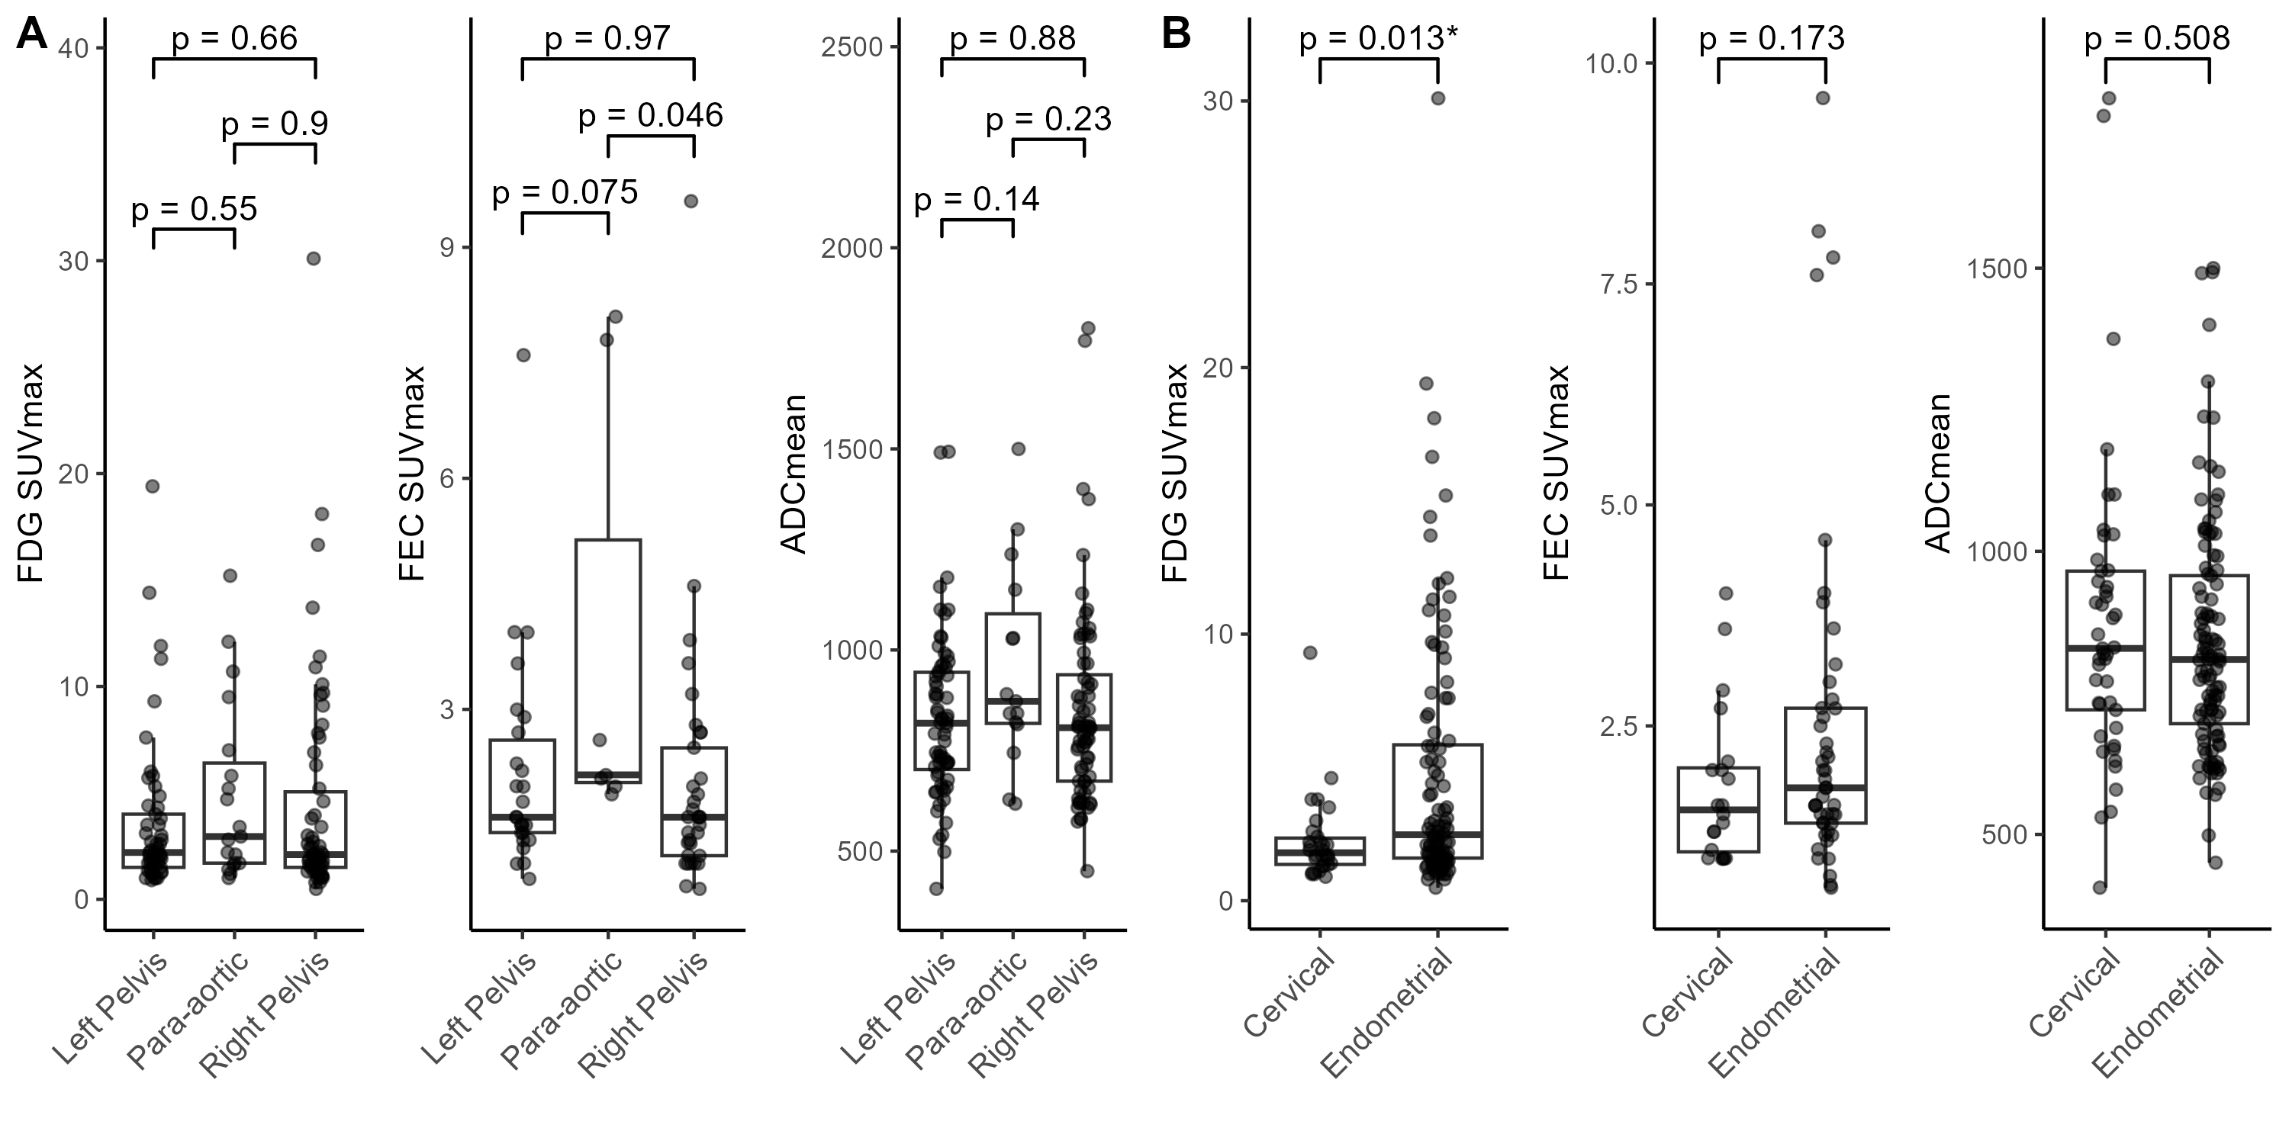
Figure 1 - (A) Quantitative measures of measured lymph nodes of each region. One-way ANOVA with Tukey’s post-hoc test was used to determine significance between regions. (B) Quantitative measures of measures lymph nodes in endometrial cancer and cervical cancer patients. Mann-Whitney U-test was used to determine significance between endometrial and cervical cancer. FDG-PET/CT (left), FEC-PET/CT (middle), and DW-MRI (right).
Raw quantitative measures from the three imaging modalities were compared between pelvic and para-aortic regions and between endometrial and cervical cancer. No significant difference was found between regions in SUVmax or ADCmean on FDG-PET/CT and DW-MRI (Figure 1A). Lymph nodes of the para-aortic region on FEC-PET/CT had significantly higher SUVmax than left and right pelvis, a trend that was consistent across all three imaging modalities. Interestingly, the average SUVmax of nodes on FDG-PET/CT was significantly higher in endometrial than in cervical cancer (Figure 1B).
Quantitative measures, both raw and calculated, were compared in benign and malignant lymph nodes in endometrial cancer. All measures were significantly higher in malignant than benign lymph nodes on FDG-PET/CT (Figure 2A). Short-axis diameter, SUVmax, and STAR were all significantly elevated in malignant lymph nodes on FEC-PET/CT (Figure 2B). ADCmean and ADCmean NTR was not significantly different between benign and malignant lymph nodes in endometrial cancer (Figure 2C).
No calculated or raw measures were significantly different between benign and malignant nodes on FDG-PET/CT and FEC-PET/CT in cervical cancer, although average raw measures were consistently higher in malignant nodes (3A & 3B). Low numbers of measured nodes in cervical cancer may limit the power of statistical analysis. Interestingly, ADCmean and ADCmean NTR were significantly lower in malignant nodes in cervical cancer (3C).
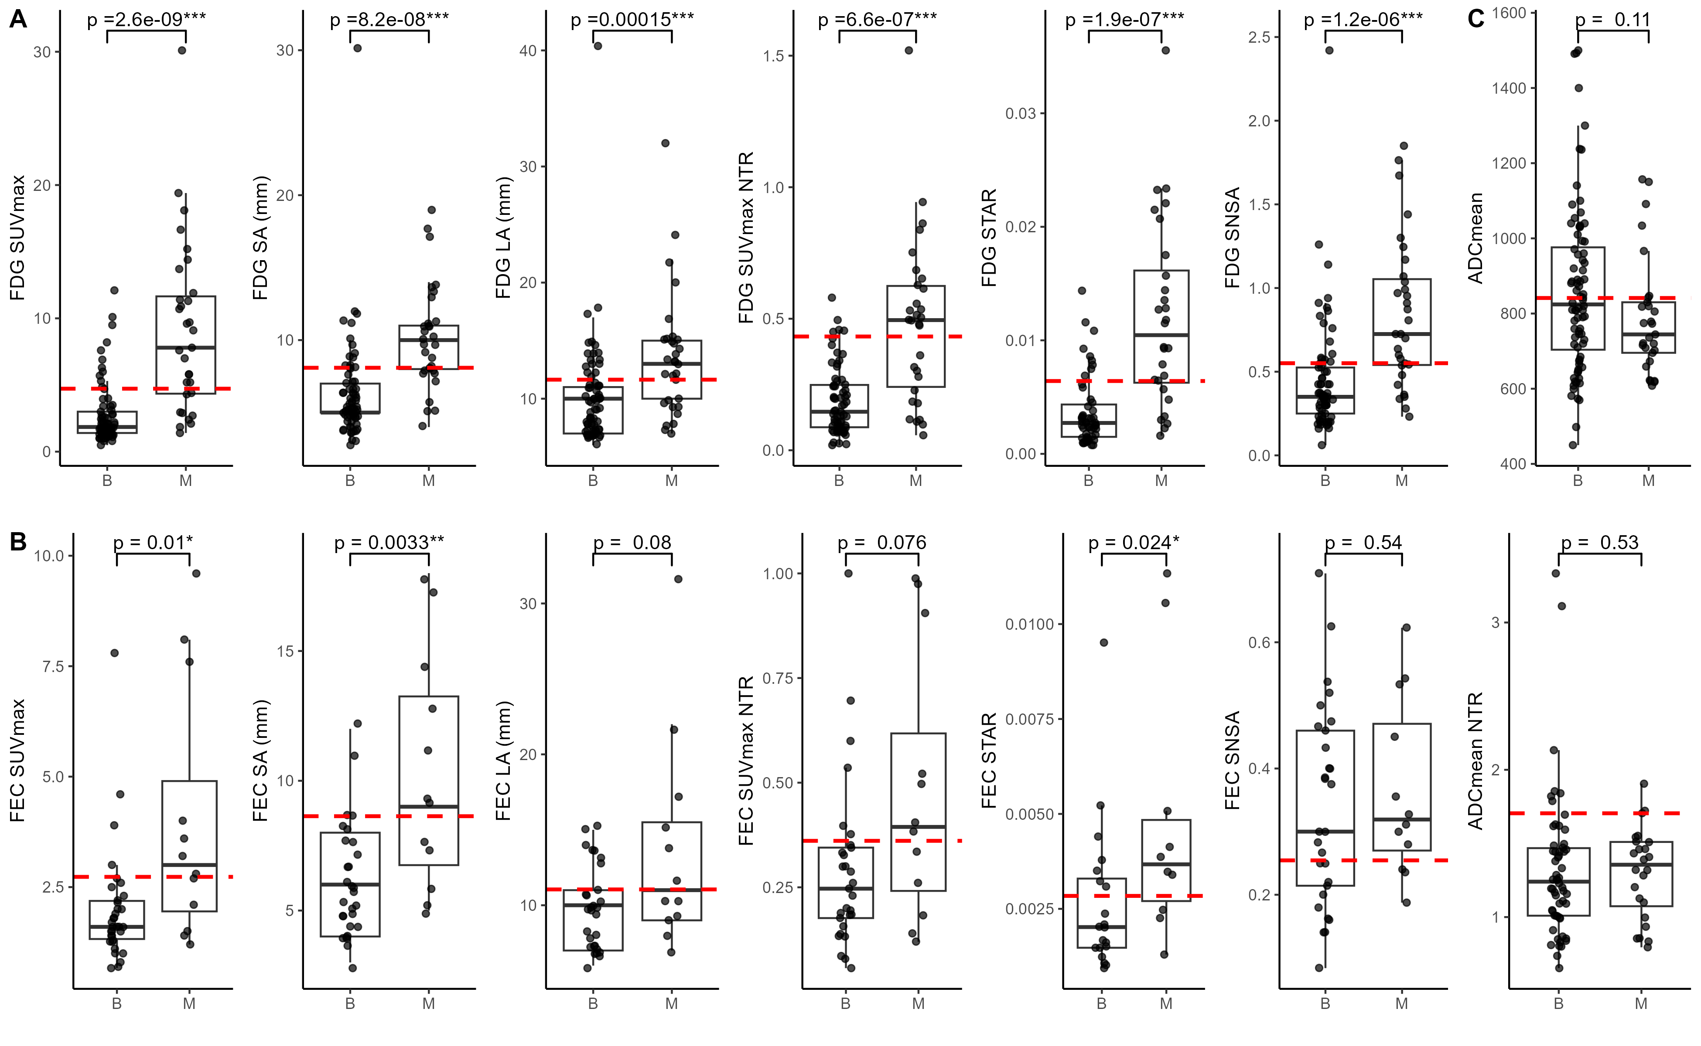
Figure 2 - Raw and calculated quantitative measures from benign (B) and malignant (M) lymph nodes in endometrial cancer. Nodes of all regions are pooled together for this analysis. Red lines represent optimal cutpoints for F1 score maximisation. Significance was tested between groups using Mann-Whitney U-test. ***, p $<$ 0.001, **, p $<$ 0.01, *, p $<$ 0.05.
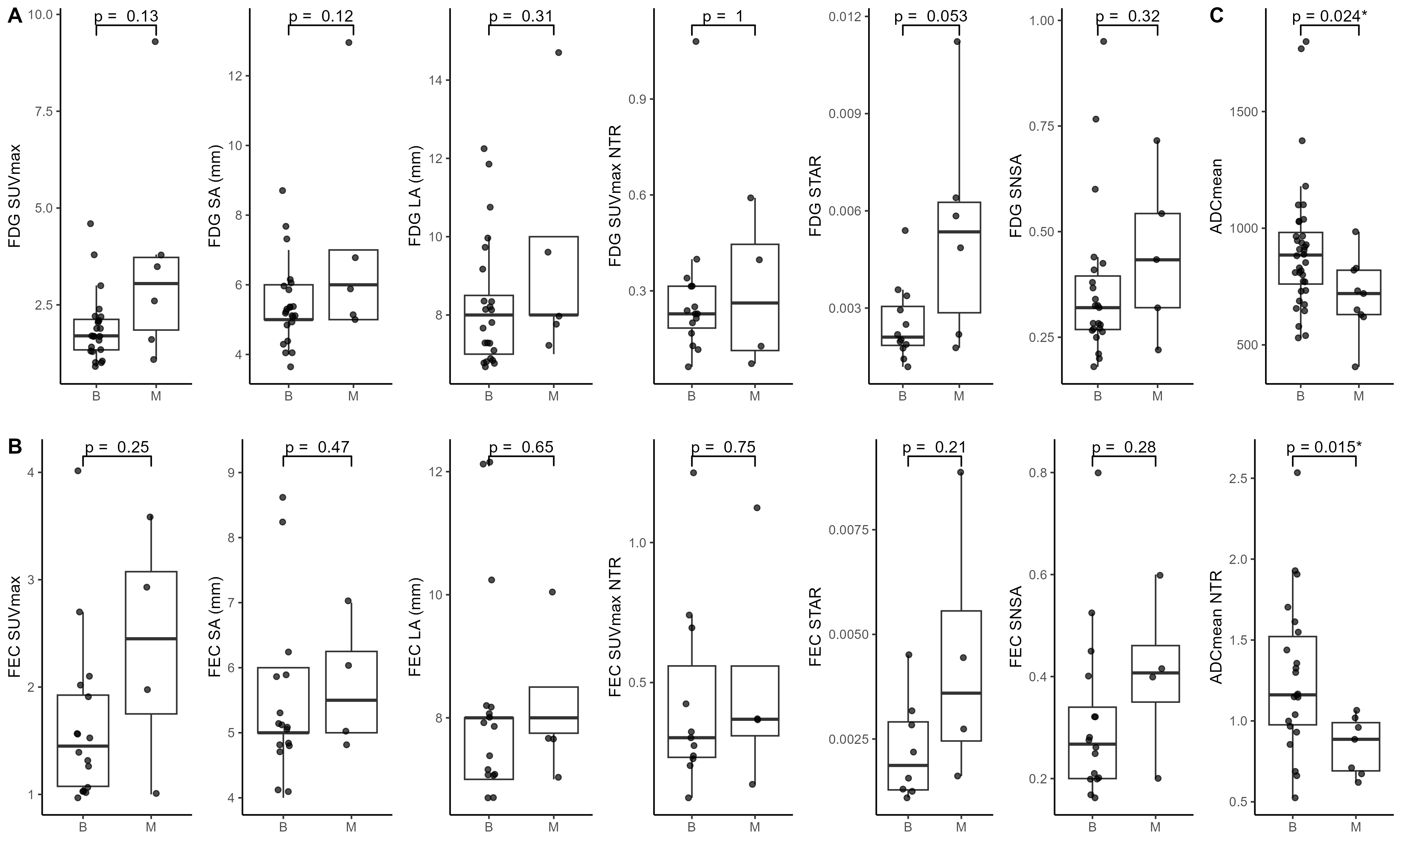
Figure 3 - Raw and calculated quantitative measures from benign (B) and malignant (M) lymph nodes in cervical cancer. Nodes of all regions are pooled together for this analysis. Significance was tested between groups using Mann-Whitney U-test. *, p $<$ 0.05.
Pearson correlations coefficients were calculated between quantitative measures in endometrial cancer (Figure 4). Short-axis diameter, long-axis diameter, and SUVmax of the lymph node were highly correlated between FDG-PET/CT and FEC-PET/CT, but did not correlate well with SUVmax of the primary tumour. SUVmax of the primary tumour correlated weakly with SUVmax of the lymph node. Furthermore, these measures were not correlated with ADCmean of the primary tumour or lymph node, except for tumour SUVmax which was inversely correlated with tumour ADCmean.
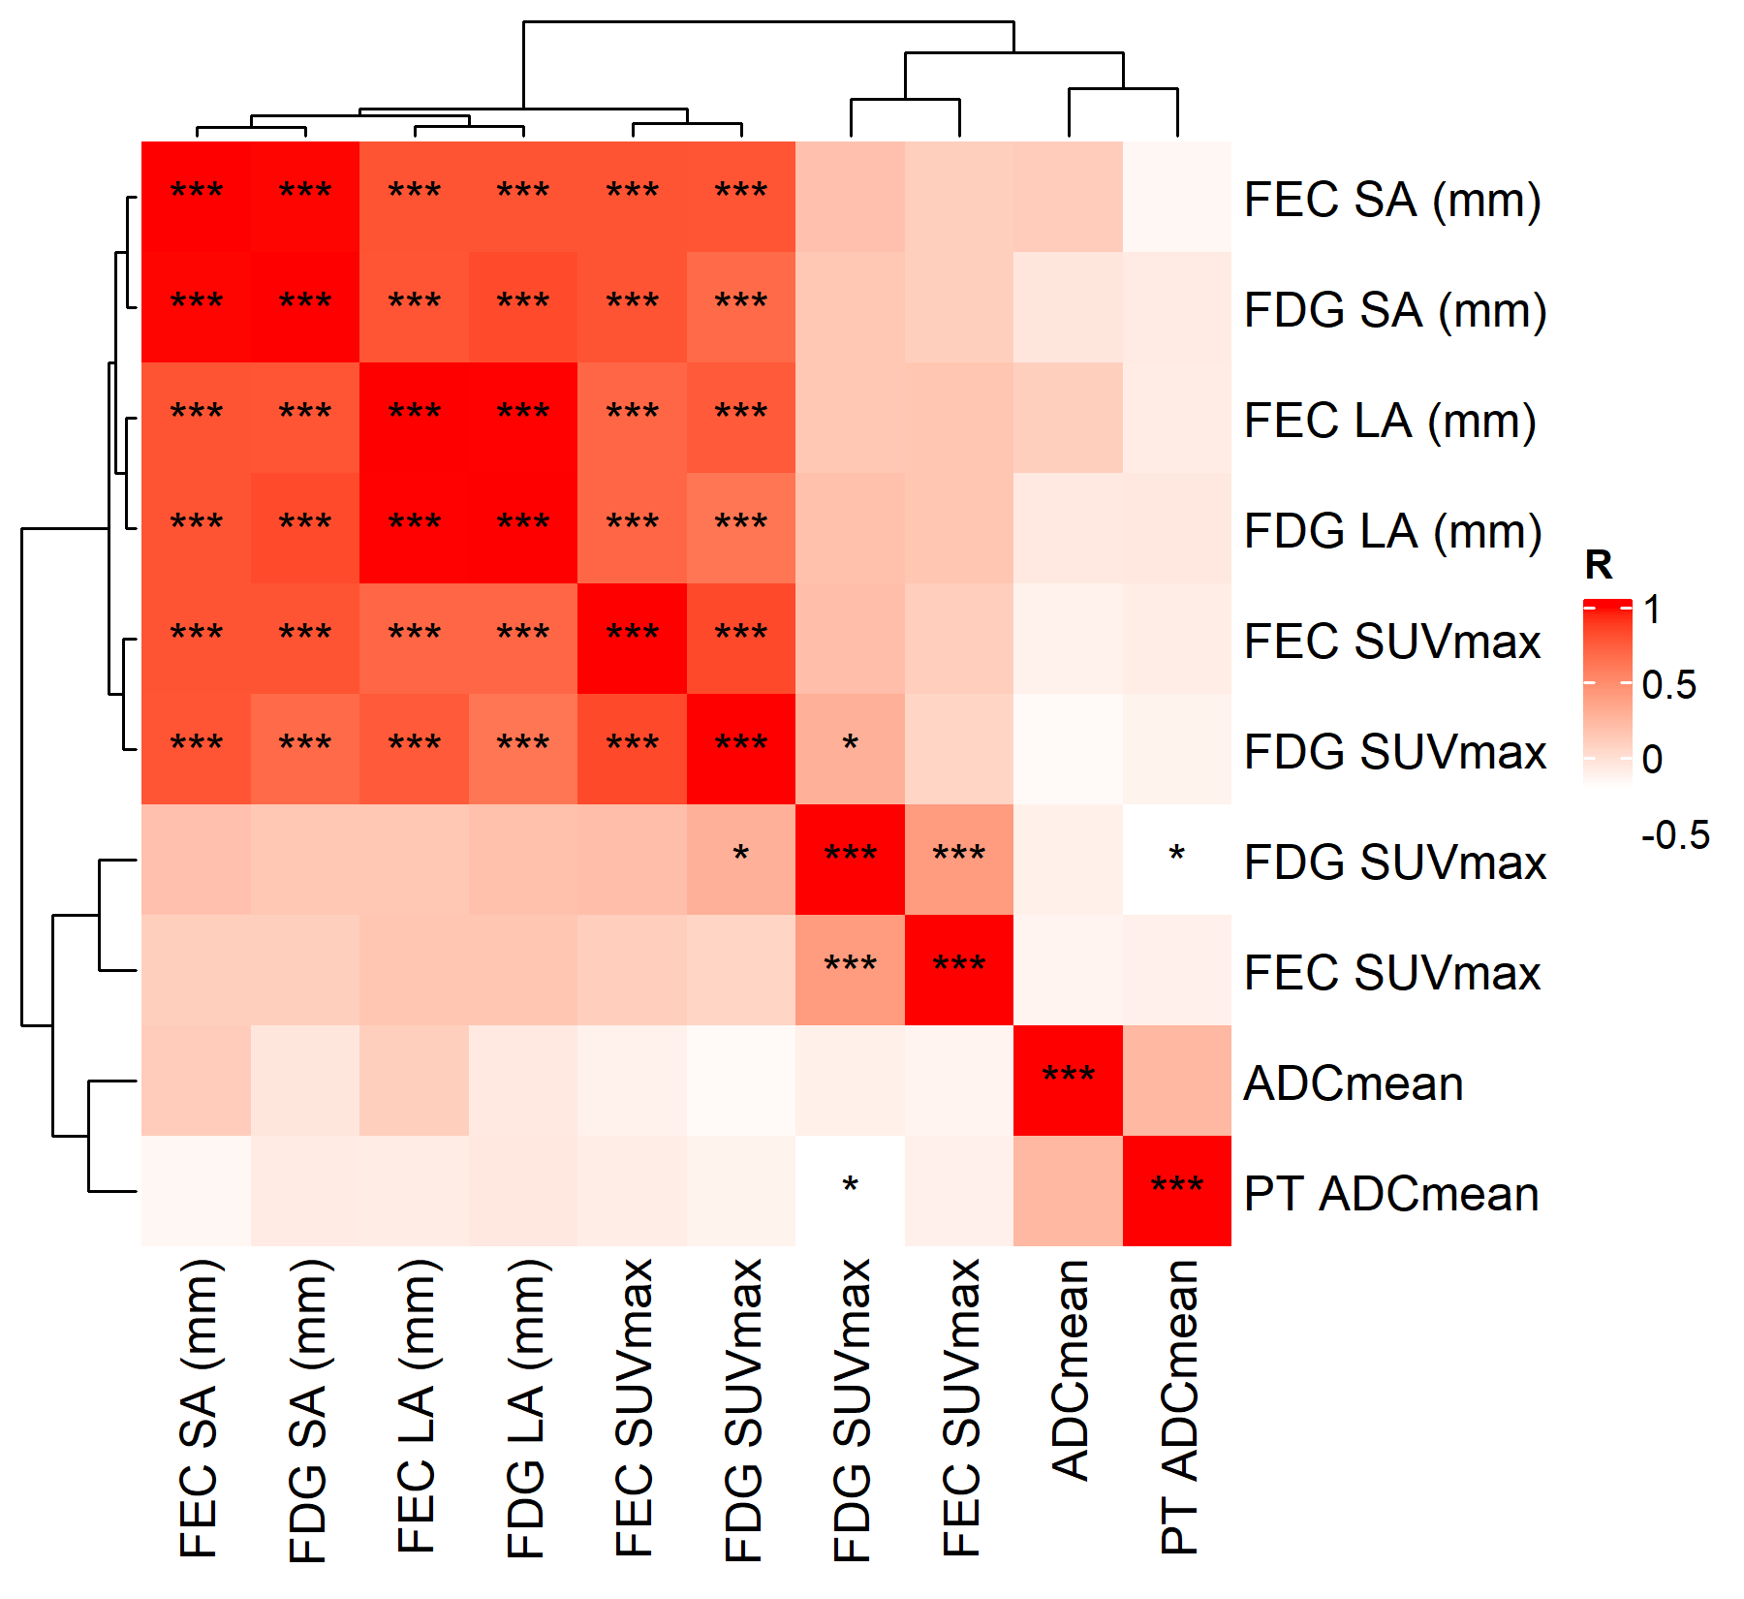
Figure 4 - Pairwise Pearson correlation coefficients between raw quantitative measures from FDG-PET/CT, FEC-PET/CT, and DW-MRI in endometrial cancer. ***, p $<$ 0.001, **, p $<$ 0.01, *, p $<$ 0.05.
Previous literature has shown elevated primary tumour SUVmax and depressed ADCmean in patients presenting with malignant lymph nodes . SUVmax of the primary tumour was significantly elevated on FDG-PET/CT but not on FEC-PET/CT, with no significant difference found on DW-MRI (Supplementary Figure [fig:quants_pt_byCanc]). No significant difference in any quantitative measure was found in primary tumours of the cervix.

Diagnostic performance of quantitative measures
Diagnostic performance of each measure, along with optimal cutpoints, in endometrial cancer is summarised in Figure 5.
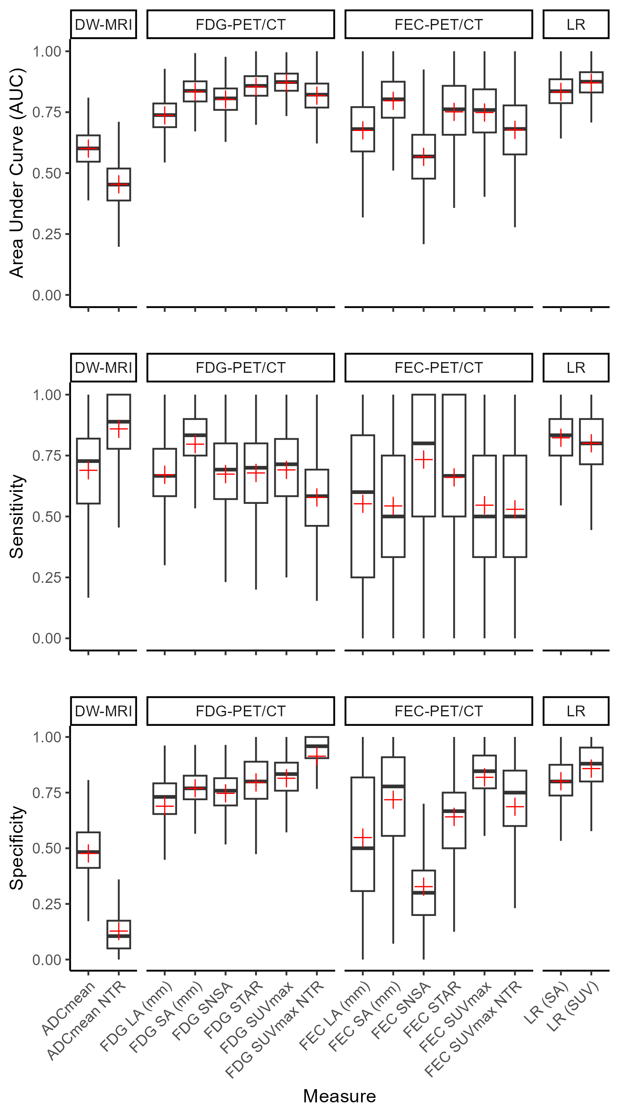
Figure 5 - Performance of all raw and calculated quantitative measures from FDG-PET/CT, FEC-PET/CT, and DW-MRI as well as performance of the univariate logistic regression (LR) model trained on SUVmax from FDG-PET/CT in endometrial cancer. Red crosses on box and whisker plots represent mean performance from bootstrapped data.
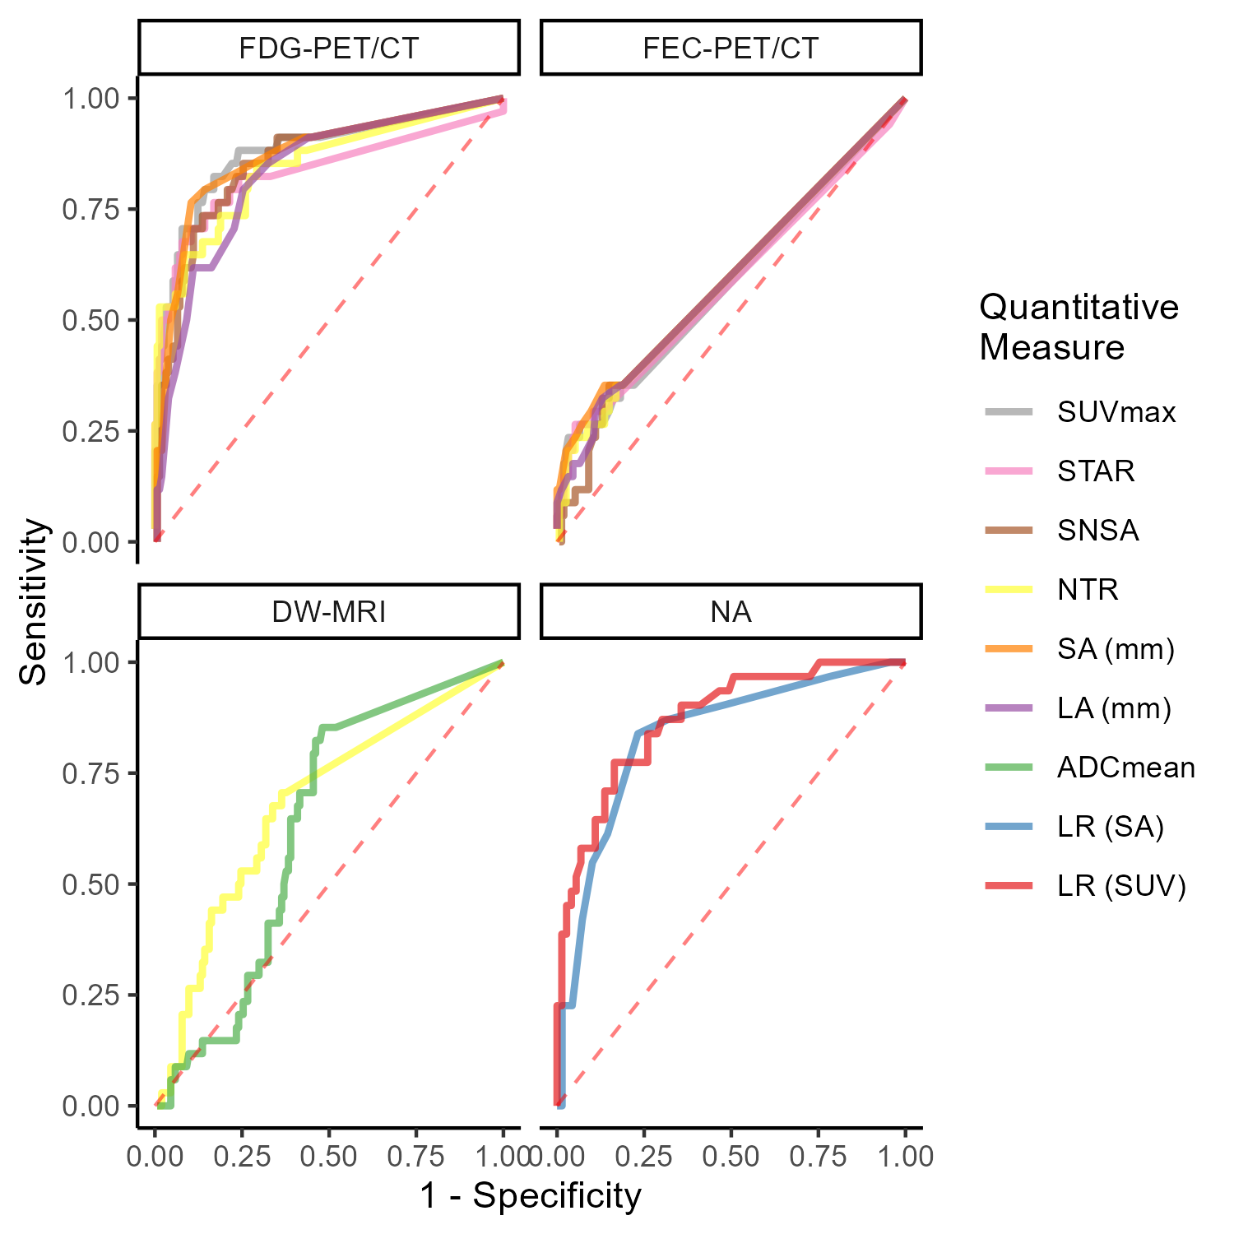
Figure 6 - ROC curves for quantitative measures from FDG-PET/CT (top left), FEC-PET/CT (top right), DW-MRI (bottom left), and the LR model (bottom right) in endometrial cancer. Line colour represents a quantitative measure for that imaging modality.
No raw quantitative measure clearly outperformed the others on FDG-PET/CT, as shown by the ROC curves in Figure 6. SUVmax from FDG-PET/CT showed relatively high sensitivity and specificity, with the highest AUC of the quantitative measures. Short-axis diameter had the highest sensitivity of all measures from FDG-PET/CT.
The AUC of SUVmax from FEC-PET/CT was lower than that of FDG-PET/CT. Large error bars for FEC-PET/CT quantitative measures suggest low sample numbers may be restricting analysis and optimal cutpoints should be interpreted with caution. ADCmean from DW-MRI showed moderate performance with moderate sensitivity, low specificity, and moderate AUC.
Of the calculated measures, STAR had the highest AUC for FDG-PET/CT with similar performance to SUVmax.
Logistic LASSO regression shrunk all coefficients of features, excluding SUVmax and SA diameter, from FDG-PET/CT to zero and exhibited relatively poor diagnostic performance (sensitivity 0.70, specificity 0.79), likely due to the sparsity of data available for training. Univariate logistic regression models fit on SUVmax (sensitivity 0.67, specificity 0.87, AUC 0.87) and SA diameter (sensitivity 0.74, specificity 0.80, AUC 0.83) from FDG-PET/CT narrowly outperformed LASSO (Figure 5). The logistic regression model trained on SUVmax performed relatively well compared to raw and calculated quantitative measures alone. The predicted probability of malignancy based on SUVmax from FDG-PET/CT is shown in Figure 7.
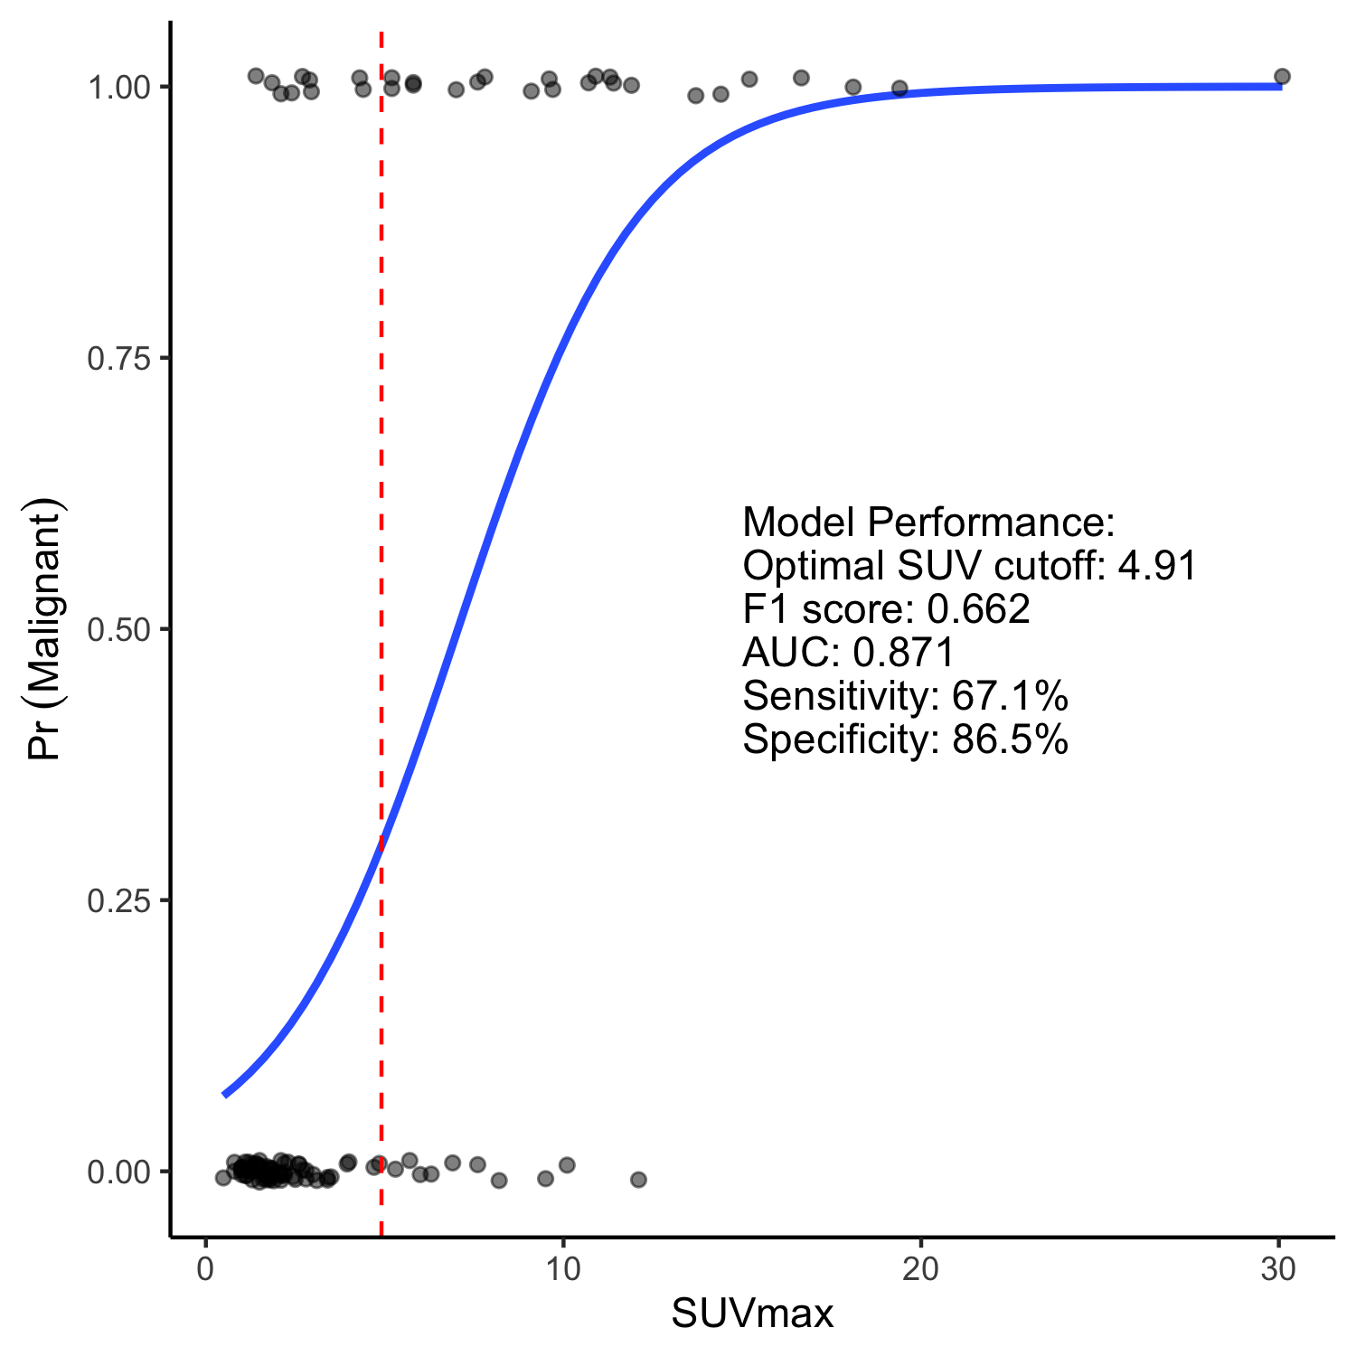
Figure 7 - Predicted probability (blue line) of malignancy of lymph nodes from a logistic regression model trained on nodal SUVmax from FDG-PET/CT in endometrial cancer. The red dashedl line represents the optimal SUV cut-off. Points represent the SUVmax of benign (bottom) and malignant (top) lymph nodes the logistic regression model was trained on.

Interobserver agreement
Intraclass correlation coefficients (ICC) were calculated for each imaging modality. FDG-PET/CT and FEC-PET/CT had excellent interobserver agreement at 0.999 (95% CI 0.998-0.999) and 0.983 (95% CI 0.963-0.992) respectively. DW-MRI had poor interobserver agreement at 0.549 (95% CI 0.345-0.702). Interestingly, the interobserver agreement between ADCmean measurements of the primary tumour on DW-MRI was higher with an ICC of 0.797 (95% CI 0.546-0.916).
Readers were more likely to take a measurement in metastatic regions. For all imaging modalities, the frequency of both readers providing a measurement in metastatic regions was higher than the frequency of both readers providing a measurement in benign regions (FDG-PET/CT: 90% vs 67%; FEC-PET/CT: 83% vs 57%; DW-MRI: 70% vs 31%).

Discussion

Starts here!

