Diagnostic performance of quantitative measures from FDG-PET/CT, FEC-PET/CT, and DW-MRI in the detection of lymph node metastases in endometrial and cervical cancer.
Ben King¹, Tara Barwick², Andrea Rockall³
The Institute of Genetics & Cancer, The University of Edinburgh, Edinburgh¹; Department of Radiology, Imperial College Healthcare NHS Trust, London²; Department of Surgery and Cancer, Faculty of Medicine, Imperial College London, London³
Email of Corresponding Author: b.g.king@sms.ed.ac.uk

Supplementary Materials

Table 1 - Demographics of patients enrolled onto the MAPPING study and eligible for analysis by meeting the primary reference standard of surgically confirmed nodal histology.
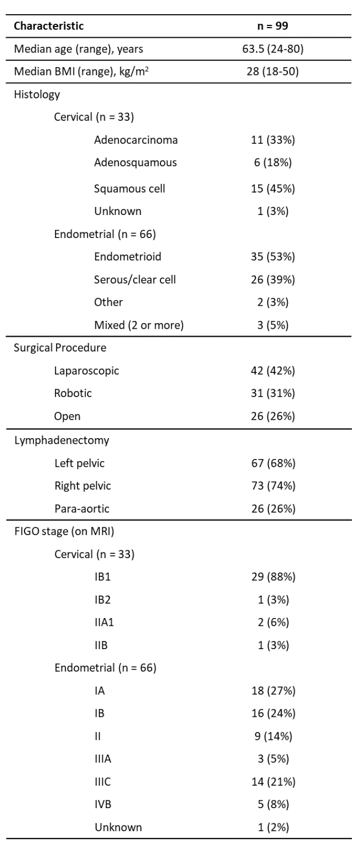

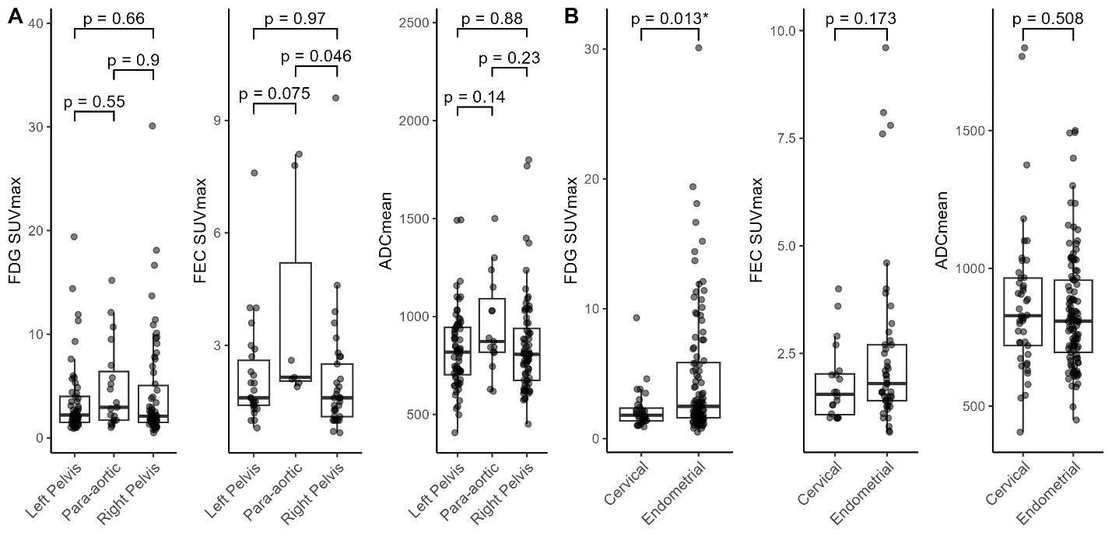
Figure 1 - (A) Quantitative measures of measured lymph nodes of each region. One-way ANOVA with Tukey’s post-hoc test was used to determine significance between regions. (B) Quantitative measures of measures lymph nodes in endometrial cancer and cervical cancer patients. Mann-Whitney U-test was used to determine significance between endometrial and cervical cancer. FDG-PET/CT (left), FEC-PET/CT (middle), and DW-MRI (right).

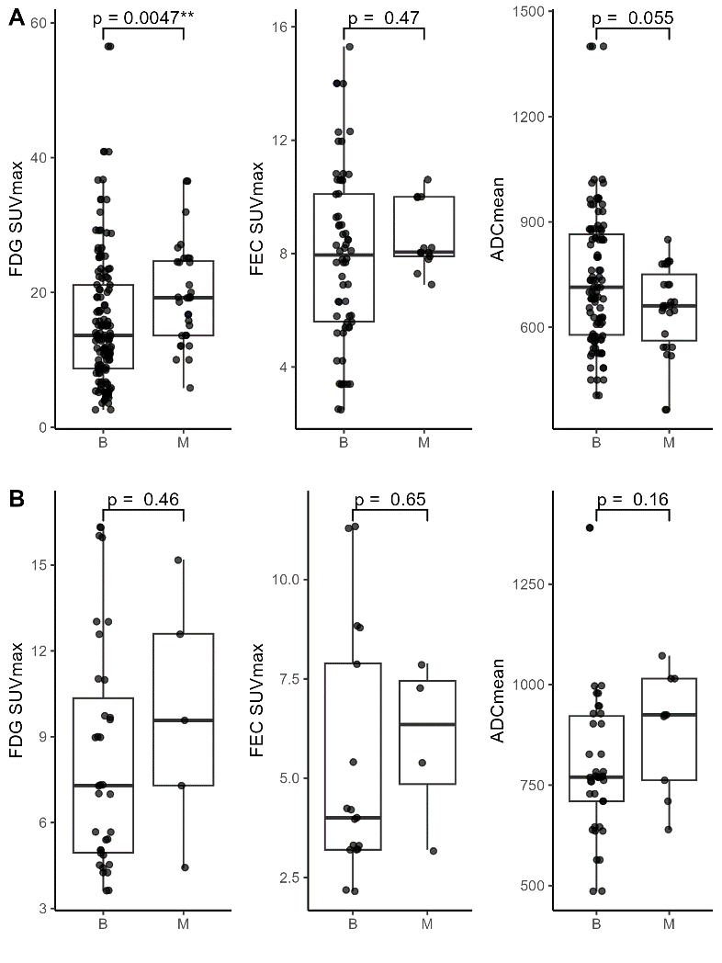
Figure 2 - (A) SUVmax was significantly elevated in primary tumours on FDG-PET/CT in patients with malignant (M) lymph nodes compared to those with benign (B) lymph nodes in endometrial cancer. (B) No significant difference in quantitative measures of the primary tumour were found for any imaging modality in cervical cancer. **, p $<$ 0.01.

