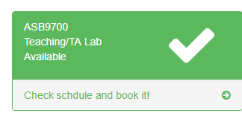Check schedule and start booking!

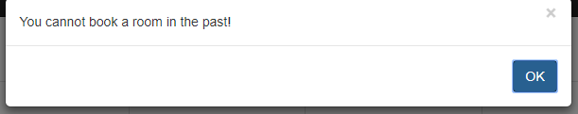Pick a date and period for your booking. You can manage your bookings at booking management page

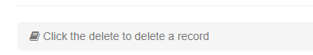You cannot book a period in the past!

这行不需要

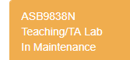

In maintenance -> Under maintenance

report violations