Table of Contents

1. 2. Kinect Evaluation 3

1.1 Calibration 4

1.2 Discrimination Between Users 6

1.3 Limited Field of View 7

1.4 Moving Base Problem 8

2. Pan Mount 11

2.1 Performance 13

2.2 Summary 16

3. 4: Person Tracking 16

4. 5: Planning 17

4.1 Point-point planner 17

4.2 Overall planning 19

4.3 Goal Generation 20

4.4 Future Work 21

List of Tables

Table 1: Conditions for Replanning 20

List of Figures

Figure 1: Kinect's calibration pose 4

Figure 2: Difficulties arise in tracking a user in contact with a chair 6

Figure 3: Obstacle avoidance may lead to target loss due 8

Figure 4: Tracking performance of Kinect under motion 10

Figure 5: DP155 Base Pan (left), Phidgets 1066_0 Servo Controller (right) 11

Figure 6: Output from Phidgets 1066_0, showing position command and open-loop feedback for position and velocity 12

Figure 7: Kinect's effective FOV without (left) and with (right) pan mount 13

Figure 8: Performance of pan mount in detecting a stationary face 14

Figure 9: Tracking performance of Kinect with pan compensation 15

Figure 10: Harlie's motion primitives 18

# Kinect Evaluation

The Microsoft Kinect is a human interface device originally developed for the Xbox to facilitate natural user interaction. The Kinect has a 640x480 RGB camera as well as a 640x480 IR camera. An infrared projector shines a known dot pattern on the scene, and by computing disparity between the known pattern and what is observed from the IR camera, a depth value can be computed for any given pixel.

The Kinect is remarkably proficient at its intended task, although when mounted on a moving base like Harlie, the Kinect is operating outside of its design parameters. The Kinect has a limited field of view (57 degrees), and normally has to be calibrated on a user before tracking can begin. The Kinect was designed to track users from a fixed position, and has trouble when used from a mobile vantage point. The Kinect is especially sensitive to sudden jolts and vibrations. The Kinect also does not work well outdoors, especially in direct sunlight (which interferes with the projected IR pattern).

The Kinect is accessed through an open-source API called OpenNI (Open Natural Interraction). However, the actual skeleton tracking is done by a closed-source binary (NITE, made by PrimeSense.) NITE provides few options for configuration, so it was not possible to probe the inner workings of the drivers and provide fixes at that level. Higher-level software workarounds had to be employed.

The Kinect has several disadvantages that had to be overcome, largely due to the closed-source nature of the skeleton-tracking software.

## Calibration

By default, whenever OpenNI detects a new user in its field of view it requires the user to stand in a calibration pose to enable an accurate measure of the user's limbs. This calibration step takes several seconds and requires the target to be still.

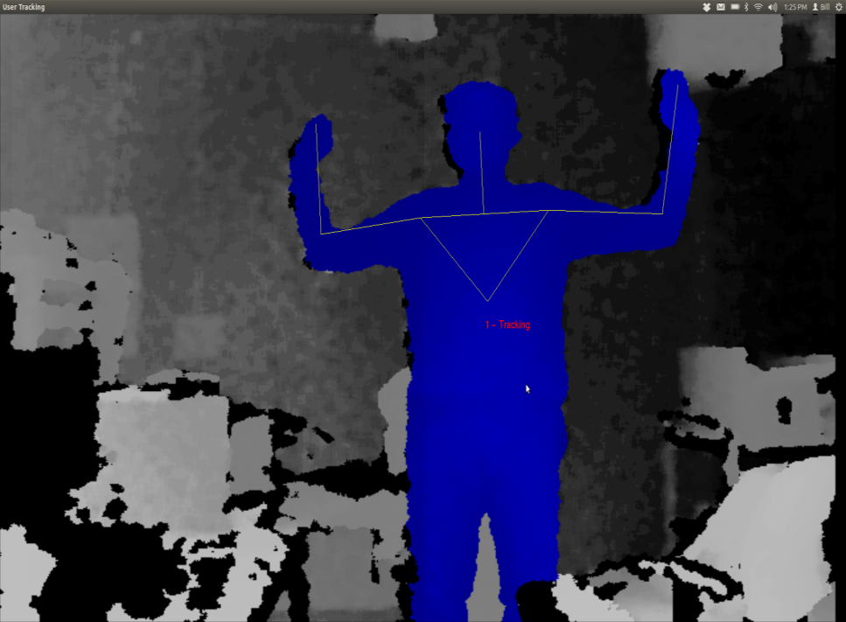

Figure 1: Kinect's calibration pose

When the Kinect is on a moving base, occasionally the target will be lost due to relative motion or jolts as discussed later. Upon target reacquisition, recalibration is frequently necessary. Recalibration would require both Harlie and the target to come to a halt, which is unacceptable given the goal of smoothly following the target. Luckily, through somewhat of a hack, OpenNI can be instructed to save the calibration of the first detected user, and for all subsequent users to use the saved calibration.

Skipping the calibration step comes at a cost. The distinctive pose required for calibration reduces the possibility of the robot following the wrong user, because it is highly unlikely that a bystander would make the pose. Without the calibration step, Harlie no longer has an easy way of telling which user to track. Furthermore, when on a moving base, the Kinect tends to classify some chairs as users. These chairs would never pass the calibration step, although without calibration they appear as spurious measurements. This issue was resolved by treating the bodies detected with OpenNI as one input to an overall Kalman filter as discussed in chapter [WHAT?].

One additional issue with OpenNI, the default behavior of the software is to track the entire human body (head, arms, torso, and legs). Full-body tracking is desirable for the Kinect’s intended application as a game controller, although Harlie's Kinect is mounted in such a way that users’ legs are often obscured (INSERT MECHANICAL DRAWING OF KINECT'S FOV). Luckily, OpenNI can be instructed to ignore legs and just track the target's upper torso, head, and arms. This results in better tracking from Harlie’s point of view, but results in an additional tradeoff. Without the shape cues that legs provide, the tracking software loses an important characteristic that can discriminate people from inanimate objects.

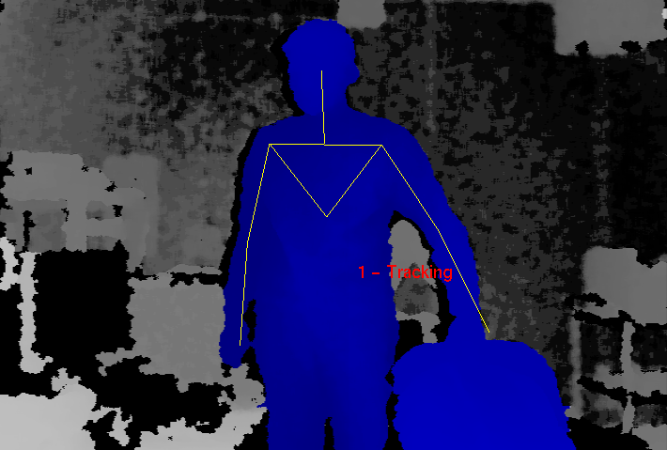

Figure 2: Difficulties arise in tracking a user in contact with a chair

## Discrimination Between Users

A major issue with the Kinect is the lack of built-in facilities for discriminating between different users. While in theory the Kinect has the potential to store color and texture information to recognize individuals, in practice, once OpenNI calibrates on a user, no information is stored other than limb measurements. As a result, if a user exits the scene, there is no guarantee that when the user is re-detected that OpenNI will assign that user the same ID. The same is true if a target is momentarily lost due to a sudden bump or relative motion.

The Kinect relies on continuity between frames to maintain a lock on a target, which is perfectly fine for its intended application as a game controller where players never leave the field of view and the Kinect is stationary so the target lock is rarely broken. However, for my application with a moving base, frequent dropouts must be dealt with. My solution, as explained later, is to use the Kinect as one of several inputs to a Kalman filter that tracks the overall hypothesized location of a person (to be discussed in a later section.)

## Limited Field of View

The Kinect has a field of view of 57 degrees. While this is sufficient for tracking a target with limited freedom from a fixed vantage point, it shows weaknesses for moving targets. When using the Kinect as the sole source of observation, Harlie must constantly face the user (within ±29 degrees) or lose the target. This puts severe constraints on the ability to maneuver and plan paths while maintaining contact with the target.

Even a task such as following a target down a straight hall can be problematic. If an obstacle appears between the user and the robot, the robot must navigate around the obstacle. As part of the obstacle avoidance, the robot will likely rotate far enough that the user leaves the Kinect's field of view, leading to a target loss. When the robot once again faces the user, it will have to re-acquire the user, leading to delay.

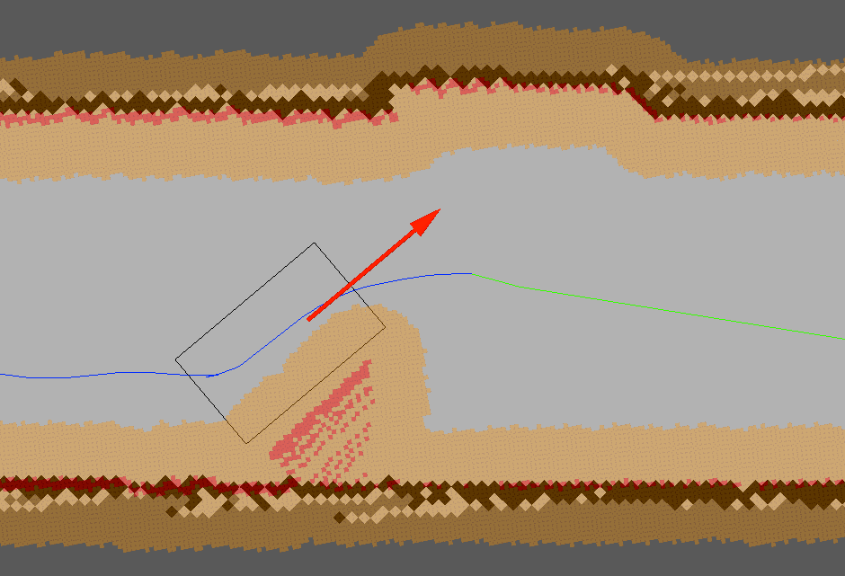

Figure 3: Obstacle avoidance may lead to target loss due

to Kinect’s limited field of view

The situation becomes even worse if the user doubles back behind the robot. In tight spaces such as hallways, the user will must come close to Harlie when moving behind it. The Kinect’s depth camera breaks down when targets are closer than 2 feet away. Thus, Harlie’s Kinect has a blind spot for close objects. In a hallway scenario, this can result in Harlie being stuck pointing at close range to a wall, within the blind-spot range. (IMAGE OF DESCRIBED SCENARIO WITH TWO-FOOT BLIND SPOT)

## Moving Base Problem

The Kinect was designed to be placed in front of a television to track users playing a game. Mounting the Kinect on Harlie's moving base poses challenges outside of the Kinect’s design parameters. When the Kinect is still, performance is obviously best. The Kinect can detect users rapidly moving through the scene, and it can easily deal with partial occlusion. The Kinect only loses a lock when a target moves very quickly or exits and reenters the scene. The Kinect can be confused if two users come close together, not being able to tell users apart by means other than their spatial positions.

Although mounted on Harlie, relative velocity must be dealt with. A walking pace for an average human is around 1 m/s. For decent maneuverability, Harlie should be able to navigate curves with a radius of 1m. Thus, by informal calculation, Harlie should be able to handle angular speeds of 1 radian/second.

The Kinect is a complicated system and the tracking software is closed-source, so it is difficult to exactly characterize the system’s performance. However, some metric of performance is necessary. A test was performed in which Harlie was rotated back and forth through 1 radian of angle (slightly less than the Kinect’s FOV) with a sinusoidal velocity profile. The Kinect attempted to track a person standing 2m away, shifting his weight from foot to foot (corresponding to 20cm of motion at 1Hz). If the Kinect performed perfectly, it would maintain a lock on the user 100% of the time. In reality, the Kinect periodically drops the user due to bumps and motion. The performance of the Kinect (the percentage of the time that it was able to maintain a lock on the user) was gathered as a function of maximum angular speed.



Figure 4: Tracking performance of Kinect under motion

The Kinect’s performance degrades as Harlie’s angular velocity increases. When the Kinect loses the target, it usually reacquires the target right away, resulting in a flickering effect as the Kinect tries to maintain a lock. With a peak velocity below 0.5 radians/second, the performance is comparable to the case of standing still. The incidence of flickering increases with speed, as well as the chance that the Kinect will lose a target and not quickly reestablish it. At the maximum tested speed of 1.0 radians/second, the Kinect performs very poorly at tracking, maintaining a lock only around 15% of the time.

In general, the Kinect performs well from a slow-moving base. At low speeds, there is not much difference from the Kinect’s stationary performance. At higher speeds, the Kinect performs more poorly. It is hypothesized that this is due partially to relative motion between the Kinect and the target, and partially due to bumps resulting from Harlie’s dynamics of motion.

# Pan Mount

To alleviate some issues inherent with the Kinect, a rotating mount was built to allow the Kinect to pan and face its target. The Kinect has a limited field of view that is problematic when it is being used from a mobile base, and the pan mount greatly expands the effective field of view. The Kinect is most adept at tracking targets with low relative motion, so the pan mount helps by lowering side-side relative motion between the Kinect and the target.

The chosen mount is a ServoCity DDP155 Base Pan (Figure 5). The DP155 is a low-cost, direct-drive pan mount that incorporates a standard hobby servo. The DP155 has a ball-bearing shaft that makes the pan platform very rigid and reduces axial stresses on the servo. The Hitec HS-485B, a mid-range hobby servo, was selected to power the mount.

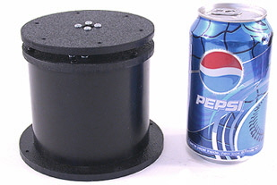 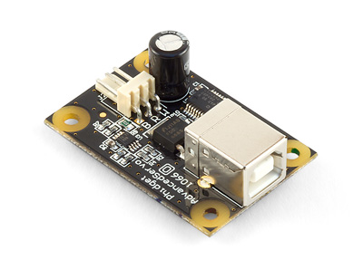

Figure 5: DP155 Base Pan (left), Phidgets 1066_0 Servo Controller (right)

To drive the servo, several servo controllers were compared and the 1066_0 PhidgetAdvancedServo 1-Motor was selected. The Phidgets 1066_0 enables precise open-loop control of a hobby servo at 30 Hz, obeying programmed constraints on velocity and acceleration. For this project, a maximum velocity of 40 degrees/sec and acceleration of 90 degrees/sec2 was chosen. The device is completely powered by a USB port and provides real-time feedback on current consumption as well as open-loop estimates of position and velocity. Phidgets provides a convenient API with bindings in multiple languages to communicate with the device.

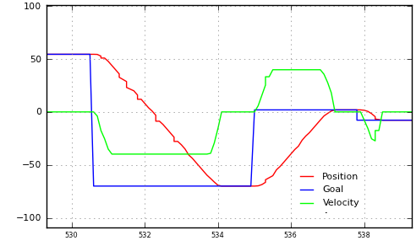

Figure 6: Output from Phidgets 1066_0, showing position command and open-loop feedback for position and velocity

To maximize field of view, the pan mount was placed on top of Harlie and near the cener. [INSERT DIAGRAM]. This required removal of an aluminum mast that previously blocked the front of the robot and the relocation of some electronics. A mount with both pan and tilt capability was initially considered, although it was determined that the Kinect’s vertical field of view was sufficient so tilt capability was eliminated to cut down on complexity and cost.

The TF (transform) API of ROS was used to represent the time-varying transform between the Kinect and the rest of the robot. The head controller software continuously monitors the last known position of the detected person, and directs the pan mount to move to that angle. The head controller repeatedly receives open-loop feedback from the Phidgets 1066_0 and publishes a transform incorporating the open-loop feedback.

## Performance

The pan mount clearly alleviates one issue with the Kinect, the limited field of view. Without the pan motion, the Kinect has a limited 57 degree field of view. The pan mount provides 180 degrees of rotation, so the Kinect’s field of view is increased from 57 degrees to an effective 237 degrees.



Figure 7: Kinect's effective FOV without (left) and with (right) pan mount

The performance of the pan mount was also tested under dynamic conditions. A subject stood 1.5m away from Harlie, while the Kinect's RGB data was fed into a Haar cascade face detector at 2Hz. The face detector located the subject’s face in Kinect-relative coordinates, which were transformed to world coordinates to account for the motion of the pan mount. If the pan mount and its associated transformations were working perfectly, the detected face would always be in the same world-relative position, no matter the position or velocity of the pan mount.

As shown in Figure 8, the pan mount performed fairly well. Most measurements were less than 5cm from the expected value (standard deviation = 3.7cm). While an error of 5cm would be troublesome for tasks that require high precision, such as mapping, this error does not pose a problem for person tracking. People are large, distinct objects, and this project could easily tolerate absolute error as high as 50cm of error in positions of reported people.



Figure 8: Performance of pan mount in detecting a stationary face

To update Figure 4, the tracking performance of the Kinect was again tested, this time with motion compensation from the pan mount. Figure 9 includes the new data. Somewhat surprisingly, the pan compensation results in decreased performance under 0.8 radians/second. Because a standard hobby servo was used in the pan mount, its motion is not entirely smooth. It is hypothesized that the pan mount introduces some jitter that makes tracking more difficult. At speeds higher than 0.8 m/s, though, the pan mount resulted in notable improvements to tracking. This increase in performance is due to the reduction in relative motion. The decrease in performance in low speeds is tolerable, made up for by the increase in performance at high speeds.



Figure 9: Tracking performance of Kinect with pan compensation

## Summary

The pan mount greatly improves the tracking capabilities of the Kinect from a mobile base, by quadrupling the effective field of view and compensating for some relative motion. The greatest problem with the current pan mount is its susceptibility to bumps and vibrations. A fairly low angular acceleration had to be programmed into the pan head to prevent jolts. In the future, a higher-grade pan mount with a DC motor and encoder could be explored to provide smoother motion. Additionally, a vibration-isolating mount could be explored to shield the Kinect from vibrations arising from the dynamics of Harlie’s motion.

# Person Tracking

Because the Kinect is not reliable enough to be used on its own, a multi-sensor approach was adopted based on the ROS people stack. A primary node maintains a Kalman filter to track the target person. The filter node continuously publishes its state, and subscribes to update messages from observation nodes. The output of the filter node also is passed on to planning as a navigation goal. This architecture makes it easy to integrate multiple sources of observation from various sensors. For this project, three sources of observation were used: a face detector, a leg detector, and a custom body detector based on the Kinect.

The face detector is one of the default nodes included in the People stack. The face detector runs an OpenCV cascade of Haar-like features on the Kinect’s camera feed to detect possible faces. The face detector then filters these matches with depth data from the Kinect, pruning faces based on plausible sizes in 3D.

The leg detector is another node distributed with the People stack. It detects legs using a boosted cascade of features computed from a LIDAR scan [*Using Boosted Features for the Detection of People in 2D Range Data, Efficient People Tracking in Laser Range Data using a Multi-Hypothesis Leg-Tracker with Adaptive Occlusion Probabilities*]

The final source of observation is a custom body detector that uses the Kinect to track users within its field of view. The body detector subscribes to the filter message, and tries to associate the filter with a person in its field of view.

# Planning

A major component of this project involved dynamic path replanning. Previous attempts at person tracking at CWRU failed. A traditional point-point planner would have to continuously replan every time that the person moved, requiring the robot to come to a halt far too often and resulting in unacceptable stuttering. This project combined a point-point planner with an intelligent rolling-window approach that successfully solves these issues.

## Point-point planner

This project’s planning is based on a point-point planner. The algorithm used is from the ROS SBPL (search-based planning lattice) package, developed jointly by developed by Maxim Likhachev at the University of Pennsylvania in collaboration with Willow Garage [GET REFERENCE].

The SBPL-based planner is a search-based, ARA* planner in 3D (x, y, θ) space. The planner uses a library of motion primitives such as lines, arcs, and spins-in-place that correspond to kinematically-plausible motions for the robot. Because the SBPL planner uses motion primitives, it produces nice, kinematically feasible paths. Previous work at CWRU involved planning using path segments (lines, arcs, spin-in-place) and thus the SBPL planner was a natural fit. Figure 10 shows Harlie’s motion primitives, including forward and reverse line moves and arc moves of two different curvatures.



Figure 10: Harlie's motion primitives

A cost can be assigned to each motion, for example to make spins in place and reverse motions more expensive than straight lines and arcs. [PICTURE]. Additionally, every robot pose along the path is checked for collision against a 2D costmap of 2.5cm resolution. The SBPL planner is fast; a typical runtime for planning several meters in a relatively clear setting is 0.1-0.2 seconds. The runtime increases for difficult moves, especially those requiring backward motion or squeezes for tight spaces, although the runtime rarely exceeds 1.5 seconds.

Modifications for this project included a motion primitive file customized for Harlie. The output of the SBPL planner was converted from a series of points to the CWRU path segment standard. Discretization error relating to the planner’s 2.5cm grid was also corrected.

## Overall planning

This project adopted an approach to allow dynamic replanning to a moving goal without the robot coming to a halt. A rolling window approach splits the robot’s path into two sections, a committed path and an uncommitted path.

The committed path represents a short-term plan that is actually passed off to steering, so it cannot be changed without bringing the robot to a halt. The committed path is about 1m long, just enough to keep the robot moving for 1-2 seconds. If it is too long, the robot will lose flexibility in planning to the target, by committing to a path that might be unsuitable several seconds from now. If the committed path is too short, the robot will run out of path before it is able to replan to the moving goal, causing the robot to come to a halt.

The uncommitted path represents the robot’s current long-term plan to get to the goal, although it is subject to change as the person moves around.

The planner continuously monitors the committed path, trying to keep its length around 1 meter. If the length drops below a threshold, path segments are shifted from uncommitted to committed. If the committed path runs out (the robot is taking a long time planning) the robot simply comes to a halt.

Table 1: Conditions for Replanning

Conditions for partial replan

* New goal
* Obstacle in uncommitted path

Conditions for full replan

* Robot currently at rest
* Partial replan fails
* Obstacle in committed path
* Target moves behind robot

When the planner gets a new goal, it prefers a partial replan from the end pose of the committed path. The planner also triggers a partial replan if a collision is detected along the uncommitted path.

Modifying the committed path is done as sparingly as possible. If a partial replan fails, the robot is brought from a halt and a full replan is performed, planning from the halt pose. A full replan is also triggered as an emergency reflex when a potential collision is detected along the committed path. A full replan is done when the robot is at rest and there is no committed path. Finally, to improve the performance of planning over short distances, a full replan is performed if the target to be tracked moves behind the robot.

## Goal Generation

For the purpose of person tracking, special consideration must be given to goal generation. Goals are received from the person tracking module, although these are unsuitable for planning. It would be impolite for the robot to attempt to plan directly to the goal, because that space is occupied by the person being tracked.

This project’s solution was to generate a “constellation” of goals offset by varying angles and distances from the target. The positions were chosen based on simulation and experience, to give Harlie flexibility in planning to the target. [PICTURE]

Upon generating the goal constellation, each goal is checked for validity, and goals in collision are removed. To keep planning time reasonable, the first four cleared goals are passed to planning. If a full replan is being performed, all goals are kept. If the robot fails to plan to all four cleared goals, it triggers a full replan.

A special case is when the target is close, approximately less than 1m away. In this case, the robot bypasses planning altogether and simply rotates to face the target.

## Future Work

The robot shows weakness tracking users at close range, especially turning around. An alternate planning algorithm could be employed at short ranges to make the response more fluid.