To alleviate some issues inherent with the Kinect, a rotating mount was built to allow the Kinect to pan and face its target. The Kinect has a limited field of view that is problematic when it is being used from a mobile base, and the pan mount greatly expands the effective field of view. The Kinect is most adept at tracking targets with low relative motion, so the pan mount helps by lowering side-side relative motion between the Kinect and the target.

The chosen mount is a ServoCity DDP155 Base Pan. The DP155 is a low-cost, direct-drive pan mount that incorporates a standard hobby servo. The DP155 has a ball-bearing shaft that makes the pan platform extremely rigid and reduces axial stresses on the servo. The [GET NAME], a mid-range hobby servo, was selected to power the mount.

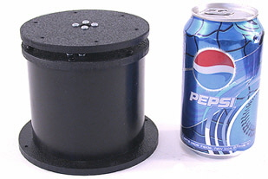

To drive the servo, several USB servo controllers were compared and eventually the 1066_0 PhidgetAdvancedServo 1-Motor was selected. The Phidgets 1066_0 enables precise open-loop control of a hobby servo at 30 Hz, obeying programmed constraints on velocity and acceleration. For this project, a maximum velocity of 40 degrees/sec and acceleration of 90 degrees/sec2 was chosen. The device is completely powered by a USB port and provides real-time feedback on current consumption as well as open-loop estimates of position and velocity. Phidgets provides a convenient API with bindings in multiple languages to communicate with the device.

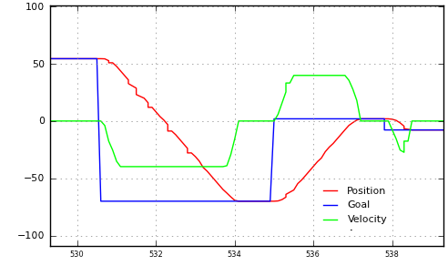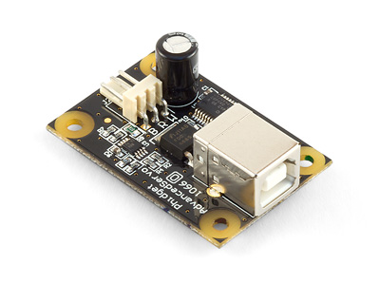

To maximize field of view, the pan mount was placed on top of Harlie and near the cener. [INSERT DIAGRAM]. This required removal of an aluminum mast that previously blocked the front of the robot and the relocation of some electronics. A mount with both pan and tilt capability was initially considered, although it was determined that the Kinect’s vertical field of view was sufficient so tilt capability was eliminated to cut down on complexity and cost.

The TF (transform) API of ROS was used to take care of the time-varying transform between the Kinect and the rest of the robot. The head controller software continuously monitors the last known position of the detected person, and directs the pan mount to move to that angle. The head controller repeatedly receives open-loop feedback from the Phidget 1066_0 and publishes a transform incorporating the open-loop feedback.

The performance of the pan mount was tested. A subject stood 1.5m away from Harlie, while the Kinect's RGB data was fed into a Haar cascade face detector at 2Hz. The face detector located the subject’s face in Kinect-relative coordinates, which were transformed to world coordinates to account for the motion of the pan mount. If the pan mount and its associated transformations were working perfectly, the detected face would always be in the same world-relative position, no matter the position or velocity of the pan mount.

As shown in Figure 1, the pan mount performed fairly well. Most measurements were less than 5cm from the expected value (standard deviation = 3.7). While an error of 5cm would be troublesome for tasks such as mapping that require high precision, this error does not pose a problem for person tracking. People are generally large, distinct objects, and this project could easily tolerate absolute error as high as 50cm of error in positions of reported people.



Figure : Performance of pan mount in detecting a stationary face

Although the pan mount greatly improves the tracking capabilities of the Kinect from a mobile base, the Kinect is still sensitive to bumps and vibrations. A fairly low angular acceleration had to be programmed into the pan head to prevent jolts. In the future, a vibration-isolating mount could be explored.