To alleviate some issues inherent with the Kinect, a rotating mount was built to allow the Kinect to pan and face its target. The Kinect has a limited field of view that is problematic when it is being used from a mobile base, and the pan mount greatly helps to expand the effective field of view. The Kinect is most adept at tracking targets with low relative motion, so the pan mount helps by lowering relative motion between the Kinect and the target. A mount with both pan and tilt capability was initially considered, although it was determined that the Kinect’s vertical field of view was sufficient, so tilt capability was eliminated to cut down on complexity and cost.

The chosen mount is a ServoCity DDP155 Base Pan. The DP155 is a low-cost, direct-drive pan mount that incorporates a standard hobby servo. The DP155 has a ball-bearing shaft that makes the pan platform extremely rigid and reduces axial stresses on the servo. The [GET NAME], a mid-range hobby servo, was selected to power the mount.

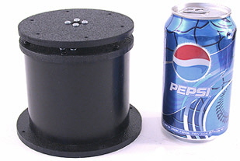

To control the mount, several USB servo controllers were compared, and eventually the 1066_0 PhidgetAdvancedServo 1-Motor was selected. The Phidgets 1066_0 enables precise open-loop control of a hobby servo at 30 Hz, obeying programmed constraints on velocity and acceleration. The device is completely powered by a USB port and provides real-time feedback on current consumption as well as open-loop estimates of position and velocity [INSERT GRAPH OF POS/VEL/ACCEL]. Phidgets provides a convenient API with bindings in multiple languages to communicate with the device.

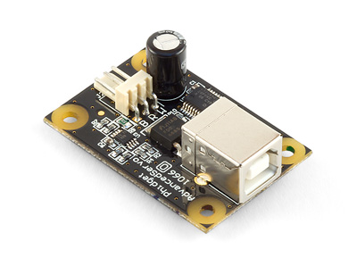

To maximize field of view, the pan mount was placed on top of Harlie and near the cener. [INSERT DIAGRAM]. This required removal of an aluminum mast that previously blocked the front of the robot, and the relocation of some electronics.

The TF (transform) API of ROS was used to take care of the time-varying transform between the Kinect and the rest of the robot. A node subscribes to a position from the person tracker, transforms it to coordinates relative to Harlie's base frame, and publishes a target angle. The head controller subscribes to this angle and communicates with the Phidget 1066_0 and publishes a transform incorporating the open-loop feedback. [INSERT FIGURE]

The performance of the pan mount was characterized. The face detector node (explained later) was run with a stationary person 1m away from the Kinect. The pan head was moved back and forth. If the pan head worked perfectly, the face would be detected in the same spot no matter the position or velocity of the pan head. [GET DATA AND INSERT FIGURE]

Because the objective of this project was to track people, great precision was not required. Because the object is to track people, the Kinect can tolerate around a foot of error for its measurements. In the future, more precise calibration could be performed to allow the Kinect to be used for mapping.

Although the pan mount greatly improves the tracking capabilities of the Kinect from a mobile base, the Kinect is still sensitive to bumps and vibrations. In the future, a vibration-isolating mount could be explored.