Final Project Report
Submission Format: PDF
Submission Location: LMS (ZIP upload); GitHub link not used for this submission.
Preparation Tools (representative): Student A (Gemini) | Student B (Claude)

1. Project Identity & Access (Repository Access)
Project Names:
• KidTask (Student A - Gazi ERTEKİN)
• BeePlan (Student B - Boran KILINÇ)
Source Code Access:
- Submitted as ZIP archives via LMS (folder structures preserved):
• SENG383-KidTask-main.zip
• SENG383-BeePlan-main.zip
Expected structure inside each ZIP (or equivalent): /src, /docs, /video, and a README.md. Since README.md is not included in the provided ZIPs, run instructions are documented below.
Run Instructions - KidTask (Java): Compile and run KidTaskApp.java (Java 8+). If using an IDE, open the /src folder as a project, then run KidTaskApp.
Run Instructions - BeePlan (Python): Install requirements (pip install -r requirements.txt) and run main.py (python main.py).

2. Design Diagrams - Final Versions (Final Design Artifacts)
The diagrams below reflect the final implemented code. For each project, we include the updated class diagram and the activity diagram matching the demonstrated user scenario.
BeePlan (Student B - Boran KILINÇ)
BeePlan - Class Diagram
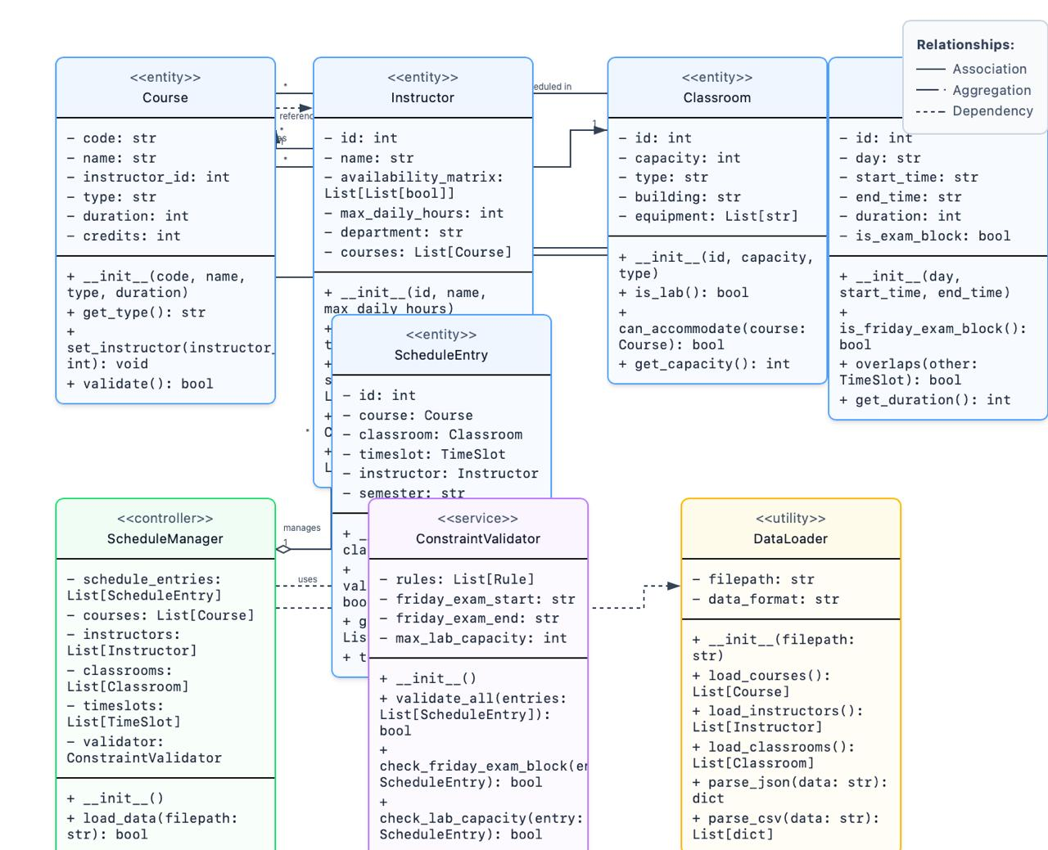
Figure B1. BeePlan UML Class Diagram (final).

BeePlan - Activity Diagram
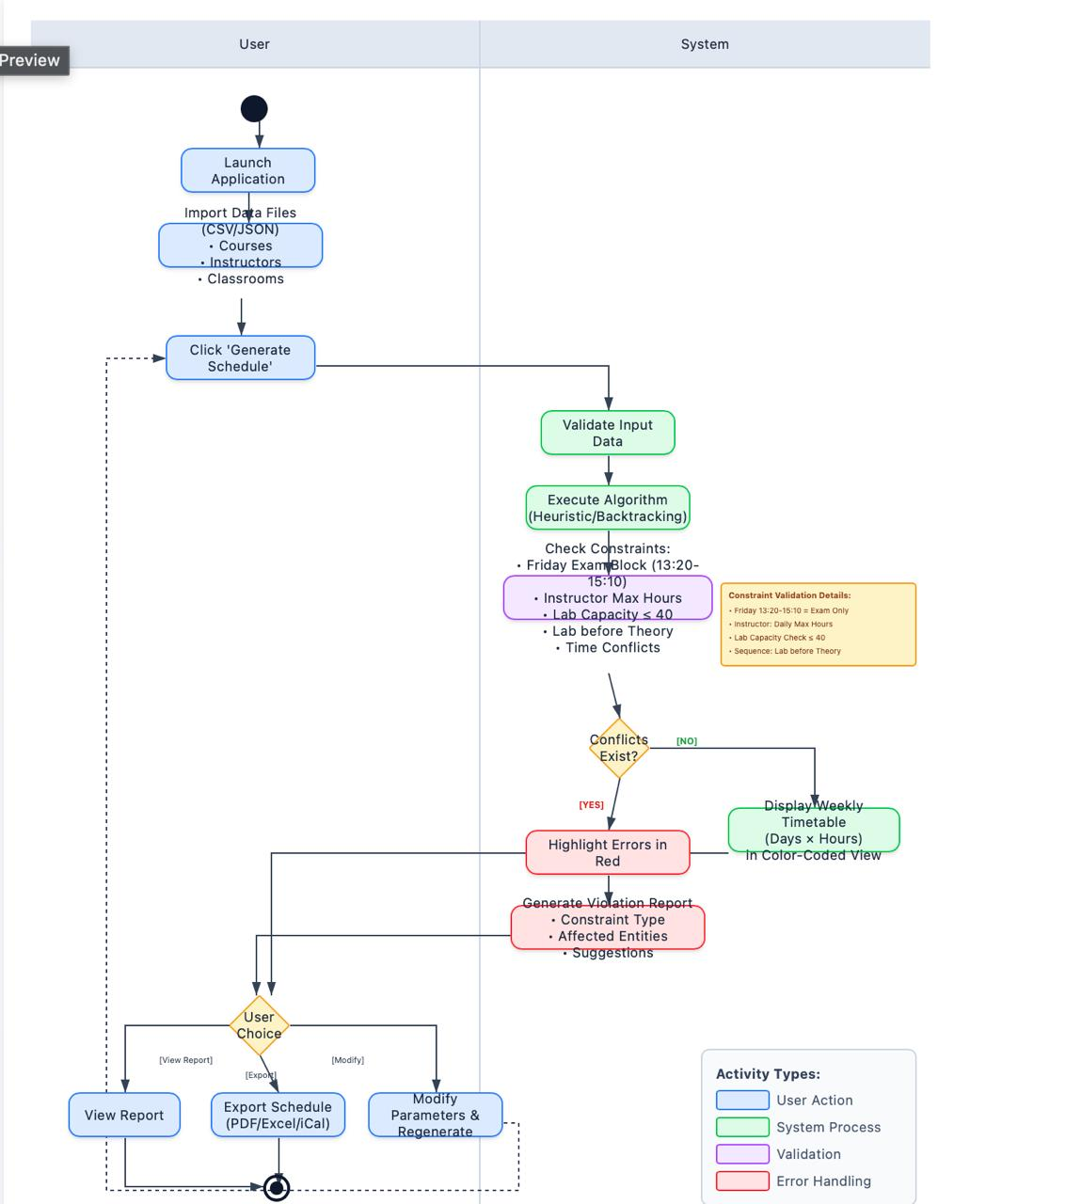
Figure B2. BeePlan Activity Diagram (user scenario and scheduling flow).

KidTask (Student A - Gazi ERTEKİN)
KidTask - Class Diagram
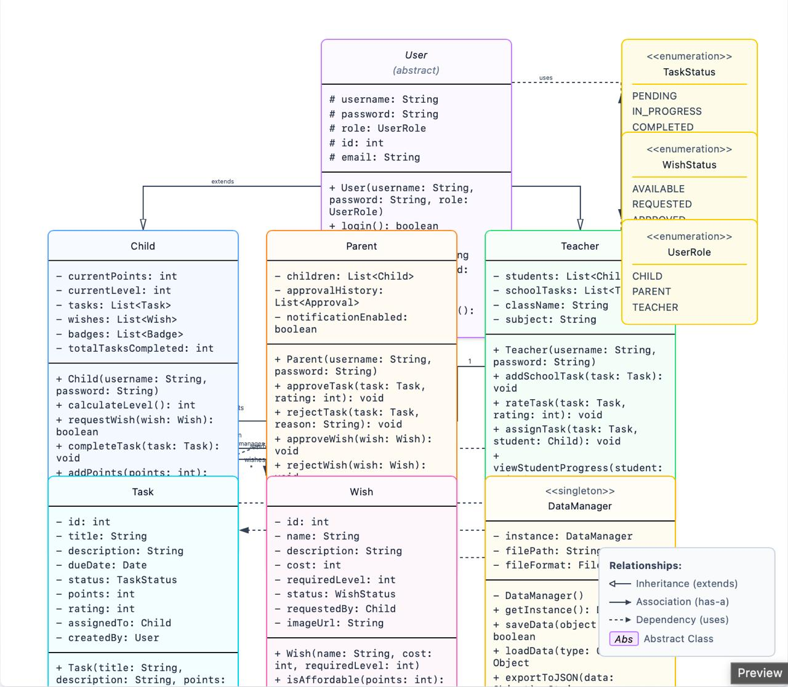
Figure K1. KidTask UML Class Diagram (final).

KidTask - Activity Diagram
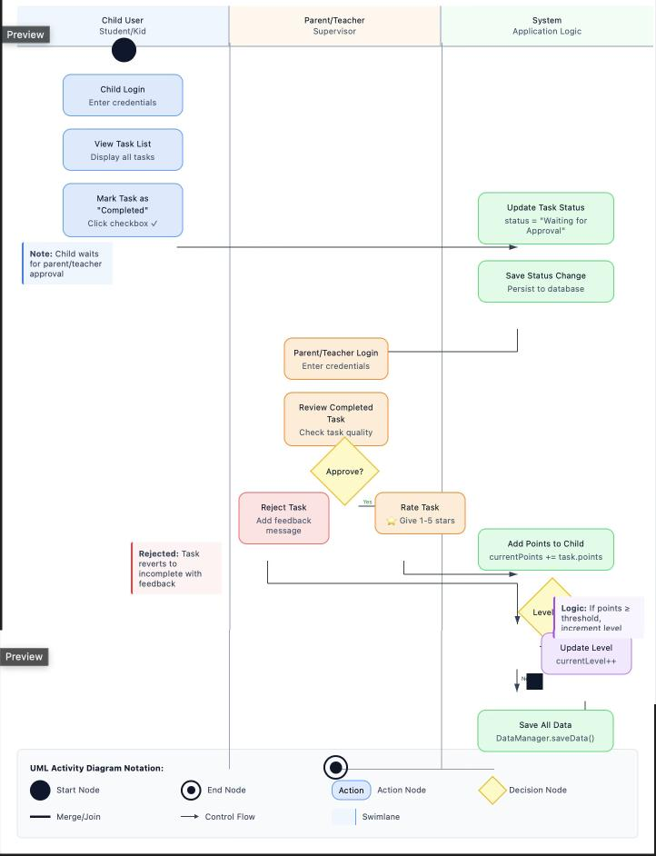
Figure K2. KidTask Activity Diagram (task completion and approval flow).
GUI Screenshots: Placeholder (to be inserted) - side-by-side comparison of initial UI mockups vs final implementation.

3. AI Usage Analysis (AI Usage & Prompts)
This section documents representative "Prompt > Output > Revision" workflows used during Design, Coding, and Testing for both projects.
Process | Tool | Prompt (Command) | AI Output Analysis | Human Revision (Final)
Design (KidTask) | Gemini | Generate a UML class diagram outline for a Kid/Parent/Teacher task-tracking app with approval and rating flow. | Initial output missed the DataManager singleton and mixed responsibilities. | Refined responsibilities, added DataManager singleton, separated GUI panels from model classes.
Coding (KidTask) | Cursor/Copilot | Implement Java Swing panels for login + dashboard + task/wish management following MVC-ish separation. | Produced workable UI code but event handling was tightly coupled and lacked validation. | Refactored handlers into dedicated methods; added input checks and safer file I/O.
Testing (KidTask) | OpenAI | Given a failing scenario where task status does not persist after restart, suggest debugging steps and fixes. | Identified likely root cause but suggested over-engineered solutions. | Applied minimal fix: ensured saveData() called after status changes; standardized file paths.
Design (BeePlan) | Claude | Propose a clean Python module structure for a schedule generator with constraints (Friday exam block, max daily hours, lab capacity). | Good separation but validator rules were too generic. | Specified explicit rule methods and aligned data model fields with JSON/CSV inputs.
Coding (BeePlan) | Copilot | Write a heuristic/backtracking scheduler loop with conflict checking and a report generator. | Generated baseline algorithm but had edge-case bug in overlap detection. | Fixed overlap logic by converting times to minutes; added deterministic sorting; improved error messages.
Testing (BeePlan) | Gemini | Create pytest-style tests for parsing and constraint validation (lab before theory, capacity <= 40). | Tests lacked negative/boundary cases. | Added malformed-input tests, boundary checks (40/41), and Friday exam slot validation.

4. V&V Test Reports (Verification & Validation)
The following test cases were executed on the final versions. 'Pass' indicates expected behavior observed.

4.1 Test Cases - KidTask (Student A)
ID | Scenario | Steps | Expected | Result
TC-K1 | Login with valid credentials | Enter correct username/password | Login succeeds; dashboard opens | Pass
TC-K2 | Login with invalid password | Enter wrong password | Error message shown; stay on login | Pass
TC-K3 | Mark task as completed | Child marks task completed | Status becomes 'Waiting for Approval' | Pass
TC-K4 | Parent approves & rates task | Parent approves and rates 1-5 | Points added; level recalculated | Pass
TC-K5 | Persistence after restart | Approve then restart app | Task status and points persist | Pass

4.2 Test Cases - BeePlan (Student B)
ID | Scenario | Steps | Expected | Result
TC-B1 | Load JSON dataset | Load sample_data.json | Parsed without error | Pass
TC-B2 | Friday exam block | Schedule non-exam course in Friday 13:20-15:10 | Rejected; error reported | Pass
TC-B3 | Lab capacity constraint | Lab capacity=41 | Rejected; suggestion shown | Pass
TC-B4 | Lab before theory | Lab scheduled after theory | Violation flagged; recommendation shown | Pass
TC-B5 | No overlaps per room | Two entries overlap same classroom | Conflict detected; scheduler backtracks | Pass

4.3 AI Tutor Bug Fixes (placeholders for screenshots)
KidTask - Bug 1 (Persistence): After approving a task, data did not persist after restart. Root cause was missing saveData() call in some state-change paths. Fix: call DataManager.saveData() after every status/points mutation. [Screenshot placeholder]
KidTask - Bug 2 (Empty state crash): Opening progress view with an empty task list caused a null/empty calculation error. Fix: add empty-state guards and show 'No tasks yet' UI message. [Screenshot placeholder]
BeePlan - Bug 1 (Overlap detection): Overlaps were missed when times were compared as strings. Fix: convert start/end times into minutes and compare integers in overlaps(). [Screenshot placeholder]
BeePlan - Bug 2 (Friday exam rule): Non-exam courses were sometimes allowed in the Friday exam block due to incomplete rule check. Fix: implement explicit is_friday_exam_block() and enforce in validator. [Screenshot placeholder]

4.4 Peer Review Findings
Review by Gazi ERTEKİN on BeePlan: (1) Improve validation summary report to include constraint type and affected entities. (2) Separate data parsing responsibilities from scheduling logic for maintainability.
Review by Boran KILINÇ on KidTask: (1) Reduce GUI-model coupling by routing changes through backend methods. (2) Enforce enum usage for roles/status values to avoid string literals.

