# YSI CALIBRATION WORK SHEET

|  |  |
| --- | --- |
| Date/Time of Calibration: 2016-01-01T01:01 | Site Location: Bridge |
| Sonde Circuit Board SN: LD-34-432 | Technician: Mike |
| Sonde SN: hhhh | Name of Instrument ID: 213-32A |

|  |  |  |  |  |  |  |
| --- | --- | --- | --- | --- | --- | --- |
| **INSTRUMENT DATA DOWNLOAD** | | | | | | |
| Stop Logging? | YES | | Correct Time? | | | YES |
| Name of Files Downloaded | | Date Range | | | Number of Samples Downloaded | |
| test | | today - tomorrow | | | test 1 | |
| NOTES:  no notes | | | | | | |
| Sonde Battery Voltage (mV) and Battery Life in days | | | | 3, 4 | | |
| **INSTRUMENT DEPLOYMENT** | | | | | | |
| Name of New File | | | | SPC Anisimov, Pavel | | |
| Time of Start Logging | | | | 01:00 | | |
| New Sonde Battery Voltage (mV)/Battery Life in days | | | | 0, 1 | | |

|  |  |  |
| --- | --- | --- |
| **Maintenance** | **Yes** | **No** |
| Turbidity wiper changed |  |  |
| ROX wiper changed |  |  |
| Batteries changed |  |  |
| O-rings changed/greased |  |  |
| ROX DO membrane changed/Cal Codes | K1: agdaad K2: getertr    K3: sfdsdfh K4: sfdsdfbs    C:undefined | |
| Probes Changed/ SNs | sdfgsd | |

**Notes:**

2 If out of range, may mean probe is dirty. Try “uncal”.To uncal with 650 handheld: Menu-Calibrate-select parameter-select 1 or 2 pt. calibration (if needed)-just before entering calibration standard value, press enter (hold down) and “esc”. To uncal with computer, type in “uncal” just before entering calibration standard value. This will only uncalibrate specific parameter, not all probes.

| **Parameter** | **Calibration Solution** | **Diagnostic Mode** | **Diagnostic Value1** | **QA Value (triplicates)** | **Pre-Cal Value** | **Post-Cal Value** |
| --- | --- | --- | --- | --- | --- | --- |
| **Specific Conductivity** | 10 mS/cm | Conductivity cell constant (Menu-Advanced-Cal Constants).  **Range:** 5.0 + .45 mS/cm2 |  | 1. |  |  |
| 2. |
| 3. |
| **pH (1st pt.)** | pH 7 | pH MV Buffer 7  **Range:** 0 + 50 mV3 |  | 1. |  |  |
| 2. |
| 3. |
| **pH 10 (2nd pt.)** | pH 10 | pH MV Buffer 10  **Range:** -180 + 50 mV3 (mV difference from pH 7 ≈ 165 to 180 mV) |  | 1. |  |  |
| 2. |
| 3. |
| **Turbidity (1st pt.)** | 0 NTU | N/A | N/A | 1. |  |  |
| 2. |
| 3. |
| **Turbidity (2nd pt.)** | 126 NTU | N/A | N/A | 1. |  |  |
| 2. |
| 3. |
| **DO ROX** | % Saturation | ODO gain:  **Range:** -0.85 – +1.153 |  | 1. |  |  |
| 2. |
| 3. |
| **Barometric Pressure** | BP Value (mmHg): | | | Source: | | |

**image_1**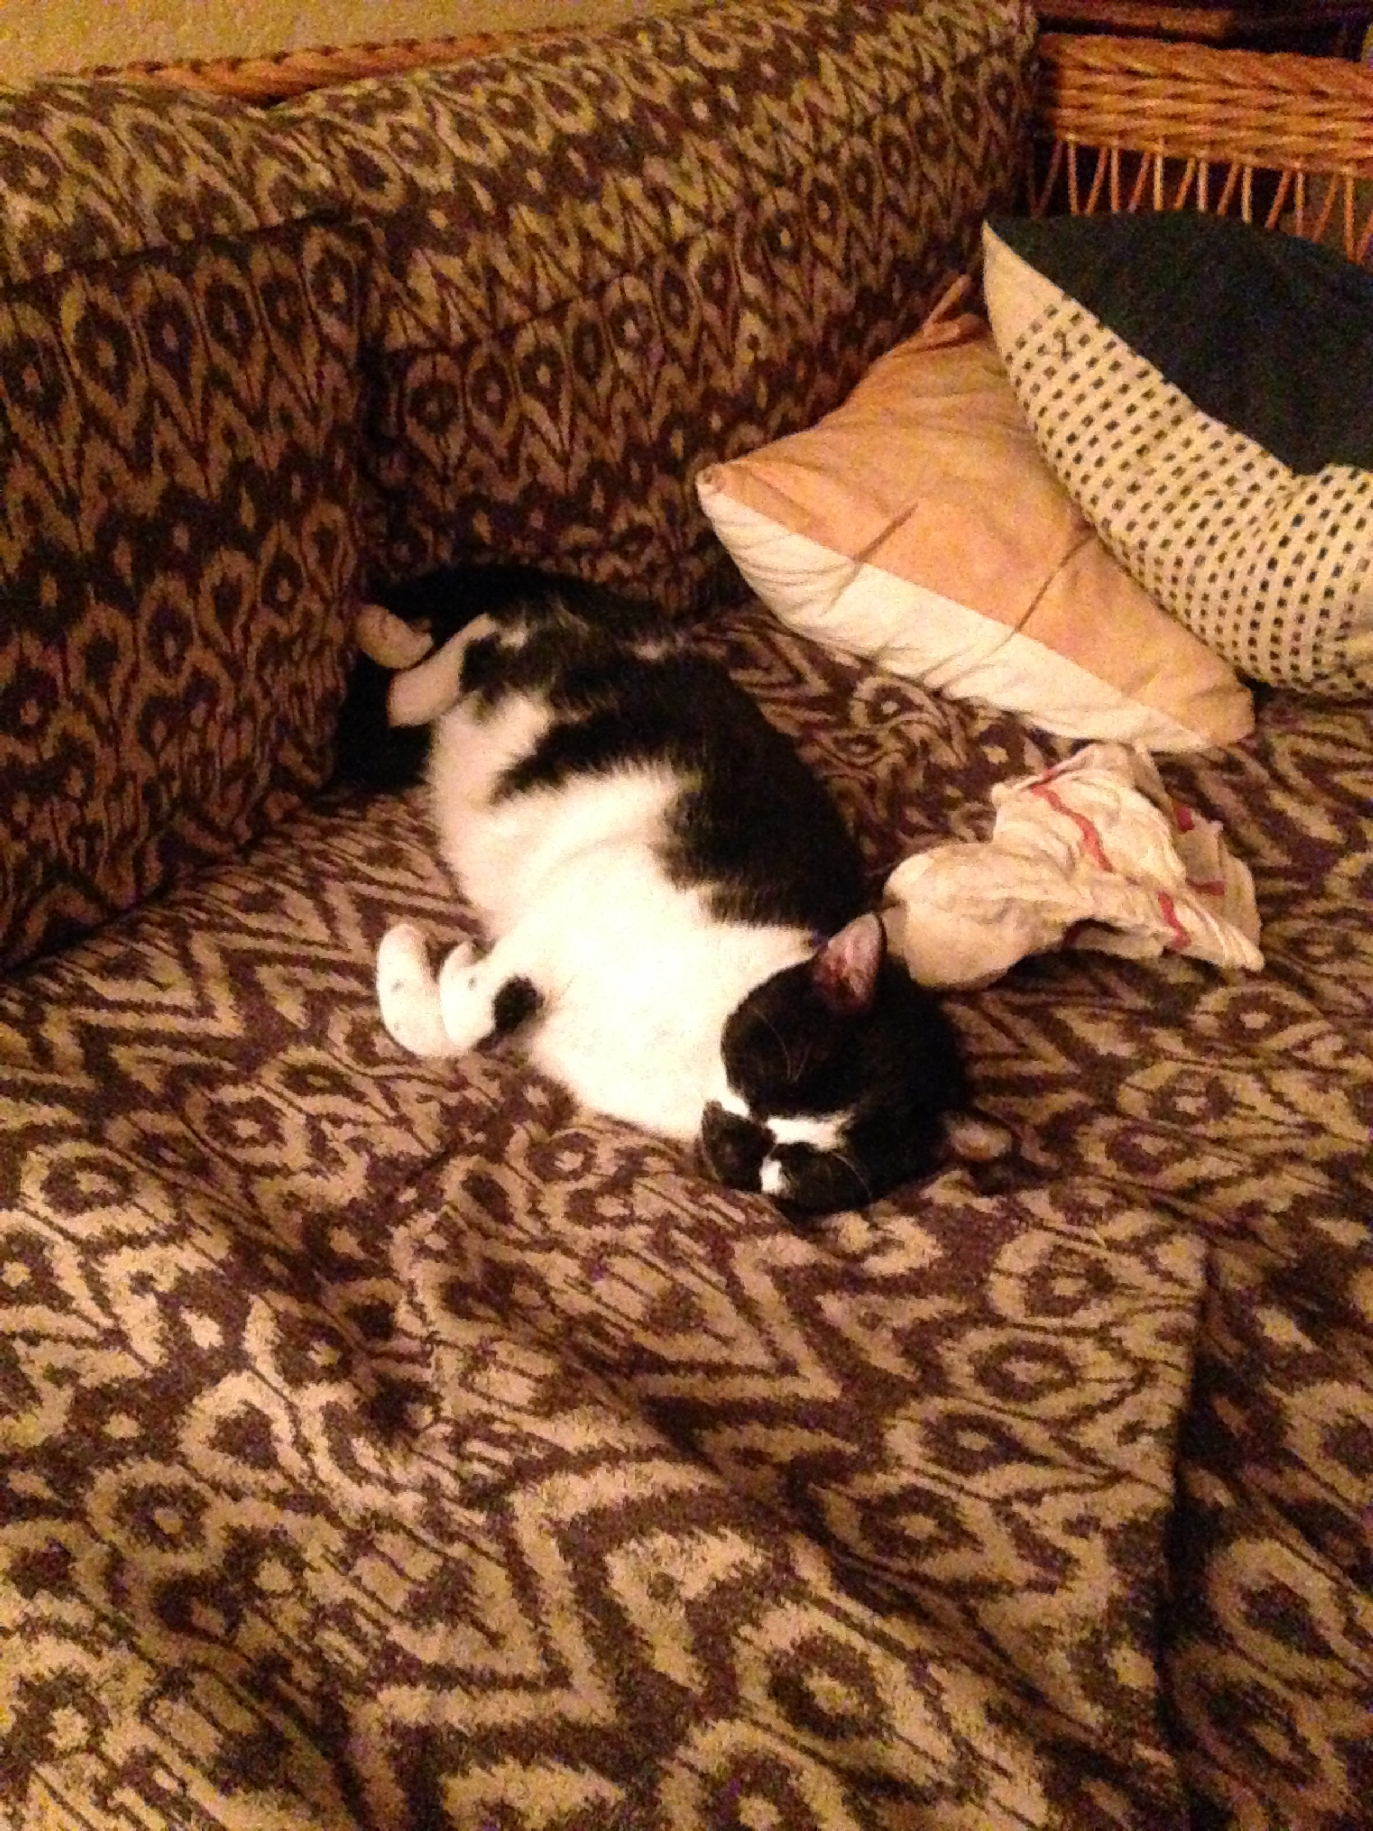

**image_2**