Methanol Fuel Cell Enabled Hybrid Power System

Process Global, Inc. (Sunnyvale, CA); Dr. Branden Kappes

Technical Category: 7.L Technologies for portable power applications

Estimated Total Project Cost: $3.6M

Project Duration: 3 years

Next generation portable electronics, remote monitoring and communications systems will increasingly require always-on technologies – such as powered sensors, continuous data acquisition, on-chip data analytics and communication– to improve functionality and extend into applications currently prohibited by relatively high energy demands.

Lithium ion batteries are sufficient to power existing portable systems, and operate at or near 100% Coulombic efficiency over both a wide state of charge and a wide range of currents. But low energy densities, below 150 Wh/kg (100 Wh/L), place prohibitive limits on the always-on state required for next generation functionality in portable devices. In contrast, direct methanol fuel cells (DMFCs) have theoretical energy densities in excess of 5000 Wh/kg (3000 Wh/L), but suffer from intrinsic electrochemical limitations to their use as stand-alone power supplies. Sluggish kinetics, and chemical-, mass transport-, and ohmic-polarization losses impede their ability to promptly respond to changes in power demand and result in a narrow optimal operating range.

A hybrid battery-fuel cell power system couples the energy density of a direct methanol fuel cell with the power response and wide operational efficiency of an all solid-state lithium ion battery (ASSLB). This project will, over three years, address the three challenges facing DMFC that impede their commercialization: high methanol crossover, high activation polarization, and poor anode catalyst longevity due to Ru dissolution. In order to reduce battery complexity, and improve the volumetric energy density, this project will improve battery technology through the development of an all solid-state lithium ion battery. This work will use dry chemical methods and ALD to chemically modify the GO surface without introducing additional structural damage to the GO sheet.

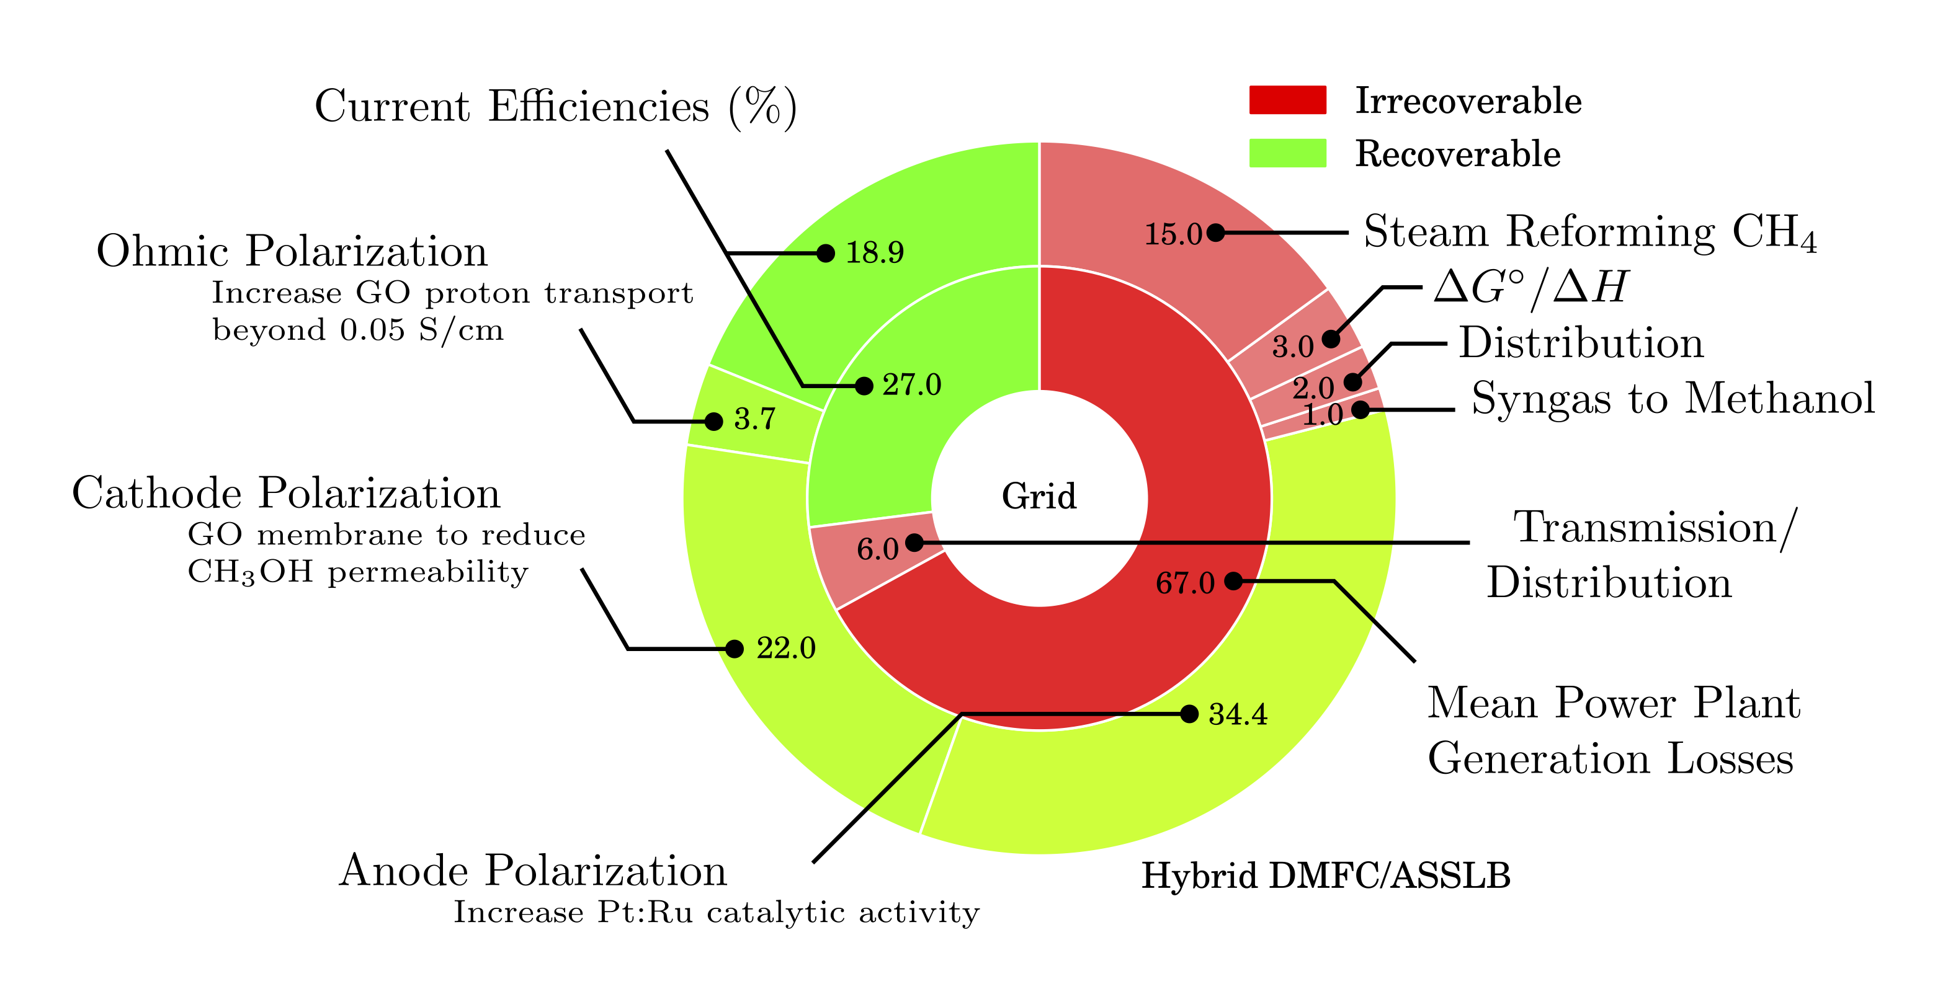

Figure 1 Potential for improved energy efficiency through use of the proposed hybrid direct methanol fuel cell/all solid-state lithium battery power system.

The resulting hybrid DMFC/ ASSLB will allow the power and energy requirements of each application to be optimized independently. While ASSLB promise 2-3 times greater energy density, DMFC has the potential to increase their energy density. Graphene oxide membranes require improvements to both proton conductivity and selectivity to lower ohmic and cathode polarization losses, respectively; improved anode catalyst activity and stability in acidic media, to decrease anode polarization; and to the lithium ion battery to improve energy density.

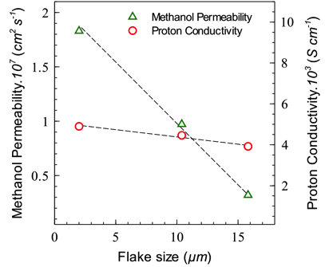

Figure 2 Methanol permeability (diffusivity) and proton conductivity through graphene oxide (GO) as a function of the mean nanoplatelet size. From Paneri2014.

Chemical modification of GO has been seen to improve the proton conductivity to values within the range of Nafion® (Sott2012a), but other reports indicate a corresponding increase in methanol permeability (Jiang2014). Sulfonation has been shown to significantly increase proton conductivity at low methanol concentrations (Jiang2012), but at higher concentrations, the sulfonic acid groups on the GO surface induce a methanol/water phase separation that reduces proton conductivity (Paneri2014). The precise nature of proton transport through GO is not known, but the insensitivity of proton transport to flake size (Fig. X) suggests through-platelet transport plays a dominant role; contrarily, the large drop in methanol permeability over that same range indicates methanol permeation occurs predominantly at platelet edges. It is thought that this phase separation phenomenon could be supressed in (Reference). Surface modification to GO using vapor phase methods, including ALD and molecular layer deposition (MLD), will enable the development of GO membranes resistant to methanol/water phase separation and proton transport through GO defects.

PGM activity has been seen to increase on substrates with catalyst nanoparticles (NPs) on them, (Feng2013a), and is known to depend significantly on the shape and size of the NPs. What work has been done in addressing catalytic activity?

What work has been done in ASSLB?

Complete electrooxidation of methanol involves the formation of carbon monoxide, which poisons platinum catalysts. Though Pt-Ru alloys are stable against CO poisoning, dissolution of Ru in the acidic environment of the DMFC anode limits anode catalyst longevity. The proposed effort will increase catalytic activity by optimization of the catalyst synthesis to produce nanoparticles of prescribed morphologies, shapes and sizes. We will pursue the catalyst optimization by combining computational tools (synthesis models, simulations of process or properties, etc.) with experimental methods/techniques of synthesis and characterization in order to predict desired materials and to achieve a fundamental understanding of their synthesis and/or control over the final product and its catalytic properties (Leong2014, example in Fig. 3). The catalytic materials systems to be addressed are metal NPs, with or without core-shell morphologies. These well-defined catalytic systems are ideal for linking experiments and modeling, providing controlled systems for building selective and complex functionalities. The proposed effort will increase catalyst stability by lowering the solubility of Ru in acidic media. Our team has extensive experience in Pt-Ru deposition including wet chemical reduction (WCR), atomic layer deposition (ALD), and sputtering.

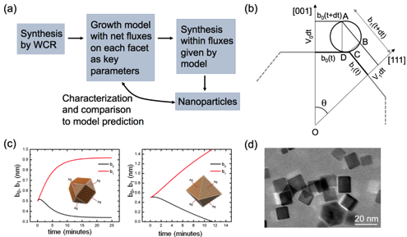

Figure 3 (a) Computationally guided synthesis of metallic nanoparticles by wet chemical reduction (WCR) –recent work at CSM (Leong2014). (b) Key parameters of the computational model: net attachment rates for each facet. (c) Predictions of the model for different ratios of attachement rates to (001) and (111) facets. (d) Actual Pd cuboctahedra synthesized by Richards' group.

Solid-state electrolytes appreciably reduce the complexity of each lithium ion cell, reducing both weight and volume. With a smaller cell, this volume and weight can be recaptured into increased fuel storage, multiplying the impact of any improvement in battery performance. An all solid-state battery using solid electrolytes is expected to have a higher energy density than a lithium ion battery using organic liquid electrolytes. Furthermore, use of solid-state electrolytes will improve the safety and reliability of lithium secondary batteries. All-solid-state batteries can be divided into two types, thin-film-type and bulk-type. For large-scale applications, bulk-type ASSLBs with high loadings of active material and solid electrolyte powders, are well suited because of their high energy density. However, ASSLBs have crucial challenges for practical applications, such as poor rate performance and poor contact between the active material and the electrolyte. Sulfide type electrolytes were developed to improve conductivity over earlier solid electrolytes, e.g. LiPON. Li2S–P2S5 and Li2S–P2S5–GeS2 systems offer ion conductivity from 10-3 to 10-2 S/cm at room temperature, similar to liquid electrolytes; and have a high, 5 V decomposition potential. With these electrolytes, the maximum resistance is observed at the cathode/sulfide electrolyte interfaces. We will use SEM, TEM, and cyclic voltammetry to understand the cathode/electrolyte interface, which has been identified as an issue of the greatest importance for the improvement in ASSLBs.

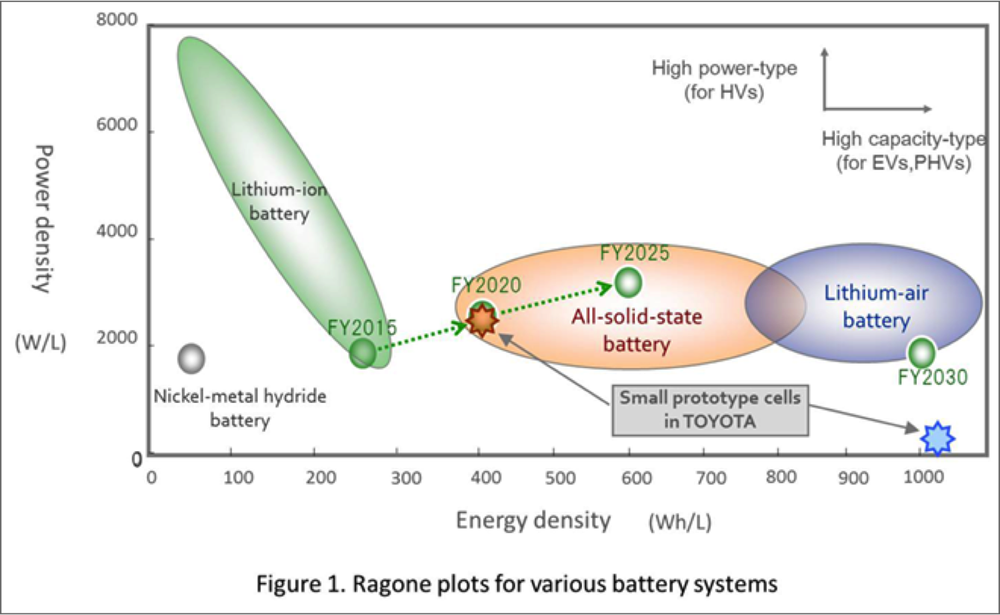

Figure 4 Ragone plot showing the timeline for the expected improvement in all solid-state batteries. Reference?

Compared to other fuel cell options, DMFCs combine the use of high energy density fuels typical of high temperature solid oxide and phosphoric acid fuel cells with the low operating temperature of hydrogen fuel cells. Commercial attempts at solid oxide fuel cells for portable applications were able to lower radiant losses by nearly two orders of magnitude, but absent cogeneration, these losses still accounted for ~50% of the energy generated by this system. Furthermore, thermal cycling of these high temperature fuel cells and the highly corrosive electrolyte of phosphoric acid fuel cells severely limit longevity in the highly cyclical nature of portable energy generation. Compared to hydrogen fuel cells, methanol has ten times (two times) the gravimetric (volumetric) energy density of hydrogen, and, because it is liquid at room temperature, greatly simplifies both handling and distribution.

Several technical performance and cost targets are necessary for a disruptive technology to take effect. For DMFC, these include an increase in the methanol concentration from 2 to 10 M; an increase in methanol permeability from 50 to 0.25 mA/cm2 (Zhao2009, Corti2014); and increase the proton conductivity for GO from 0.0045 to 0.05 S/2 (Paneri2014, Sone1996); and a twofold reduction in price, from $550/kWh to $250/kWh (Kamarudin2009).

ASSLB targets include in increase in lithium conductivity from XXX to YYY; improved electrode – specifically cathode – contact with the electrolyte; an increased energy density from 250 to 400 Wh/L; and a cost reduction from $1450/kWh to $1000/kWh (Kararudin2009).

**Proposed Work**

Year 1 will focus on the development of individual components with significant improvements toward the target performance metrics. This will include (1) synthesis and characterization of candidate graphene oxide and chemically modified GO membranes. Modifications to GO will include addition of dopants followed by thermal stabilizationa and controlled reduction of the oxide-containing functional groups. Molecular dynamics simulations of proton transport through graphene oxide will be used to evaluate the efficacy of chemically modified GO membranes. (2) Synthesis and analysis of the stability, activity, and performance of the anode catalyst layer under conditions near and around those expected during fuel cell operation. Improvements to the catalyst will involve modeling and growth/deposition of Pt-Ru alloy nanoparticles. (3) Synthesis and characterization of a solid state battery electrolyte: lithium conductivity, cycle stability, … (4) Finally, system level modeling efforts will be put in place to pre-optimize operating conditions based on the evolving properties of the catalyst layer, membrane and battery properties.

Year 2 will focus on the achieving the target performance metrics for all individual components. Fuel cell components will be integrated into a test cell for controlled performance testing at the Energy Systems Integration Facility at NREL. Solid-state battery components will be integrated into a coin cell configuration for electrochemical testing.

Year 3 will optimize the performance of the integrated fuel cell and battery systems under simulated real-world operational variations. Merging the fuel cell and solid-state battery into a hybrid power system will be done at PGI.

is surpressed inthese defects have a to By combining battery technology with direct methanol fuel cells, advancement in this hybrid system does not hinge on improvement in any single technology, but rather benefits from every individual improvement: in battery capacity, catalyst activity, or membrane performance.

Key technical risks include…

Technical risks will be mitigated by…

Several techno-economic challenges exist that stand in the way of commercialization. Both anode and cathode require platinum and platinum-group metal catalysts. Typical loading levels, 2.5 mg/cm2 on each catalyst layer, account for a price of $1366/kW, based on platinum at $1162/oz. At this cost, the price per kilowatt is in line with existing lithium ion batteries (Kararudin2009), but does not provide a sufficient cost-reduction incentive to justify changing technologies.

**Team Organization and Capabilities**

**Project Prime**: Process Global, Inc. brings to the table…

*Principle Investigator*: Dr. Branden Kappes is an expert in… and will provide…

**Project Partner**: NREL will bring…

*Key Member*: Dr. Chunmei Ban is an expert in… and will provide…

*Key Member*: Dr. Steven Christensen is an expert in… and will provide…

*Key Member*: Dr. Katherine Hurst is an expert in… and will provide…

**Project Partner**: Colorado School of Mines will bring…

*Key Member*: Prof. Cristian Ciobanu is an expert in… and will provide…

Within the last three years, all members of the current team have collaborated on projects relevant to the proposed effort. Drs. Ban and Kappes collaborated on an ARPA-E funded project on organic flow batteries that completed December 2014, and have numerous publications on lithium ion batteries. Drs. Ciobanu and Kappes have collaborated on… Drs. …