Methanol Fuel Cell Enabled Hybrid Power System

Process Global, Inc. (Sunnyvale, CA); Dr. Branden Kappes

Technical Category: 7.L Technologies for portable power applications

Estimated Total Project Cost: $3.6M

Project Duration: 3 years

Next generation portable electronics, remote monitoring and communications systems will increasingly require always-on technologies – such as powered sensors, continuous data acquisition, on-chip data analytics and communication – to improve functionality and extend into applications currently prohibited by relatively high energy demands. Lithium ion batteries are sufficient to power existing portable systems, and operate at or near 100% Coulombic efficiency over both a wide state of charge and a wide range of currents. But low energy densities, below 150 Wh/kg (100 Wh/L), place prohibitive limits on this always-on In contrast, direct methanol fuel cells (DMFCs) have theoretical energy densities in excess of 5000 Wh/kg (3000 Wh/L), but suffer from intrinsic electrochemical – sluggish kinetics, and chemical-, mass transport-, and ohmic-polarization losses – that impede their ability to promptly respond to changes in power demand and result in a narrow optimal operating range.

A hybrid battery-fuel cell power system couples the energy density of a direct methanol fuel cell with the power response and wide operational efficiency of an all solid-state lithium ion battery (ASSLB). Figure 1 shows the potential impact of a hybrid DMFC/ASSLB power system. Coal, petroleum, natural gas, and nuclear fuels powering steam, gas turbine, ICE, and combined cycle generation at present average 33% efficiency (67% loss), with an additional 6% loss from transmission and distribution. Fuel cells currently operate at an efficiency of ~19%, but unconstrained by Carnot efficiency, DMFCs could theoretically achieve a 79% efficiency, including production and distribution. This project will, over three years, address the three challenges facing DMFC that keep their efficiencies below our 35% target efficiency: high methanol crossover, high anode polarization due to low catalyst activity, and high cathode polarization due to mixed potential losses. In order to reduce battery complexity, and improve the volumetric energy density of the hybrid power system, this project will improve battery technology through the development of an all solid-state lithium ion battery. The resulting hybrid DMFC/ASSLB will allow the power and energy requirements of each application to be optimized independently.

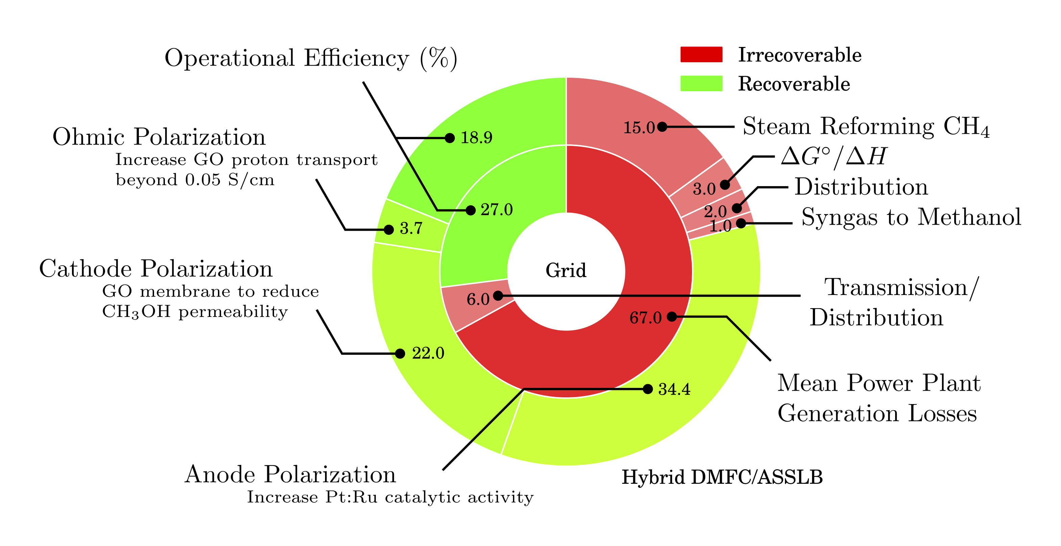

Figure 1 Potential for improved energy efficiency through use of the proposed hybrid direct methanol fuel cell/all solid-state lithium battery power system.

Graphene oxide (GO) has recently been identified as a membrane with extremely high selectivity and permeability to water (Nair2012), but low intrinsic proton conductivity (Tateishi2013). However, the proton conductivity of sulfonated GO has recently been shown to be comparable to that of Nafion® (Sott2012a), but at the cost of increased methanol permeability (Jiang2014); and although sulfonation has been shown to significantly increase proton conductivity at low methanol concentrations (Jiang2012), at higher concentrations the sulfonic acid groups on the GO surface induce a methanol/water phase separation that reduces proton conductivity (Paneri2014). The precise nature of proton transport through GO is not known, but the insensitivity of proton transport to GO flake size (Figure 2) suggests through-platelet transport plays a dominant role; contrarily, the decrease in methanol permeability over that same range indicates methanol permeation occurs predominantly at platelet edges. We propose to modify the GO surface using vapor phase methods, including ALD and molecular layer deposition (MLD), to enable the development of GO membranes that resist methanol/water phase separation while increasing proton transport. For DMFC, success would be an increase in the methanol concentration from 2 to 10 M; a decrease in methanol permeability from 50 to 0.25 mA/cm2 (Zhao2009, Corti2014); and increase the proton conductivity for GO from 0.0045 to 0.05 S/2 (Paneri2014, Sone1996); and a twofold reduction in price, from $550/kWh to $250/kWh (Kamarudin2009).

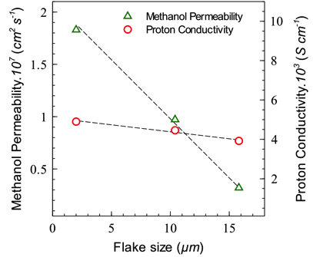

Figure 2 Methanol permeability (diffusivity) and proton conductivity through graphene oxide (GO) as a function of the mean nanoplatelet size. From Paneri2014.

PGM activity is affected by both the nature of the substrate (Feng2013a) and by the shape and size of the catalyst nanoparticles (NPs). The proposed effort will increase catalytic activity by optimization of the catalyst synthesis to produce nanoparticles of prescribed morphologies, shapes and sizes. We will pursue catalyst optimization by combining computational tools (synthesis models, simulations of process and properties) with synthesis and characterization to improve catalyst activity and achieve a fundamental understanding of their synthesis and/or control over the final product and its catalytic properties (Leong2014, example in Fig. 3). The catalytic materials systems to be addressed are metal and metal-alloy NPs, with or without core-shell morphologies. These well-defined catalytic systems are ideal for linking experiments and modeling, providing controlled systems for building selective and complex functionalities. The proposed effort will increase catalyst stability by lowering the solubility of Ru in acidic media. Our team has extensive experience in Pt-Ru deposition including wet chemical reduction (WCR), ALD, and sputtering. In addition to technical challenges, economic challenges exist that impede DMFC commercialization. Among these, catalyst cost plays a major role. Both anode and cathode require platinum and platinum-group metal catalysts. Loading levels of 2.5 mg/cm2 on each catalyst layer account for a price of $1366/kW, based on platinum at $1162/oz. At this cost, the price per kilowatt is higher than existing lithium ion batteries (Kararudin2009), and does not provide a sufficient cost-reduction incentive to justify changing technologies. Therefore to reduce catalytic loading, we will also investigate the targeted growth of Pt to GO surface defects using ALD, localizing catalyst deposition to the centers of proton transport.

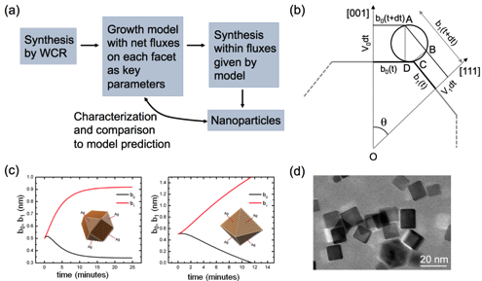

Figure 3 (a) Computationally guided synthesis of metallic nanoparticles by wet chemical reduction (WCR) –recent work at CSM (Leong2014). by Richards and Ciobanu. (b) Key parameters of the computational model: net attachment rates for each facet. (c) Predictions of the model for different ratios of attachement rates to (001) and (111) facets. (d) Actual Pd cuboctahedra synthesized by Richards' group.

Solid-state electrolytes appreciably reduce the complexity of each lithium ion cell, reducing both weight and volume. With a smaller cell, this volume and weight can be recaptured into increased fuel storage, multiplying the impact of any improvement in battery performance. An all solid-state battery using solid electrolytes is expected to have a higher energy density, reliability, and reduced safety concerns compared to a lithium ion battery using organic liquid electrolytes. All-solid-state batteries can be divided into two types, thin-film-type and bulk-type. For large-scale applications, bulk-type ASSLBs with high loadings of active material and solid electrolyte powders, are well suited because of their high energy density. However, ASSLBs have crucial challenges for practical applications, such as poor rate performance and poor contact between the active material and the electrolyte. Sulfide type electrolytes were developed to improve conductivity over earlier solid electrolytes, e.g. LiPON. Li2S–P2S5 and Li2S–P2S5–GeS2 systems offer ion conductivity from 10-3 to 10-2 S/cm at room temperature, similar to liquid electrolytes; and have a high, 5 V decomposition potential. With these electrolytes, the maximum resistance is observed at the cathode/sulfide electrolyte interfaces. ASSLB targets include in increase in lithium conductivity from XXX to YYY; improved electrode – specifically cathode – contact with the electrolyte; an increased energy density from 250 to 400 Wh/L; and a cost reduction from $1450/kWh to $1000/kWh (Kararudin2009).

**Proposed Work**

Year 1 will focus on the development of individual components with significant progress toward the stated performance metrics. This will include (1) synthesis and characterization of candidate graphene oxide and chemically modified GO membranes. Modifications to GO will include addition of dopants followed by thermal stabilization and controlled reduction of the oxide-containing functional groups. … Very limited work has been done on the chemical modification of GO for DMFC membranes. This addresses two of the three problems: proton conductivity (ohmic losses) and methanol crossover (mixed potential losses). Chemical modification of the GO can be done with ALD/MLD to control the surface to promote proton conductivity, deposit catalyst, and control hydrophobicity. Molecular dynamics simulations of proton transport through graphene oxide will be used to evaluate the efficacy of chemically modified GO membranes. (2) Synthesis and analysis of the stability, activity, and performance of the anode catalyst layer under conditions near and around those expected during fuel cell operation. Improvements to the catalyst will involve modeling of catalyst composition and morphology and growth/deposition of Pt-Ru alloy nanoparticles. (3) We will use SEM, TEM, and cyclic voltammetry to understand the cathode/electrolyte interface, which has been identified as an issue of the greatest importance for the improvement in ASSLBs. (4) Finally, system level modeling efforts will be put in place to pre-optimize operating conditions based on the evolving properties of the catalyst layer, membrane and battery properties.

Year 2 will focus on attaining the target performance metrics for all individual components. Fuel cell components will be integrated into a test cell for controlled performance testing at the Energy Systems Integration Facility at NREL. Solid-state battery components will be integrated into a coin cell configuration for electrochemical testing.

Year 3 will optimize the performance of the integrated fuel cell and battery systems under simulated real-world operational variations. Merging the fuel cell and solid-state battery into a hybrid power system will be done at PGI.

By combining battery technology with direct methanol fuel cells, advancement in this hybrid system does not hinge on improvement in any single technology, but rather benefits from every individual improvement: in battery capacity, catalyst activity, or membrane performance.

Key technical risks include…

Technical risks will be mitigated by…

Key technical risks for ALD and MLD modification of GO platelets reside in ineffectiveness of the sulfonic groups. The risk will be mitigated by reserving the flexibility to pursue alternative functionalizations, such as fluorine-based chemistries. The Pt-Ru-R (R = N, C, B) catalysts may be susceptible to agglomeration, making their shape and chemistry ineffective. Our team has explored additional functionalization of the carbon support with nitrogen to prevent aggregation in prior work and the capabilities are available to integrate this process to catalyst optimization.

**Team Organization and Capabilities**

**Project Prime**: Process Global, Inc. brings to the table…

*Principle Investigator*: Dr. Branden Kappes is an expert in… and will provide…

**Project Partner**: NREL will bring…

*Key Member*: Dr. Chunmei Ban is an expert in… and will provide…

*Key Member*: Dr. Steven Christensen is an expert in catalyst characterization and will support process feedback for the optimization of the DMFC components.

*Key Member*: Dr. Katherine Hurst is an expert in material synthesis and will perform catalyst synthesis and GO formation and modification.

**Project Partner**: Colorado School of Mines will bring…

*Key Member*: Prof. Cristian Ciobanu is an expert in… and will provide…

Within the last three years, all members of the current team have collaborated on projects relevant to the proposed effort. Drs. Ban and Kappes collaborated on an ARPA-E funded project on organic flow batteries that completed December 2014, and have numerous publications on lithium ion batteries. Drs. Ciobanu and Kappes have collaborated on… Drs. …